**Evidence 1**

Place original image before changes here:

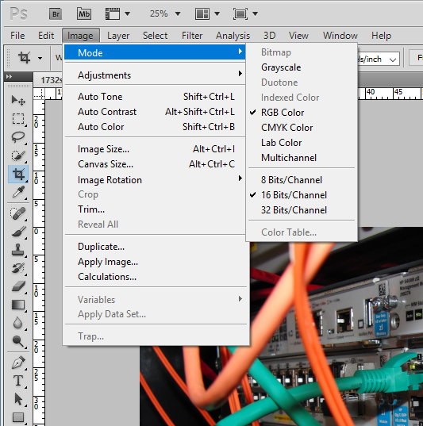

Place image after changes here:

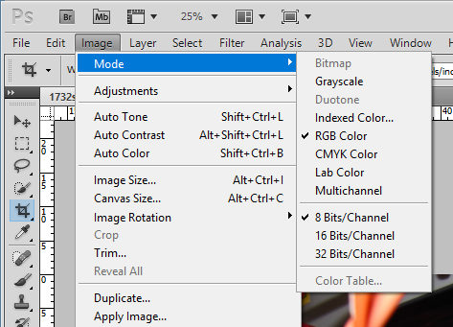

**Evidence 2**

Place image of folder showing folder name, all file names, extensions and sizes:



**Evidence 3**

Place your evaluation here:

The original png file was a large file size. It has been changed into a jpg image and has its bits per channel reduced to 8 bits from 16 bits. This will enable the image to load faster in the browser. Although the quality of the image will be reduced a bit.

**Evidence 4**

Place screenshot of the cropped image here:

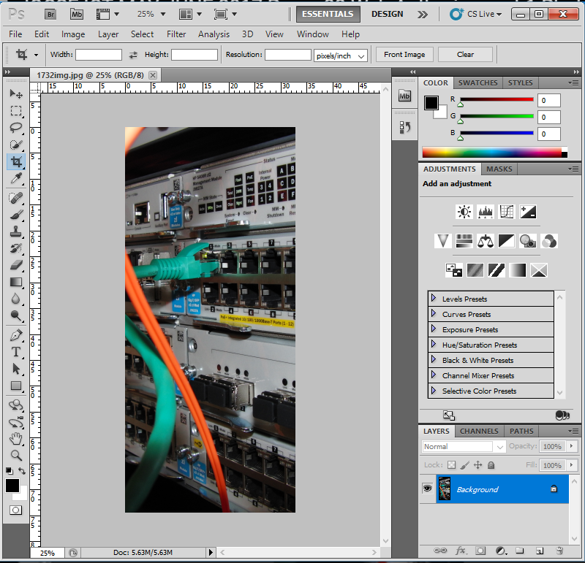

**Evidence 5**

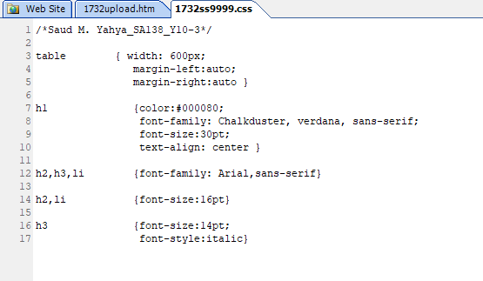

**Evidence 6**

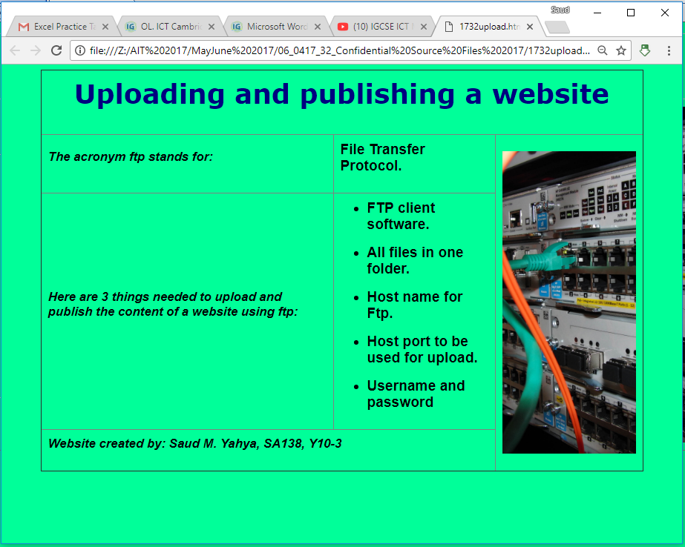

**Evidence 7**

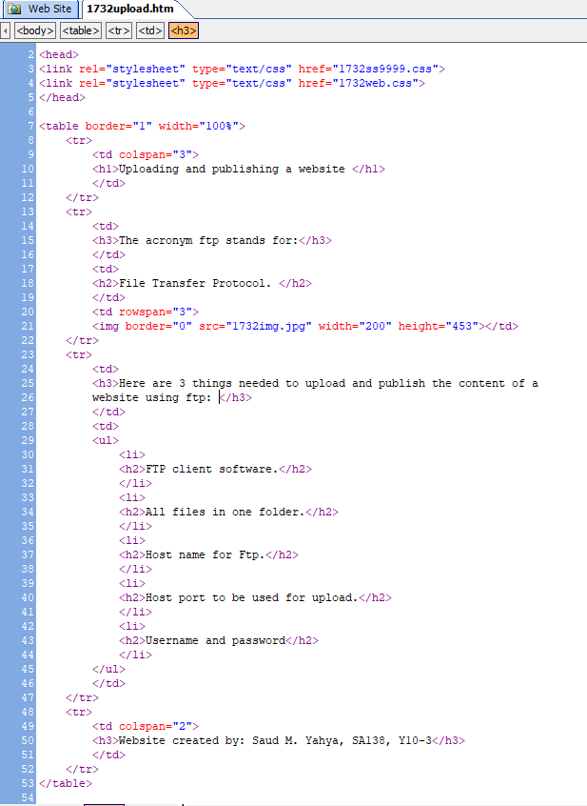

**Evidence 8**

**Evidence 9**