Traffic Sign CNN Implementation and Verification Report
  - P2 model and laptop software for the Basys3 project
Prepared for the project team and course review 2 November 2026
We built a Python training baseline, compared 16 by 16 and 32 by 32 grayscale inputs, and implemented an integer golden model of the selected CNN. The selected float checkpoint and its quantized integer version both achieve 97.50 percent accuracy on the same 2,760-image validation set. These results support keeping 16 by 16 as the working design for RTL integration.

Purpose and scope
P2 supplies image preprocessing, offline training, integer model parameters and expected outputs for hardware verification. The FPGA team will implement CNN inference. The current system classifies a supplied sign crop; it does not locate signs in full road scenes. The lecturer guide defines the project requirements. The teammate plan provided overall context, rather than a mandatory architecture or numerical format.

Completed work
Area | Evidence
Dataset preparation | 13,890 selected images decoded and checked; fixed split by physical sign track
Float model training | Six runs across two resolutions and three initialization seeds
Quantization | Signed 8-bit weights and explicit scaling under contract p2-int-v1
Integer reference | Vectorized inference and a separate serial integer MAC oracle
Software verification | Eight automated checks passed; 25 vectors matched at every layer
Hardware test artifacts | 154 .mem files, numerical contract, parameters, layouts and checksums

Current completion boundary
Python numerical simulation is complete for this provisional contract. RTL simulation, synthesis, board tests, UART comparison, final held-out testing and a team-approved release have not been completed. The exported files are ready for interface review; they are not evidence of a working FPGA implementation.

Dataset and preprocessing
We used the user-selected Kaggle distribution of GTSRB in Tubes/dataset. The full local inventory contains 39,209 training images, 12,630 test images and 43 classes. The baseline uses eight classes from Train only. All selected images passed decoding, CSV dimension and ROI checks; this does not extend the decoding claim to every class in the full dataset.
Model index | GTSRB ID | Sign meaning | Training | Validation
0 | 1 | Speed limit 30 | 1770 | 450
1 | 2 | Speed limit 50 | 1800 | 450
2 | 12 | Priority road | 1680 | 420
3 | 13 | Yield | 1740 | 420
4 | 14 | Stop | 630 | 150
5 | 17 | No entry | 900 | 210
6 | 18 | General caution | 960 | 240
7 | 38 | Keep right | 1650 | 420

The split contains 11,130 training images from 371 tracks and 2,760 validation images from 92 tracks. Class and track identifiers are parsed from source filenames. All views of one physical sign stay together, reducing leakage from adjacent video frames. The split seed is 2026; approximately 80 percent of tracks per class enter training.

Implemented preprocessing
Read the annotated ROI with inclusive maximum coordinates, crop the RGB image, convert to Pillow grayscale, and bilinearly resize to 16 by 16 or 32 by 32. The prepared image remains uint8. Float training divides these pixels by 255. Integer inference receives the same pixel bytes and accounts for the input scale numerically. No histogram equalization, mean subtraction or random augmentation was used in this baseline.

Data integrity and limitations
The generated manifest preserves paths, original labels, model indices, tracks, split assignment, dimensions and ROI coordinates. The audit records a selected-source checksum. The auxiliary Test/GT-final_test.csv is empty; the main Test.csv is populated. Neither test file nor test images were used by the training or quantization experiment. New photos require a supplied ROI or a manually selected sign crop.

Float model and training method
The network uses standard operations that can be implemented with a time-multiplexed RTL datapath. It has one convolution layer and one classifier. We trained it once per experiment seed; the integer version derives from the same learned parameters rather than a separately trained network.
Stage | Configuration | 16 by 16 output
Input | One grayscale channel | 1 x 16 x 16
Convolution | 8 filters, 3 x 3, stride 1, no padding, bias | 8 x 14 x 14
ReLU | Clamp negative float activations to zero | 8 x 14 x 14
Max pooling | 2 x 2 window, stride 2 | 8 x 7 x 7
Flatten | Channel then row then column order | 392
Fully connected | 392 features, eight biased logits | 8
Argmax | Lowest class index wins ties | Class 0 to 7

Training configuration
Training used CPU PyTorch, Adam with learning rate 0.001, batch size 128 and inverse-frequency class-weighted cross entropy computed from training labels only. Each run allowed 40 epochs and stopped after 12 epochs without improved validation accuracy. The best validation-accuracy checkpoint was reloaded for final run metrics. Initialization seeds were 42, 43 and 44; the data split stayed fixed. No softmax is required at inference because argmax operates directly on logits.
Calculated quantity | 16 by 16 | 32 by 32
Pooled features | 392 | 1,800
Weights excluding biases | 3,208 | 14,472
Biases | 16 | 16
MACs per image | 17,248 | 79,200
Weight bytes at 8 bits | 3,208 | 14,472

The operation counts exclude bias additions, pooling comparisons, rescaling, memory access and controller stalls. They are not measured latency or resource utilization. The larger input also enlarges the fully connected layer, so this compares practical designs rather than isolating resolution as the only variable.

Float validation experiment
Input | Seed | Best epoch | Training accuracy | Validation accuracy
16 x 16 | 42 | 39 | 98.31% | 97.50%
16 x 16 | 43 | 36 | 97.92% | 97.32%
16 x 16 | 44 | 39 | 97.16% | 96.34%
32 x 32 | 42 | 29 | 98.52% | 96.74%
32 x 32 | 43 | 39 | 98.72% | 96.38%
32 x 32 | 44 | 39 | 98.50% | 97.21%

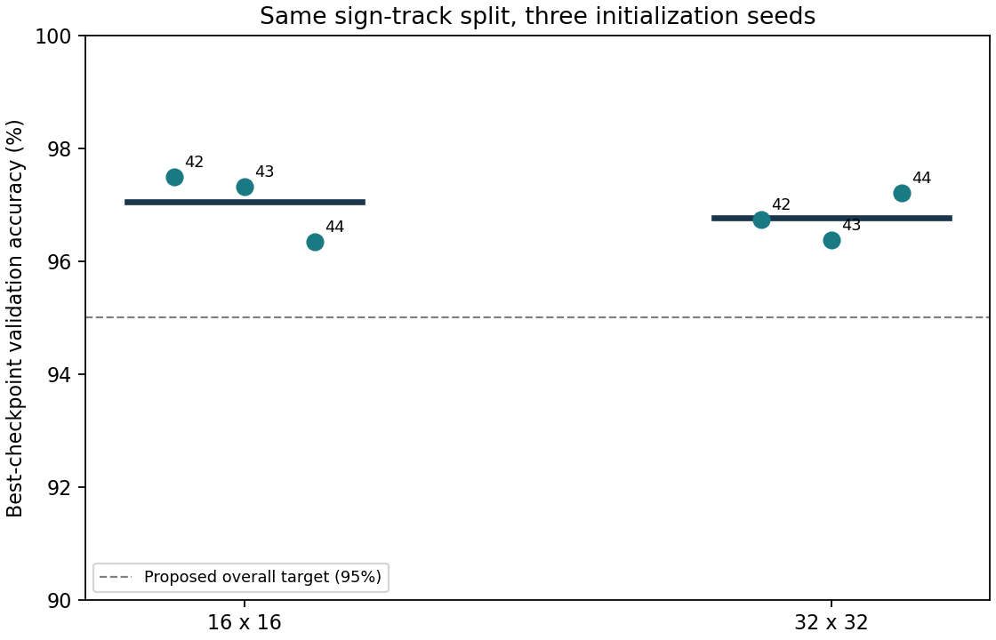
Figure 1 Validation accuracy across initialization seeds on the same grouped split. Dots are runs; horizontal solid lines are means. The dashed line is the proposed overall target.
Mean validation accuracy is 97.05 percent for 16 by 16 and 96.78 percent for 32 by 32. Population standard deviations across seeds are 0.51 and 0.34 percentage points, respectively. All six runs exceed the proposed 95 percent overall accuracy and 90 percent recall per class targets. These are project working criteria, not lecturer requirements.
We selected the 16 by 16 seed 42 checkpoint at epoch 39 for the first integer experiment. It achieved 97.50 percent validation accuracy. The difference between resolutions is small and does not establish statistical superiority. Some runs improved near epoch 40, so the models are baselines rather than fully optimized designs. The result supports keeping the smaller design as the working candidate.

Integer numerical contract
The integer golden model implements contract p2-int-v1. Quantization uses symmetric per-layer weight scales and no zero-point offset. Activation calibration uses the maximum post-ReLU float convolution value over all 11,130 training images only. Validation images do not set the activation scale.
Quantity | Contract
Input | uint8, 0..255, scale 1/255
Weights | int8, -127..127, separate scale per layer
Bias and MAC accumulators | int32; bias first, then products; overflow forbidden
Activation | uint8 restricted to 0..127; scale 0.0612918223
Rescale | Unsigned 16-bit multiplier, shift 0..47; int64 intermediate
Pooling | Exact 2 x 2 maximum, stride 2
Scores | Eight int32 logits, no output rescale
Decision and layout | First argmax on ties; CHW flattening and C array order

Scale conversion and rounding
For each weight layer, the scale is max(abs(float weights))/127. Quantized weights and biases use nearest rounding with ties to even. Bias units equal the product of the layer input scale and weight scale. The training activation maximum is 7.78406143, giving the activation scale above. Fully connected scores have a shared real scale of 0.000798104393, so integer argmax is valid.
For convolution accumulator A, the actual activation rule is:
min(127, (max(0, A) x 34172 + 16777216) >> 25)
ReLU occurs before rescaling. The rounding addition implements nearest rounding with halfway values upward for nonnegative inputs. Float and integer logits are approximations of one another; exact equality is required between future RTL scores and the integer golden model, not between float and integer scores.

Overflow analysis
Conservative bound including biases | Maximum magnitude
Convolution serial partial sums | 181,902
Classifier serial partial sums | 610,764
Rescale product plus rounding addition | 6,232,732,360

Bounds include biases and maximum input magnitudes, covering every serial partial sum. Overflow is forbidden. The int64 rescale is conservative; 34 signed bits cover these fixed parameters. Narrowing requires a contract revision and verification.

Integer simulation and verification results
Validation metric | Measured result
Selected float accuracy | 97.50%
Integer golden accuracy | 97.50%
Accuracy decrease | 0.00 percentage points
Float and integer prediction agreement | 99.67%
Changed predictions | 9 of 2,760
Activation values clipped above 127 | 0 of 4,327,680

Class | Float recall | Integer recall
Speed limit 30 | 92.89% | 93.56%
Speed limit 50 | 99.33% | 99.11%
Priority road | 96.67% | 96.67%
Yield | 97.38% | 97.14%
Stop | 96.67% | 96.67%
No entry | 100.00% | 100.00%
General caution | 99.17% | 99.17%
Keep right | 99.52% | 99.29%

Equal overall accuracy does not mean the models make identical decisions. Nine predictions changed, while the total number correct remained the same. Speed limit 30 remains the weakest class, although its recall rises from 92.89 to 93.56 percent. Integer logits converted back to real units have mean absolute error 0.18536 against float logits.

Verification performed
Eight automated checks passed. They cover track separation, inclusive cropping, tensor dimensions and cost counts, ReLU and halfway rounding, saturation, zero shift, overflow rejection, pooling and flatten order, argmax ties and hexadecimal encoding. An independent serial implementation using Python integers matched the vectorized golden model at every stage for 20 real validation images and five synthetic inputs: zeros, maximum values, checkerboard, ramp and impulse.
This establishes consistency of the two software arithmetic implementations and generated vectors. It does not verify RTL control, memory latency, timing closure or physical hardware. Final held-out accuracy is also unmeasured because the official test set remains reserved.

Artifacts and remaining integration work
Artifact or module | Purpose
data.py and model.py | Shared preprocessing and trainable float architecture
train.py and report.py | Reproducible experiments, metrics and plots
quantize.py | Training-only calibration, parameter conversion and vector exports
golden.py | Integer-only inference and independent scalar oracle
INTEGER_CONTRACT.md | Arithmetic specification and run instructions
parameters.npz and contract.json | Quantized arrays, actual scales, bounds and model identity
mem/ and vectors/ | Four parameter .mem files and 25 six-stage vector packages
checksums.json and MEMORY_LAYOUT.md | Artifact integrity and address, word-width and encoding rules

The integer output directory is build/reference_model/integer_v1/. It contains 154 .mem files: four weight/bias files and six files for each of 25 vectors. Files use one hexadecimal word per line, two’s complement for signed values and C flatten order. Weight files are 8-bit words; biases, convolution accumulators and scores use 32-bit words. Inputs, activations, pool values and predictions use 8-bit words.

Reproduction
python -m pytest reference_model/tests -q
python reference_model/train.py --sizes 16 32 --seeds 42 43 44 --epochs 40
python reference_model/quantize.py
Run from the repository root with the documented dependencies and local dataset. Existing run directories are not overwritten; use a fresh --output directory to repeat. Checkpoints must be trusted local files. Build outputs are ignored by Git and need a shared release location for teammates.

Remaining work and recommendation
Review the provisional arithmetic and memory map with RTL owners, agree any width reductions, and connect each module testbench to the exported vectors. Implement dump comparison and UART batch integration after those interfaces are agreed. Package the final parameters, preprocessing version and source checkpoint, then evaluate the frozen model on the held-out test set. Synthesis, timing, utilization, board accuracy and board-versus-golden agreement remain team integration tasks.

Evidence sources
Measured sources: build/reference_model/baseline_v1/summary.json, data_audit.json and split_manifest.json; build/reference_model/integer_v1/metrics.json, contract.json and vectors/manifest.json.
Implementation and interpretation: reference_model/README.md, INTEGER_CONTRACT.md, DELIVERABLES.md, tests/ and results/. Earlier Word and PowerPoint files describe the planning stage; this report records the completed experiments.
Dataset download source: https://www.kaggle.com/datasets/meowmeowmeowmeowmeow/gtsrb-german-traffic-sign/data . The user-supplied lecturer guide supplies the project requirements.

