Traffic-Sign Recognition on Basys3: The Plan in Pictures
Oct 29, 2026 · Simplified version of Traffic_Sign_Recognition_Project_Plan.docx
Each section is one idea: a picture, one or two sentences, and a table of the words it uses. For exact numbers and rules, see the full plan. This version already uses the subsystem split shown in section 8, Who builds what.
Contents
# | Section | # | Section
1 | The project in one picture | 8 | Who builds what
2 | How the CNN recognises a sign | 9 | Talking to the laptop
3 | Preparing the pictures | 10 | How fast it is
4 | Training, and turning it into chip files | 11 | How we test
5 | The Day-1 accuracy check | 12 | The seven days
6 | Numbers inside the chip | 13 | If something goes wrong
7 | Using the board | 14 | What we hand in

1. The project in one picture
We build a traffic-sign recogniser on the Basys3 board. A picture goes in, our own hardware decides which of 8 signs it is, and the answer appears on the display.
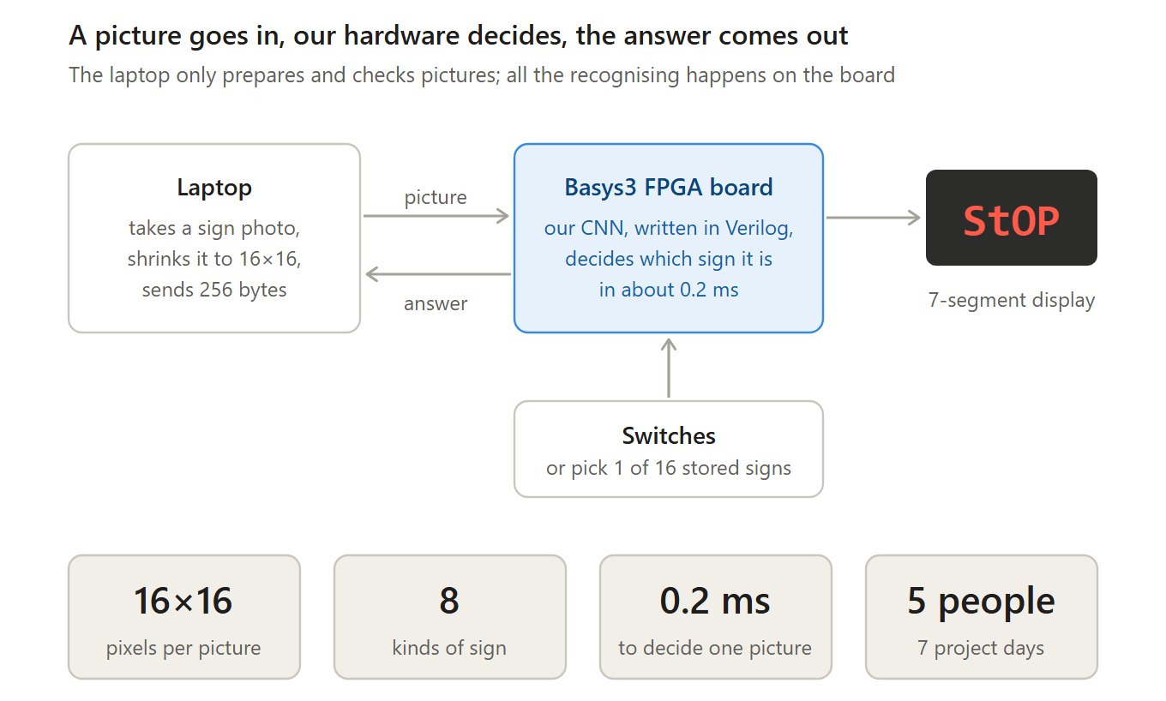
Words to know
Term | What it means
FPGA | A chip whose internal wiring we can program. We describe a circuit in code, and the FPGA becomes that circuit.
Basys3 | Our FPGA board: an AMD Artix-7 chip, a 100 MHz clock, 16 switches, 16 LEDs, 5 buttons and a 4-digit display.
CNN | Convolutional neural network: a kind of AI that recognises pictures by finding small patterns and combining them.
Verilog, RTL | Verilog is the language we write hardware in. RTL (register-transfer level) is code that describes a circuit, not a program that runs step by step.
UART | A simple way to send bytes one bit at a time. The board's USB cable carries it to the laptop.
7-segment display | The 4-digit display on the board. Each digit is made of 7 bars, which is why letters look like “StOP”.

2. How the CNN recognises a sign
The picture passes through five steps. Each step shrinks the data, until only 8 scores are left: one per sign.
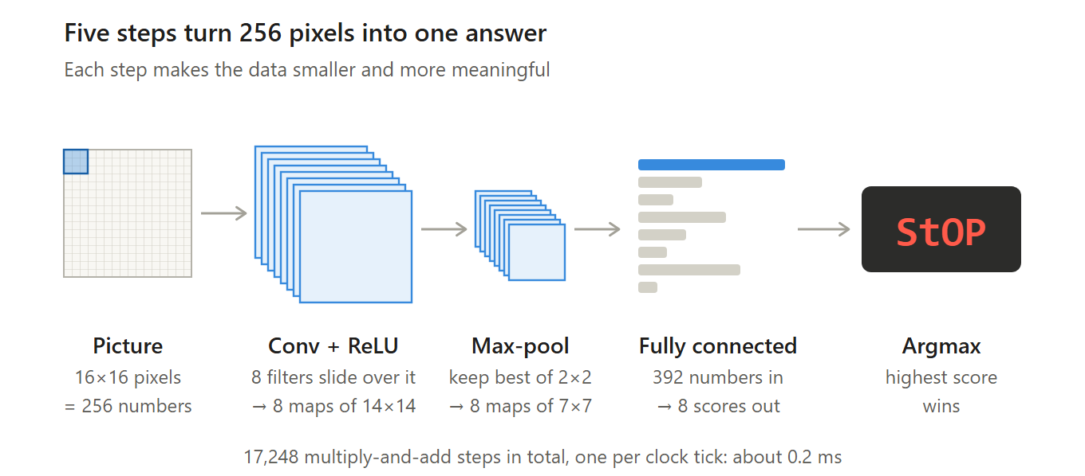
Words to know
Term | What it means
Pixel | One dot of the picture. In grayscale it is a single number: 0 is black, 255 is white.
Convolution | Sliding a small 3×3 window over the picture. At each spot, the 9 pixels are multiplied by 9 learned numbers and added up.
Filter (kernel) | The 9 learned numbers used in a convolution. Each filter reacts to one pattern, such as an edge in one direction. We use 8 filters.
Feature map | The result of one filter over the whole picture: a 14×14 grid showing where that pattern appears.
ReLU | Replace every negative number with 0, so only the patterns that were found are kept.
Max-pool | Keep only the largest number in each 2×2 square. The maps shrink from 14×14 to 7×7 but keep the strongest signals.
Fully connected layer | All 392 pooled numbers are multiplied by learned weights and added up, once per sign, giving 8 scores.
Score (logit) | How strongly the CNN believes the picture is a given sign. Higher means more likely.
Argmax | Pick the position of the largest score; that position (0 to 7) is the answer. On a tie, the lower number wins.
Multiply-accumulate (MAC) | One multiplication added to a running sum. The CNN needs 17,248 of them per picture.

3. Preparing the pictures
We use 8 signs with clearly different shapes from the GTSRB photo collection. Every picture is cleaned up the same way before training and before it is sent to the board.
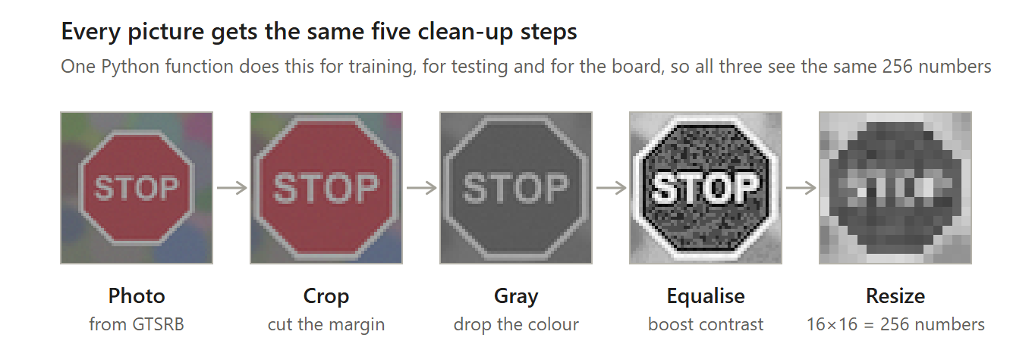
The 8 signs
Display code | Sign | Why it is in the set
StOP | Stop | Octagon, known worldwide
yLd | Yield | Upside-down triangle
no E | No entry | Red circle with a white bar
PrIo | Priority road | Diamond
CAUt | General caution | Triangle with an exclamation mark
rIGt | Keep right | Blue circle with an arrow
30 | Speed limit 30 km/h | Tests reading numbers
50 | Speed limit 50 km/h | Tests reading numbers; likely to be confused with 30
Words to know
Term | What it means
GTSRB | German Traffic Sign Recognition Benchmark: a free collection of more than 50,000 labelled sign photos in 43 kinds. We use 8 kinds.
Class | One kind of sign, such as Stop. The CNN chooses one of 8 classes.
Grayscale | Brightness only, no colour: one number per pixel instead of three.
Histogram equalisation | Spreads the brightness values over the full 0 to 255 range, so dull photos get more contrast.
Augmentation | During training only: small random shifts, turns and brightness changes, so the CNN copes with imperfect photos.

4. Training, and turning it into chip files
Training happens once, on a laptop. The board never learns anything; it only uses the finished numbers, which are built into the chip.
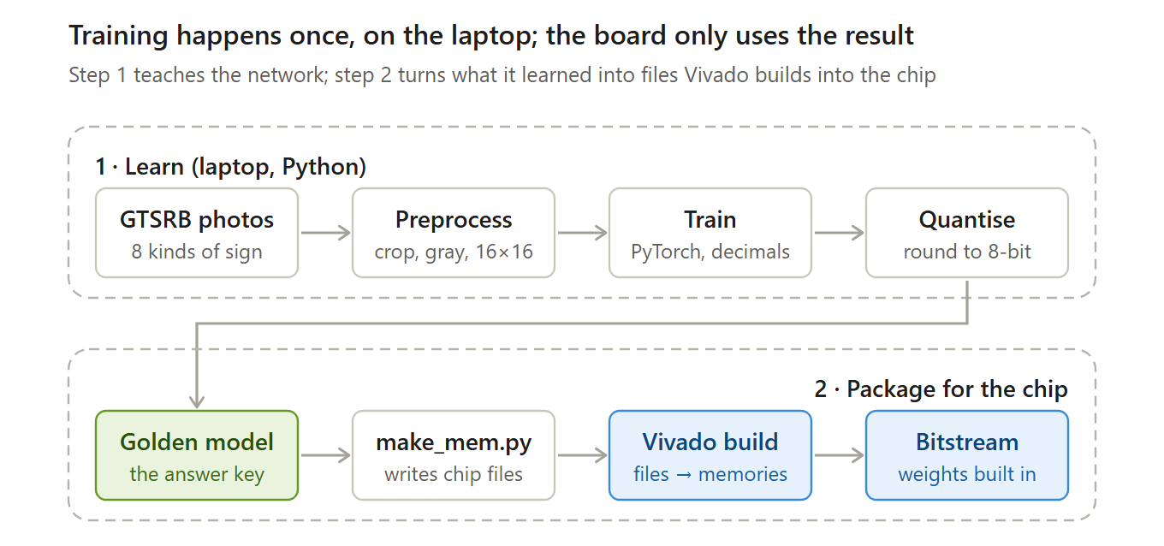
Words to know
Term | What it means
Training | Showing the CNN thousands of labelled photos and adjusting its numbers until its answers are right. Done in PyTorch, a Python AI library.
Inference | Using the finished CNN to recognise a new picture. This is the only thing the board does.
Weight | One learned number inside the CNN. We have 3,208 of them.
Bias | One extra learned number added to each filter's or each sign's sum. We have 16.
Quantisation | Rounding the trained decimal numbers to small whole numbers (8-bit, −127 to 127). Whole-number hardware is much smaller and faster.
Golden model | A Python program that does exactly the same whole-number maths as our hardware. It is the answer key for every test.
.coe and .mem files | Text files listing numbers, one per memory address. Vivado fills on-chip memories from .coe files; testbenches read .mem files.
params.vh | A generated Verilog file holding constants: the biases and the rescale numbers M and S.
Bitstream | The final file Vivado produces. Loading it onto the FPGA turns the chip into our circuit.

5. The Day-1 accuracy check
Before anyone writes hardware, we check that 16×16 grayscale pictures are good enough. The result decides which of three paths we take.
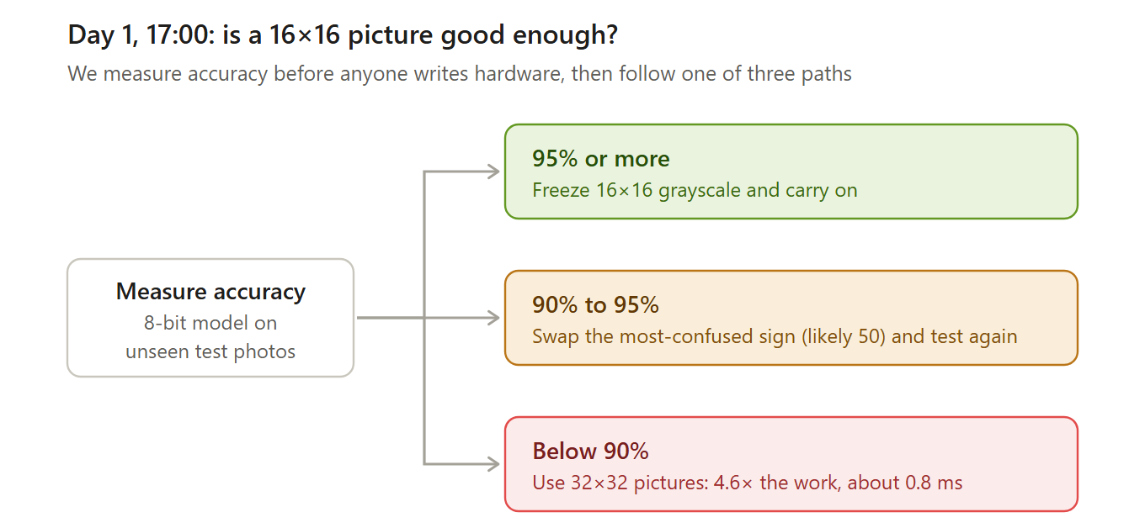
Words to know
Term | What it means
Accuracy | The share of test photos the CNN gets right.
Test set | Photos kept aside and never used in training, so the accuracy is honest.
Most-confused sign | The sign the CNN mixes up with another most often, read from a confusion matrix (a table of true sign against answer).
Freeze | Stop changing something so others can rely on it. After Day 1, picture size and number formats stay fixed; only the weights may change, until Day 5.

6. Numbers inside the chip
The chip only uses whole numbers of fixed size. Each value gets just enough bits to hold its largest possible value.
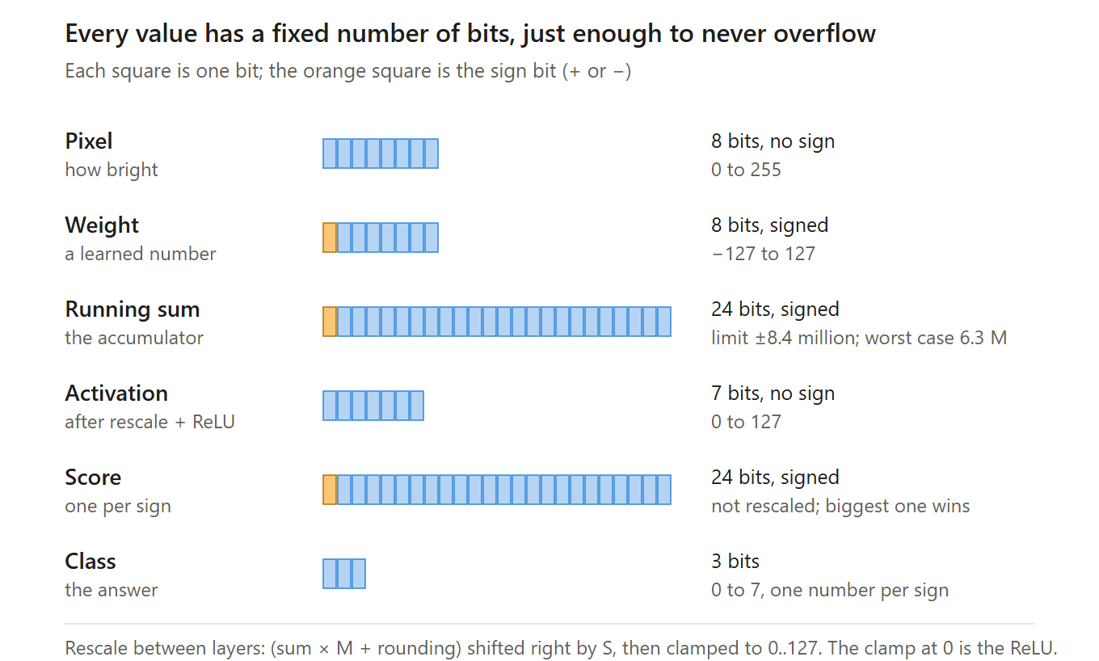
Words to know
Term | What it means
Bit | A single 0 or 1. N bits hold 2^N different values, so 8 bits hold 256.
Signed, unsigned | Signed numbers can be negative and use one bit for the sign. Unsigned numbers are 0 or more.
Accumulator | The register that holds the running sum while multiply-adds are added up. Ours is 24 bits.
Overflow | When a result is too big for its bits and wraps around to a wrong value. Our widths are chosen so this cannot happen.
Rescale (M, S) | Shrinks a 24-bit sum back to a small number: multiply by M, add half for rounding, then shift right by S bits (divide by 2^S).
Clamp | Force a value into a range: below 0 becomes 0, above 127 becomes 127.

7. Using the board
Switches choose the picture and what the display shows; LEDs and the display show the result. There are two ways to give the board a picture.
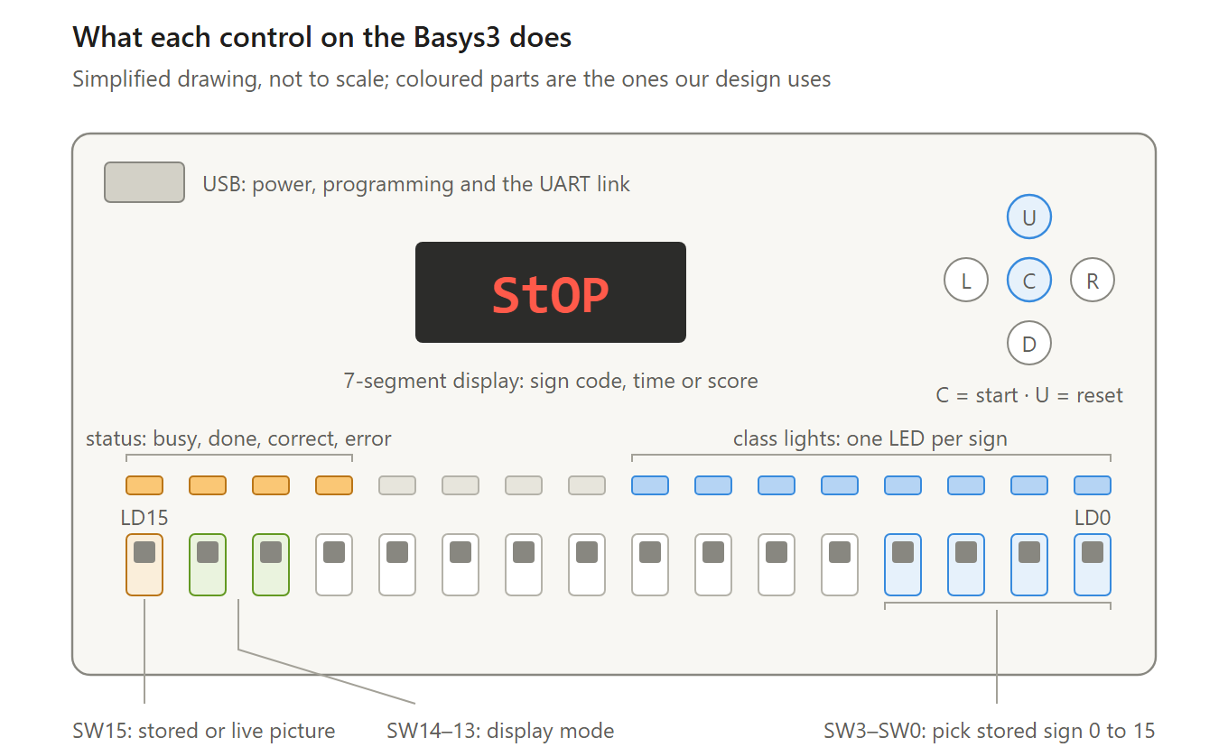
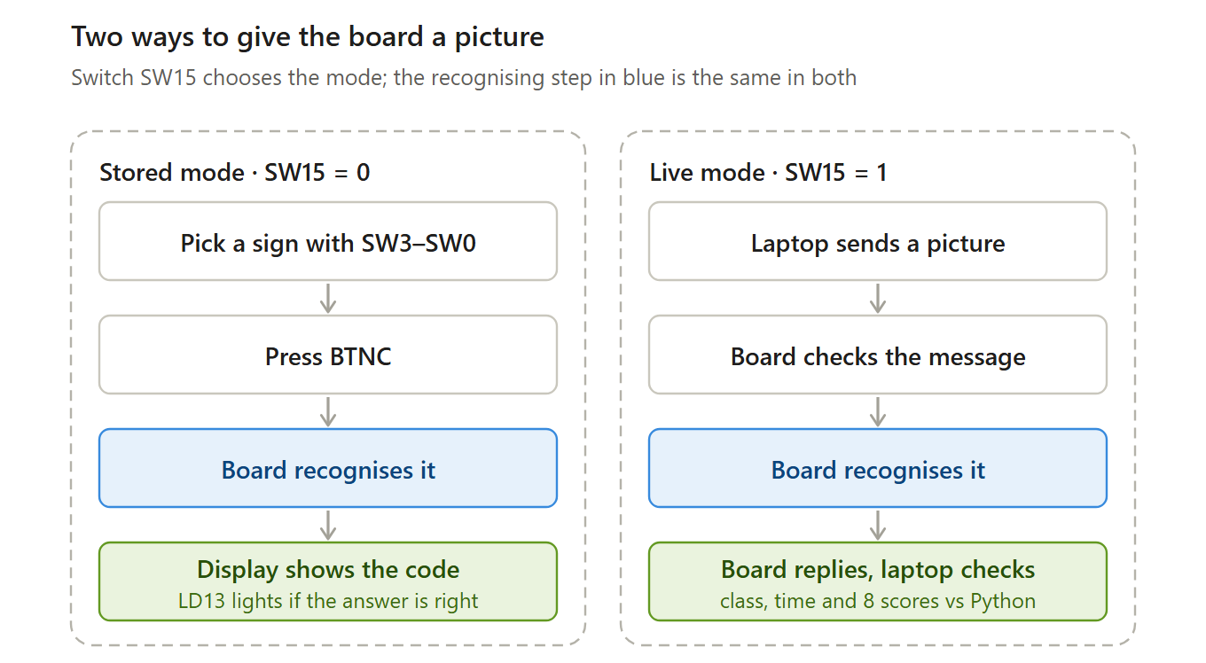
Words to know
Term | What it means
Stored mode | The 16 test signs are stored inside the chip. SW3–SW0 pick one, and BTNC starts the run.
Live mode | The laptop sends any picture over USB. The board replies with its answer, the time taken and all 8 scores.
Display modes | SW14–SW13 choose what the display shows: the sign code, the time per picture in µs, or the score.
Score mode | Pressing BTNC runs all 16 stored signs and shows how many were right, for example 15.16 for 15 of 16.
Status LEDs | LD15 busy, LD14 done, LD13 correct (stored mode only), LD12 UART error.

8. Who builds what
The design is split into five subsystems, one per person. Follow a picture from Image input down P3's column, then up P4's column. Arrows that cross a box edge are hand-offs between people, agreed on Day 1.
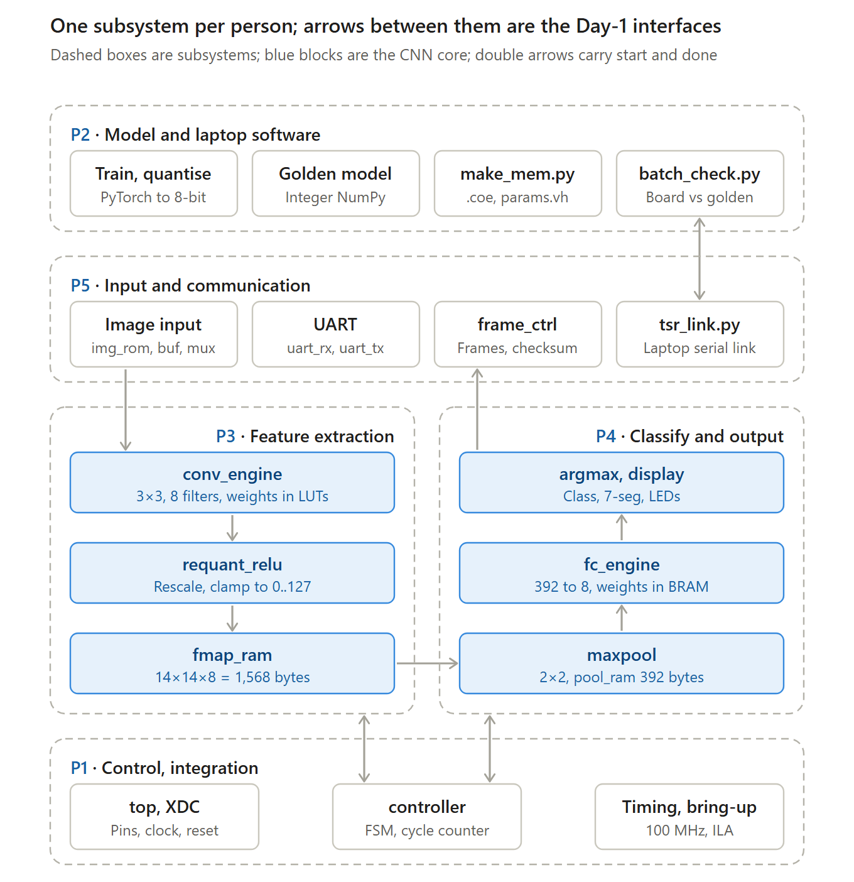
What each box does
Owner | Box | What it does
P2 | Train, quantise | Teaches the CNN with sign photos, then rounds its numbers to 8-bit whole numbers.
P2 | Golden model | Python copy of the hardware's exact maths: the answer key for every test.
P2 | make_mem.py | Turns the trained numbers and test pictures into files Vivado loads.
P2 | batch_check.py | Sends hundreds of test pictures to the board and checks every answer.
P5 | Image input | Picks the picture: one of 16 stored signs, or the one just received (switch SW15).
P5 | UART | The serial port: receives bytes from the laptop and sends bytes back.
P5 | frame_ctrl | Unpacks each incoming message and packs the reply.
P5 | tsr_link.py | Laptop side of the cable: opens the COM port, sends pictures, reads replies.
P3 | conv_engine | Slides 8 small 3×3 filters over the picture to find patterns.
P3 | requant_relu | Shrinks the sums back to 0–127 and turns negatives into 0.
P3 | fmap_ram | Memory holding the 8 pattern maps until P4 reads them.
P4 | maxpool | Keeps the strongest value in each 2×2 square.
P4 | fc_engine | Gives each of the 8 signs a score.
P4 | argmax, display | Picks the highest score and shows it on the display and LEDs.
P1 | top, XDC | Wires every module to the real pins: clock, switches, buttons, LEDs.
P1 | controller | Starts each stage in order and counts clock ticks.
P1 | Timing, bring-up | Makes the design run at 100 MHz, then loads and debugs it on the board.
People
Person | Subsystem | Buddy
P1 | Control and integration (also owns the interfaces between parts) | P4
P2 | Model and laptop software | P1
P3 | Feature extraction | P4
P4 | Classify and output | P3
P5 | Input and communication | P2
Words to know
Term | What it means
Module | One block of Verilog with its own inputs and outputs, such as conv_engine.
Subsystem | A group of modules that one person owns, from design to board test and report section.
Interface | The agreed wires and timing between two modules, such as an address going in and a data byte coming out.
Controller (FSM) | A finite-state machine: a circuit that steps through LOAD, CONV, POOL, FC and DONE, starting each engine in turn.
Start and done pulses | Signals that are 1 for a single clock tick: start tells an engine to begin, done says it has finished.
BRAM | Block RAM: ready-made memory blocks inside the FPGA. Our chip has 50.
LUT | Look-up table: the small logic cell the FPGA builds circuits from. Our chip has 20,800.
DSP slice | A ready-made multiplier inside the FPGA. Our chip has 90; we need about 2.
XDC | The constraints file: which Verilog signal goes to which pin, and how fast the clock is.
Buddy | The person who reviews your code and takes over your part if you are away.

9. Talking to the laptop
The laptop and the board exchange fixed-size messages over the USB cable. The laptop always waits for a reply before sending the next picture.
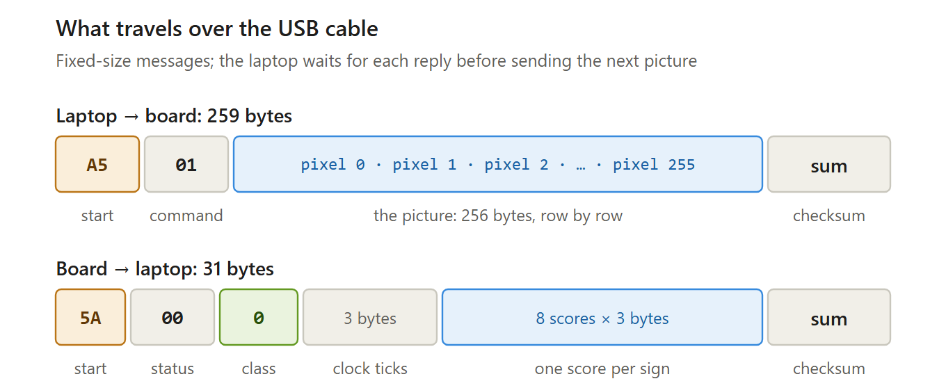
Words to know
Term | What it means
Byte | 8 bits: a number from 0 to 255. One pixel is one byte.
Baud rate | Bits per second on the link. We use 115,200, so one byte takes about 87 µs.
Frame | One complete message, from its start byte to its checksum.
Sync byte | The fixed first byte that marks the start of a frame: A5 from the laptop, 5A from the board.
Checksum | The low 8 bits of the sum of the message bytes. The receiver adds them again; a mismatch means the message was damaged.
Status | 00 OK, 01 bad checksum, 02 timeout, 03 unknown command.
Timeout | If more than 10 ms passes between bytes, the board drops the frame. If no reply comes within 200 ms, the laptop resends once.
COM port | How the USB-UART link appears on the laptop. Python opens it with the pyserial library.

10. How fast it is
The CNN needs about 0.2 ms per picture. Sending the picture over USB takes about 100 times longer, so in live mode the cable sets the speed.
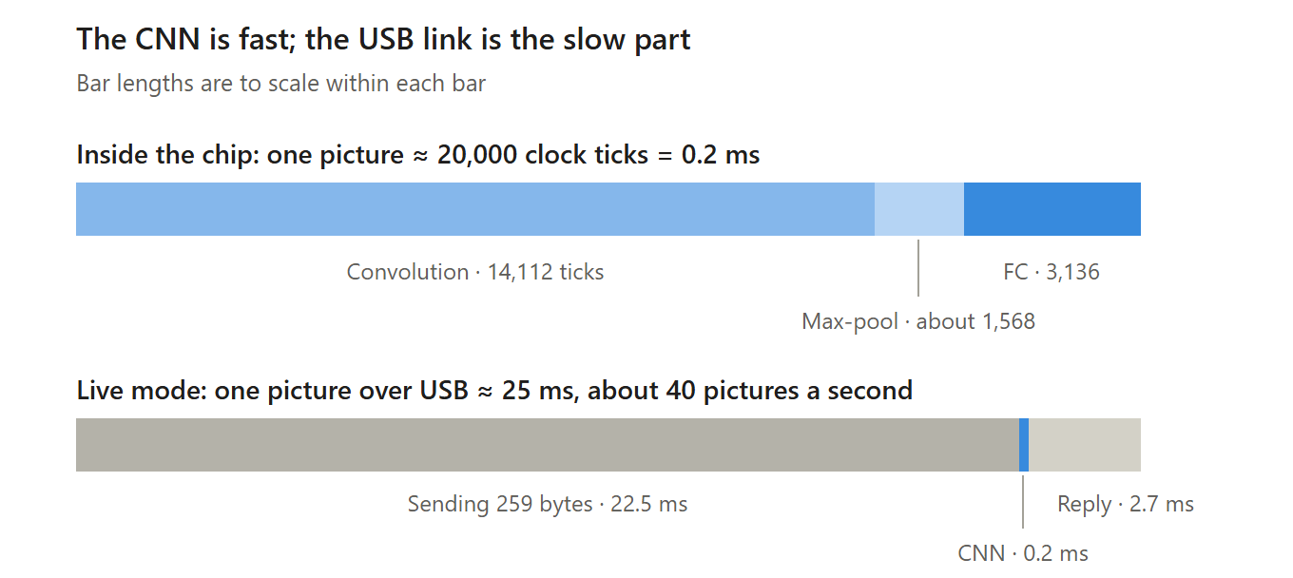
Words to know
Term | What it means
Clock, MHz | The heartbeat that steps the whole circuit. 100 MHz means 100 million ticks per second, one every 10 ns.
Clock cycle (tick) | One beat of the clock. Our design does one multiply-add per tick.
Latency | Time from start to answer for one picture: about 20,000 ticks, or 0.2 ms.
Throughput | Pictures per second. About 40 in live mode, limited by the USB link.
Cycle counter | A counter on the chip that measures latency exactly. Its value is sent back in every reply.

11. How we test
We test from small to big. Each step must match the Python answer key exactly before we move on.
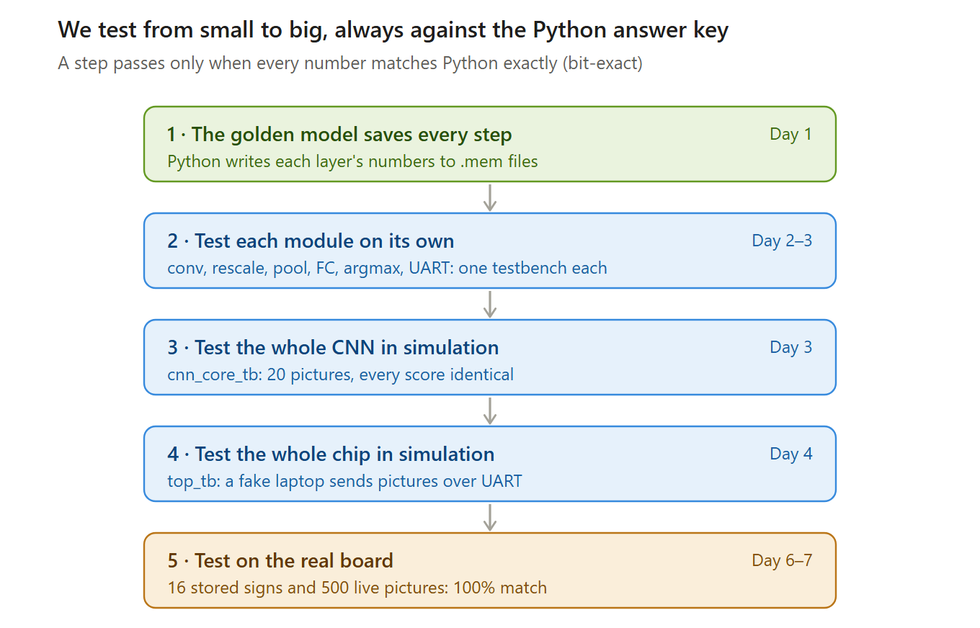
Words to know
Term | What it means
Testbench | Verilog code that feeds inputs to a module in simulation and checks its outputs. It is never built into the chip.
Simulation | Running the Verilog on the computer instead of the board, so every signal can be inspected.
Bit-exact | Every number identical to the golden model: not just close, and not just the same final answer.
Unit test | Testing one module on its own before connecting it to others.
Integration | Connecting the modules together and testing them as one system.
ILA | Integrated Logic Analyzer: a probe built into the chip that records internal signals on the real board, for debugging.

12. The seven days
Each person has one main task per day. Five gates (go/no-go checks) keep the week on track; the board must work by Day 6 at 14:00.
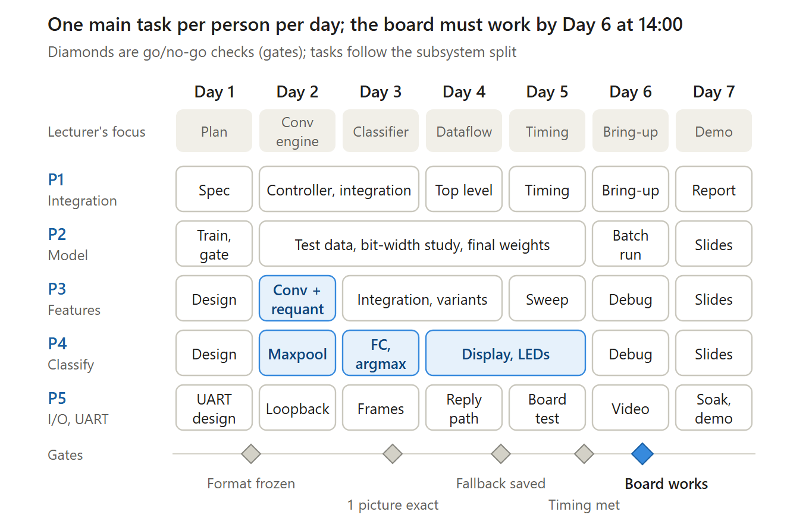
The five gates
Gate | When | Passes when | If it fails
Format frozen | Day 1, 17:00 | 8-bit accuracy measured; sizes and formats fixed | Swap a sign or move to 32×32 before Day 2
1 picture exact | Day 3, 14:00 | cnn_core_tb matches Python on one picture | P1 pairs with the owner of the first wrong layer
Fallback saved | Day 4, 17:00 | top_tb passes in both modes; simulation demo saved | Stop adding features; Day 5 morning goes to integration
Timing met | Day 5, 17:00 | No timing errors at 100 MHz; a bitstream exists | Run the CNN at 50 MHz
Board works | Day 6, 14:00 | Board matches Python on all 16 stored signs and 100% of the live batch | No extras; Day 7 morning goes to debugging
Words to know
Term | What it means
Gate | A fixed time where we check one result and decide go or no-go.
Daily review | Every day at 14:00: a short presentation with evidence, by a different presenter each day.
Fallback | The prepared backup demo: the full simulation plus board demos of the parts that work.

13. If something goes wrong
Every big risk already has a backup plan, decided in advance.
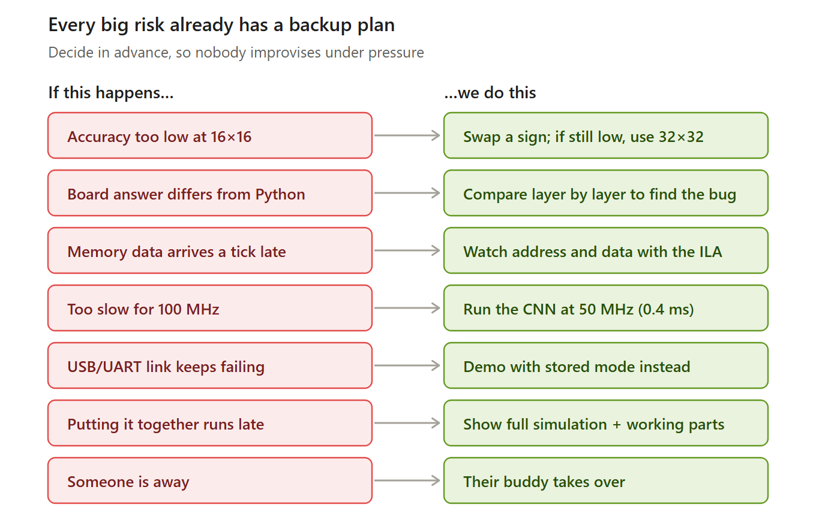
Words to know
Term | What it means
Timing, slack | Whether every signal arrives within one clock tick. Negative slack means the circuit is too slow for 100 MHz.
Clocking Wizard | A Vivado tool that makes a slower clock, such as 50 MHz, if 100 MHz is too fast.

14. What we hand in
Everything comes from the Git repository by Day 7. Tick each item when it is done.
Item | Who
☐ Verilog code (rtl/) | P1 collects
☐ Testbenches and their PASS logs (tb/) | Each owner
☐ Memory files: .coe, .mem, params.vh | P2
☐ Pin file basys3.xdc | P1
☐ Build script build.tcl and README | P1
☐ Bitstream, tagged in Git | P1
☐ Live demo in both modes | Everyone
☐ Backup demo video | P5
☐ Results report: match rate, accuracy, speed, chip use | P1, P2
☐ Final report | P1 assembles, everyone writes
☐ Slides | Everyone
☐ Daily log | Everyone

