# **Kathmandu University**

**Department of Computer Science and Engineering Dhulikhel, Kavre**



**A Report on ‘Lab Work 5’ [COMP 232]**

**Submitted by:**

**Saugat Poudel (63)**

**Submitted to:**

**Dr. Rajani Chulyadyo**

**Department of Computer Science and Engineering**

**Submission Date**: April 19, 2022

**LAB-5**

1. Create a table that stores the following information about users:
   1. ID
   2. Username
   3. Email
   4. First name
   5. Last name
   6. Date of birth
   7. Age
2. Create a table named user_logs with the following columns:
   1. ID
   2. Old_value
   3. New_value
   4. Description
   5. Log_time
3. Create the following functions
   1. Function that returns the full name of the user with the given ID
   2. Function that returns the number of users
   3. Function that returns the age of the user with the given ID
4. Create the following stored procedures
   1. SP to update the full name of the user with the given ID
   2. SP to update the age of the user with the given ID
5. Create the following triggers
   1. Trigger that populates full name on adding a new user
   2. Trigger that populates age on adding a new user
   3. Trigger that inserts a new row in user_logs if any value is updated in users table. If last name of a user is updated, the following values must be inserted into the user_logs table:  
      <old last name>, <new last name>, 'Last name updated', current time

3) Create the following functions

1. Function that returns the full name of the user with the given ID

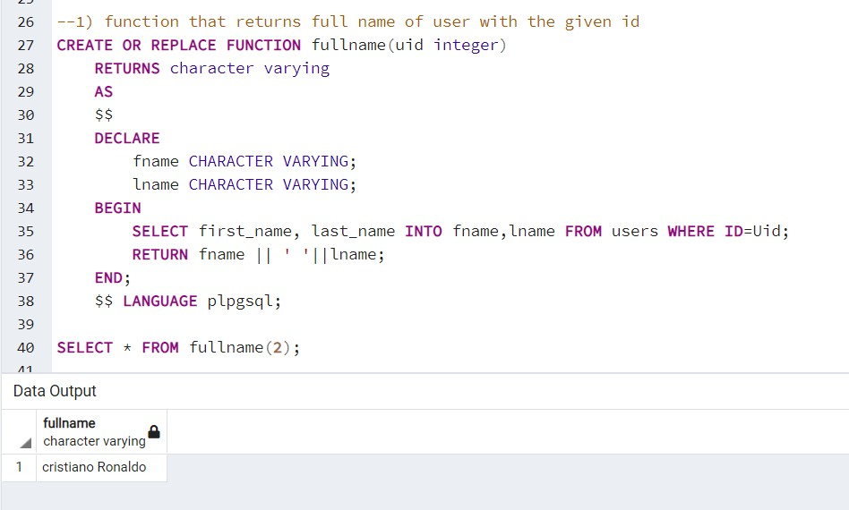

1. Function that returns the age of the user with given ID

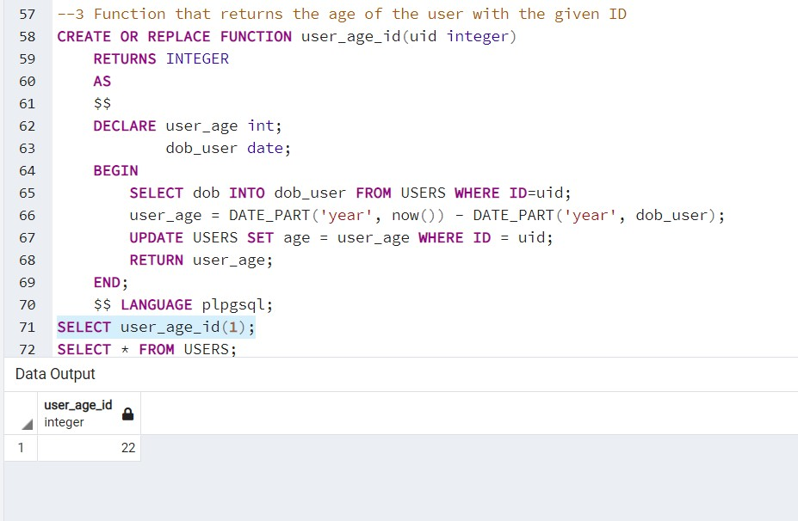

4.1

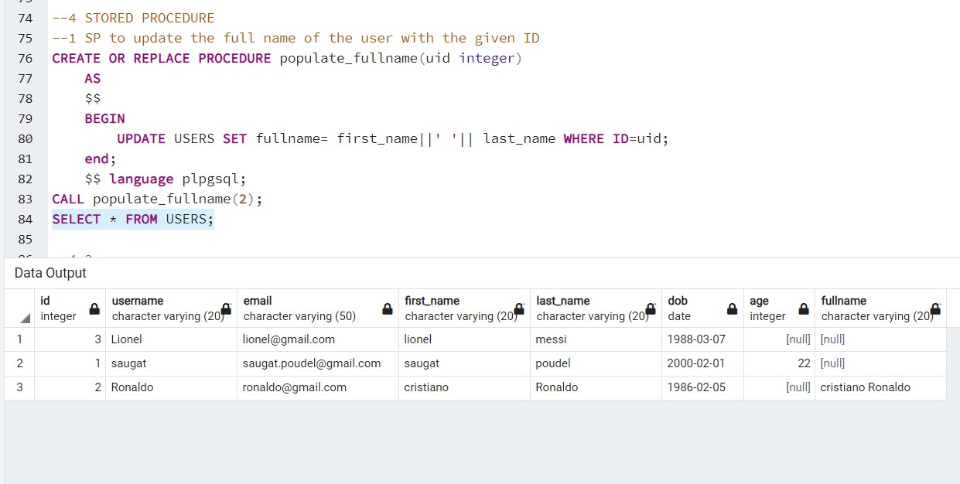

4.2

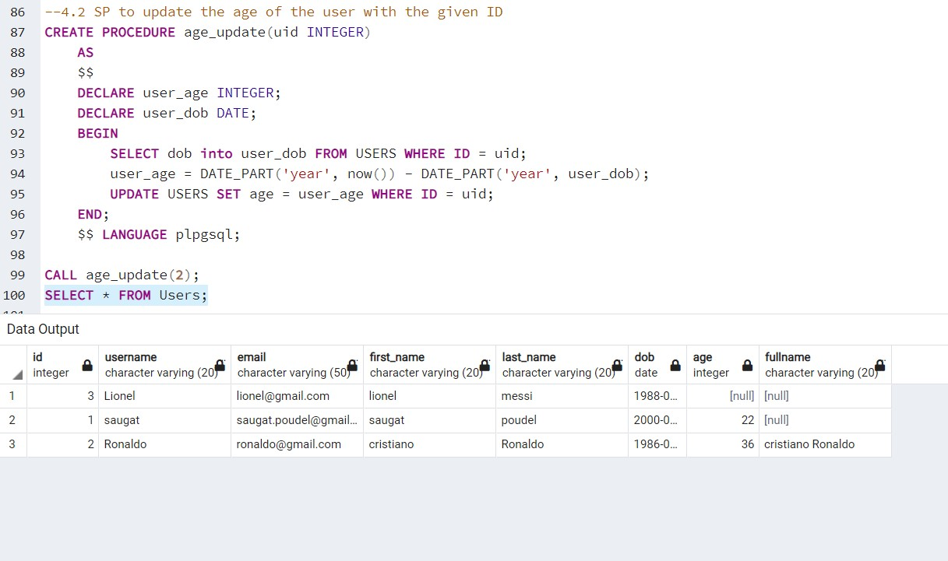

5.1

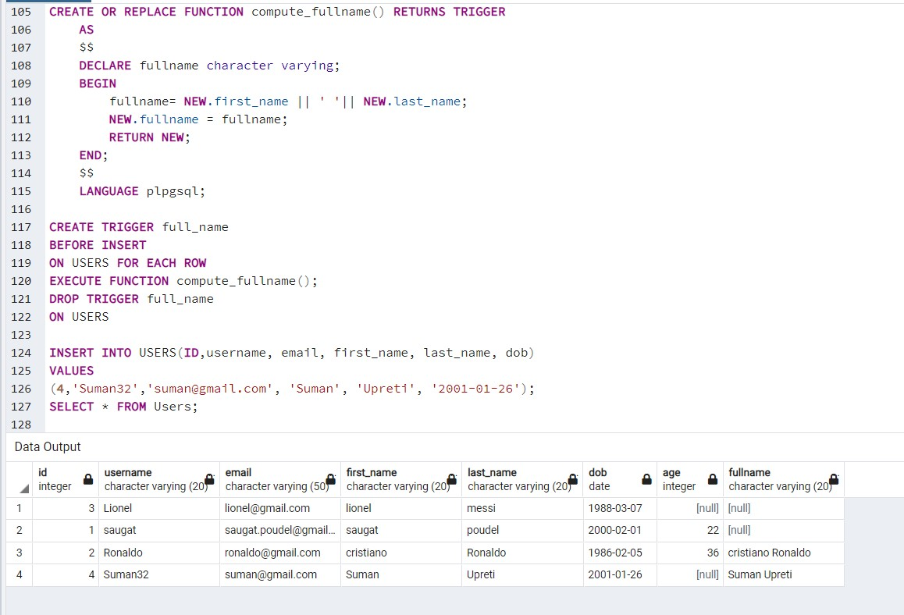

5.2

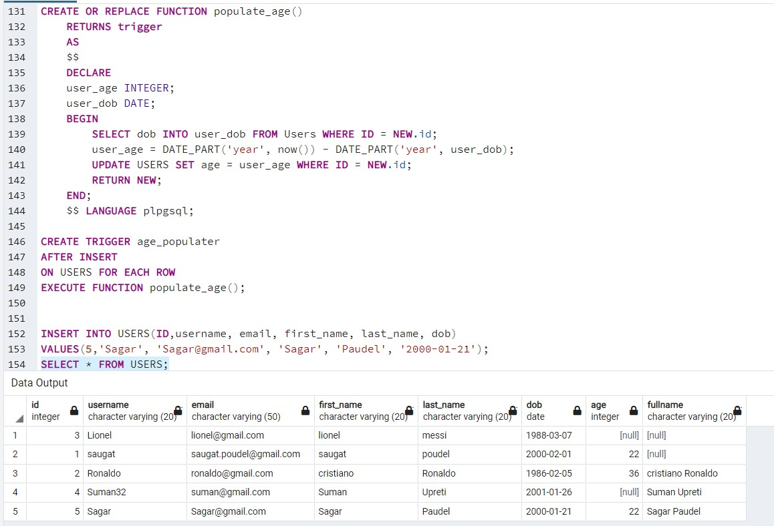

5.3

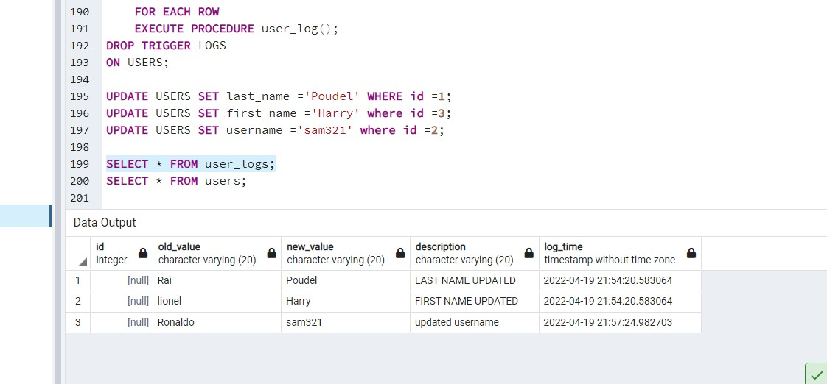

5.3

