******Chapter 13**

**Recommendation Reports**





**Sample Recommendation Report**

Recommendation Reports **| 303**



Roberta Boyles

Page 2

July 15, 20—

**SCOPE**

Interstate Development’s directors have suggested that we rank safety as the first criterion. The well-being of our employees and the public is our first priority.

Funce must be able to transport bulky, heavy loads of

product and display items as well as personnel up to 11 miles between each of our six stores.

To make sure we stay within budget, we have ranked our third criterion as cost. The directors have allocated $26,500 for a new Courier Service vehicle.

Eﬃciency and environmental impact is our fourth criterion. The directors have set the goal of reducing our carbon footprint by 20 percent over the next five years. We would like the new vehicle to contribute to that eﬀort.

The remainder of this report will compare both cars to the four criteria.

**DISCUSSION**

**Safety**

A new vehicle must include:

1. Driver, front side, and passenger side airbags.
2. An
3. Vehicle stability control system.

**2011 Dynasty Freedom Hybrid.** According to the Dynasty website and sales brochures from a localdealership, the Freedom Hybrid has all three airbags as standard equipment. The Freedom also includes an

of phones and music systems.

An innovath Crossing Alert, which

warns of the approach of hidden traﬃc. This safety feature could be valuable in preven

that have occurred with Courier Service cars in the past. Another important note is that the 2010

Freedom was the Insurance Ins

star ra

well.

**Sample Recommendation Report, cont.**

**304** |Chapter 13



Roberta Boyles

Page 3

July 15, 20—

**2011 BLAU Pronto Hybrid.** The BLAU Pronto’s standard equipment includes the three airbags,an

**Conclusion.** While both vehicles meet the subcriteria for safety, the Freedom Hybrid is likely to have a

higher safety ra

features.

**Function**

The new vehicle will be driven almost en

of clothing, display materials, and occasionally personnel. Thus, the car needs to be large enough to accommodate packages as well as people comfortably and safely.

**2011 Dynasty Freedom Hybrid.** The Freedom seats five and has front legroom of 42.3 inches andrear legroom of 36.7 inches. It has a trunk volume of 16.5 square feet.

**2011 BLAU Pronto Hybrid.** The Pronto seats five and has front legroom of 41.7 inches and rearlegroom of 38.3 inches. It has a trunk volume of 10.6 square feet.

**Conclusion.** Both vehicles are designed to seat five people and have similar space for occupants.

However, the Dynasty Freedom has a considerably larger trunk volume for transpor

display elements such as mannequins.

**Cost**

Because the directors allocated $26,500, the cost of the vehicle must not exceed that amount.

**2011 Dynasty Freedom Hybrid.** The price range for the Freedom Hybrid is $19,270–$26,150.

Dynasty has a $725 des

**2011 BLAU Pronto Hybrid.** The price range for the BLAU Pronto is $26,150–$29,045. BLAU has a $750des

**Conclusion.** Both vehicles could meet the third criterion. The price ranges listed are MSRP(manufacturer suggested retail price) and do not include rebates or tax incen hybrid/fuel-eﬃcient cars.

**Sample Recommendation Report, cont.**

Recommendation Reports **| 305**



Roberta Boyles

Page 4

July 15, 20—

**Ef**

The new vehicle must be eﬃcient and environmentally friendly. Interstate Development’s directors suggest the following features:

1. Hybrid or all electric engine
2. Fuel economy
3. Low environmental impact

Table 1 depicts a comparison of subcriteria for both vehicles.

|  |  |  |  |  |
| --- | --- | --- | --- | --- |
|  | **FEATURES** |  | **DYNASTY** | **BLAU** |
|  |  |  | **Freedom Hybrid** | **Pronto Hybrid** |
|  |  |  | |  |
| Engine |  | 2.5L Atkinson-Cycle I4 gas | | 2.4L CVT |
|  |  | 191 horsepower | | 187 horsepower |
|  |  |  | |  |
| MPG |  | 41 city/34 highway | | 33 city/34 highway |
|  |  |  |  |  |
| Transi | electric up to 47 mph | | electric up to 45 mph | |
|  |  |  |  |  |

Table 1. Comparison of Eﬃciency Features

**2011 Dynasty Freedom Hybrid.** The Freedom Hybrid boasts 41 miles per gallon in the city, where itselectric motor can be used up to speeds of 47 miles per hour. Because the car can reach speeds of up to 47 miles per hour on its electric motor, it rarely needs to use the gas engine in city driving. A bonus is that its eco-friendly cloth seats are made of recycled fabric.

**2011 BLAU Pronto Hybrid.** Although the Pronto Hybrid meets the subcriteria, its stato but do not match those of the Freedom.

**Conclusion.** The Dynasty Freedom Hybrid meets and exceeds our subcriteria for eﬃciency and lowenvironmental impact.

**Sample Recommendation Report, cont.**

**306** |Chapter 13

Writing@Work

Anne Nickel is a brand engagement consultant in London, England, for a global brand-building company called The Brand Union. Her job requires

a combination of marketing and management skills. She advises clients about what they need to change

inside their organization to fit and promote their brand.

In her role, Anne writes recommendation reports to help clients learn how to strategically adjust their marketing campaigns, business practices, communication methods, and reward policies. According to Anne, these reports combine information gathered through other kinds of writing. “In order to write a recommendation report, one also has to write interview questions, interview notes, an implementation plan, and briefs for the design team that tell them what to produce for the client. So it requires a diverse writing skill set.”

She believes that persuasive documents like these need to do many things at once in order to have the desired effect on their audience. “Recommendation reports require both rational and emotional persuasion. Case studies and statistics can be used as evidence for rational persuasion. Visuals, like graphics and video, help emotional persuasion by bringing life to ideas beyond the words used to enunciate them.”

Anne emphasizes that brilliant evidence and graphics will not do anything for your report if you fail to address the correct audience. “It is important to direct your recommendation to a person who will be open to your ideas and support them. Sometimes this person is the top decision maker and in control of the budget, but other times it is someone who has the connections or authority to be a cheerleader for your ideas and pitch them to the powers that be.”

|  |
| --- |
| Courtesy of Anne Nickel |

Recommendation Reports **| 307**

****In an unsolicited report, your audience is not expecting your recommendations. You may have difficulty gauging this reader’s reaction. Your reader may be receptive and appreciate your initiative in helping to make decisions. On the other hand, your audience may be unwilling to accept your recommendations for a variety of reasons. For example, Kamelia, a production supervisor at a large wholesale nursery, was asked by her manager to help select the walkie-talkies to be issued to all employees. Because Kamelia’s supervisor was already committed to purchasing the walkie-talkies, he was receptive to her recommendation.

receptive to your suggestions.

 Warm Up

Look at the sample recommendation report that introduces this chapter. Where is the actual recommendation made? Is this a logical place for the recommendation? Why or why not?



**WHAT IS A RECOMMENDATION REPORT?**



The **recommendation report** is a problem-and-solution report, a written answer to a need that arises in the workplace. Most problems, however, have more than one solution. The recommendation report suggests the best solution to a problem or need. It helps readers make a choice. Employees write recommendation reports to help decision makers choose the best solution. Recommendation reports help people solve large and small problems, from constructing a building to selecting a new computer.

Sometimes the recommendation is the purchase of equipment. In the sample at the beginning of the chapter, Lorraine Nevelle and Rodrigo Reyes examine two vehicles and recommend the 2011 Dynasty Freedom Hybrid for Interstate Development’s courier service. Throughout this chapter, you will look more closely at some of the decisions Lorraine and Rodrigo made while writing their report.

Sometimes a recommendation report proposes a course of action. For example, Hennepin Logging has decided to expand and has narrowed the location of its new plant to three towns in Virginia. The report compares and contrasts the three sites against the **criteria**—factors on which a decision is based—the company thinks are important and recommends a location. You will see how the writer gathers data and plans the report.



**TYPICAL READER**

Someone who must make a choice between several options; a decision maker who is seeking accurate, specifi c information focused on prioritized factors for each option.

**WRITER’S FOCUS**

Meeting the reader’s needs by addressing the reader’s prioritized factors for each option in a clear, detailed, accurate manner and

The report can be **solicited** (asked for) or **unsolicited** (not asked for). In solicited reports, your reader asks you to analyze several alternatives. This reader understands the need and will be more

by organizing the information logically and presenting it in the standard organizational plan for recommendation reports.

The last time you bought school supplies, you chose from among several alternatives. Knowing that you needed a three-ring binder, you probably examined several different three-ring notebooks. The choice you made depended on factors you considered important and may have included cost, special features such as clipboards or zippered pencil pouches, durability, and color. Companies go through the same thinking process when they make choices.

Decision makers who have the power to implement your recommendations read recommendation reports. Sometimes one person reads the report, and a committee or board often votes on recommendations. The report is usually written to a supervisor, but sometimes recommendations are made to coworkers.



**308 |** Chapter 13

An analysis of your audience’s attitude may affect how you organize your report. A **receptive audience,** readers who are open to ideas or suggestions, will be ready to read the recommendation early in the report (as is presented in the sample at the beginning of this chapter). An **unreceptive audience,** readers who are not open to ideas or suggestions, will require more careful research and supporting information up front, with the recommendation coming last. You need to lead this reader carefully to your recommendation. Table 13.1 shows the strategies for accommodating receptive and unreceptive audiences.



Recommendation reports are persuasive. **Persuasive writing,** writing to convince others, requires that you analyze audiences carefully, for your job



|  |  |
| --- | --- |
| **RECEPTIVE AUDIENCE** | **UNRECEPTIVE AUDIENCE** |
|  |  |
| Introduction | Introduction |
|  |  |
| Recommendation | Scope |
|  |  |
| Scope | Discussion with more details |
|  |  |
| Discussion with limited details | Recommendation |
|  |  |
| **Table 13.1** |  |

Recommendation Reports **| 309**

 Warm Up



Some television commercials help viewers defi ne a problem. Some commercials are problems about which people already know. Other commercials are problems that listeners may not have considered before.

List some problems that commercials defi ne. For example, an ad selling mouthwash may make people wonder whether they have bad breath.

**STARTING A RECOMMENDATION REPORT**

After you have analyzed your audience, you must define your problem, brainstorm solutions, and devise criteria.

**Define Your Problem**

In a solicited report, the person or group who requested the recommendation report has identified the problem. The problem is usually evident, but put it into words anyway. In the opening sample report, Lorraine and Rodrigo stated the problem: “The vehicle currently used to circulate documents and product among the six downtown retail stores, a 2006 Dynasty XL7, poses a safety hazard to the drivers and pedestrians because of brake and transmission problems. It also does not present a positive image for the company because four accidents have left it dented and rusty.”

In an unsolicited report, the problem may need more explanation. Unlike the solicited report, the unsolicited report is not requested. No one except the report writer has noticed the problem or considered solutions. Therefore, you must make certain that readers see the problem and its importance clearly. If the problem needs more explanation than one or two sentences, consider placing the explanation in a separate paragraph or paragraphs in the introduction.

**310 |** Chapter 13

State the problem as specifically and precisely as possible. For example, “The roof of Roosevelt Farms Bed and Breakfast leaked during the October 2, 2009, hurricane and stained the dining room ceiling” is a better problem statement than “Roosevelt Farms Bed and Breakfast had a leak.”

**Brainstorm Solutions**

Now brainstorm solutions to the problem. You may need others to help you generate possible solutions. Explain the problem to your colleagues and tell them you would like their ideas. Tell them that the focus is creative problem solving and that the time for criticism will come later.

Take notes as ideas emerge. You could act as moderator to keep the group on track and stop any criticism that creeps in. Narrow the choices to two or three. You may use others’ advice to help narrow the choices.

When Lorraine and Rodrigo brainstormed solutions to the vehicle problem, they generated a list of six vehicles. They narrowed the list to two when they decided that an all-electric vehicle cost too much.

The search for solutions also may require research. Professional journals and newsletters, LISTSERVs, government documents, and company reports may reveal findings that influence your recommendations. Seek as much information as you need to brainstorm solutions.

**Devise Criteria**

As you narrow your solution choices, decide what criteria to use. Interview people about what is important to consider when making your choice. Ask all concerned—administration, workers, people who have used one of the solutions. Getting opinions is important so that the solution you recommend works for everyone.

Roneika West was asked to write a report for Hennepin Logging to recommend a town in Virginia for the construction of a new plant. After several meetings, three sites were selected as possible locations. Roneika consulted with others to help her devise criteria. Table 13.2 shows some of the preliminary information she gathered by consulting Hennepin’s management, the workers who will relocate, and a furniture manufacturer who buys wood from the company.



|  |  |
| --- | --- |
| **FROM** | **TOWN SHOULD HAVE** |
|  |  |
| Administration | 10-acre plot of land |
|  | Available workforce |
|  | Adequate power supply |
|  |  |
| Workers who will relocate | Effective, successful schools |
|  | Affordable housing |
|  |  |
| Local furniture manufacturer | Safe roads |
| **Table 13.1** | Consistent, adequate water supply |
|  |
|  |  |
| **Table 13.2** |  |

Recommendation Reports **| 311**

**FORMATTING AND ORGANIZING****RECOMMENDATION REPORTS**



The recommendation report is a highly structured report that uses a consistent outline and a comparison/contrast discussion. You may have seen such reports written as multipage paper documents. However, the best format for a recommendation report may not be a multipage paper document. In fact, you have many formatting choices for these types of reports.

If you are submitting a report to a prospective client, you might send it as an e-mail attachment, post it to a website, create and send a CD-ROM, or provide hyperlinks in a Microsoft® Word document. As with other decisions, you should base your choice of format on the audience’s needs.

For instance, an audience that frequently uses the Internet would appreciate the ease and speed of having access to an online report. In contrast, some readers are more comfortable with a traditional print document; so the writer could submit a paper copy or send the document as an e-mail attachment. Whatever the format, recommendation reports follow the same basic outline.

Warm Up

Look closely at the headings in the sample recommendation report beginning on page 303. What kind of information goes under each heading?

**Outline**

The recommendation report consists of introductory material, a recommendation (summary of discussion), scope (what the report covers and why), and discussion (analysis of criteria—the factors used in making the decision).

***Introduction***

The introductory section:

States the purpose of the report. Briefly explains the problem.

Narrows the choice to two or three items. Gives a criteria list.

Previews the rest of the report.

May include the investigation method.

The model introduction in Figure 13.1 on the next page orients the readers to the information in the body of the report—the site recommendation for a real estate license review course. This

Bob Kantin, spokesperson for an online company that develops and sells sales proposal systems, has written the online article “Recommendation Reports and Internal Politics.”



Go to the NET Bookmark for

Chapter 13 and read Kantin’s article. Do you agree with him? Are internal politics a signifi cant concern for all recommendation report writers? for some recommendation report writers? Explain.

*www.cengage.com/school/bcomm/techwtg*

Recommendation Reports **| 313**

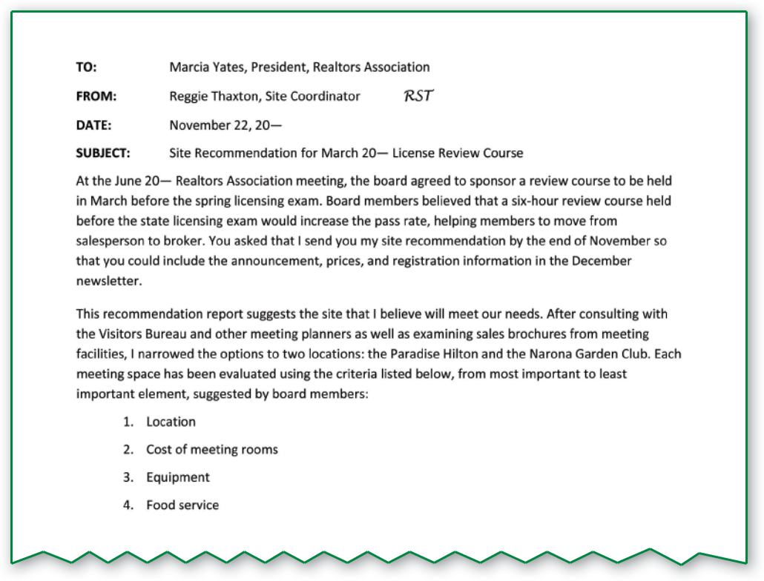

**Figure 13.1** Sample Introduction

model introduction explains the history and the problem, the recommended solution, the criteria, and the investigation method.

***Recommendation***

The recommendation section of the report:

Makes the recommendation.

Uses criteria to summarize reasons for the recommendation.

Because readers want the important information first, the recommendation section appears early in the report unless the report is unsolicited. As Figure 13.2 shows, this section may be brief. In longer reports describing more complex situations, the section could be several paragraphs. If you offer multiple recommendations, number and list them.



**Recommendation**

I recommend that the March 20— review course be held in the meeting room of the Paradise Hilton. This venue offers a central location, a reasonable cost for use of the facilities (when the hotel caters the luncheon), access to requested electronics with on-site technicians for service, and hot and cold menus.

**Figure 13.2** Sample Recommendation

**314 |** Chapter 13

***Scope***

The scope section:

Lists criteria, in descending order from most important to least important, that were given in the introduction.

Explains why the criteria were chosen and why they are ranked as they are.

This discussion assures writers and readers that they agree on important factors in the decision. This section also explains how information is analyzed, as shown in Figure 13.3 in the description of criteria and explanation of why each criterion was chosen.

***Discussion***

The discussion section:

Analyzes each of the criteria thoroughly.

Draws conclusions about which item is better for each criterion.

Organize the discussion section of the report by criteria, starting with the most important and moving to the least important. Give each criterion a major heading. Each criterion is introduced with an explanation of essential elements or features. Then each item being considered is compared to the ideal set in the introduction. Finally, a conclusion shows the results of the comparison for the criterion. Figure 13.4 presents one part of a discussion section.

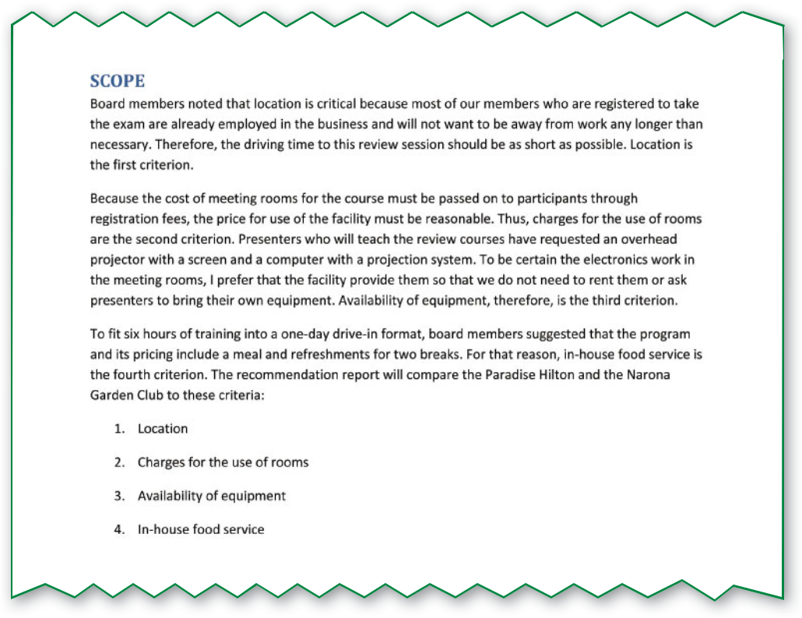

**Figure 13.3** Sample Scope Section

Recommendation Reports **| 315**

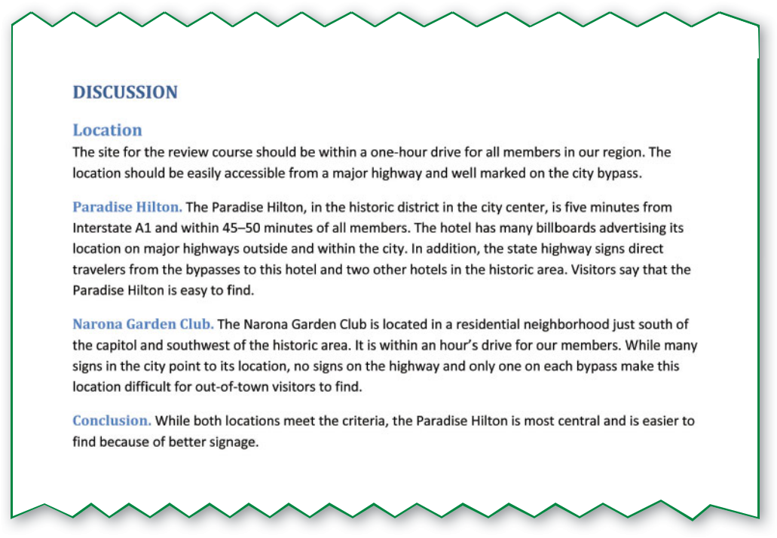

**Figure 13.4** Discussion Section

Remember, receptive readers are interested primarily in the recommendation, which is why it appears early in the report. Unreceptive readers, however, are more likely to be persuaded if the recommendation is placed last, after the discussion.

**Comparison/Contrast Discussion**

Most recommendation reports follow an organizational plan called *point by* *point,* as in the sample report at the beginning of the chapter.



**Point-by-point organization** zigzags from one item to the next, comparingor contrasting some aspect of one item to the same aspect of another item. Under the safety heading in the opening sample report, the writers compare the safety features of the two cars. Both vehicles are collected under one point, or criterion—in this case, safety. Figure 13.5 shows the zigzag from one item to another.

**2011 Dynasty Freedom Hybrid** **2011 BLAU Pronto Hybrid**



Safety  Safety

Function  Function

Cost  Cost

Eﬃciency and Environmental Impact  Eﬃciency and Environmental Impact

**Figure 13.5** Point-by-Point Organization

**316 |** Chapter 13

Table 13.3 links a general outline for this section (left column) to the headings in the discussion section (right column) in the model report.

**Appendixes**

Appendixes are another component of some recommendation reports. **Appendixes,** the plural of*appendix,*are supplementary materials that appearat the end of a document. Report writers may decide to attach information, documents, or supporting materials they believe will aid the audience in understanding the report.



Each document or supplementary item is entered and labeled as a separate appendix. Usually, elements that become appendixes are not directly involved in the report but are closely aligned to information presented.

For instance, a recommendation report suggesting the hiring of four part-time salesclerks rather than one full-time employee could include a company salary scale as Appendix A and a chart of employee shifts and positions as Appendix B. Some information drawn from these documents would probably be used in the report, but the entire documents might be too distracting to include. So they would appear at the end of the document as appendixes, where readers may refer to them.





**COMPOSING RECOMMENDATION REPORTS**

While decisions about formatting and organizing a recommendation report are likely to have an impact on readers’ perceptions, those elements are secondary to decisions made in composing: setting criteria, evaluating criteria, and researching criteria.

**Setting Criteria**

Criteria, the factors on which you base a decision, play an important role in the recommendation report. Table 13.4 shows where and how criteria are used.

The criteria you choose depend on what you, your audience, and your colleagues think is important. Safety, function, cost, and efficiency and environmental impact are important factors in the choice of a new car for Interstate Development, as noted in the introduction of the report at the beginning of this chapter. After you select criteria, you must present them in a logical, consistent way.



All criteria must be presented with a name, a **rank** (the relative importance of one criterion to another), and a **standard** (a means of defining and limiting a criterion). Choose a simple name, usually a noun that is parallel to the other criteria. Some reports use questions such as *What is the cost?* and *How safe is this option?*

**

Give each criterion a rank to show its relative importance to the other criteria. Which is the most important criterion? the second most important? the third most important? List them in descending order, from most to least important. The rank of criteria may change depending on the circumstances.

For example, younger workers with families moving with the Hennepin Logging operations to Virginia might rank the criteria for an acceptable town as schools (first), family entertainment (second), and medical facilities



**CRITERIA ARE**

|  |  |  |
| --- | --- | --- |
| Introduced | in the | Introduction |
|  |  |  |
| Summarized | in the | Recommendation |
|  |  |  |
| Explained and ranked | in the | Scope |
| (Why chosen and ranked?) |  |  |
|  |  |  |
| Evaluated (one by one) | in the | Discussion |
|  |  |  |
| **Table 13.4** |  |  |

**318 |** Chapter 13

After reviewing the report, make a list of similarities and diﬀerences between the New Jersey report and the sample recommendation report beginning on page 303.

**COMMUNICATION TECHNOLOGIES**

**Some recommendation reports are long, formal, and directed to a large and diverse audience. In such cases, these reports are often published online instead of or in addition to being published in print. Do an online search for one such recommendation by the New Jersey Teen Driver Study Commission.**

**Think Critically**

(third). Older workers might rank the criteria as medical facilities (first), family entertainment (second), and schools (third).



Finally, determine the standards of (or limits to) the criteria. For example, if Interstate Development will not pay more than $26,500 for a vehicle, then that amount, $26,500, sets the standard for cost. If families moving with Hennepin Logging to Virginia expect a class A trauma center to be within a half hour’s drive of the town, an accredited trauma center with a class A certification within a 25-mile radius could be the standard for medical facilities.

You may need help refining your criteria. In the opening sample report, the vehicle had to meet several subcriteria under safety. Seek ideas and opinions from as many stakeholders as possible. In your report, list subcriteria when you get to the appropriate criterion section. Like criteria, subcriteria should be listed in descending order of importance.

In the opening sample report, the vehicle had to meet several subcriteria under safety. Because the decision makers consider safety to be of primary concern, it is ranked as the first criterion. The standard is security for passengers and cargo. And subcriteria include driver, front side, and passenger airbags; an

antilock braking system; and a stability control system. The recommendation is based on findings related to the criteria and subcriteria. Table 13.5 summarizes how to develop the criteria in your report.

**Evaluating Criteria**

Evaluating criteria is a step-by-step process. Jacob is comparing the safety features of two swing sets for his daycare center: Play Time Gym Set and Kiddie Swing Set. Consider the three subheadings—Play Time Gym Set, Kiddie Swing Set, and Conclusion—under the criterion *Safety* in a recommendation report comparing playground equipment for a daycare center. Under *Play Time Gym Set,* the writers discuss the safety subcriteria for one set of swings. Under *Kiddie Swing Set,* the writers discuss the same safety subcriteria for another set of swings. On the following page, Table 13.6 shows how, through discussion, the writers check off the subcriteria one by one.

The checklist shows at a glance that the Play Time Gym Set more completely meets the preschool’s needs for safety. The Play Time Gym Set meets four out of four needs; the Kiddie Swing Set meets one out of four needs. A simple count shows that the Play Time Gym Set wins in the safety category. After the comparison is made, the results are easy to summarize in the conclusion, which follows the discussion of each item.



|  |  |
| --- | --- |
| **NAME** | A noun, noun phrase, or question |
|  |  |
| **RANK** | Criteria listed from most important to least important |
|  |  |
| **STANDARD** | A limit that clarifies each criterion (cost, size, quantity, and so on) |
|  |  |
| **SUBCRITERIA** | A list of more detailed criteria that fall under one criterion heading |
|  |  |

**Table 13.5**

Recommendation Reports **| 319**

**THE PLAY TIME GYM SET MEETS THE SUBCRITERIA EASILY.**

|  |  |  |
| --- | --- | --- |
| Smooth edges | ✓ | It has plastic seats with rounded edges. |
|  |  |  |
| Secure cap covers | ✓ | Fewer caps are needed because of the round edges. |
|  |  |  |
| Slide under 10 feet | ✓ | Slide is 6 feet long. |
|  |  |  |
| Inability to absorb heat | ✓ | Slide is plastic and will not absorb heat. |
|  | | |
| **THE KIDDIE SWING SET DOES NOT MEET ALL OF THE SUBCRITERIA.** | | |
|  |  |  |
| Smooth edges | ✗ | It has galvanized frames with few rounded edges. |
|  |  |  |
| Secure cap covers | ✗ | More cap covers are needed. |
|  |  |  |
| Slide under 10 feet | ✓ | Slide is 6 feet long. |
|  |  |  |
| Inability to absorb heat | ✗ | Slide is metal and will absorb heat from the sun. |
|  |  |  |

**Table 13.6**

Suppose the Kiddie Swing Set had met only the special features and cost criteria and the Play Time Gym Set had met only the safety criteria. Then you would make a judgment call. Safety is ranked as the first concern, more important than special features and cost. Therefore, you would recommend the Play Time Gym Set.

Suppose, however, that both items meet the criteria. Then you should look for some deciding factor. Maybe the cost of one item is lower. Maybe the delivery is quicker or the guarantee is better. In those rare cases where there is no real difference between the two items, you are free to recommend either one—or you may want to set other criteria.



|  |
| --- |
| nidda/iStockphoto.com |

**320 |** Chapter 13

**Researching Criteria**

Research data for a recommendation report can come from a variety of places. Much of the research you conduct for a recommendation report will be field research in which you use surveys, interviews, and visits. Websites, manuals, and catalogs can provide product information. Print media in the library can be useful

too. *Consumer Reports,* government publications, business indexes, professional journals, and the many ways to research electronically also can provide data you need.



Roneika West, in her recommendation report to Hennepin Logging, used several sources. She interviewed coworkers and workers at another logging operation. She surveyed the employees who would move to the new site. Roneika visited the three towns in Virginia and interviewed town officials. She reviewed government tax base documents on the Internet. Sometimes personnel, sales brochures, a visit to a store, or sales representatives provide all of the information the writers need.

Be alert to opportunities to present research data in graphics. The opening sample report uses tables of features. Other possibilities for graphics are pictures or diagrams of equipment, pie graphs of survey results, and bar graphs to compare items.

|  |
| --- |
| Riser/Getty Images |





Recommendation Reports **| 321**

******Chapter 13**

**Review**

**SUMMARY**

1. Decision makers read recommendation reports. Reports can be solicited (asked for) or unsolicited (not asked for). For receptive audiences, place the recommendation section early in the report. For unreceptive audiences, place the recommendation section later in the report.
2. Writers get started on a recommendation report by defining the problem, generating possible solutions, and devising criteria. They interview colleagues and others to help with the prewriting process.
3. The recommendation report follows a tight structure using a consistent outline and a comparison/contrast discussion. The major sections include an introduction, the recommendation, the scope, a thorough discussion, and appendixes. The comparison/contrast organization follows a point-by-point pattern that discusses all solutions under one heading or criterion. The recommendation report may be presented in one of many different formats based on the audience’s needs.
4. Criteria are presented in the introduction, summarized in the recommendation, explained in the scope, and thoroughly analyzed in the discussion.