**Presentations**



**WRITE TO LEARN**

Recall speakers whose performances you have enjoyed. For instance, you may have had an instructor who held your attention from the moment you entered the classroom. Perhaps you appreciated a speaker at a club meeting or special event. What made these speakers effective communicators? List the qualities and actions that helped these speakers to be effective. For instance, consider these questions: What did the speaker do to get your attention at the beginning? What did the speaker provide as visual support so you could better understand the message?



*Focus on Presentations*

Read the sample presentation slide on the next page and answer these questions:

1. Who is the intended audience?
2. What does the title contribute to the slide?
3. Why is the information in the notes not covered in the slide?
4. Does the slide need animation? Why or why not?

*What If?*

1. The writer had intended to deliver the presentation only online?
2. Readers were unfamiliar with America’s economic situation?
3. All audience members were experts in accounting?

**278 |** Chapter 12

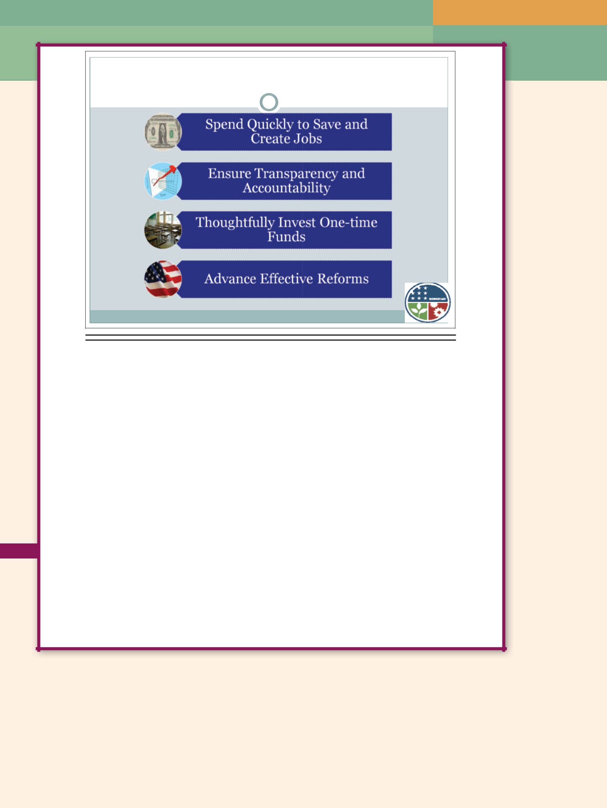**Guiding Principles**

**Guiding Principles**

The overall goals for stimulating the economy in the short term and for investing wisely; funds are used to improve schools, raise achievement, drive reforms, and produce better results for children and young people for the long-term health of our nation

Four principles guide the distribution and use of ARRA funds:

**Spend funds quickly to save and create jobs.** ARRA funds will be distributed quickly to states,local educational agencies, and other entities to avert layoffs, create and save jobs, and improve student achievement. In turn, states and LEAs are urged to move rapidly to develop plans for using funds that are consistent with the law’s reporting and accountability requirements and to begin spending funds promptly to help drive the nation’s economic recovery.

**Ensure transparency, reporting, and accountability.** To prevent fraud and abuse, support themost effective uses of ARRA funds, and measure and track results accurately, recipients must publicly report how funds are used. Due to the unprecedented scope and importance of this in-vestment, ARRA funds are subject to additional and more rigorous reporting requirements than what normally apply to grant recipients.

**Invest one-time ARRA funds thoughtfully to minimize the “funding cliff.”** ARRA representsa historic infusion of funds that is expected to be temporary. Depending on the program, these funds are available for only two to three years. These funds should be invested in ways that do not result in unsustainable continuing commitments after the funding expires.

**Enhance student achievement through school improvement and reform.** Used this way, thesefunds close the achievement gap and help students from all backgrounds achieve high standards.

**Sample Presentation Graphics**

From *The American Recovery and Reinvestment Act: Saving and Creating Jobs and Reforming Education,* United States.

Dept. of Education. Web. 3 Apr. 2009.

Presentations **| 279**

****Writing@Work

Elizabeth K. Tripodi is an attorney in Washington, D.C. She represents primarily shareholders of publicly traded companies in lawsuits

against the company when there has been fraud.

|  |  |
| --- | --- |
| Tripodi | For Elizabeth, a successful presentation is multifaceted: |
|  |
| Elizabeth | “A good presentation immediately provides an overview of |
| where the presentation is going. It involves some sort of |
|  |
| of | visual aid as well so that a listener is engaged both aurally |
| and visually. Finally, I think anecdotes always make a |
| Courtesy |
| presentation more interesting.” |
|  |
|  | When preparing a presentation, Elizabeth meticulously |

researches and outlines her material. “Research is such a key element, especially when preparing for a hearing before a judge. You need to be prepared to address any and all of the judge’s concerns. After researching, I outline my presentation. Following an outline ensures that I’m clear, concise, and that my audience can follow my reasoning.”

“After outlining, it’s practice, practice, practice,” says Elizabeth. “I like to start rehearsing in a room by myself, getting comfortable with the material and my arguments. It also helps me to hear my own voice,” she notes. “I often ask other attorneys to pretend they are the judge hearing my case so that I can practice performing well under pressure and reacting to various scenarios.”

Elizabeth knows that delivering a great presentation depends in part on connecting with your audience. “If I know what the audience expects, I will tailor my presentation to them. In addition, I think eye contact with your audience is essential. Be comfortable with your material and try not to read from a script. Finally, make sure your presentation style suits your personality. For me, it’s about seeming professional, friendly, and intelligent.”

**Think Critically**

1. Who are Elizabeth’s audiences in the courtroom?
2. What can Elizabeth learn by practicing in front of someone who role-plays the judge? What does she risk if she does not practice this way?

Printed with permission of Elizabeth Tripodi

**280 |** Chapter 12

Providing clear information targeted to the audience’s needs and delivered appropriately for the situation.

**WRITER’S FOCUS**

**Any person or employee needing informa-tion delivered verbally, often with graphic aids to enhance the message.**

**TYPICAL READER/LISTENER**

**GETTING STARTED ON PRESENTATIONS**

The success with which you handle oral reporting may determine whether you are successful in your profession. You may have the best new product idea for your company. However, for your idea to become a reality, you must communicate it to the management team and convince the team members to try the product. This chapter explains how to plan, organize, compose, prepare, rehearse, and present oral reports effectively.

The higher up the corporate ladder you move, the more likely you are to give oral presentations. The audience, formality, and purpose may vary. For instance, you may give presentations to **internal audiences** (listeners in the presenter’s organization). Your audience may be colleagues above or below you in the organizational hierarchy—or both. You also may give presentations to **external audiences** (listeners outside the speaker’s organization), such as suppliers, vendors, and customers.



Some oral presentations will be as informal as an impromptu gathering where you answer questions. These spontaneous **informal presentations** occur without preparation or rehearsal. Instead, you use your experience and knowledge to provide insight. Listeners will expect thought and



clarity, but they will not expect you to recall precise details. Other presentations will be elaborate and carefully prepared sessions. These **formal presentations,** planned in advance and rehearsed, are usually scheduled for an office, an auditorium, or a conference room. These locations may include tools for the presenter’s use—ranging from a podium and microphone, to a whiteboard, to more high-tech aids such as SMART Board™ interactive whiteboards and LCD projectors. Formal presentations often include printed material for distribution, posters, product samples or models, and multimedia slides.



During your career, you may be asked to present solutions to problems; results of investigations; policies or procedures; progress on projects; benefits of ideas, products, or services; or training seminars.



**Communication**

**Dilemma**

Shelton Corbett and Jody Kolema were assigned to make a presentation before their company’s board of directors on new licensing guidelines. Because of other projects taking longer than expected, Shelton and Jody are behind schedule in planning their presentation. As they begin rehearsing with slides, Jody realizes that Shelton has incorporated complete passages as well as a visual aid from another company’s website.

**Think Critically**

What action, if any, should Jody take?

Warm Up



What presentations or public speaking do you expect to do in your career?



Presentations **| 281**



 Warm Up

Think about your public speaking experiences. Perhaps you have given a report in class or led a club meeting. If you have not had many speaking opportunities, imagine what the experience would be like. Write a description of one challenge and one victory of speaking. Then list what you like and dislike about public speaking and share your list with the class.

**282 |** Chapter 12

 **STOP AND THINK**

What are some of the differences between informal and formal presentations?



**PLANNING**

The planning stage is essential in the creation of presentations. This is the

stage in which you analyze your audience, develop a topic, create effective

graphic aids, assess the location, plan your time, and anticipate stage fright.

**Audience**

Analyzing your audience is as important in oral reports as it is in written reports. You need to know your listeners in order to connect with them.

Begin your audience analysis by asking why you are making the presentation and what you want to achieve. You must understand the goal if you want to reach it. For instance, Will’s manager asked him to comment on a new pillow display. Will explained at length how he thought the pillows were too soft when, in fact, all the manager wanted to know was whether the display was sturdy and safe. If Will had understood that his manager was asking about the staging of the display, Will could have answered appropriately.

Once your purpose is clear, try answering the following questions:

Who is the audience—customers? clients? technical experts? managers? sales staff? product developers?

What is the audience’s role? How will the audience use the information? Will the audience be a single person, a small group, or a large group?

If the audience is a group, is that group made up of the same types or roles (all engineers or all sales staff) or is it diverse?

Is the audience more comfortable with words or with numbers and statistics?

What impresses the audience?

What are the audience’s expectations?

Will the audience use the information themselves or pass it along to others? How much, if anything, does the audience already know about the topic?

Is the audience familiar with the jargon related to this topic? Or will you need to define and explain technical aspects of the presentation?

How comfortable is the audience with technology? Does the audience expect multimedia in the presentation?

What history does the audience have with this topic? Is the audience likely to come with an approving, neutral, or hostile attitude?

The better you know your audience, the more effective you can be in meeting the audience’s needs and achieving your purpose.



|  |
| --- |
| NejroN/iStockphoto.com |

**Topic**

Sometimes speakers choose their own topics. However, when asked to speak at work (and in school), you often are assigned a topic. In business, managers often ask employees to prepare a written document such as

a progress report, a solution to a problem, or an incident report. After submitting the written report, the employee may be asked to make an oral presentation. For example, Edith Frost, a machinist at Tarboro Machine Corporation, wrote a report that suggested three new safety measures for all machine operators. She submitted the report to the plant safety officer and the vice president. Edith’s supervisor then asked her to present her plan at the next managers’ meeting.

**Graphic Aids**

Research suggests that an audience takes in less than 25 percent of what a speaker says. One way to increase your audience’s comprehension is by using graphic aids. Graphic aids clarify ideas and highlight important information, allowing audiences to both see and hear the message.

***Guidelines for Choosing What to Illustrate***

When you think of adding graphic aids, you must decide what to illustrate.

Use these questions to help you:

What information is most important?

What data is most complex or most difficult to understand?

What concepts, statistics, or figures are particularly important?

Presentations **| 283**

Once you answer those questions, you will have selected the ideas your audience needs to understand and, as a result, determined what ideas to illustrate. The next question is how best to illustrate a particular idea.

***Types of Graphic Aids***

Graphic aids can include photographs, line drawings, charts, tables, objects, or multimedia. For instance, a presenter discussing environmental hazards might use a flip chart to diagram the amount of chemicals found in groundwater. A student speaking to her classmates about erroneous ideas associated with cerebral palsy brought her brother, a police detective with cerebral palsy, to class as a graphic aid.

The various types of graphic aids—flip charts, transparencies, slides, multimedia, dry erase boards, handouts, physical objects, and more—range from simple and inexpensive to complex and costly. The time and cost of development must be considered along with effectiveness when choosing graphic aids. You do not want to spend a great deal of time or money to create a working prototype of a new product when no action or decision is expected. The time and expense could not be justified for a simple informational presentation. However, the investment might be reasonable if production decisions were to be made.

|  |
| --- |
| Photodisc/Getty Images |

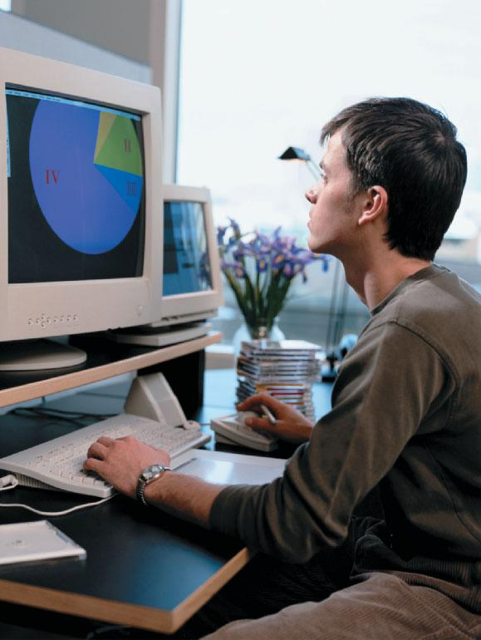

In addition to time and cost, the location (room or space) and audience size

are factors in determining the types of graphics to use. For example, flip charts and posters are appropriate for small audiences in close spaces. Objects, demonstrations, marker boards, and transparencies may work well with a medium-sized group as long as everyone can see the graphic easily. In large meeting facilities, multimedia presentations and films provide images that are large enough for everyone to see.

Other factors to consider are artistic talent (yours or your company’s) and equipment. If your organization has a graphic arts department that can produce quality graphs, charts, photographs, films, or electronic aids, your only challenge may be selecting the ideas you want illustrated and choosing from your options. On the other hand,

you may have to rely on your own skills and talent. When professionals are not available, you may need to choose a simple graphic aid because you can prepare it easily. That is, you might create a simple slide presentation instead of planning, developing, and editing a film that includes sound and captions.

**284 |** Chapter 12

***Guidelines for Creating Graphic Aids***

When you develop graphics, keep your audience’s needs in mind. The following guidelines will help you:

Make the graphic large enough for everyone to see easily—even people sitting in the back or the corners of the room.

Do not crowd numbers or images on a graphic aid.

Remember that although attractive design counts, the message is more important.

Consider handouts for the audience, which they can refer to later.

The following tips are for use with presentation software such as PowerPoint®:

Select landscape layout for your slides. It gives you longer lines for your text.

Give each slide a title or heading.

Select a font that the audience can easily read from a distance, such as **Times New Roman Bold** or **Arial Black**.

Use serif fonts to improve readability. Because sans serif fonts present a cleaner, crisper image, use these fonts for titles of slides.

Choose a font size that is readable and that suggests the importance of elements on the slide. Generally, these sizes are appropriate:

* 1. Titles: 24–36 points
  2. Other text: 18–24 points
  3. Source notes: 14–16 points

Capitalize the first letter of important words in titles of slides. Words that are in all uppercase letters are difficult to read.

In bulleted lists, capitalize only the initial letter of the first word (and, of course, proper nouns and proper adjectives).

Use the Notes section as a reminder of your next point; specific facts, figures, or quotations; cues when someone else will be advancing the slide; or reminders such as “Make eye contact.”

If you have clip art or an image that supports the text on a slide, place it in the lower right corner.

Keep slides simple and uncluttered. Use phrases and keywords and limit the number of lines on a slide to six or fewer.

If you use transition effects between slides, make the effect meaningful.

On your speaker’s notes pages, number the slides so you can quickly move to a particular slide when someone asks a question.

Do not preset timings in your slides. If you advance the slides manually, you can pace yourself rather than force your speech to fit the predetermined increment of time for each slide.

Presentations **| 285**

**Location**

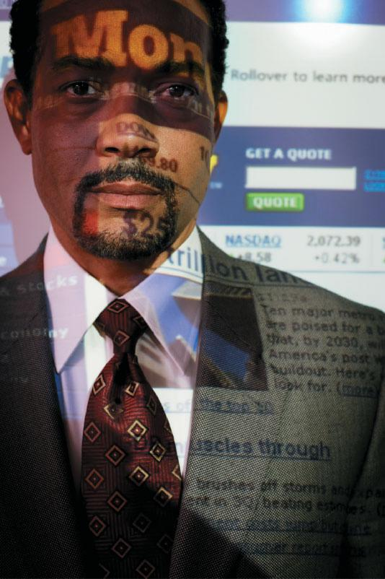

Presenters also should plan for the presentation’s location, which can be very important. For example, if you will be making a union presentation to a construction crew at an outdoor job site, using a projector and screen probably is not an option. If you are using a small conference room to make a presentation about new soccer league rules, demonstrating an illegal shot block could be difficult.

In addition to their own needs regarding location, presenters should plan for the audience’s needs as well. Answer the following questions about the location to prepare for your presentation.

|  |
| --- |
| Photodisc/Getty Images |

***Speaker’s Considerations***

Is a speaker’s podium available? Is a table or space available for handouts and demonstration tools?

Will you be standing directly in front of the audience, or will you be sitting in front of or with the audience?

Is the stage elevated, or are you on the same level as the audience?

How much space does the room encompass? How well does sound carry? How loudly will you need to speak in order to be heard?

If a microphone is needed, is it a wireless, podium, or handheld mic? Is audiovisual equipment installed, or must you bring your own?

Is available equipment compatible with your software and hardware?

Will you need passwords, keys, or codes to access the equipment, software, or Internet?

How much space do you have for moving around during your presentation?

Are people available to help you with equipment or to distribute handouts? Will someone introduce you, or will you introduce yourself?

***Audience’s Considerations***

Is the location difficult to find or reach? Are directions available? Is the location accessible for people with disabilities?

If needed, are restrooms and refreshments available? Where? Will all members of the audience be able to see and hear?

**286 |** Chapter 12

Is the location appropriate and comfortable (design, lighting, temperature) for the type of presentation?

Will the audience be seated or standing?

Are the seats arranged appropriately for the group in attendance?

**Time**

Presenters should plan to meet the time expectations of the audience. If you are invited to present, the person who invites you should let you know how much time you have to speak. If the host does not give you a time, ask.

Speakers who ignore audience expectations often lose the audience’s attention. For example, when you go to class, you expect the class to be conducted within the typical time period. How would students respond if their instructor kept the class 30 minutes beyond the usual time? Listeners often respond by fidgeting, focusing on distractions, and sometimes even walking out. Keep listeners’ attention by complying with the time frame you are given.

Also plan for the proper rate of speaking. Speak slowly when you share difficult or complex ideas and pause after each major section or idea. Nervous speakers tend to talk too fast and may frustrate the audience. To avoid this problem, be aware of your pacing.

**Stage Fright**

You may think it odd that a textbook tells you to plan for stage fright when most people want to avoid it. Yet stage fright is not something to eliminate; it is energy you should use. Many professional speakers will tell you that you cannot eliminate nervous reactions when speaking. Those reactions, they say, are natural responses to stress. Instead of trying to suppress stage fright, let it work for you. To harness this energy, you should:

Recognize and plan for how your body responds to anxiety.

Anticipate excess **adrenaline** (a stimulant that excites and creates extra energy) to give your introduction and important points extra emphasis.



 **STOP AND THINK**

Would an audience of your classmates be more interested in how school policy affects taxpayers or how school policy affects students? Explain.



**ORGANIZING AND COMPOSING**

When you are making a presentation, listeners cannot refer to a previous page if they find your ideas unclear or confusing. Therefore, you should organize and compose your oral presentations for the listeners’ situation and needs.

**Selecting an Organizational Plan**



For most presentations, you will probably use the **direct approach.** With the direct approach, you state the main idea first and then explain and support

Warm Up



Think of messages you have prepared to give orally, such as planning to ask someone for a date or a favor. Under what circumstances would it be better to communicate an important message in writing? Under what circumstances would it be better to communicate an important message in a formal oral presentation? In a brief journal entry, explain the diﬀerences and similarities between oral and written composition.

Presentations **| 287**

that idea with details. Stating the main idea first lets your listeners know what your subject is, what points you will make, and how you will proceed.

On the other hand, if you know that your audience opposes the point that you support or if you want to be especially persuasive, consider using the **indirect approach.** With an indirect approach, you gradually build yourevidence, convincing the audience of your point, which you state at the end of your presentation.



**Previewing Organization**

Regardless of organizational strategy, give the audience a preview so they know what plan you are following. The preview is like a map showing a driver where to turn and how far to go. Your preview explains the order of your ideas. Here are two examples of typical preview statements:

This recommendation contains four major parts: review, staffing, operational policy, and production.

The SOP for student interns involves completing treatment plans, writing care instructions, and recording patient progress.

**Composing the Introduction**

Listeners typically recall the first and last points they hear. Therefore, plan for a strong introduction and conclusion. If you are uncertain how to introduce your presentation, think as your audience might. What would get your attention? You would want to know the topic; the points the speaker will support; and how this issue affects you, the listener. Your introduction should announce the topic and points you will make. In addition, you want to give the listeners something to which they can relate—some connection. For example, an address by a woman to her town’s commissioners began this way: “My friend Marquita died last month. She should not have been in the path of a car going 45 miles per hour, nor should any of your children, grandchildren, or neighbors. Our town must protect its citizens by providing bicycle paths and enforcing helmet laws.”

Depending on your audience and purpose, try one of several introductions:

A direct quotation, usually from a well-known source

A **rhetorical question**—a question designed to provoke thought; a question for which the speaker expects no answer

A startling fact or statistic to grab a listener’s attention A statement you then disprove

An **anecdote,** a humorous story



For example, if you were making a class presentation on the advantages of modern medicine, you might begin this way:

If you were born in the United States in 1990, you had a life expectancy of 75.4 years. On the other hand, people born in 1970 were expected to live only 70.8 years. According to these statistics, you will outlive your mother and father by 4.6 years. (United States: National Center for Health Statistics)

**288 |** Chapter 12

The startling fact that the audience’s generation is expected to live 4.6 years longer than their parents’ should grab the listeners’ attention, particularly because these statistics relate to the audience’s mortality.

**Composing the Body**

These guidelines will help you compose the body of an oral presentation:

Address people. Include the words *you* and *your* early and often. Use words your audience will know. Define unfamiliar terms.

Use simpler sentences than you use when writing.

Give listeners information they want or need and fully explain its relevance.

Emphasize main points. Because listeners take in only a small percentage of what they hear, repeat or restate essential ideas.

Announce transitions so the audience will not miss the connection from one point to the next.

Answer questions you think your audience is likely to ask.

Stay within your time limit, meeting the audience’s expectations.

**Composing the Conclusion**

Conclusions are important because they are the last point or topic the audience will hear. Therefore, they require as much planning as introductions do. An effective conclusion should hold the audience’s attention, summarize key points, and call for action if requested.

 **STOP AND THINK**

John wants to persuade his parents, who do not allow him to drive long distances alone, to let him drive 55 miles to a basketball tournament. The ideas that John plans to share with his parents are that (a) driving is the least expensive and safest way to get to the tournament, (b) he has behaved responsibly when given other opportunities, and (c) the bus does not travel to the location. Place these ideas in the most effective order for John to present to his parents.



**PREPARING**

After you complete the planning process, you need to prepare notes and your image. Doing so will help ensure that you deliver an effective presentation. Risks are huge if you neglect your preparation. Without notes, you are left with only your memory, which sometimes fails under stress. Without personal preparation, you may become preoccupied with your clothing or hair, feeling greater frustration and losing ground with the audience.

Warm Up



Think about your experiences speaking both with and without notes. If possible, discuss these experiences in small groups. Review the benefi ts of using notes and problems you have had with them.

Presentations **| 289**

**Outlines and Notes**

A practiced performance with an outline or notes yields an informal, conversational style. Speakers may generate an outline using presentation software such as Microsoft® PowerPoint® or develop an outline using a word processor or a pen. With an outline or notes on index cards or paper, you will be able to talk to your audience, not read to them.

To reach this point, you must organize your ideas effectively. If you were writing a report, your next step would be to compose sentences, build paragraphs, and create a document. For an oral presentation, however, you should avoid extended writing. A complete paper with sentences and dense paragraphs might encourage you to read the text rather than interact with your audience. Or fearing that you might lose your place in all of that text, you might avoid the text entirely and try to speak from memory.

An outline or notes should show each main point in your presentation. Under each main point, list facts, figures, or quotations that support the point. For precision and accuracy, do not trust your memory for such specific information in front of an audience. For example, the outline in Figure 12.1 shows one section of a report on progress for upgrading warehouse computers.

For the first point of an outline or a note card, write a word or phrase that will trigger your memory. Then go on to the next point of your speech.



1. Shipping and Receiving Area 1

4 installations

Problems with location of wiring, Module MJD364

Area 2

Work completed; 3 installations Approval of supervisor

Level 3

Work incomplete; 1 installation Relocation of shelving unit, Module SDP21 Network concern

Scheduled December 9, 20—

**Figure 12.1** Excerpt from a Presentation Outline

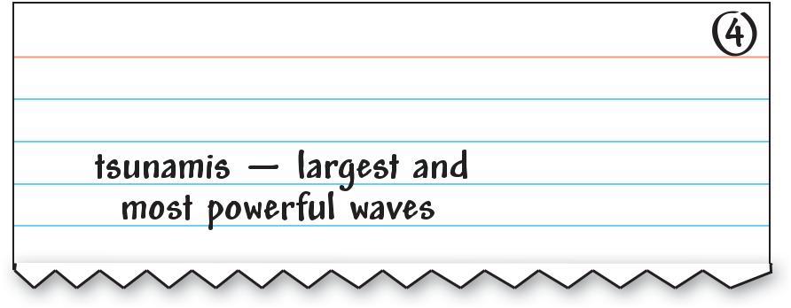

**Figure 12.2** Note Card for Oral Presentation

**290 |** Chapter 12

For each idea, prepare a point in an outline or on a note card similar to the one in Figure 12.2. This card reminds the speaker that this section of the talk is about tsunamis, the huge destructive waves that often occur in the Pacific Ocean, striking places such as Sri Lanka, Japan, and Indonesia.

If you are developing computer slides for a presentation, most software allows you to add notes. These notes reinforce the logical flow of the discussion and highlight details such as statistics, quotations, and important facts. For instance, PowerPoint® allows you to print handouts with two, three, four, six, or nine slides per page, including space for notes.

Figure 12.3 on the following page shows a PowerPoint® handout. You can use it to add notes for yourself, or you can give it to the audience so they can write notes as you talk.

When preparing outlines or notes, remember these important points:

Do not write notes as complete sentences or long phrases. Even experienced speakers would be tempted to read these.

Prepare neat notes that are surrounded by adequate white space. Use large print so you can read the notes easily.

Structure notes uniformly: use numbered lists, bulleted lists, or outline form.

If you are using cards, write only one idea on each card. If you are using printed notes or outlines, use a large, easy-to-read serif font.

Number notes or cards from beginning to end. On note cards, place the card number in the upper right corner, as shown in Figure 12.2. Should the cards become disorganized, you can sort them quickly.

Use outlines and notes to spark your memory. By glancing at the words, you will be able to look at your audience and deliver a portion of your speech. Thus, you can converse with the audience using a polished approach.

**Personal Appearance**

In addition to note cards and graphic aids, image has a big impact on the way listeners receive a speaker’s message. You probably know how appearance can affect communication in everyday situations. For example, think about the way a salesperson might treat you if you are wearing worn jeans and

an old T-shirt. If you have not experienced this treatment yourself, you likely have seen other people treated differently because of their clothing or grooming.

When you select clothing for a presentation, consider the audience’s expectations and the situation in which you will be speaking. For instance, someone addressing city council would probably dress as formally as its members do (in business attire). On the other hand, a speaker addressing children at a youth center would dress more casually. Whatever you wear, make sure you are comfortable in the outfit. If you feel good about the way you look, you will speak with confidence.

If you have done everything you can to prepare for success, you are ready to move to the rehearsal phase.

Presentations **| 291**

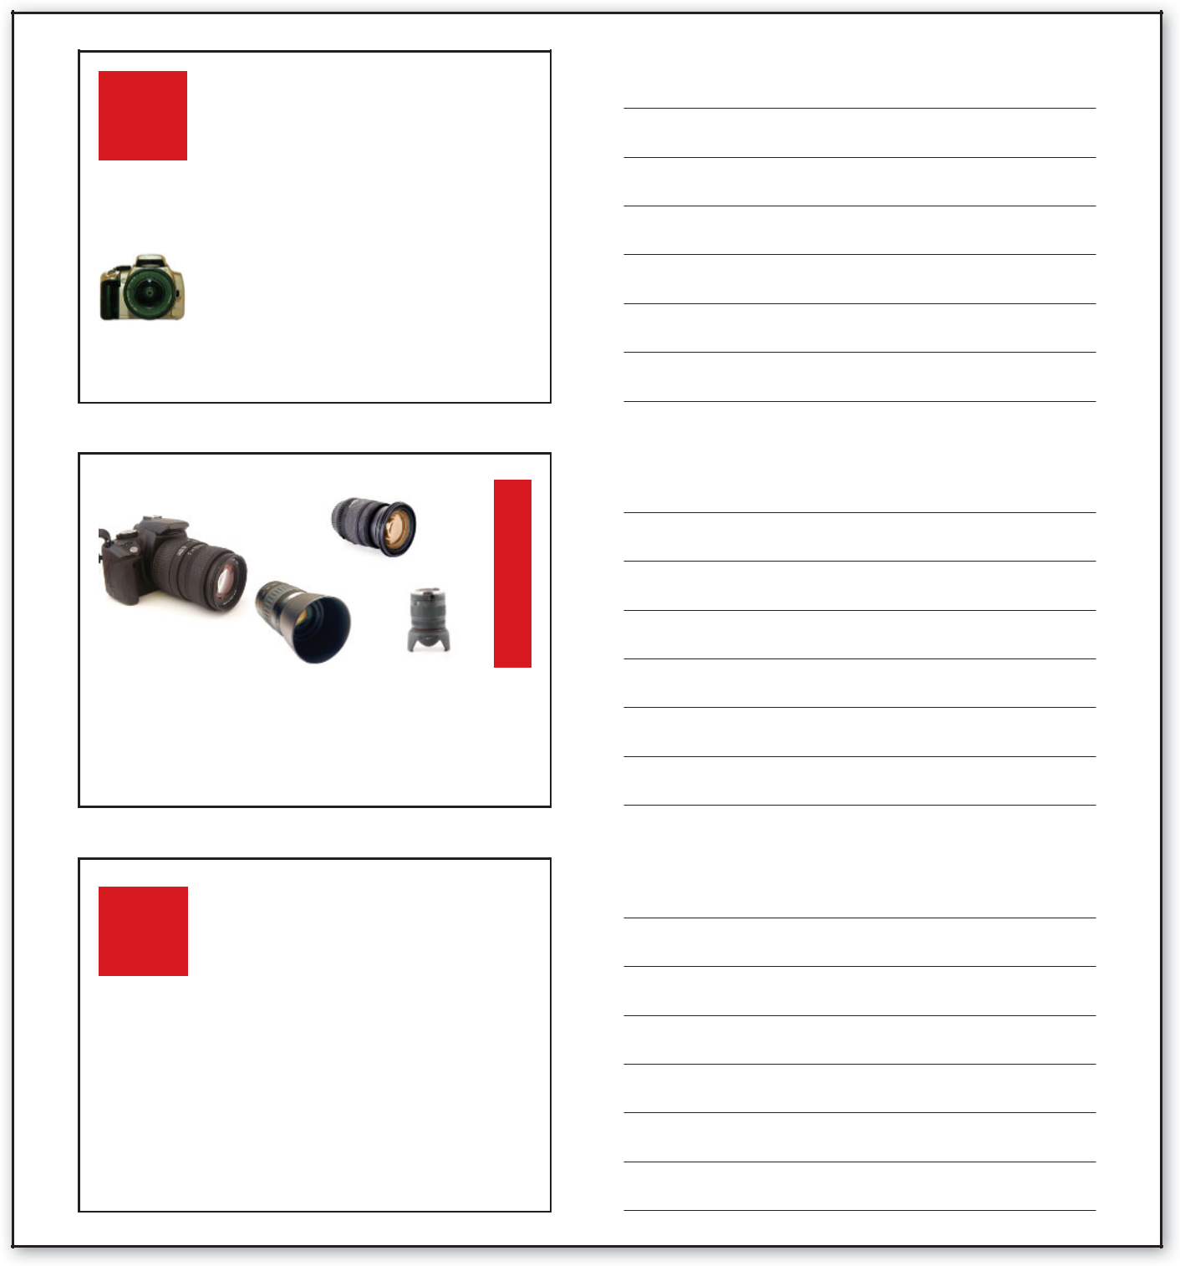

Commonly Used

Digital Cameras

 **Automatic cameras**

 the most common type of camera

 **Semiautomatic and manual cameras**

 the beginner’s camera

SLR digital camera

 **SLR digital cameras**

 the professional’s camera

Lenses

 **3x zoom lens -** focal length of 35–105 mm

 **Wide-angle lens -** 14–50 mm

 **Telephoto lens -** technically any lens longer than 50 mm

Image Size & Resolution

|  |  |
| --- | --- |
| **Pixels** | **Maximum Image Size** |
|  |  |
| **2.0 million** | **1,600 x 1,200** |
|  |  |
| **4.0 million** | **2,272 x 1,704** |
|  |  |
| **6.5 million** | **3,072 x 2,048** |
|  |  |

**Figure 12.3** PowerPoint® Handout with Space for Notes

 **STOP AND THINK**

Would running shorts ever be appropriate dress for a presentation? Explain.



|  |
| --- |
| Permission by Kassie Bryan |

**292 |** Chapter 12

**REHEARSING**

Expert presenters—even professional speakers—will say that you must rehearse if you want to give a successful presentation. Practicing helps you develop a conversational style. In fact, good speeches are a conversation between speaker and audience, only slightly more polished than the conversations you have with friends. Practice provides experience— experience that soothes nerves and builds confidence. After several rehearsals (with adjustments each time), you will have a presentation with which you are pleased and you can trust that your presentation will go well.

Using your note cards and graphic aids, you should practice your speech.

When you first deliver the talk, you can identify parts you like and dislike.

Delivering the speech a second time, you can change what you do not like.

When you are comfortable with your delivery, you have rehearsed enough.

You have reached a conversational style.

Speakers practice their speeches in different ways, including using an audio recorder, a mirror, a video camera, or a live audience. With experience, you will decide which methods work best for you.

**Using an Audio Recorder**

After recording your presentation, take a break. Later, with the benefit of time and a fresh perspective, listen to your recording for the following:

Rate (how fast you talked)

Volume (how loudly or softly you talked)

Pronunciation (how distinct your words were)

Inflections (what your changes in pitch and tone were) Time (how much time you took to present your ideas)

If you find that you are talking too rapidly, something that often occurs when people are nervous, adjust your pacing. Change your volume so everyone can hear you but will not think you are yelling. Listen and correct pronunciation, particularly of unfamiliar or challenging words. Avoid speaking in monotone by varying your pitch and tone appropriately for the message. Finally, check the length of your rehearsed presentation to ensure that you are within your time limit.

**Using a Mirror**

Watch yourself in a mirror as you practice your presentation. Put yourself in the role of the audience. What do you see that will enhance or detract from the message? Check for:

Appropriate facial expressions. For example, do not grin when delivering sad news such as suicide rates. Likewise, do not finish your presentation without having changed expressions.

Effective use of your body and hands. (Do your hand movements emphasize major points, or do they tend to distract your listener from the topic?)

Warm Up



Think about other skills you have developed—sports, music, or art. How much practice is enough? What does this tell you about oral presentations? Respond to these questions in a brief journal entry.

Presentations **| 293**



 Warm Up

Discuss these questions with your classmates: Can oral presentations be fun? How can you make

presenting fun?

**294 |** Chapter 12

**Using a Video Camera**

Do not review the presentation immediately. Wait until you have more perspective—perhaps in an hour or the next day. When you do view the recording, pretend to be your audience. Look for strengths as well as weaknesses. With this **auditory** (sound) and visual information, check for the following:



How you sound

Whether your pacing works How you look

What message you deliver

**Using a Live Audience**

Ask a friend or family member to listen to you practice your presentation. After delivering the speech, invite **feedback**—comments and suggestions to help you improve. Try some of these questions:



What was my speech topic? What point did I try to prove? Did I make eye contact?

Did I speak loudly enough?

Did I tend to use verbal tics such as *and, uh, um,* or *like*? Was my conclusion effective?

Did I pronounce words correctly?

 **STOP AND THINK**

While an audio recorder provides useful feedback when you are rehearsing a speech, what does it *not* tell you? In small groups, discuss your answers.



**PRESENTING**

Once you have thoroughly prepared, check the environment to ensure the best situation and present with confidence.

**Checking the Room**

Arrive early for your presentation. During that time, make sure listeners will be comfortable and can see clearly and hear well. Consider seating, lighting, temperature, equipment, and graphic aids.

***Seating***

Check the arrangement of chairs. Are they arranged so that you can communicate effectively? For example, if you want group discussion, the chairs should be placed so that people can see each other. Also, everyone in the room should be able to see you (and any other presenters) easily.

***Lighting***

Make sure your audience will have enough light to see and take notes. Correct any glaring and overly bright spots. In a room that is lighted properly, your audience can concentrate on your message.

***Temperature***

Check the temperature controls. People who are uncomfortably hot or uncomfortably cold will not be good listeners.

***Equipment and Graphic Aids***

Check all equipment to make sure it is working properly and prepare for problems. Remember Murphy’s Law: If something can go wrong, it will! Make sure you have an extra bulb for the projector, markers, and anything else you might need.

Before the event, determine how you will post or display your materials. Consider visibility and access when arranging your graphic aids. Graphics need to be located so that:

Everyone in the room can easily see them. You can point to the graphics as you talk.

You can reach equipment to make adjustments, such as turning up the volume. The equipment has a power supply.

**Delivering the Message**

Having prepared for the presentation, you are ready to enjoy talking with your audience. Use the following pointers to help you deliver an effective message:

Use appropriate facial expressions.

Maintain eye contact, which shows your interest and concern.

Explain every graphic. Tell people exactly what you want them to understand.

Post or distribute handouts only when you want the audience to use or read them. You may ask someone to distribute them for you.

Consult your notes, but do not read from them.

Continue to talk even when something goes wrong. Recover as best you can, but go on. Do not call attention to a mistake by apologizing.

Remember that your audience wants you to succeed. Your audience’s desire for an effective presentation, along with the self-confidence you gained from being fully prepared, will ensure a positive experience.

Give your audience an opportunity to ask questions if the program and time allow. If you cannot answer a question, respond in a positive way: “I’m sorry that I don’t have the answer to your question, but I’ll be happy to check my sources and get back to you later this week.”

 **STOP AND THINK**

Should you display your poster before you begin to speak? Is eye contact with your audience desirable? Explain.



Presentations **| 295**

 Warm Up



Imagine that three employees walk into a meeting expecting to make a sales presentation. Each expects to make his

or her own presentation, but when they arrive at the meeting, all three are asked to speak. How do you think the presentation will go?

**ORGANIZING A GROUP PRESENTATION**

Presenting with others requires special consideration. Collaboration provides many opportunities to share diverse perspectives and expertise. However, group presentations require careful planning if they are to be effective. Collaborators must act as a team and plan for developing a topic, setting time limits, moving between speakers, providing graphic aids and handouts, answering questions, and managing the presentation.

**Dividing the Topic**

When collaborating on a presentation, speakers must plan roles and responsibilities. One important issue to discuss is who will be responsible for presenting what information. For example, three employees making a planning proposal might divide the discussion this way: Speaker 1—introduction

of speakers, their qualifications, and the problem prompting the proposal; Speaker 2—the proposed solution and the budget; Speaker 3—the conclusion and the requested action. Therefore, the division of topics may dictate the order of presenters.



**Focus on**

**Ethics**

You live in an age when a great deal of business is being conducted globally. That means that at some point in your career, you may have an opportunity to attend a meeting in Japan, give a presentation in Australia, or create and present a training course via a videoconference in Brazil.

Because more business is being conducted globally, knowing the proper methods for presentations across cultures is extremely important. Beginning with the presentation planning stage, you must be aware of how cultural practices and expectations of the audience are different from your own. Research the audience’s culture and plan for differences to ensure that your presentation is well received.

For example, while presenting to an international audience, you should be aware of gestures that are not universal. In Greece, nodding your head up and down means “no,” not “yes.” In Australia, a “thumbs-up” gesture is considered inappropriate.

You also should research the formality of the culture. Jokes are not appropriate for some audiences. Dressing formally makes other audiences uncomfortable.

No matter what cultural differences you face, the most important rule to remember is to respect those differences.

**Think Critically**

What are some cultural differences evident in your community? How does being aware of them give you the opportunity to be a more effective communicator?

**296 |** Chapter 12

In addition, sometimes a speaker’s expertise will require that he or she deal with a particular aspect, such as an accountant explaining a budget. If speakers are equally qualified to present the material, the group must define other reasons for assigning roles.

**Setting Time Limits**

The same way individual speakers must stay within a time limit when making a presentation, group presenters also have an obligation to stay within a time frame. After the group determines the length of the entire presentation, the members should decide the time allotted each member, keeping in mind the material each member will cover and its relative significance. Given a 30-minute slot in the agenda, the team members presenting the planning proposal might divide their time this way:

|  |  |  |
| --- | --- | --- |
| Speaker 1 | Introduction of speakers and their | 10 minutes |
|  | qualifications; problem prompting |  |
|  | the proposal |  |
| Speaker 2 | Proposed solution and budget | 15 minutes |
| Speaker 3 | Conclusion and requested action | 5 minutes |

**COMMUNICATION TECHNOLOGIES**



In today’s age of global communications, many presentation teams are made up of members from across the globe. Therefore, presenters must have a way to keep track of presentation documents and ideas. They also must have a quick way to distribute the most current documents and keep team members up to date. That is where virtual oﬃce space comes into play. This space can be on the Web or on their company’s intranet. It allows the storage of shared fi les as well as space for discussion groups. Members also can use virtual bulletin boards to post the latest updates.

**Think Critically**

What are advantages and disadvantages of having oﬃce space on the Web? on an organization’s intranet?

Speaker 2 is allotted the most time because explaining the proposed plan and justifying its budget are critical. If the

audience does not understand this information, the proposal may not be approved. In addition, Speaker 2 must prove that a significant problem exists. Speaker 3 needs less time, not because concluding is unimportant, but because conclusions should be direct and brief, giving the audience time to ask questions.

Members of groups should be even more careful than individual speakers to stay within their time limit. If one speaker exceeds his or her time limit, another presenter is left with less time.

**Transitioning Between Speakers**

Audiences expect to be introduced to speakers. In a group presentation, the speakers may choose to have another person introduce them or to introduce themselves at the beginning of the session. Another option is for each presenter to be introduced right before he or she begins to speak.

When various speakers are answering questions, listeners prefer to be reminded of the responding speaker’s name. Often a moderator will name the presenter as the moderator asks him or her to address a question, such as “Dr. Quan, would you like to answer the question on profiling?”

**Providing Graphic Aids and Handouts**

Group presenters should discuss the use of graphic aids and handouts when planning their presentation. Coordinating the appearance of slides,

Presentations **| 297**

*****www.cengage.com/school/bcomm/techwtg*

*Go to the NET Bookmark for Chapter 12. Read Tufte’s article.*

*In a brief paper, discuss whether you agree or disagree with his commentary.*

*In an article published in the magazine Wired,* Edward Tufte makes somepointed comments about the use of presentation software and PowerPoint® in particular.

Use the *Oral Report* *Evaluation Form* worksheeton the website when you practice oral presentations. Go to www.cengage.com/ school/bcomm/techwtg. Click the link for Chapter 12; then click Data Files. The worksheet gives you the opportunity to learn from the evaluation and from advice provided by the listeners.

transparencies, and handouts adds to the professionalism of a group presentation. For example, members could agree to use one slide template; a certain color, scheme, or typeface; or the same headers and footers. Members should decide when to distribute handouts. Will all handouts be provided to listeners at one time, or will each presenter be responsible for distributing his or her own handouts? Because some speakers do not want the audience reading handouts while they speak, they may prefer to distribute all handouts at the end of the presentation. Other speakers may want the audience to have copies of materials

so they can take notes during the discussion. Speakers should discuss and agree on a plan before the presentation.

Speakers also must decide what equipment they will need. For instance, when two speakers plan to use overhead transparencies and the third speaker wants an LCD projector, they should agree on where to place the equipment and whether any equipment must be moved between presentations.

Presenters using the same multimedia equipment should know their software needs and make sure the equipment is compatible.

**Answering Questions**

Group presenters should anticipate questions and plan how to answer them. In some presentations, the group may allow each speaker to take questions when the speaker ends his or her portion. Other groups will answer questions only after all presenters have completed their speeches. Presenters also should know whether a moderator will assign each question to a particular presenter or whether the presenters will select questions. Speakers are wise to plan answers for questions they expect to be asked. Therefore, collaborators might divide the topic areas so that each presenter can prepare for questions in a certain area.

Groups may perform more effectively with leadership. Thus, many groups have a lead presenter, a chairperson, or someone who manages the process. The lead presenter often represents the group in discussions with meeting planners and acts as liaison, then corresponds with group members to keep them informed. The lead presenter sometimes speaks first, previewing the presentation or stating objectives, or last, summarizing key points and moderating questions. The lead presenter may have other responsibilities, including:

Keeping speakers on schedule; calling time for those who talk too long.

Keeping questions moving; preventing arguments and the monopolization of discussions.

Responding to requests for more information; mailing materials.

An effective leader will ensure that all group members’ talents are used and that all opinions are heard.

 **STOP AND THINK**

In a collaborative presentation, how do speakers determine who will speak when? Do groups need a lead presenter or chairperson? Why or why not?