**Kathmandu BernHardt College**



**A CASE STUDY REPORT ON**

**PHARMACY MANAGEMENT SYSTEM**

**Submitted to**

**Dept. of CSIT**

Kathmandu BernHardt College

**Submitted by**

Manish Bhattarai (15439/074)

Nirvik K.C. (15444/074)

Safal Mahat (15454/074)

Saugat Tiwari (15458/074)

Feb,2021



**ACKNOWLEDGEMENT**

We would like to express our special thanks of gratitude to Department head of Bihani Medical Concern as well as to the staff members who gave us the golden opportunity to do research on information system of **'Pharmacy Management System'** through which we get a chance to present report of case study covering the related topic of our subject, **'System Analysis And Design'**. This case study cannot be completed without the effort and co-operation from our group membersWe know about so many aspects of system practically. We also sincerely thank our lecturer of this course, Rambabu Mehta and Kumar Prasun for the guidance and encouragement in finishing this case study and also teaching us in this course.



Members:

1. Manish Bhattarai
2. Nirvik K.C.
3. Safal Mahat
4. Saugat Tiwari



**TABLE OF CONTENT**

**Chapter-1**

1.1 INTRODUCTION 1

1.2 OBJECTIVES 1

1.3 LIMITATIONS 1

1.4 INTRODUCTION TO SYSTEM 2

1.5 OBJECTIVES OF SYSTEM 2

**Chapter-2**

2.1 REQUIREMENT ANALYSIS 3

2.2 SYSTEM ANALYSIS 3

**Chapter-3**

3.1 SYSTEM DESIGN 6

3.2 SYSTEM DEVELOPMENT 12

**Chapter-4**

4.1 SYSTEM TESTING 13

4.2 SYSTEM INSTALLATION 13

4.3 SYSTEM MAINTENANCE 14

CONCLUSION 15



RECOMMENDATION 15

APPENDIX………………………………………………………………………………………16

**1.1 INTRODUCTION**

We are a group of 4 students namely, Manish Bhattarai, Nirvik K.C., Safal Mahat and Saugat Tiwari. For this case study report of System Analysis and Design, we have prepared a full documentation on **‘Pharmacy** **Management System’** for **‘Bihani Medicine Concern’**. This case study report is concerned to avoidcomplexity of human tasks. In Pharmacy Maintenance System, we can avoid the difficulty to maintain the details and bill and patient details. An efficient Pharmacy management system can make the work easier by giving the details of the medicine when its name is entered. It becomes very difficult in big medical stores to handle the details of all the medicines manually, so using this pharmacy manage system we can maintain the records of the medicines.

**1.2 OBJECTIVES**

The objectives of this case study are:

* To study and analyze the adopted system of the business.
* To suggest improvements that can be made to make the system more effective and efficient.
* To design a better system as a replacement of existing system (if necessary).

**1.3 LIMITATIONS**

The limitations are:

* The analysis was performed by students who lacked prior experience in this field.
* This case study report was carried out for learning purposes rather than for commercial purpose so certain aspects remained confidential for the system analyst and designers.

**1.4 INTRODUCTION TO SYSTEM**

This case study is concerned about a pharmacy management system that will be used for a wholesale pharmacy. The purpose of this system is to manage all data derived for the pharmacy to maintain their business through the system rather than recording the data manually which possesses more risk to the business to maintain and to avoid any loss of data. Pharmacy management System is a system the consist of data entry, retrieval and monitoring stock, sales, customer recorders and management and administrator records and information about the available drugs in the store. The system provides two types of methods which are quantity and expire date of drugs. This system checks the date to remind the salesman if certain products is going to expire, and also checks the quantity of products remaining to alert the salesman if the product is going out of stock.

**1.5 OBJECTIVES OF SYSTEM**

The objective of this system is to establish a System for pharmacy shops so as to improve all the performance and efficiency of pharmacy shops management. In order to achieve the goal efficiency, there are some specific objectives that should be implemented. It is the user-friendly application for Pharmacist which reduces the burden and helps to manage all sections of Pharmacy like Medicine management and Billing etc., which improve the processing efficiency. It deals with the automating tasks of maintaining of Bills. In Pharmacy, Billing management is the key process. Including safe data store about medicine as well as fast searching, delete and update of medicines. The pharmacy management system is easy for use so the user can do pharmacy actions without ambiguities.

Pharmacy management system makes the pharmacy organizations computerized by creating neat work through minimizing or eliminating wasting of time as well as removing the resources such as papers for data saving since know a days is paper based, decrease malfunctioned works on the medical usage by giving correct information on each medicine.

**2.1 REQUIREMENT ANALYSIS**

The requirement specification is produced at the culmination of the analysis task. The function and performance requirement analysis are refined by establishing a complete information description, a detailed functional and behavioral description, an indication of performance requirements and design constraints and appropriate validation criteria. Multiple visits to the company were made, in each visit various questions were asked to administrator and staffs. From these visits, following requirement analysis were made:

**2.1.1 Functional Requirements**

Functional requirements define the fundamental actions that system must perform.

The functional requirements for the system are divided into three main categories,Medicine stock, Customer information and billing and Sale and supplier info. For further details, refer to the use cases.

1. Medicine Stock

1.1. The system shall record stock of medicines.

1.2. The system shall be updated with arrival of new stock.

1.3. The system shall notify the expired stock of medicines.

1.4. The system shall keep record of medicine details,

1. Customer info and billing

2.1. The system will display the customer info.

2.2. The system will generate the bill.

2.3. The system shall store the customer information.

2.4. The system shall keep record of the billing.

1. Sale and supplier info

3.1. The system shall display the supplier information and update it from time to time.

3.2. The system shall display the number of sale with record of profit and losses.

**2.1.2 Non-Functional Requirements**

Functional requirements define the needs in terms of performance, logical database requirements, design constraints, standards compliance, reliability, availability, security, maintainability, and portability.

**2.2 SYSTEM ANALYSIS**

**2.2.1 Feasibility Study**

A feasibility study is an analysis of how productively a venture can be finished, representing components that influence it. For example, economic, technological, legal and scheduling factors. Project managers utilize practicality to decide possible positive and negative consequences of a venture before capitalizing an extensive amount of time and money into it. Feasibility study examines the practicability of an idea, a project or even a new business. The objective of feasibility study is to place an accentuation on latent issues that could befall if the project is sought after and decide whether, after every substantial factors are taken into account, the project should be pursued or not. It enables organizations to determine all of the obligatory details to make a business prosperous. A feasibility study distinguishes strategic issues, and almost all business-related issues, alongside provide answers to lighten them. The different feasibility study conducted on this project are described in detail below:

**i) Operational feasibility**

Operational feasibility is mainly concerned with issues like whether the system will be used if it is developed and implemented. Since the system being built will be mostly beneficiary to the organization, there has been no resistance from the potential users that will affect the possible application benefits. Considering this, the management i.e. the owner in this case has been fully

supportive of the idea regarding the development of this project. The current business practice is very traditional in a sense that most of the works done are manual and rather not tends to be much digitized. The development and implementation of this system will considerably make the workflow of the organization more productive. Keeping in mind that early involvement of the potential users reduces the probability of resistance towards the new system, we have updated the users regarding the changes made and new features added to the system so as to avoid any conflicts in the future. The implementation of the system makes the processes undergoing in the system more reliant and greatly reduces the operation time of various activities in the organization. However, the redesign process and the shifting from manual to digitized way is not a one day process. All the information about the products and accounting related data should be transferred to the new system. We believe that the proposed system will really benefit the organization.

**ii) Technical feasibility**

Technical feasibility assesses the current resources (such as hardware and software) and technology, which are required to accomplish user requirements in the software within the allocated time and budget. For this, the software development team ascertains whether the current resources and technology can be upgraded or added in the software to accomplish specified user requirements. For this feasibility study, we studied the complete functionality to be provide in the system and checked if everything was possible using different types of frontend and backend tasks. The organization already possesses all the hardware requirements for the system so no additional hardware charges were made. The computer system currently being used in the organization also has the latest software updates required to run the system. However, to connect to the server, an application called XAMPP server was added in order to run the system.

**iii) Economic feasibility**

It determines whether the required software is capable of generating financial gains for an organization. The implementation of this system does not bear any hardware expenses and consists fully of software development expenses only for the organization considering they already have all the hardware equipment present. For the system, there is no additional manpower requirement and no additional cost involved in maintain the system, if any problem arises is very minimum. This is a very important aspect to be considered while developing a project so we have chosen the technology based on minimum possible cost factor. Overall, we have estimated that the benefits the organization is going to receive is from the proposed system will surely overcome the initial costs and later on, the running cost for the system.

**iv) Behavioral feasibility**

In this type of feasibility check we come to know if the newly developed system will be taken and accepted by the work force i.e. the people who will use it.

As the application has extensively user friendly graphical user interface which helps the users to navigate through the pages without the concern of any ongoing backend process. Hence the users

of this system will most probably not encounter any problem in finding or searching the content from the system.

**3.1 SYSTEM DESIGN**

We have designed the efficient new system for the “**BIHANI MEDICAL CONCERN**”. For this we design the logical design of the system.

**3.1.1 Logical Design**

In this part we have considered designing DFD, ER Diagram and UML.

The DFD of the system is as below.

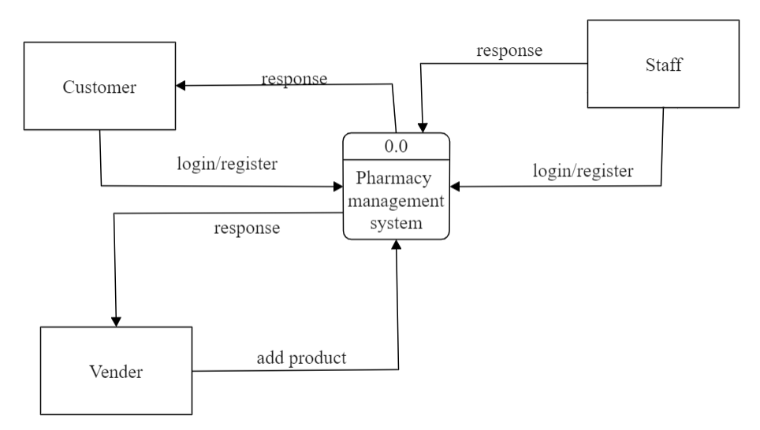

*Figure1.0: Context level DFD*

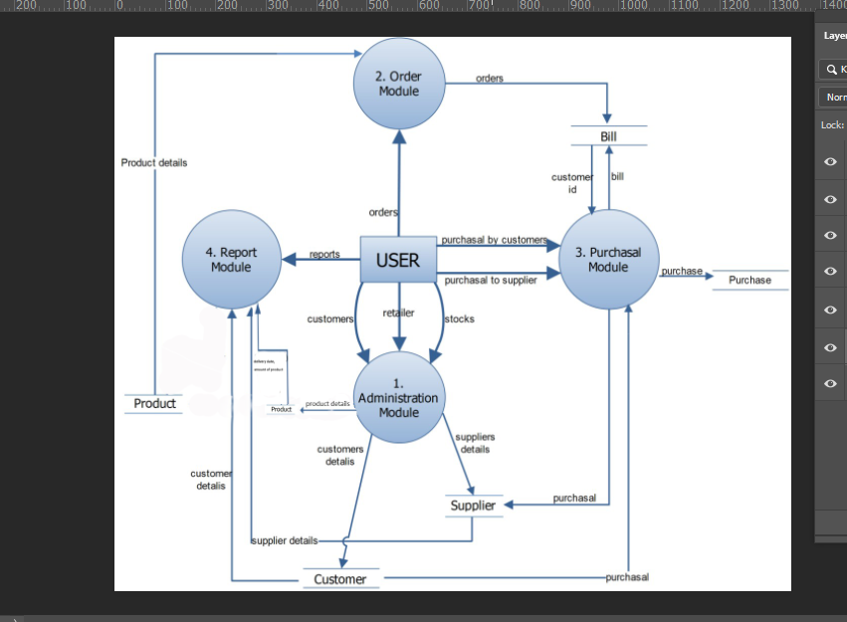

*Figure1.1: DFD Level 2*

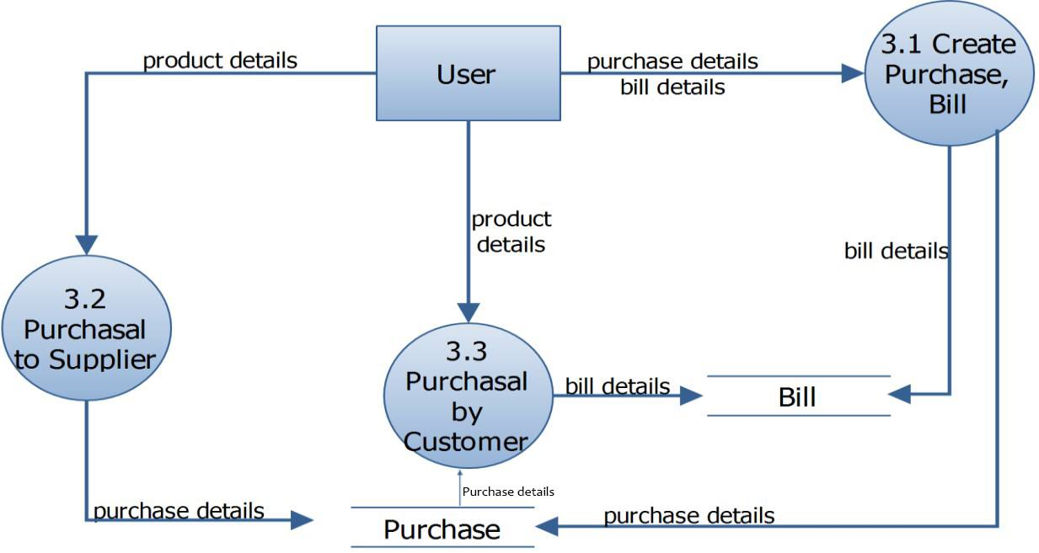

*Figure1.2: DFD Level-2 of Purchasal*

The ER diagram for the system is as below

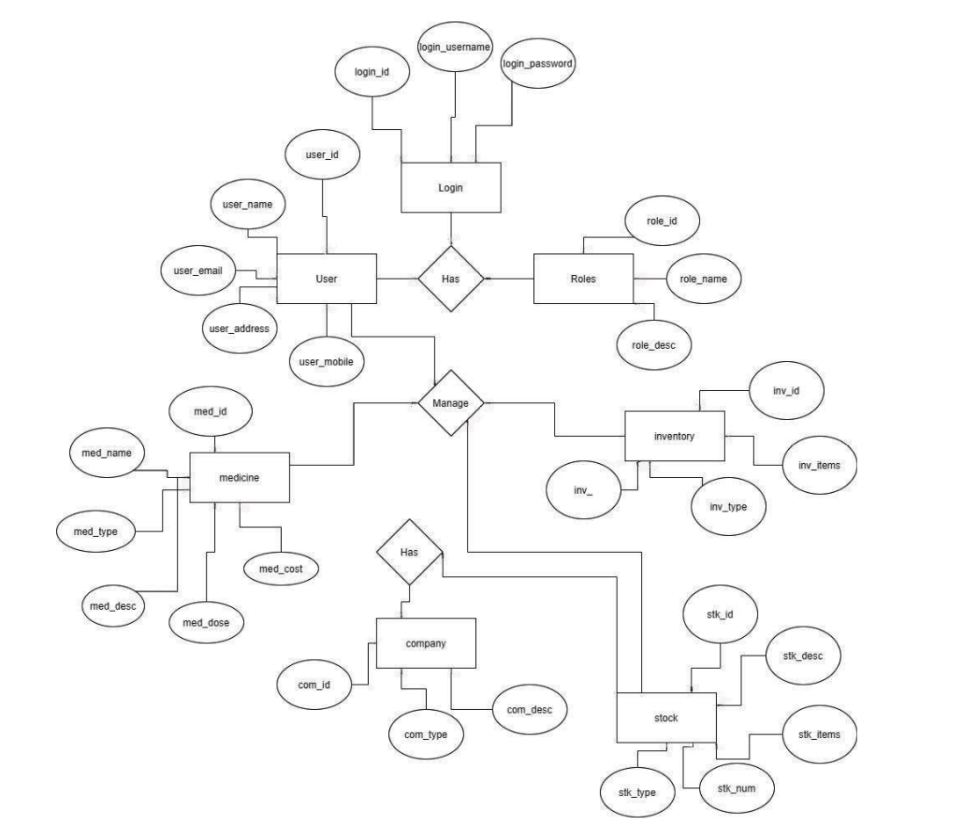

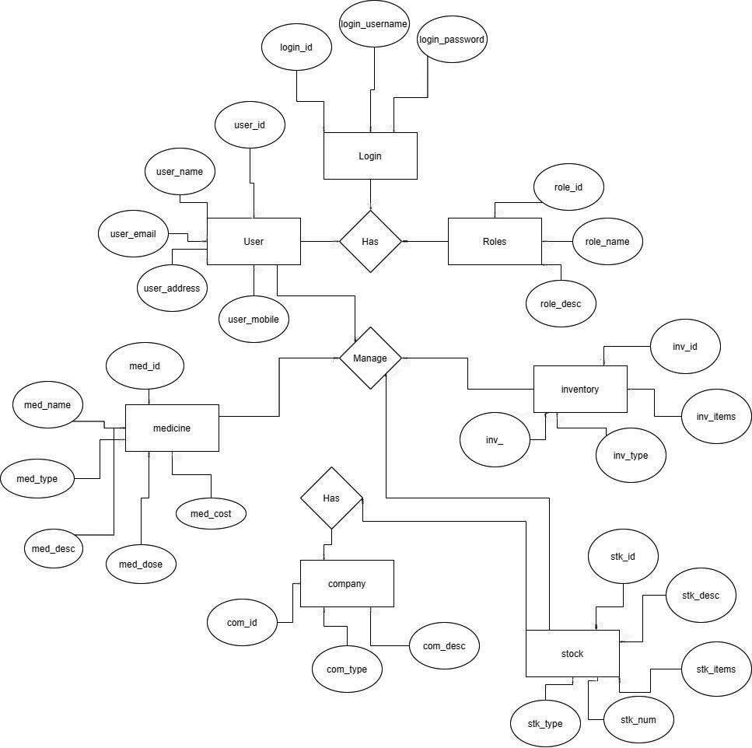



*Figure2.0: ER Diagram for PMS*

The above ER diagram shows thehow “entities” such as people, objects or concepts relate to each other within a system. It has seven entities namely, user, login, roles, medicine, inventory, company and stock. Each of this entity has own attributes and connected to each other with the help of relation with them.

For the UML we have created 3 diagrams.

1. Class Diagram
2. Sequence Diagram
3. Use Case Diagram
4. **Class diagram**

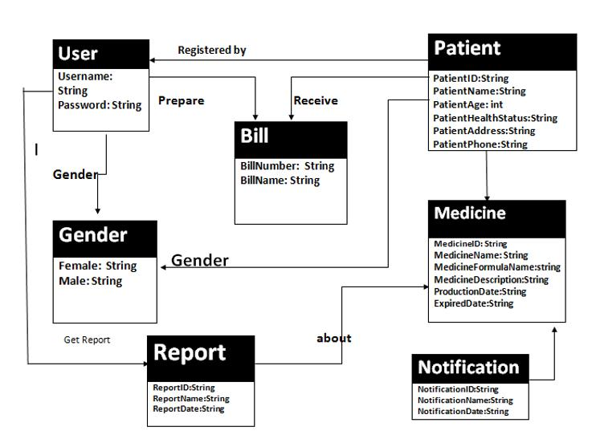

*Figure3.1: Class Diagram for PMS*

The above class diagram has seven classes namely, User, Bill, Patient, Gender, Report, Medicine and Notification. This diagram shows the static structure diagram that describes the structure of a system by showing the system's classes, their attributes, operations (or methods), and the relationships among objects.

1. **Use case diagram**

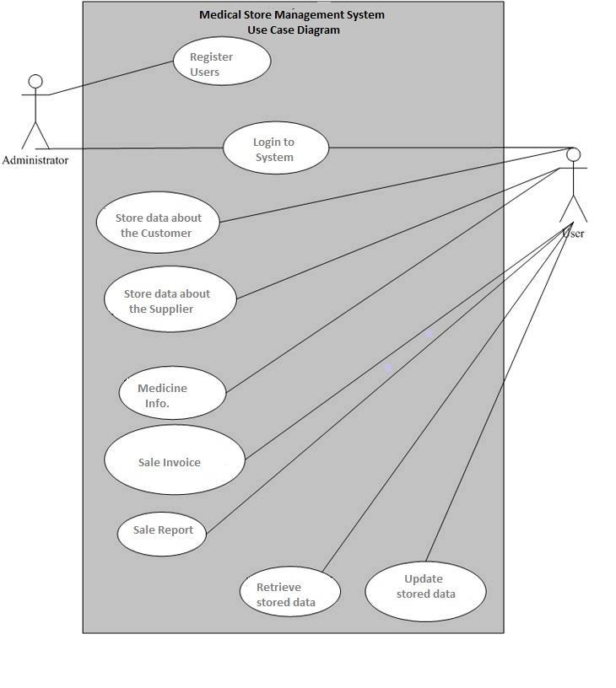

*Figure3.2: Use Case Diagram for PMS*

A key concept of use case modeling is that it helps us design a system from the end user's perspective. It is an effective technique for communicating system behavior in the user's terms by specifying all externally visible system behavior.

1. **Sequence Diagram**

Sequence diagram for Login into the system

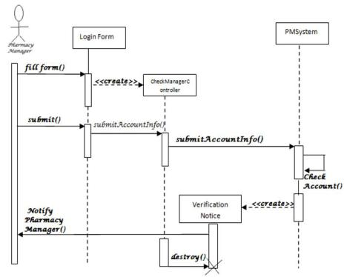

*Figure3.3: Sequence Diagram for PMS*

The above diagram is a type of interaction diagram because it describes how—and in what order—a group of objects works together. These diagrams are used by software developers and business professionals to understand requirements for a new system or to document an existing process.

**3.2 SYSTEM DEVELOPMENT**

Systems development is the process of defining, designing, testing and implementing a new software application or program. It can include the internal development of customized systems, the creation of database systems or the acquisition of third party developed software. There are 3 significant systems development techniques that been used to solve systems’ problems. The system advancement strategies are SDLC (Systems Development Life Process), JAD (Joint Application Development), and RAD (Quick Application Development).

1. **Tools**

Database: MySQL

Backend: Javascript, PHP

Frontend: HTML, CSS, Bootstrap

1. **Development Method**

We have chosen the spiral development method while developing the system. Spiral Model is a combination of a waterfall model and iterative model. Each phase in spiral model begins with a design goal and ends with the client reviewing the progress. We started with a small set of requirements and went through each development phase for those set of requirements. The team added functionality for the additional requirement in every-increasing spirals until the application is fully developed. The reasons for choosing this method are:

* Additional functionality or changes can also be done at a later stage.
* Cost estimation becomes easy as the prototype building is done in small fragments.
* Development is fast and features are added in a systematic way
* There is always a space for customer feedback.

**4.1 SYSTEM TESTING**

Before actually implementing the new system into operation, a test run of the system has been done for removing the bugs. It is an important phase of a successful system. After codifying the whole program of the system, a test plan should be developed and run on a given set of test data.

The output of the test run should match the expected results.

Table 1.0: shows the output of the test runs

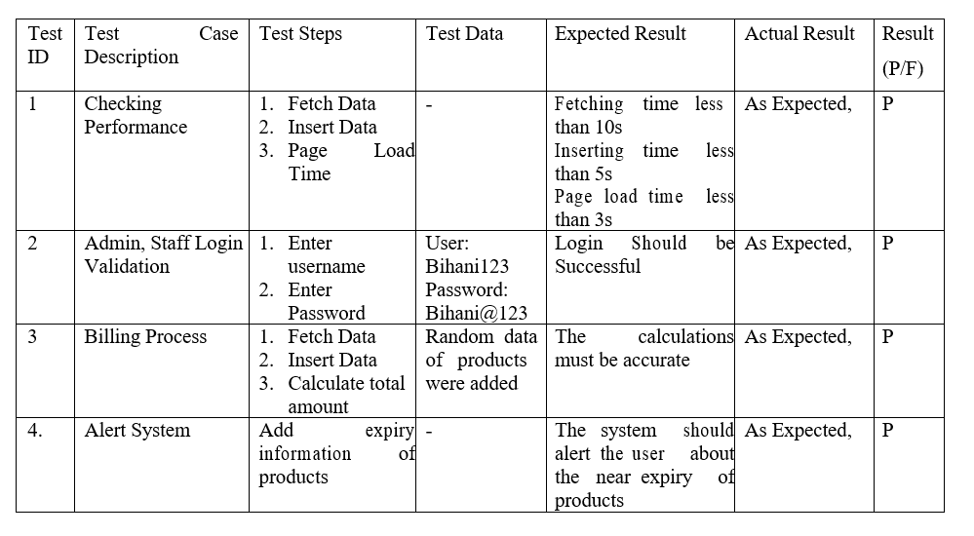

**4.2 SYSTEM INSTALLATION**

This is a phase in which the system analyst did an evaluation of the changeover method that should be used to switch from present manual system to the developed computerized system. After a close analysis the analyst came up with parallel changeover method as the most appropriate for the system. Parallel conversion refers to running the old system and the new system at the same time, in parallel. When the same results can be gained over time, the new system is put into use and the old one is stopped. One advantage of running both systems in parallel is the possibility of checking new data against old data to catch any errors in processing in the new system.

The main disadvantages include the cost of running two systems at the same time and the burden on employees of virtually doubling their workload during conversion. The reason for choosing parallel processing are:

* It’s possible to troubleshoot any errors arising from loading process without affecting the hotel’s transactions as the manual system will still be in place to carry out the hotel activities smoothly.
* Provides time for employees to learn and adapt to the new system.
* Lowers the risk to the management in case of a technical hitch or breakdown as the manual system will still be in place as the analyst fixes the technical hitch.

**4.3 SYSTEM MAINTENANCE**

System maintenance is an ongoing activity, which covers a wide variety of activities, including removing program and design errors, updating documentation and test data and updating user support. The results obtained from the evaluation process help the organization to determine whether its information systems are effective and efficient or otherwise. The process of monitoring, evaluating, and modifying of existing information systems to make required or desirable improvements may be termed as System Maintenance. To ensure notifications do not disrupt operations or degrade a system’s performance or security, organizations should establish appropriate change management standards and procedures. Routine changes are not as complex as major modifications and can usually be implemented in the normal course of business. Routine change controls should include procedures for requesting, evaluating, approving, testing, installing, and documenting software modifications. Maintaining accurate, up-to-date hardware and software inventories is a critical part of all change management processes. Management should carefully document all modifications to ensure accurate system inventories. Management should coordinate all technology related changes through an oversight committee and assign an appropriate party responsibility for administering software patch management programs.

**CONCLUSION**

Pharmacy management system is actually a software which handles the essential data and save the data. This software helps in effectively managing the pharmaceutical store. It provides the statistics about medicine and drugs which are in stock which can then also be updated and edited. It works as per the requirement of the user and have options accordingly. It allows user to enter the manufacturing as well as the expiry date of medicine place in stock and also for sales transaction. This software also has the ability to assist in the billing process, create sales report and printing the receipts. Overall, the main purpose of this pharmacy management system is effective and easy handling of pharmacy data and its management.

**RECOMMENDATION**

Our recommendation to the system includes:

* + Password protecting the system to protect the system from unwanted users
  + Keeping a backup of the data in the system so as to prevent any loss of data in the future.
  + Online integration of the system can be done so customers can order online.

**APPENDIX**

Index page:

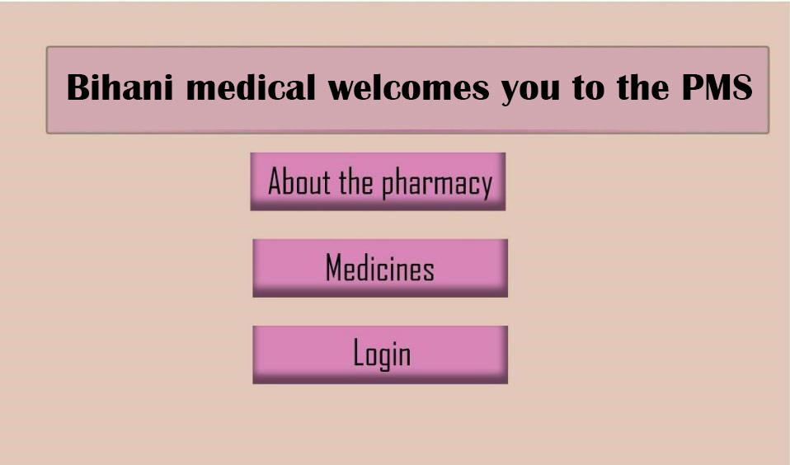

Admin Panel:

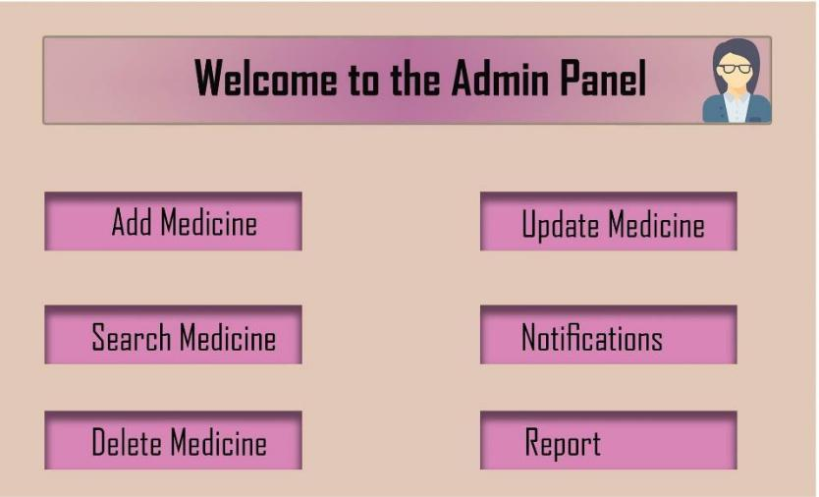

Login page:

