Entity RelationShip   
UI Flow Diagram

Deliverable Two

GROUP 16 Hussain Bootwala – 3925 9618 Saugat Chetry – 9118 8418 Anitha Ranganathan - 7678-3421 Nishant Agarwal - 6199-1874

**Entity Relationship Diagram**:

The following ER diagram elicits our system design to provide the decided functionality in an efficient and quick manner:

**Entities**

1. **User**: User indicates every End-User of our application, participating in property searches, posts properties, requests for property price estimates and life score of an area.
2. **Registered User**: Once a user signs up to our application, their information such as name, phone number and login credentials (email address and password) will be recorded for future use. A permanent ID will be assigned to every individual registered user.
3. **Unregistered User**: Guest users will be assigned a temporary ID to use the application, however, they will not be given access to confidential data such as owner details, and will not be allowed to post properties for sale.
4. **Buyer**: Every buyer’s preferences will be stored in the database, to allow us to show relevant properties per his preferences upon login.
5. **Seller**: Every seller will be able to post their properties on the website. The seller id is derived from the registered user id.
6. **Property:** Each property is uniquely identified by its property id. This entity will host both historical data of previous sales over a long period, used for data analysis whilst providing price estimates, as well as, current property listings and recent sales. It will contain pertinent information such as number of bedrooms, bathrooms and floors, and square feet living, estimated price, sale status, etc.
7. **Property Features:** Every property can have certain extra attributes/features which are stored in a name-value format. For example, parking availability, view, furnishing, etc. This is a weak entity dependent on the property entity and totally participates with it.
8. **Area Features:**Our system calculates the “life score” of every area which are delineated on the bases of its zip code. It considers the crime rate, number of schools, restaurants, and shopping places, to determine the residential viability of the area. Every property resides in an area and hence is associated to the area features.
9. **Reviews:** Every registered user is allowed to write reviews about the properties listed on the website. Each review has a star rating and an optional comments section.

**Relationships**

1. **Seller – has – Properties**: One seller can post multiple Properties.
2. **Property – has – Reviews:** One Property can have multiple Reviews.
3. **User – writes – Reviews:** Multiple Users can write reviews for multiple Properties
4. **Property - has – Property Features**: One property can have more than one property features.
5. **Property – includes – Area Features:** Each property resides in an area (identified by its zip-code), which has certain features.
6. **User – queries- for Properties:** Each user will query for and view all the properties. This relationship will record which user searched for which properties, and that will be used to identify popular properties.

C:\Users\hboot\AppData\Local\Microsoft\Windows\INetCacheContent.Word\DBMS_Project (4) (4).png

www.proptrends.com/estimate

www.proptrends.com/ signup

**Forgot Password**

User can change their existing password.

**Sign Up Page**

Signup form to be filled by user which includes First Name, Last name, Email ID, password, phone number, address

Once the user has signed up, he will automatically be logged into the system.

Display all songs and vihj

www.proptrends.com/buy

www.proptrends.com/sell

www.proptrends.com/lifeScore

www.proptrends.com/lifeScore

www.proptrends.com/ signup

www.proptrends.com/buy

www.proptrends.com/lifeScore

www.proptrends.com/login

www.proptrends.com/login/changePassword

**Login**

User login by entering the username and password.

Options: Forgot password

New User can sign up if not already registered

**Life Score (Visualizations)**

User enters certain features of their house upon which the pricing trends are shown, such as the most queried house, most searched area, change of prices with year, average prices of properties in his neighborhood, max and min price of the houses sold in his locality.

**Sell**

The seller enters the property specification to be put on sale.

Additional requirements of the seller are also defined.

**Buy**

Properties will be listed according to the various

search parameters such as price range, no of bathroom and bedroom required, different amenities available, to refine the search process.

User can click on particular property to view additional details.

**USER INTERFACE DESIGN**

**User Home Page**

Tabs:

Buy

Sell

Estimation

Life Score (visualization)

Sign up

Login

Search for properties under a particular tab based on certain features.

Functions: User can sign up for the application to access advanced features such as buy or sell.

www.proptrends/estimate

**Estimation**

Form to fill the estimation criteria such as zip code, bedrooms, Square feet living etc. upon which the property price is estimated.

Optional: Special recommendations is presented to increase the property prices, such as renovation etc.

www.proptrends.com/buy/{propertyId}

**Comments**

The users can post their reviews pertaining to specific properties.

**Property Details**

User has the access to all the features of the house.

Button is provided to view the owner details.

Comments section is provided to post queries or share their experience and view other reviews.

www.proptrends.com/buy/{propertyId}/comments

Our application will allow users to buy/sell, estimate the price of the property and also look into the “life score” of listed properties. A flow for the user who wishes to buy a property is listed below:

1. The Home Page

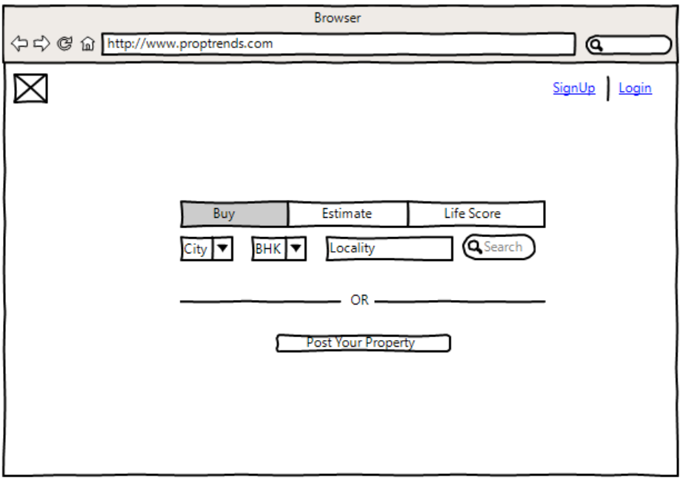

This is the home page of our application. It will have 4 options for the user to choose namely “Buy”, ”Sell”, “Estimate” and “Life Score”. Users can search for properties by selecting the appropriate option and then providing the details of the property they seek to find.

2. All Properties Page

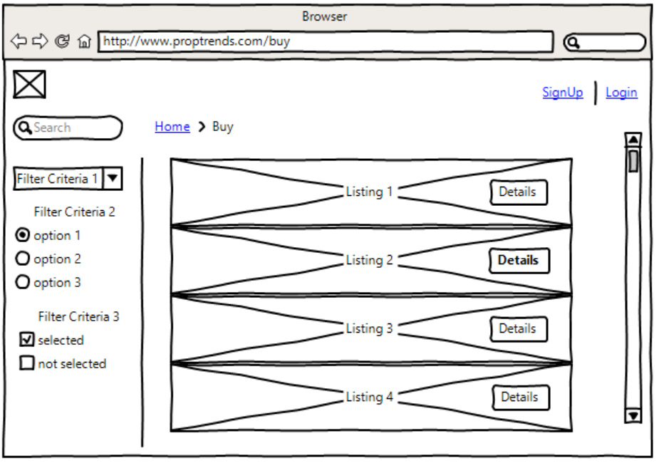

This page will show all the properties that match the users search criteria from the Home Page. All properties are listed with a short summary. The user can get further information about a property by clicking on it.

3. Sign In/Sign Up page

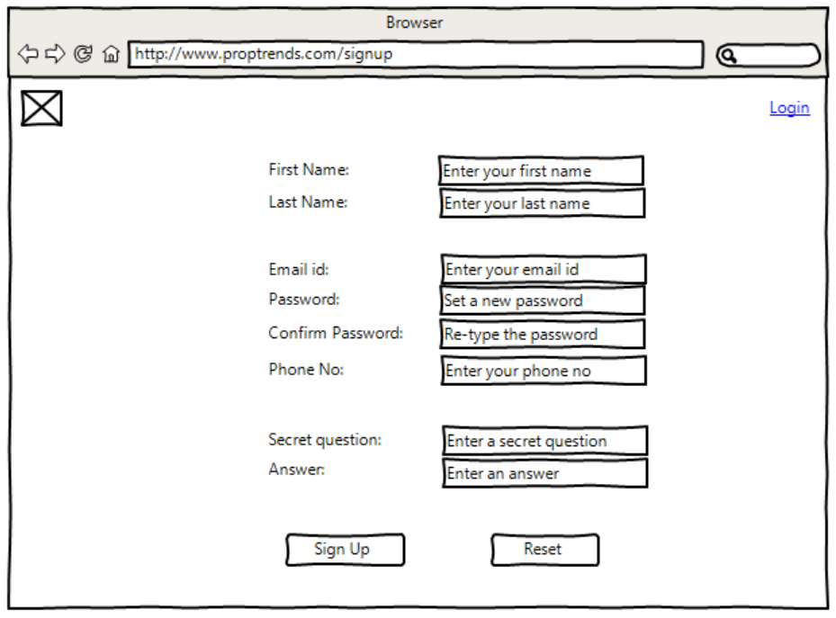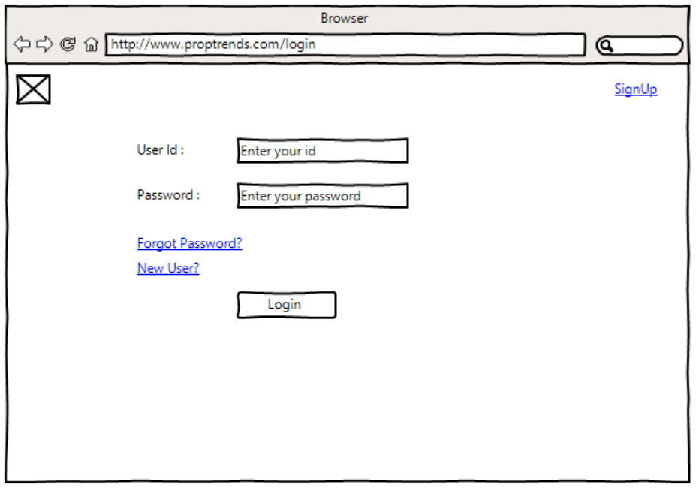

Whenever the user wants to get further details of a listed property, he has to “signin” or “signup”. This is done in-order to protect the information about the property from being available publically (only registered users will be able to get the details of the property).

Once the user has successfully signed in, he/she will get the details of the property and property owner. The user can finally choose to submit a review of the property.

4. Review Page

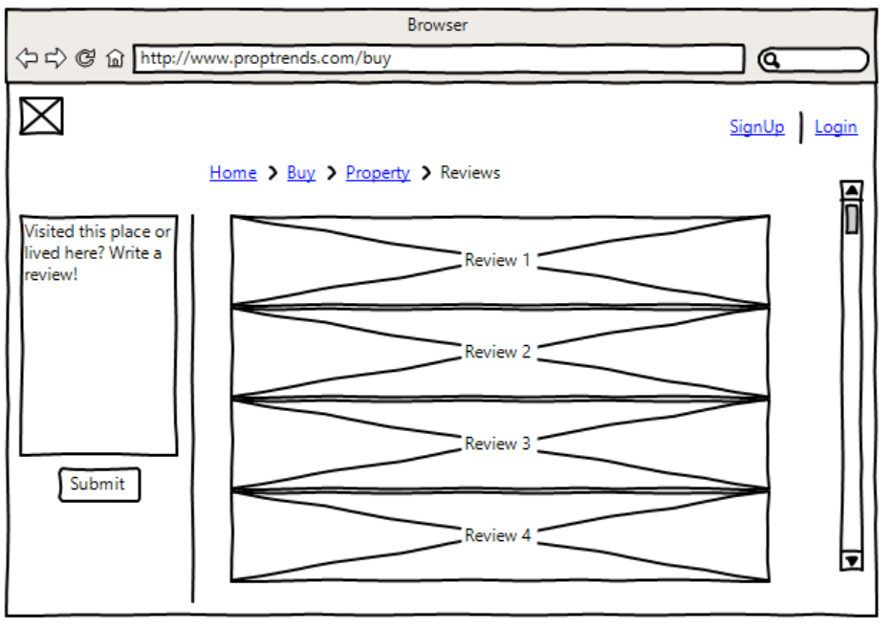

This is the page where the registered users will be able to write reviews about properties the have viewed in the system. Reviews will be stored and used to rate the properties ranking/popularity within the system.

For a user who wants to sell his/her property, he has to select “post your property” in the home page and then proceed as below:

1. Sell

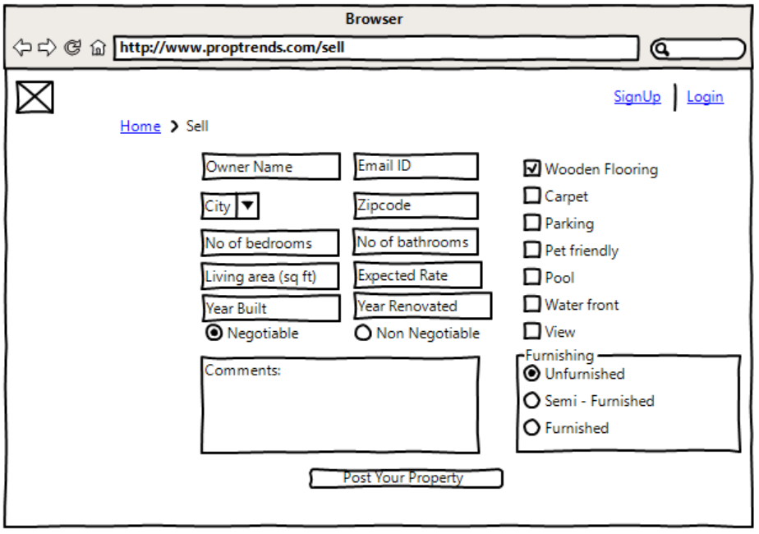

Here the user can list down all the features of the property and then click on the “Post Your Property” button. If the user is not logged in, then he will be prompted to login. Once logged in, the user’s property will be posted.

For users who want to evaluate the rate of their property, they can select the “estimate” tab and flow along:

1. Estimate

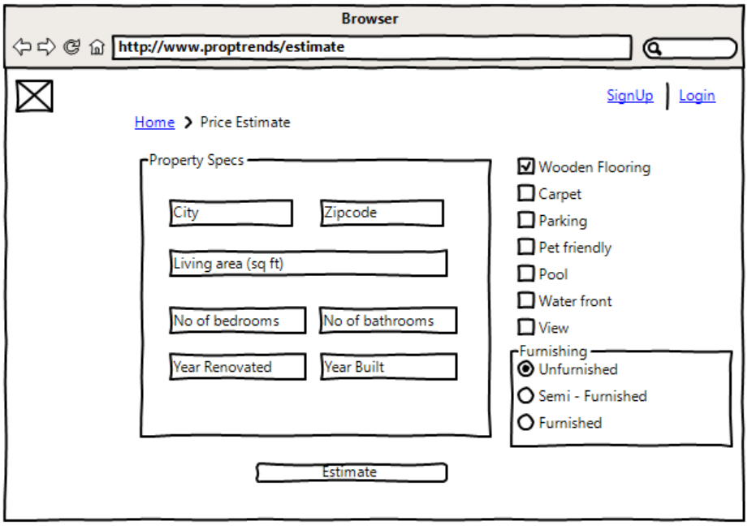

In this page the user provides the details of the property like “city”, ”zipcode”, “living area (sq. ft.)” etc. and then clicks on the estimate button. The system will taken in all the inputs from the user and return an estimated value of the property.

For those who want to find out the “life-score” of a region (and of properties located there), they can select the “Life Score” tab in the home page and enter the zip-code of the area. They will be directed to:

Life Score:

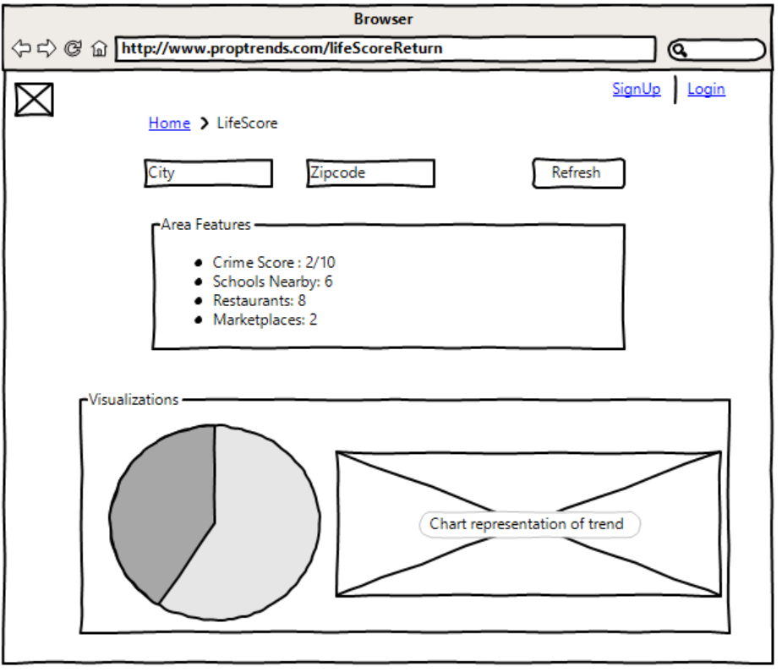

In this page the “life-score” which is calculated based on various aspects like “crime-rate”, ”number of schools”, ”nearby restaurants” etc. is shown to the user in the form of charts and graphs.