User Manual

1. **Login and Registration:**

Click on the login button on the navigation bar in the home page and it will take you to the login page with login form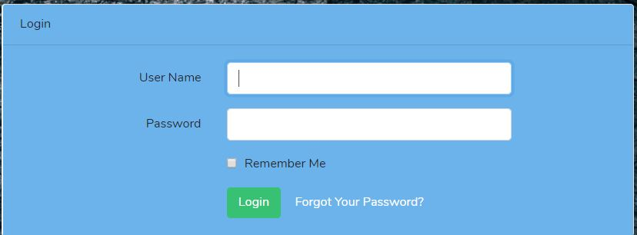

Enter your registered user name and password and click login and you will be logged in if the provided credentials are correct. If you don’t have an account registered then click register on the navigation and registration form will appear.

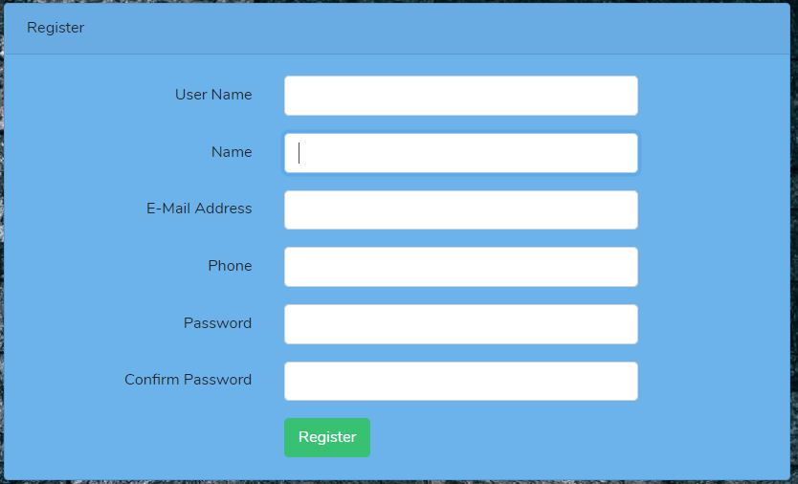

Enter your details and click register button and you will be registered.

1. **Search for available room and book a room:**



Go to reservation on the navigation bar and a page with form as below will be displayed.

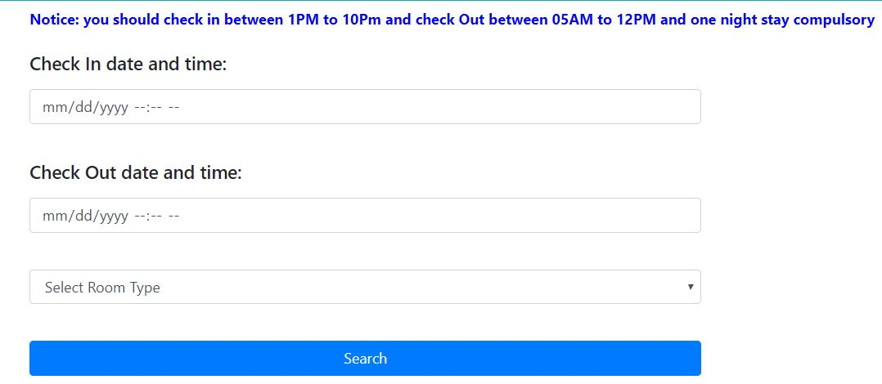

Enter your check in and check out date and time in the text box. The check in date should be from the date you are booking onwards and check out date should be days after the date of check in. check in time is from 2 pm to 10pm and checkout time is from 5am to 12 pm. Then after that select the room type you want according to your need which includes single, couple and family rooms. After all details are inserted click search.

Rooms available in that time will be displayed in a table and to book that room click on the book button in the same row of that room.

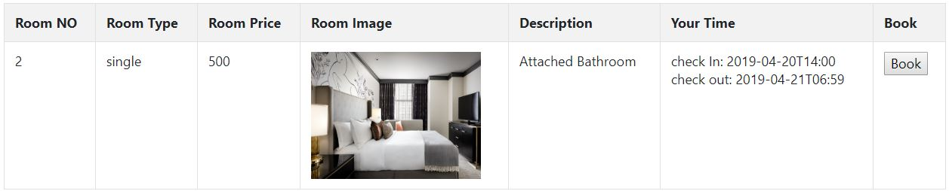

1. **View Menu and place an order:**

Click on the Menu option on the navigation and a page with menu items and their details will be displayed.

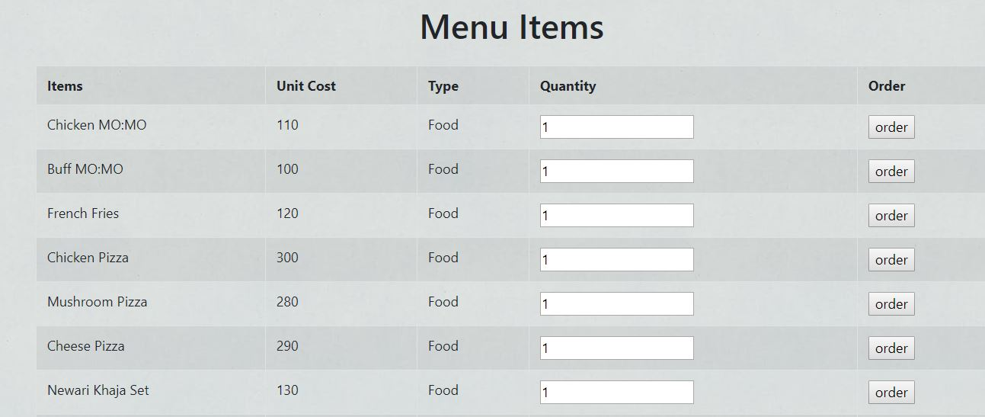

Enter the quantity you want and click order button and that item will be ordered. You should be Checked In for ordering the items or else you will not be able to order any items.

1. **View bill of old stays, expenses of staying time and cancel an booking:**

Click my stays option in the navigation bar and a page with details of your all booking, old stay and currently staying will be displayed

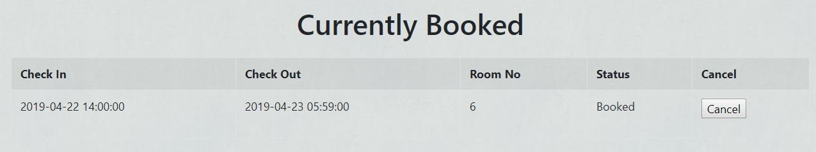

If you want to cancel the booking you can click the cancel button on the currently booked row

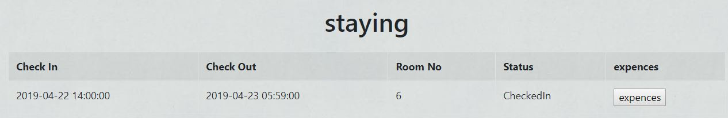

If you want to know what to check your expenses excluding room price than click on expenses button on staying row and a page with your expenses on that stay will be shown.

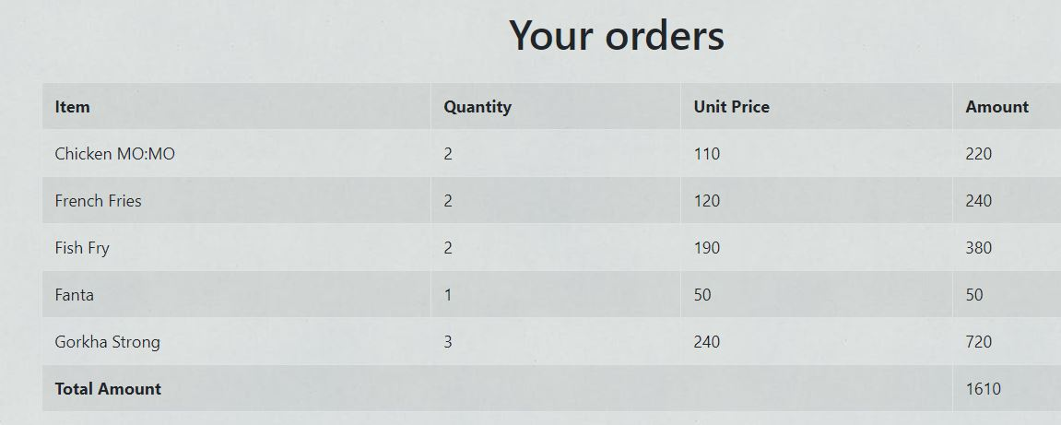

If you want to see the bill of an old stay then click on the bill button of the stay you want to see bill of in the old 