Contents

1. Introduction 3

1.1 Project Introduction 3

1.2 Justification for project 3

1.2.1 Background of the project 3

1.2.2 Problem Statement 3

1.3 Description of the project 3

1.3.1 Features 3

2. Project Scope 4

2.1 Scope and Limitation of project 4

2.2 Aims and Objectives 4

3. Development Methodology 5

3.1 Methodology used 5

3.2 Design Pattern 6

3.3 System Architecture 7

4. Work Breakdown Structure (WBS) / Scheduling 9

4.1 Work Breakdown Structure 9

4.2 Milestones 10

4.3 Scheduling / Gantt chart 12

5. Risk Management 14

6. Configuration Management 14

7. Conclusion of the project 16

Figure 1. Waterfall Model 6

Figure 2. MVC 7

Figure 3. Three tire architecture 8

Figure 4.WBS 9

Figure 5. Scheduling 12

Figure 6.Gantt chart 13

Figure 7.Directory structure 15

Figure 8.Configuration folder 15

# 1. Introduction

## 1.1 Project Introduction

Guest house management system is a web based application designed for the guest house to manage their transactions as well as to give information about the guest house and get the required information’s that is available.

## 1.2 Justification for project

### 1.2.1 Background of the project

People trying to minimize their expenses when they are going to places far from home so likely than hotels they prefer guest houses. Using the website of the guest house customers and view the room picture and their prices and if like the room can book it online. Customers can see if the room is empty, booked or occupied. Customer can get other information of the guest house through the website like any packages and other.

### 1.2.2 Problem Statement

Giving information about the guest house to customers is not so smoot as well as the proper details of the facilities provided by the guest house to the customers. People often have to visit the guest house to book or view the room and know the prices of rooms, packages provided by the guest house. Some customers have to return with dissatisfaction if the facilities are not as they except. Customers sometime have to return due to all available rooms pack and the details of the rooms occupied or empty have to be saved in paper which gives employee little bit of hard time. With this project customers can view proper information’s about the guest house online and book the rooms online. Customer can also see if rooms are packed or not as well as makes the employee easier to save the information about the rooms.

## 1.3 Description of the project

### 1.3.1 Features

The features of the project are as follows:

* Customers can view the rooms online
* Customers can view whether room is booked or not
* Customer can select package that are given
* Admin can add, edit and delete packages
* Customers can add reviews
* Customer gets free stay after 5 visits
* Save details of check in and check out as expenses of the customer etc.

# 2. Project Scope

## 2.1 Scope and Limitation of project

This project likely is for both user and their customers. This project helps the customer to know about the guest house properly as well as help them to check for empty rooms and if like them book it for their date required. Admin can add new packages and customers can select the prefer package. Proper information is transmitted to the customer and reviews from customer is transmitted to guest house so they can know if they are missing something.

As there is likely not a perfect thing this project also have some limitations. Customers can book online but online payment is not included which may result fake booking. Smart card for regular customers are not provided so can’t recognize them if minor change in customer data which may result dissatisfaction to the regular customer.

## 2.2 Aims and Objectives

**Aim:**

* Provide upto date information to the customer
* Develop user friendly and helpful application
* Proper data management
* Give more facilities to the customer

**Objectives:**

* All information about the room their packages and facilities provided by the guest house including their price is shown.
* Information of booked room, occupied room and empty room are updated
* Information of the customer as well as the information of the guest house is properly saved as well as their expenses.
* reviews from customer are seen for further development of the guest house
* Rooms can be booked online if empty for their date required and select the room they prefer

# 3. Development Methodology

## 3.1 Methodology used

Development methodology is a framework that is used to plan, structure and control the process of developing an information system. For my development, I will use waterfall methodology. As it is a sequential design approach, it is easy to manage due to the rigidity of model.

Waterfall model is very simple methodology of software development. There are sequential steps which are proceeded after the completion of one due to which there is no overlapping during the process. The steps involved in this methodology are:

* **Requirement gathering and analysis:**The first phase involves understanding what need to be design and what is its function, purpose etc.
* **System Design:** The requirement specifications from first phase are studied in this phase and system design is prepared. System Design helps in specifying hardware and system requirements and helps in defining overall system architecture.
* **Implementation:** With inputs from system design, the system is first developed in small programs called units, which are integrated in the next phase. Each unit is developed and tested for its functionality which is referred to as Unit Testing.
* **Testing:** All the units developed in the implementation phase are integrated into a system after testing of each unit.  Testing is done so that the client does not face any problem during the installation of the software.
* **Deployment of System:** Once the functional and non-functional testing is done, the product is deployed in the customer environment or released into the market.
* **Maintenance:** This step occurs after installation and involves making modifications to the system to improve performance. These modifications arise due to change requested by the customer. Client is provided with regular maintenance and support for the developed software.

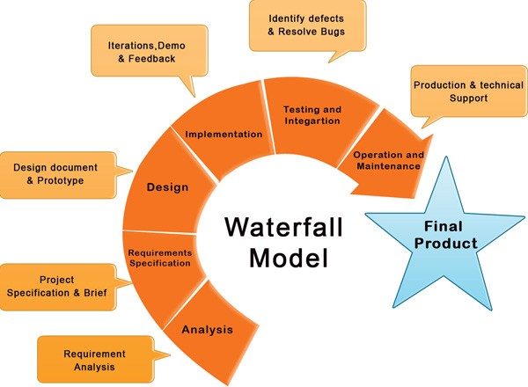

Figure 1. Waterfall Model

## 3.2 Design Pattern

Among the various types of design pattern like Factory pattern, prototype pattern, Model View Controller, Singleton pattern etc. I have chosen the Model View Controller (MVC) pattern.

Model view controller is an architectural pattern commonly used for developing user interfaces that divides an application into three interconnected parts. This pattern is used to separate application’s concerns. In this pattern the model is known as the central component of the pattern which directly manages the data, logic and rules the application. A view can represent the information of chart diagram, bar chart etc. And the Controller accept the input which convert it to command for mode and view. The reasons to choose this pattern are as follows:

* **Faster development process:**
* **Modification does not affect the entire model**
* **Ability to provide multiple views**
* **Support for asynchronous technique.**

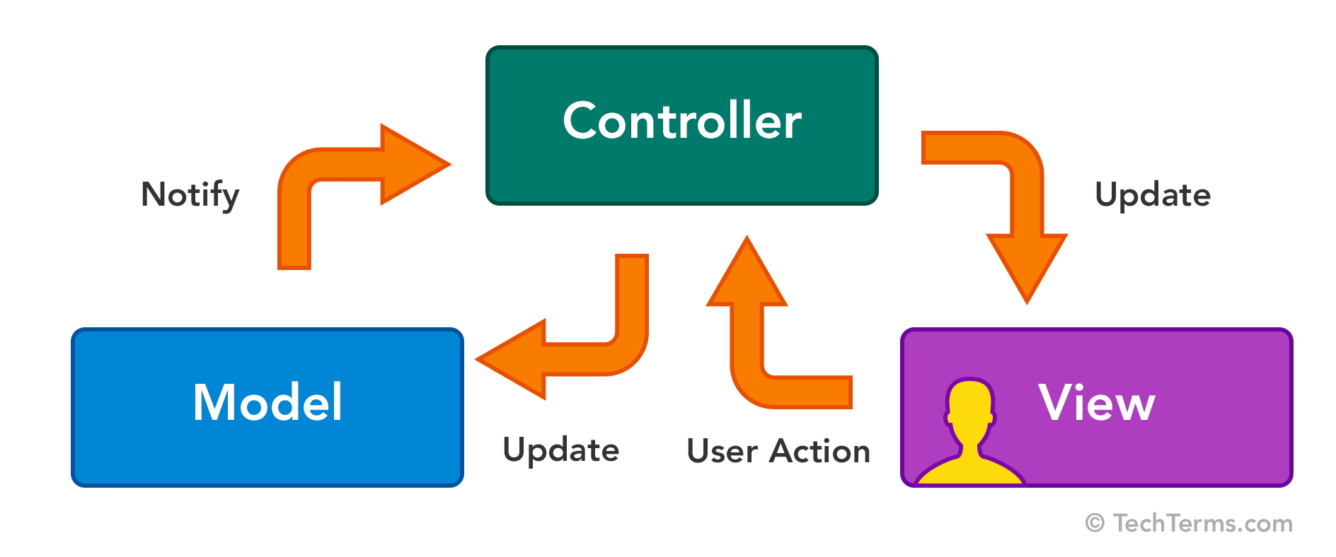

Figure 2. MVC

## 3.3 System Architecture

I have decided to use three tire architecture. Three-tier architecture is a client-server architecture in which the functional process logic, data access, computer data storage and user interface are developed and maintain independent modules on separate platform. The three tier in this architecture are:

Client tier:

This is a top level which display the information related to the services which is available in this website.

Application tier:

It is also known as the middle tier of the application. This tier is pulled from the upper tier known as presentation tier and control the functionality by performing detail processing.

Data tier:

It is a server where the information is stored and retrieve. Data in this tier kept independent of application servers.

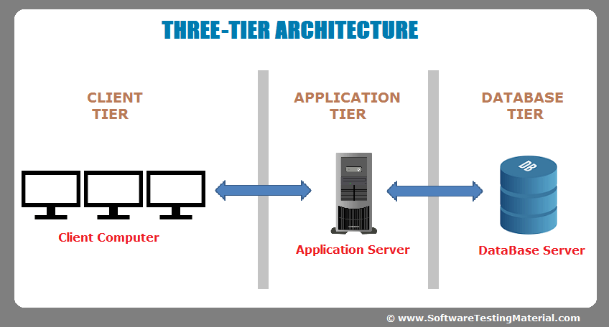

Figure 3. Three tire architecture

# 4. Work Breakdown Structure (WBS) / Scheduling

## 4.1 Work Breakdown Structure

The WBS is the systematic breakdown of project into small parts where each part is related and followed by another. It organizes the teams into manageable so that teams can understand each level of the project. It makes any complex project more manageable. 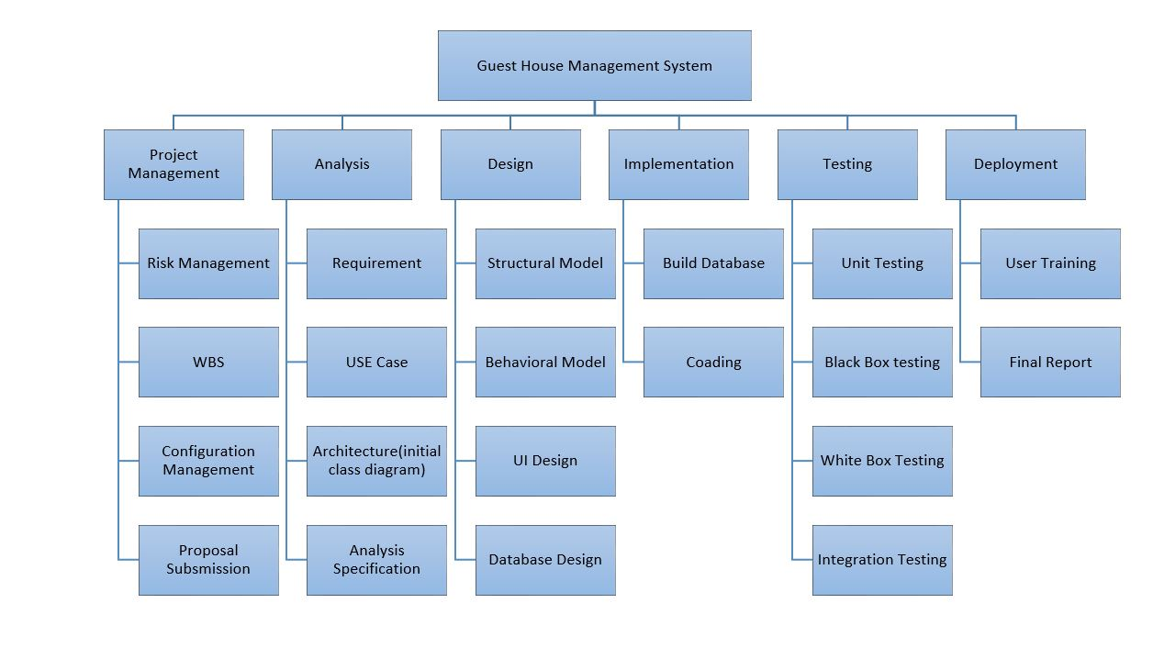

Figure 4.WBS

## 4.2 Milestones

Milestones are tools used in project management to mark specific points along a project timeline. We used milestone to measure the performance of our project according to the timeline.

|  |  |
| --- | --- |
| **Milestones** | **Date(MM/DD/YY)** |
| **Project Management**  Risk Management  WBS  Configuration Management  Proposal Submission | **12/21/18-1/3/19**  12/21/18-12/25/18  12/26/18-12/27/18  12/28/18-12/30/18  12/31/18-1/3/19 |
| **Analysis**  Requirement  Use Case  Architecture ( Initial Class Diagram)  Analysis specification | **1/4/19-1/28/19**  1/4/19-1/8/19  1/9/19-1/15/19  1/16/19-1/22/19  1/23/19-1/28/19 |
| **Design**  Structural Model  Behavioral Model  UI Design  Database Design | **1/29/19-2/27/19**  1/29/19-2/3/19  2/4/19-2/12/19  2/13/19-2/19/19  2/20/19-2/27/19 |
| **Implementation**  Building Database  Coding | **2/28/19-3/31/19**  2/28/19-3/9/19  3/10/19-3/31/19 |
| **Testing**  Unit Testing  Integration Testing  Blackbox Testing  Whitebox Testing | **4/1/19-4/10/19**  4/1/19-4/2/19  4/3/19-4/5/19  4/6/19-4/7/19  4/8/19-4/10/19 |
| **Deployment**  User Training  Final Report | **4/11/19-4/20/19**  4/11/19-4/16/19  4/17/19-4/20/19 |

**Description of Milestones:**

* **Project Management (14 days)**
* **Risk Management (5 days)**
* **WBS Management (2 days)**
* **Configuration Management (3 days)**
* **Proposal Submission (4 days)**
* **Analysis ( 25 days )**
* **Requirement (5 days)**
* **Use Case (7 days)**
* **Architecture (7 days)**
* **Analysis specification (6 days)**
* **Design( 30 days)**
* **Structural Model (6 days)**
* **Behavioral Model (9 days)**
* **UI design (7 days)**
* **Database Design (8 days)**
* **Implementation (32 days)**
* **Build database (10 days)**
* **Coding (22 days)**

* **Testing (10 days)**
* **Unit testing (2 days)**
* **Integration testing (3 days)**
* **Black box testing (2 days)**
* **White box testing (3 days)**
* **Deployment (10 days)**
* **User training (6 days)**
* **Final report (4 days)**

## 4.3 Scheduling / Gantt chart

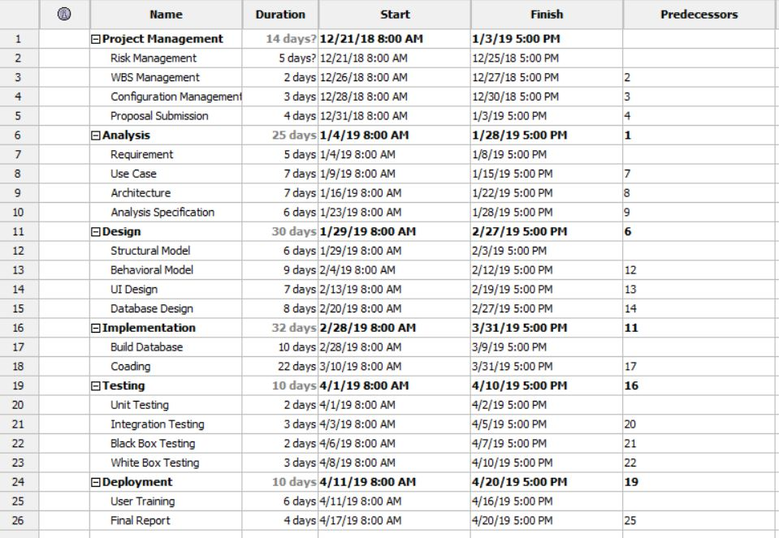

Figure 5. Scheduling

**Gantt chart**

A Gantt chart is a graphical tool which shows activities or tasks performed against time. It is also known as visual presentation of project where the activities are broken down and displayed on a chart which makes it easy to understand and interpret.

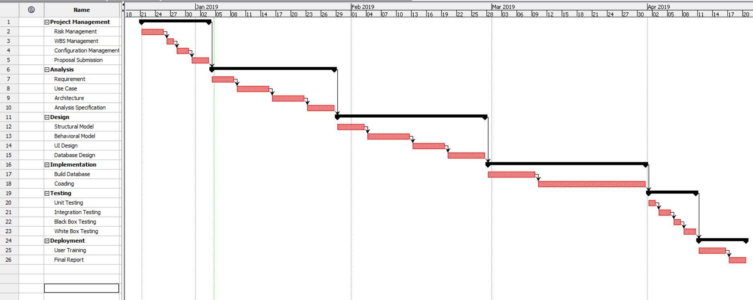

Figure 6.Gantt chart

# 5. Risk Management

To identify and avoid the possible risk that may occur during the development of our project is risk management. It helps us to tackle the problem in real time when project should be implemented.

**Impact = Likelihood * Consequence**

Risk Likelihood values are shown as follows

|  |  |
| --- | --- |
| Likelihood | Value |
| Low | 1 |
| Medium | 2 |
| High | 3 |

Risk Consequence values are shown below

|  |  |
| --- | --- |
| Consequence | Value |
| Very low | 1 |
| Low | 2 |
| Medium | 3 |
| High | 4 |
| Very High | 5 |

|  |  |  |  |  |  |
| --- | --- | --- | --- | --- | --- |
| S. No | Risks | Likelihood | Consequences | Impact | Solution |
| 1 | Server failure | 1 | 5 | 5 | Suitable environment and equipment for server |
| 2 | DDoS attack | 2 | 2 | 4 | Use of proper firewall |
| 3 | Phishing | 2 | 3 | 6 | Proper planning is to be done in every phase. |
| 4 | Identity theft | 3 | 3 | 9 | Proper study of customer |
| 5 | Information leakage | 2 | 4 | 8 | Proper security |
| 6 | Hard disk crash | 2 | 5 | 10 | Data must be backed up in external drive or in clouds. |
| 7 | User error | 2 | 2 | 4 | User training |

# 6. Configuration Management

The process of keeping and tracking the detail data, so the updates can flow with the existing project. Files and folder should be safely stored in a systematic order, so that it can be easily excessed whenever we need to. When configuration management is done, the consistency of the projects becomes better. The given figure shows the configuration management of my project:

d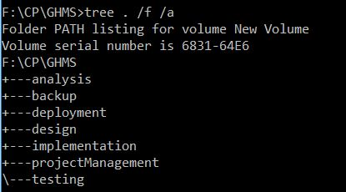

Figure 7.Directory structure

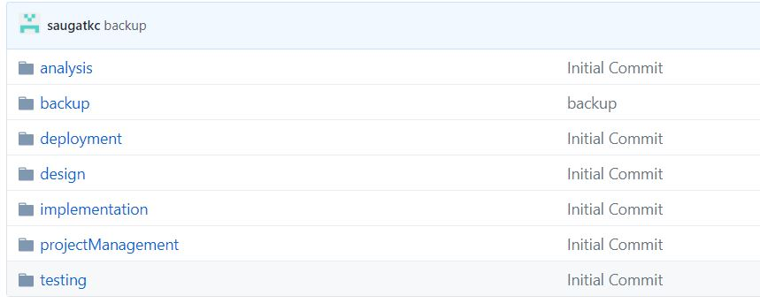

Figure 8.Configuration folder

# 7. Conclusion of the project

The project is developed to make easier for the user to get information of the guest house and their facilities as well as customer for checking the information and to book the rooms online. The application will be reliable, efficient and easier for a user to work on it. The application will be user friendly for the user. Hence, this proposal will be used as the guideline for the final project.