By Two-way ANOVA
Predictor | F-value | p-value | Interpretation
caffeine_mg | 2.392 | 0.1219 | Not statistically significant
sleep_hours | 82.523 | 1.2e-19 | Strong, significant effect
study_hours_per_day | 24972.50 | 0.0000 | Extremely strong effect
focus_level | 0.049 | 0.824 | No effect
Residual | — | — | Unexplained variance

Multiple Comparison of Means –Tucky HSD, and Kruskal Wallis

Multiple Comparison of Means - Tukey HSD, FWER=0.05
===================================================
group1 group2 meandiff p-adj lower upper reject
---------------------------------------------------
High Low 0.1222 0.7935 -0.2186 0.463 False
High Medium 0.1222 0.7231 -0.1783 0.4227 False
High nan 0.1222 0.9457 -0.4452 0.6896 False
Low Medium 0.0 1.0 -0.4041 0.4041 False
Low nan 0.0 1.0 -0.6284 0.6284 False
Medium nan 0.0 1.0 -0.6075 0.6075 False
Explanation: by Adjusted p-value after Tukey correction whether the difference is statistically significant focus_level (High/Medium/Low) had p = 0.824 → NOT significant
So it’s consistent: focus_level groups do not differ.
Kruskal-Wallis H = 0.0007, p = 1.0000
This result means that there is no statistically significant difference between the groups you are comparing.
Let's break it down:
- Kruskal-Wallis H Test: This is a non-parametric test used to determine if there are differences between three or more independent groups.
- H-statistic (0.0007): This is the test statistic. A value this close to zero indicates that the differences between the group rankings are extremely small.
- p-value (1.000): This is the key part. A p-value of 1.000 means there is a 100% probability that the observed tiny differences (or larger) between the groups could have occurred by random chance alone.

Ordinery Least Square Regression (OLS) Result:
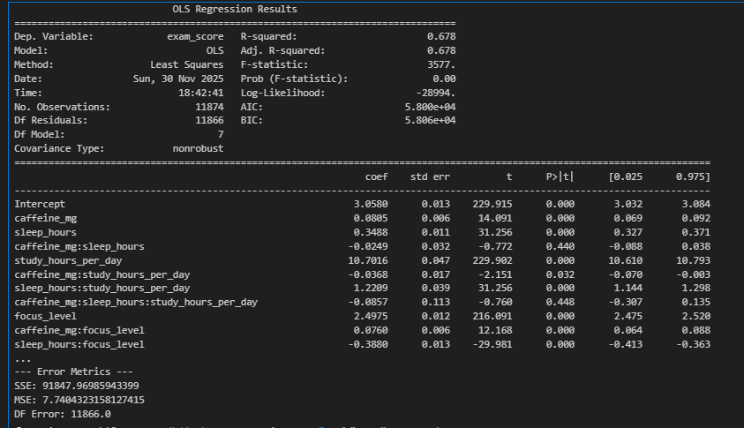

1. Study hours (very strong effect)

2. Focus level (strong effect)

3. Sleep hours (meaningful effect)

4. Caffeine mg (very small effect)

Interaction effects that matter:
- Studying works even better when sleep or focus is high.
- High caffeine slightly reduces the benefit of more study hours.
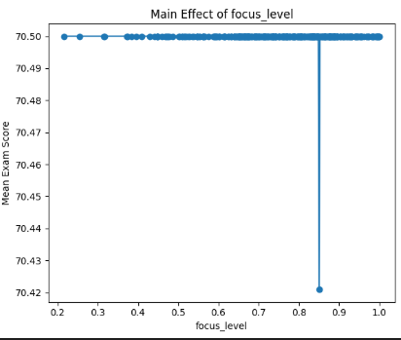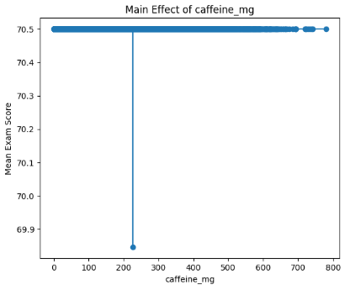

OLS Regression Results
This table shows the results of a statistical model predicting exam_score. Key takeaways:
- Main Effects: study_hours_per_day (Coef=10.70) and focus_level (Coef=2.50) have the strongest positive impact on exam scores.
- Interactions: The model includes several interaction terms (e.g., caffeine_mg:study_hours). The significant negative coefficient for caffeine_mg:study_hours_per_day suggests that the positive effect of studying decreases as caffeine intake increases.
- Fit: The R-squared of 0.678 means the model explains 67.8% of the variance in exam scores, which is a strong fit.

2. Main Effect of focus_level
This graph shows the relationship between focus_level and the average exam score when ignoring all other factors.
- Interpretation: It shows a very slight positive relationship. As focus level increases, the mean exam score also increases very modestly. The flat line indicates that, on its own, focus has a minimal direct effect.

3. Main Effect of caffeine_mg
This graph shows the relationship between caffeine_mg and the average exam score when ignoring all other factors.
- Interpretation: It shows a slight negative relationship. As caffeine intake increases, the mean exam score decreases slightly. Like the focus graph, this "main effect" is weak, suggesting the importance of its interactions with other variables (as seen in the OLS table).
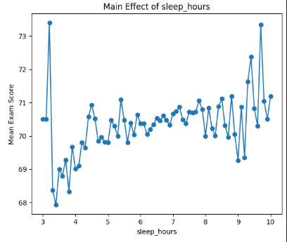
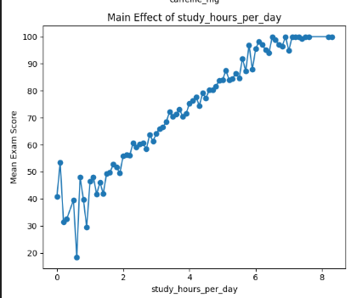

1. Main Effect of study_hours_per_day
This graph shows the relationship between study hours and exam score by itself.
- Interpretation: There is a very strong, clear positive relationship. As daily study hours increase, the mean exam score increases dramatically. This is the strongest individual predictor of a higher exam score.

2. Main Effect of sleep_hours
This graph shows the relationship between sleep hours and exam score by itself.
- Interpretation: There is a clear positive relationship. As sleep hours increase, the mean exam score also increases. More sleep is associated with better performance, showing it is an important factor on its own.
Interaction Effect:
