Diffrential 1-

Stress-

| MAXI | 0.90281MPa |
| --- | --- |
| MIN | 0MPa |

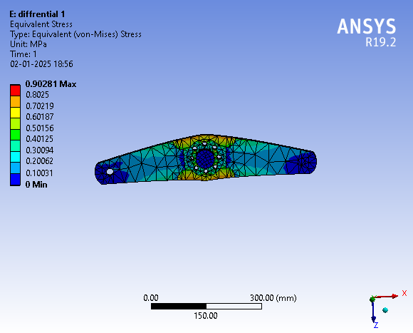

Diffrential 2-

Stress-

| MAXI | 10.548MPa |
| --- | --- |
| MIN | 0MPa |

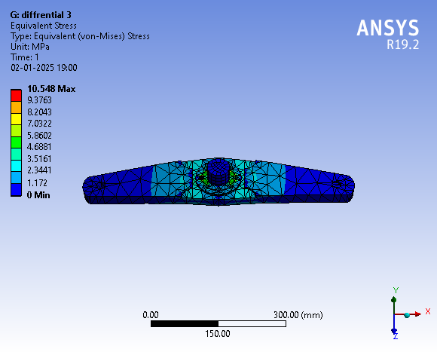

Differential 3-

Stress-

| MAXI | 16.895MPa |
| --- | --- |
| MIN | 0MPa |

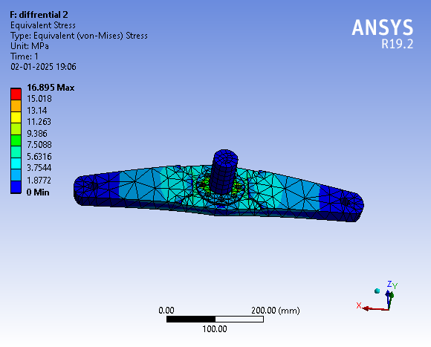

Comment- The FOS is 15 and it is very much stable and can hold 15times more weight then given.