Stephen August

SER316

Assignment 7

GitHub Repo – <https://github.com/saugsut88/memoranda_Saugsut>

**Chosen Method Eclipse**

Task 1-

**E-Size**

1. Total Lines of code in the project: **22539,** Total LOC in src.main.memoranda = **2187**
2. Largest single code file in src.main.memoranda and its total lines of code: **EventsManager LOC = 329**
3. Inspect CurrentNote.Java – what method did the Metrics tool use to determine Total LOC? Describe the method? **The method used here is one that only counts code that is executable it ignores that of comments and that of white space. The count in the Metrics plug in for CurrentNote.java is 28, in eclipse there are 39 lines. White space count is 10 lines, and comments = 1 line 39-10-1=28 to match that of the Metrics plug in**

**E-Cohesion**

1. The tool Calculates “Lack of Cohesion of Methods” using Henderson-Sellers method (LCOM2) What is the definition of LCOM2 and how is it calculated? **LCOM2 low value = high cohesion except 0, LCOM2 is the equals the percentage of methods that do not access a specific attribute averaged over all attributes in the class. Using the formula 1-sum(mA)/(m*a)**
   1. **sum(mA) = sum of mA over the attributes of the class**
   2. **m = number of methods in a class**
   3. **a = number of variables in a class**
   4. **mA = number of methods that access a variable**
2. Which class has the highest Cohesion and do you have an idea why? **HistoryItem.java, this is the class that shows a high degree of cohesion while ignoring the reported 0’s as they are most likely due to having 0 methods or attributes. This is a simple class it only has 2 variables, and every method in the class access these variables. Some classes access both others only one but all access something.**

**E-Complexity**

1. What is the cyclomatic complexity in the src.mian.memoreanda package: **Mean 1.746**
2. What class has, on average, the worst McCabe Cyclomatic Complexity (CC) and what is it? **Start.Java has the highest mean at 3.5, however EventsManager.java has the highest count at 16**
3. Go back to your code and reduce the CC, chose any class in src.main.memoranda reduce it by a small amount somewhere explain what you changed and why, and why it reduced the CC, and by how much you were able to reduce the CC. **This task was focused in EventsManager.java as it had the highest count of CC. The new Mean CC for EventsManager.java is 2.219, reducing the total CC Mean of src.main.memoranda to 1.719, the main thing I changed was removing the if(XXX == null) return null, statements these catches seemed extra. They are commented as //T1-E**

**E-Package-Level Complexity**

1. What do Afferent and Efferent coupling mean?
   1. **Afferent Coupling – The number of classes in other packages that depend upon classes with in the current package,**
   2. **Efferent Coupling - Number of classes in other packages that the classes in a package depend on, dependence on externalities**
2. What package has the worse Afferent Coupling measure and what is the value? **The worst package is the main.java.memoranda.util package with 57 classes in other packages relying on this classes in this package**
3. What package has the worse Efferent Coupling measure and what is the value? **main.java.memoranda.ui with 49 classes in other packages that these package classes depend on.**

**Worst Quality**

1. Which class has the worst quality and why? **My recommendation on a package that has the worst quality would be main.java.memoranda.ui, this package has a higher then the rest Lines of code, a higher then the rest LCOM2 value, and a relatively high mean Cyclomatic Complexity. All three of these combined along with the large size of the package make this package prone to difficulty, errors, and circular dependencies that can be difficult to get to the bottom of.**

Task2-

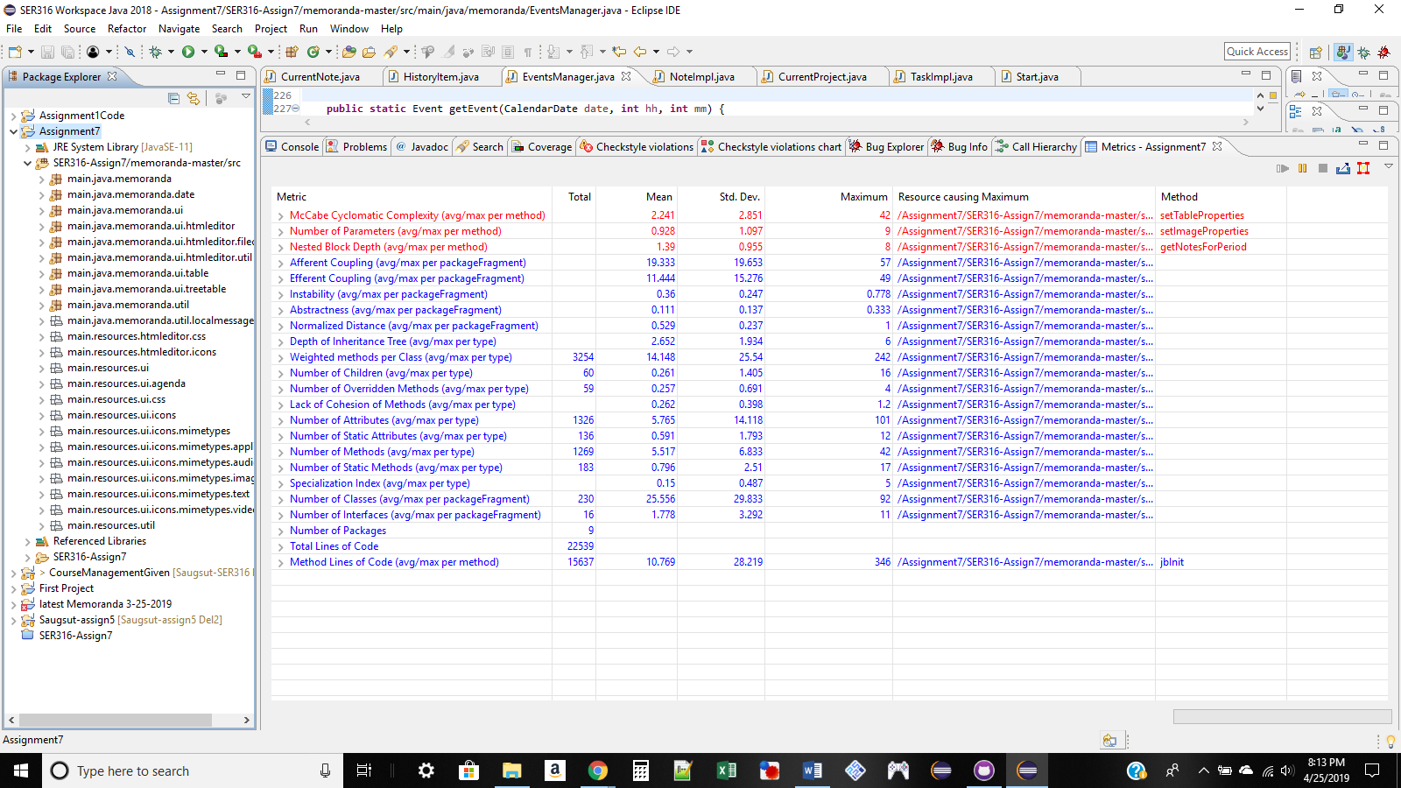

Image 1: Task 2 step 1 Screen shot of Metrics tool before any refactoring

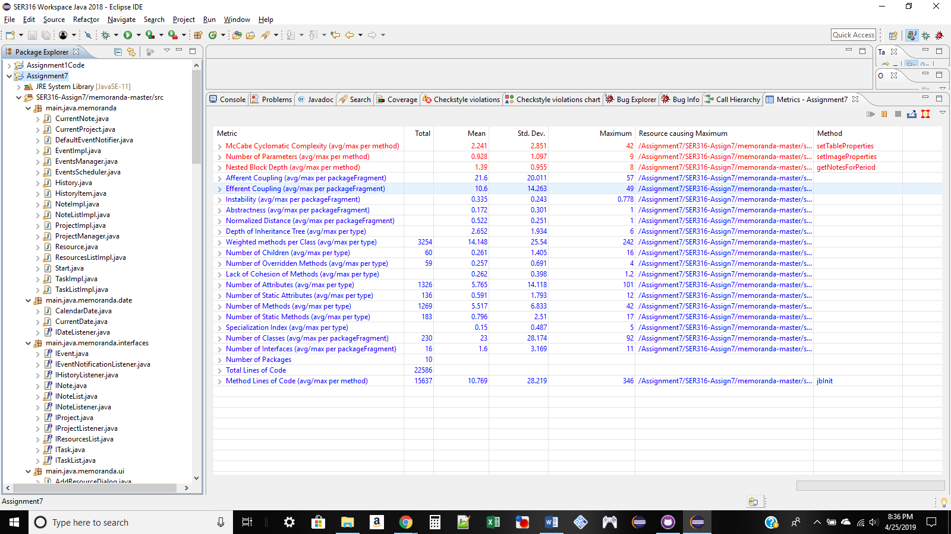

Image 2: Task 2 step 7 re run of metrics after refactoring

Step 8 compare:

Did any metrics improve after refactoring? Pick and state a metric (or metrics) whose value changed, and indicated why it changed and whether it changed for the better (or worse) because of the refactoring.

Yes metrics improved: Efferent coupling improved, instability slightly,

Efferent coupling changed for better while Afferent coupling changed for worse. This is expected as we have created a new package in total thus creating a new set of dependencies for both cases.

Task 3- Find code smells and refactor

1. Find code smells with in a class

Package: main.java.memoranda.ui

Class: PreferencesDialog.java

Smell: Large Class

Refactor: this class is large due to the construction of all of the panels with in the class. To refactor this class into something more manageable and readable the code is to be refactored in to a class per panel and these panels to be imported and constructed into the preferences dialog class.

1. Find code smells between classes

Package: main.java.memoranda.ui / main.java.memoranda.interfaces

Class: DefaultEventNotification.java, IEventNotificationListener.java, EventScheduler.java

Smell: Lazy Class

Refactor: This interface and class are small, leaving little reason to have an interface, removing the interface and directly accessing the class is the better approach for this small of a LOC count.

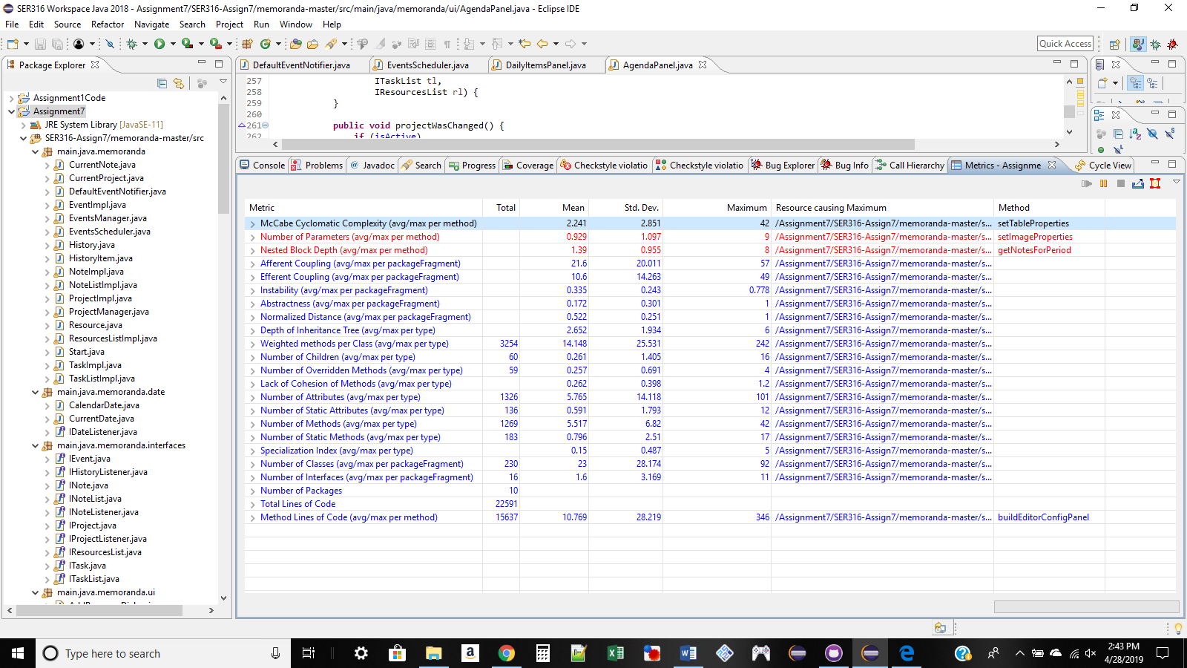

The code smells I Found and activated on did very little to change any over all metrics. However I was able to eliminate an interface, reducing a redundancy loop, as well and lower the LOC count for an extremely large java class.