01) Create an entity relationship diagram that lists the attributes of the entities mentioned above and the

relationships between them. Show your diagram in your PDF (20%)

Answer:

ER DIAGRAM

There are 9 steps for constructing an ER diagram

STEP 1 : Identify Entities
-EMPLOYEES
-DEPARTMENTS
-BUILDINGS

STEP 2: REMOVE DUPLICATE ENTITIES
In this case we don’t have any.

STEP 3: List the attributes of each entity
Employees : (EX_NO,Name ,Salary,EMP_ID)
Department: (Dep_Name, Dept_ID)
Building: (B_ID,Location)

STEP 4: Mark the primary Keys
Employees : (EX_NO,Name, Salary,EMP_ID)
Department: (Dep_Name, Dept_ID)
Building: (B_ID,Location)

Step 5:
Department
Worksrks
Employee

Department
Building

Has

Step 6: Describe the cardinality of relationships

Employee to Department (M to 1): Many employee works in one Department
Building to Department (1 to M): One building has many Departments

Step 7: Remove redundant relationships

We don’t have any in our condition

Step 8: Combine into single diagram

Employee
Department
Building
Has
Worksrks

M 1 M

1

Step 9: Splitting many to many relationships
We don’t have any in our case

02) Create a database out of your ER diagram and show the create table statements that were used.

Answer:

Questions 2,3:

CREATE TABLE EMPLOYEE(employeeID STRING(10) PRIMARY KEY, FirstName STRING(10), LastName STRING(10), Salary STRING(10), ExNumber STRING(10));

INSERT INTO EMPLOYEE(employeeID, FirstName, LastName, Salary, ExNumber) VALUES('JS', 'John', 'Smith', '35000', '1234');

INSERT INTO EMPLOYEE(employeeID, FirstName, LastName, Salary, ExNumber) VALUES('JD', 'John', 'Doe', '45000', '4164');

INSERT INTO EMPLOYEE(employeeID, FirstName, LastName, Salary, ExNumber) VALUES('TS', 'Traci', 'Simms', '50000', '4455');

INSERT INTO EMPLOYEE(employeeID, FirstName, LastName, Salary, ExNumber) VALUES('CT', 'Caitlyn', 'Terrell', '40000', '1234');

INSERT INTO EMPLOYEE(employeeID, FirstName, LastName, Salary, ExNumber) VALUES('MB', 'Montgomery', 'Burns', '100000', '0666');

INSERT INTO EMPLOYEE(employeeID, FirstName, LastName, Salary, ExNumber) VALUES('AP', 'Alphonso', 'Peck', '50000', '4455');

INSERT INTO EMPLOYEE(employeeID, FirstName, LastName, Salary, ExNumber) VALUES('LB', 'Lanford', 'Burnham', '60000', '4455');

CREATE TABLE DEPARTMENT(departmentID STRING(10) PRIMARY KEY, Career STRING(20));

INSERT INTO DEPARTMENT(departmentID, Career) VALUES('CEO', 'CEO department');

INSERT INTO DEPARTMENT(departmentID, Career) VALUES('HR', 'HR department');

INSERT INTO DEPARTMENT(departmentID, Career) VALUES('IT', 'IT department');

INSERT INTO DEPARTMENT(departmentID, Career) VALUES('EN', 'The Engineering department');

CREATE TABLE BUILDING(buildingID STRING(20) PRIMARY KEY, location STRING(20));

INSERT INTO BUILDING(buildingID, location) VALUES('M', 'The main building');

INSERT INTO BUILDING(buildingID, location) VALUES('W', 'The workshop');

CREATE TABLE EmID(

employee_ID STRING(20),

department_ID STRING(20),

FOREIGN KEY(employee_ID) REFERENCES EMPLOYEE(employeeID),

FOREIGN KEY(department_ID) REFERENCES DEPARTMENT(departmentID),

PRIMARY KEY(employee_ID, department_ID)

);

INSERT INTO EmID(employee_ID, department_ID) VALUES('JS', 'IT');

INSERT INTO EmID(employee_ID, department_ID) VALUES('JD', 'HR');

INSERT INTO EmID(employee_ID, department_ID) VALUES('TS', 'EN');

INSERT INTO EmID(employee_ID, department_ID) VALUES('CT', 'IT');

INSERT INTO EmID(employee_ID, department_ID) VALUES('MB', 'CEO');

INSERT INTO EmID(employee_ID, department_ID) VALUES('AP', 'EN');

INSERT INTO EmID(employee_ID, department_ID) VALUES('LB', 'EN');

CREATE TABLE MANAGER(

department_ID STRING(20),

building_ID STRING(20),

Manager_ID STRING(20),

FOREIGN KEY(Manager_ID) REFERENCES EMPLOYEE(employeeID),

FOREIGN KEY(department_ID) REFERENCES DEPARTMENT(departmentID),

FOREIGN KEY(building_ID) REFERENCES BUILDING (buildingID),

PRIMARY KEY(Manager_ID, department_ID, building_ID)

);

INSERT INTO MANAGER(department_ID, building_ID, Manager_ID) VALUES('CEO','M', NULL);

INSERT INTO MANAGER(department_ID, building_ID, Manager_ID) VALUES('HR','M', 'MB');

INSERT INTO MANAGER(department_ID, building_ID, Manager_ID) VALUES('IT','M', 'CT');

INSERT INTO MANAGER(department_ID, building_ID, Manager_ID) VALUES('EN','W', 'LB');

PRAGMA foreign_keys = on;

Questions 4:
select EMPLOYEE.FirstName, EMPLOYEE.LastName, DEPARTMENT.Career FROM DEPARTMENT JOIN MANAGER ON DEPARTMENT.departmentID = MANAGER.department_ID JOIN EMPLOYEE ON EMPLOYEE.employeeID = MANAGER.manager_ID;
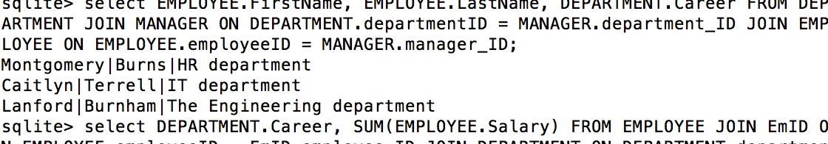

Questions 5:
select DEPARTMENT.Career, SUM(EMPLOYEE.Salary) FROM EMPLOYEE JOIN EmID ON EMPLOYEE.employeeID = EmID.employee_ID JOIN DEPARTMENT ON DEPARTMENT.departmentID = EmID.department_ID GROUP BY DEPARTMENT.Career ORDER BY SUM(EMPLOYEE.Salary) DESC;
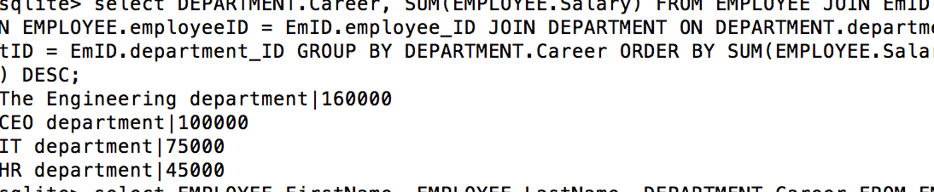

Questions 6:
select EMPLOYEE.FirstName, EMPLOYEE.LastName, DEPARTMENT.Career FROM EMPLOYEE JOIN MANAGER ON EMPLOYEE.employeeID = MANAGER.Manager_ID JOIN DEPARTMENT ON DEPARTMENT.departmentID = MANAGER.department_ID;
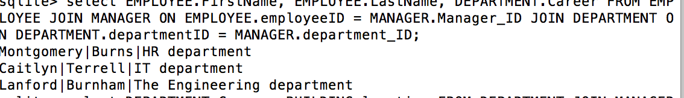

Questions 7:
select DEPARTMENT.Career, BUILDING.location FROM DEPARTMENT JOIN MANAGER ON DEPARTMENT.departmentID = MANAGER.department_ID JOIN BUILDING ON BUILDING.buildingID = MANAGER.building_ID WHERE BUILDING.location = ('The main building');
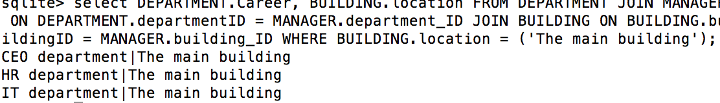

Questions 8:
select DEPARTMENT.Career, EMPLOYEE.ExNumber FROM DEPARTMENT JOIN EmID ON DEPARTMENT.departmentID = EmID.department_ID JOIN EMPLOYEE ON EMPLOYEE.employeeID = EmID.employee_ID WHERE DEPARTMENT.Career = ('The Engineering department');
