- What is this table representing? Is there anything missing from the tables?
Answer:

It is a database of a drone company where they launch different drones by assigning certain missions to them. There are two tables used here drone and survey.
Table Drone is using certain attributes to store the information about the drone. Like id is assigned to every drone they have and launch_date is used to record when the drone was launched, name is storing the drone’s name. They have different types of drone which is stored in the database using type attribute.
To record the information about their survey they are using table survey where id records every single survey made, mission attribute is used to record information related to the mission, duration is recording the time taken by the drone to complete the survey. They have 10 different drones used number of times and to separate them iddrone attribute is used.
The tables are missing an important relation that is we don’t have a foreign key relation between table survey and table drone.

- What is the maximum duration of each drone?
Answer:
iddrone | Maximum duration
1 | 296
2 | 299
3 | 299
4 | 297
5 | 300
6 | 299
7 | 292
8 | 299
9 | 297
10 | 300

- What is the minimum duration of each drone?
Answer:
iddrone | Minimum duration
1 | 13
2 | 8
3 | 4
4 | 9
5 | 5
6 | 10
7 | 8
8 | 4
9 | 7
10 | 6

- What is the total survey time?
Answer:
The total sum duration is 122429
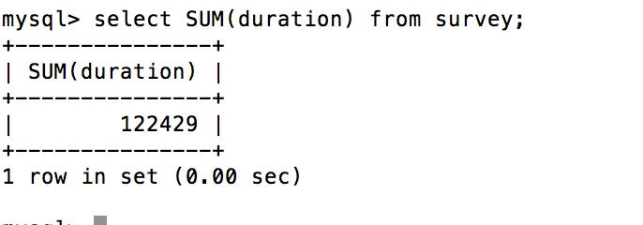

- What is the total survey time of each drone?
iddrone | surveytime
1 | 12864
2 | 12667
3 | 11264
4 | 11968
5 | 12955
6 | 8320
7 | 10834
8 | 14798
9 | 13764
10 | 12995

- What is the total survey time of each drone in ascending order?

iddrone | surveytime
6 | 8320
7 | 10834
4 | 11968
3 | 11264
2 | 12667
1 | 12864
5 | 12995
10 | 12995
9 | 13764
8 | 14798

7. If it costs €4.50/h to rent a drone, how much has the drone of type “Nulla Integer

LLC” made (in Euro)?
Answer:
55 survey has been done using “Nulla Integer LLC” and if it costs €4.50 to rent a drone then total money made
= 4.5 * 55
= 247.5€

8. Query for the drone type that completed the survey with the survey id of 320
Answer:
select name from drone where id in(select iddrone from survey where id = 320);
