

Title: GNSS Lab Report
Lab 1: GNSS Positioning

Course: AAE4203 — Guidance and Navigation
Group: [Group XX]
Members: [Name (Leader); Name; Name; Name]
Member IDs: [ID; ID; ID; ID]
Instructor: Prof. Weisong WEN
Department: Department of Aeronautical and Aviation Engineering
School: The Hong Kong Polytechnic University
Date: October 30, 2026
Abstract
We logged 14.2 min of 1 Hz raw multi-GNSS measurements with a u-blox ZED-F9P receiver near Block X, PolyU, on 30 October 2026. The antenna moved for the first 5.9 min (two laps of a loop of about 50 m) and was static for 8.3 min. GPS L1 pseudoranges were corrected for broadcast satellite orbit and clock, group delay, Klobuchar ionosphere (coefficients decoded from the logged subframes) and Saastamoinen troposphere, using a Python port of the course rinex2csv.m that we verified against the MATLAB output. Position and clock bias were then estimated per epoch by elevation-weighted iterative least squares. 838 of 853 epochs (98.2 %) were solved with 4–7 GPS satellites (median HDOP 1.46). The static position is 22.305585° N, 114.179976° E, h = 18.2 m; its horizontal scatter has a median radius of 2.2 m and a 95th percentile of 21 m, and it agrees with the receiver’s multi-GNSS solution to 1.1 m horizontally and 6.2 m vertically. The largest errors come from weak, newly acquired signals. On the UrbanNav benchmark the GPS-only baseline solved 93.68 % of epochs ([2D RMSE, rank and improvements: fill in]).
Keywords: GNSS, single point positioning, weighted least squares, urban positioning, UrbanNav

Data Collection
A u-blox ZED-F9P receiver board ([kit Kxx]) with [antenna model] was connected by USB to a laptop running u-center [version] (port COM6). The receiver output 46 UBX message types and NMEA sentences at 1 Hz. The ones used here are UBX-RXM-RAWX (code, carrier phase, Doppler and C/N₀ per signal), RXM-SFRBX (broadcast navigation subframes), NAV-HPPOSECEF and NAV-PVT (the receiver’s own solution and speed), NAV-SAT (azimuth and elevation) and NAV-DOP. The antenna was placed [mounting: tripod / ground / bench] in the semi-open area near Block X; surroundings: [buildings, trees and sky view in four directions; weather].
Logging started at 08:12:47 UTC (08:13:05 GPST). The receiver’s ground speed (NAV-PVT) had a median of 1.0 m/s until 08:18:56 GPST, and both our solution and the receiver’s solution trace the same loop of about 51 m × 53 m twice (311 m in 5.9 min, Fig. 3). From 08:18:57 GPST (time of week 461 937 s) the speed stayed below 0.1 m/s, so the static part lasts 8.3 min (501 epochs), shorter than the 15–20 min the lab asks for. Tracking ended at 08:27:16 GPST: the file continues to 08:31:00, but its last 223 RXM-RAWX messages contain no measurements, so the RINEX file holds 853 epochs. The site and log are summarised in Table 1.
Figure 1: [Insert site photo and the four sky photos]. Data collection environment near Block X.
Table 1: Data collection summary.
Field | Value
Location | Near Block X, PolyU; static point 22.305585° N, 114.179976° E, h = 18.2 m (WGS-84)
Date / time | 30 Oct 2026, 08:13:05–08:27:16 GPST (08:12:47–08:26:58 UTC)
Duration | 14.2 min at 1 Hz (853 epochs): 5.9 min moving + 8.3 min static
Receiver | u-blox ZED-F9P ([kit Kxx]), [antenna]
Software | u-center [version]; RTKCONV-EX 2.5.1; Python 3.13
Signals | GPS L1 C/A, L2C; Galileo E1, E5b; BeiDou B1I, B2I; GLONASS L1, L2
Raw file | COM6___9600_261030_081848.ubx (11.6 MB), data/raw/ in GitHub
Weather | [weather, temperature]

Raw Data Analysis
RXM-RAWX holds 40 775 signal measurements. On average 6.8 GPS, 7.4 Galileo, 7.9 BeiDou and 7.9 GLONASS satellites had a valid pseudorange per epoch (Fig. 2a). Only 7 GPS satellites (G02, G04, G08, G09, G16, G27, G31) had a broadcast ephemeris in the log; G03, G26 and G28 were tracked but no ephemeris was decoded in the 14 min. The GPS-only solver therefore used 4 (148 epochs), 5 (404), 6 (279) or 7 (7) satellites.
Median C/N₀ was 43 dB-Hz for GPS L1 C/A, 38 for L2C, 39/37 for Galileo E1/E5b, 42/40 for BeiDou B1I/B2I and 36/30 dB-Hz for GLONASS L1/L2. For GPS L1 (Fig. 2b), the two highest satellites G27 (73–79°) and G08 (56–63°) were steady at about 47 dB-Hz once static. G04, at 59° elevation, averaged only 37 dB-Hz and repeatedly dropped to about 20 dB-Hz and lost lock. A weak signal from a high satellite suggests that something near the antenna blocked or diffracted it [check against the site photos]. Following the tutorial’s rule of thumb (> 40 dB-Hz strong, < 30 dB-Hz at moderate elevation suspicious), G02, G03, G26 and G28 (25–29 dB-Hz mean) were weak. While walking, all signals fluctuated strongly because of body blockage and changing multipath.
The sky plot (Fig. 2c) shows satellites in all directions. The GPS satellites used were G27 (73–79°), G04 (59°), G08 (56–63°), G16 (41–45°), G09 (31–35°), G31 (29–32°) and G02 (15–16°, at the mask). With these satellites the GPS-only HDOP had a median of 1.46 (max 4.0) and VDOP 2.56 (max 8.4), against 0.57 and 1.01 for the receiver’s multi-GNSS solution (Fig. 2d). The DOP spikes occur when only 4 GPS satellites remain. With the tutorial’s user range error of 5.7 m, the median GPS-only geometry gives roughly 8 m horizontal and 15 m vertical 1σ error.
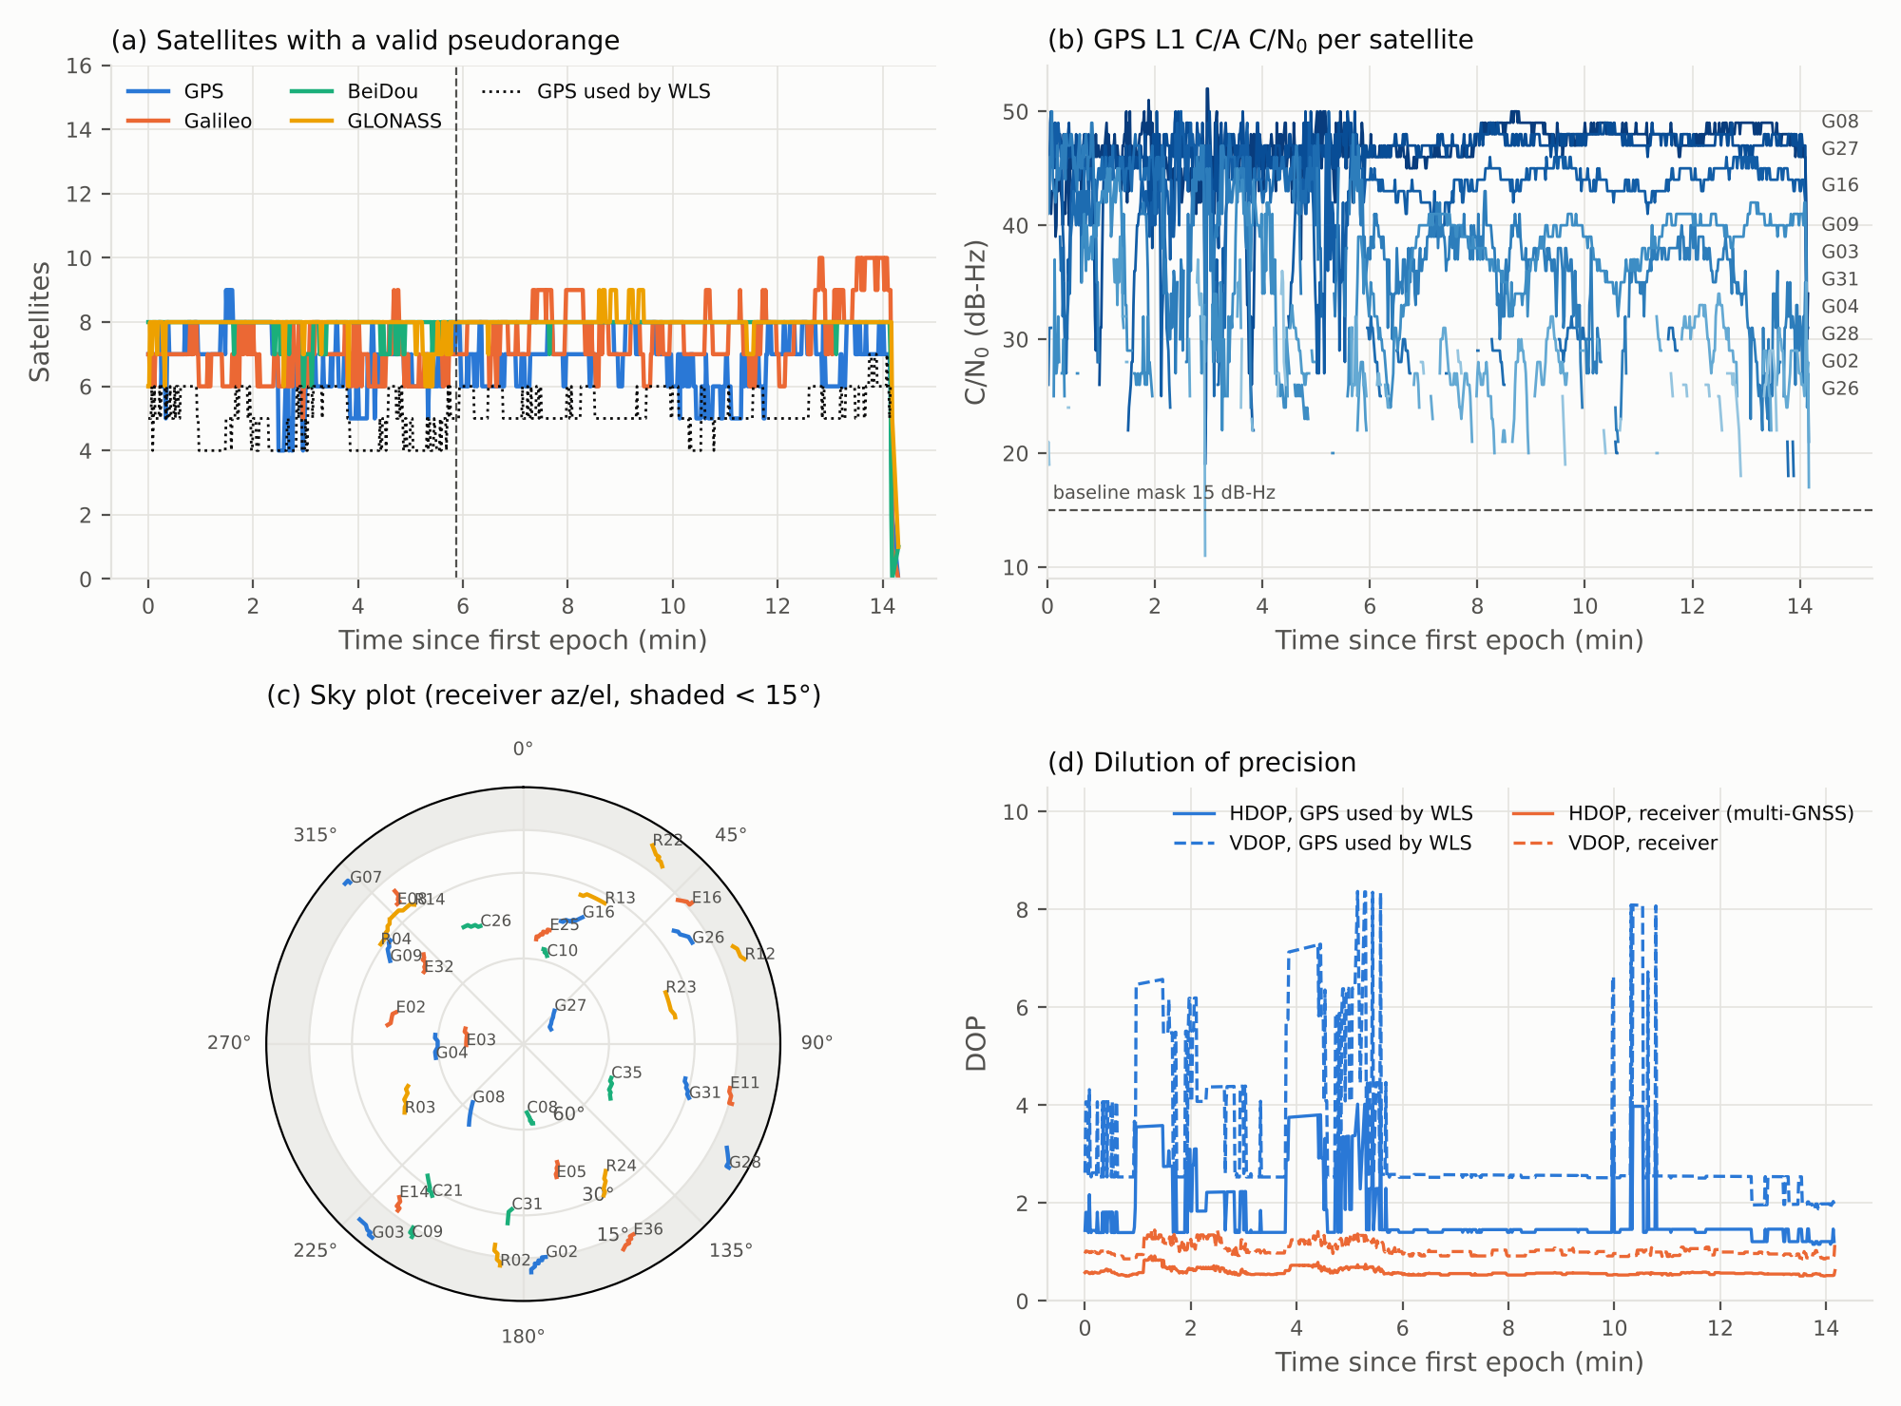
Figure 2: Raw data quality: (a) satellites with a valid pseudorange per constellation and GPS satellites used by the solver; (b) GPS L1 C/A C/N₀; (c) sky plot from NAV-SAT; (d) GPS-only DOP of the satellites used versus the receiver’s multi-GNSS DOP. Dashed line in (a): start of the static part.

SPP Algorithm (Least Squares)
Each epoch is solved independently from GPS L1 C/A pseudoranges with the course solver WLSE_spp.py in its gps mode [1, 2]. The measurement model is
$ρ_{i}=∥x-s_{i}∥+cΔt+ε_{i}$, (1)
where x is the receiver ECEF position, sᵢ the satellite position at signal transmission, cΔt = b the receiver clock bias in metres and εᵢ the remaining noise, multipath and NLOS error. The satellite position and clock come from the broadcast ephemeris (RTKLIB eph2pos [6]), evaluated at the transmission time tᵣ − ρᵢ/c − δtˢᵢ, with the relativistic clock term. Each pseudorange is then corrected and modelled as
${\tilde{ρ}}_{i}=ρ_{i}+c δt_{i}^{s}−c T_{GD,i}−I_{i}−T_{i}=∥s_{i}−x∥+\frac{ω_{e}}{c}\left(x_{i}^{s} y−y_{i}^{s} x\right)+b+ε_{i}$, (3)
with the satellite clock δtˢᵢ, the group delay Tᴳᴰ from the ephemeris, the Klobuchar ionosphere Iᵢ [4] and the Saastamoinen troposphere Tᵢ (standard atmosphere, 70 % humidity) [5]. The last term of the range is the Earth-rotation (Sagnac) correction. RTKCONV wrote no ionosphere coefficients to the NAV file, so we decoded them from the logged RXM-SFRBX subframe 4 page 18 (three identical copies, from G08, G27 and G31): α = (1.676e-08, -7.451e-09, -1.192e-07, 1.192e-07), β = (118784, -65536, -327680, 327680). Linearising (3) about the current estimate gives the design-matrix row and misclosure
$H_{i}=\left[\begin{matrix}−e_{i}^{⊤} & 1\end{matrix}\right], v_{i}={\tilde{ρ}}_{i}−{\hat{r}}_{i}−\hat{b}, e_{i}=\frac{s_{i}−\hat{x}}{∥s_{i}−\hat{x}∥}$, (4)
and the weighted least-squares update
$δ=(H⊤WH)^{-1}H^{⊤}Wv$, (2)
with elevation weights
$W=diag\left(w_{1},…,w_{n}\right), w_{i}=max{\left(sinθ_{i}, 0.05\right)}^{2}$, (5)
Iteration starts from the previous epoch’s solution (from the Earth’s centre for the first epoch) and stops when ‖δ‖ < 10⁻⁴ m (at most 30 iterations); a solution is accepted only if its distance from the Earth’s centre is 6300–6420 km. Satellites are used if healthy, with elevation ≥ 15° and C/N₀ ≥ 15 dB-Hz; epochs with fewer than four are omitted, never filled.
The course converter rinex2csv.m needs MATLAB, so we ported it line by line to Python (src/rinex2csv.py). On the UrbanNav benchmark it converts the same 1437 of 1534 epochs as the MATLAB-generated benchmark/gps_csv, with an identical missing-data pattern and identical pseudoranges and group delays. On all epochs that do not use G02, satellite positions agree to 2×10⁻⁷ m and clocks, ionosphere and troposphere to 10⁻⁹ m. For G02 the benchmark NAV holds two valid ephemerides and the two codes pick different ones (≤ 0.29 m clock, ≤ 1 m orbit difference). Our own NAV file has one ephemeris per satellite, so this cannot occur there.

Code Listing
Listing 1 is the per-epoch solver used (unchanged from the course). Full code, data and a one-command rebuild (run_all.sh) are at https://github.com/saul-gitman/AAE-4004-lab.
def gps_solution(sp, pr, clk, ion, trp, tgd, seed):
"""One GPS clock, weighted LS, Sagnac correction."""
x = np.r_[seed.copy(), 0.0] # [x, y, z, b], b in metres
corrected = pr + clk - ion - trp - tgd
for _ in range(30):
delta = sp - x[:3]
ranges = np.linalg.norm(delta, axis=1)
H = np.column_stack((-delta / ranges[:, None],
np.ones(len(sp))))
sagnac = OMGE / C * (sp[:, 0]*x[1] - sp[:, 1]*x[0])
if np.linalg.norm(x[:3]) > 6e6: # elevation weights
lat, lon, _ = ecef_to_lla(*x[:3])
phi, lam = np.radians([lat, lon])
up = np.array([np.cos(phi)*np.cos(lam),
np.cos(phi)*np.sin(lam), np.sin(phi)])
sine = delta @ up / ranges
weights = np.maximum(sine, 0.05)**2
else: # first iterations from Earth centre
weights = np.ones(len(sp))
scale = np.sqrt(weights)
dx, _, rank, _ = np.linalg.lstsq(
H * scale[:, None],
(corrected - ranges - sagnac - x[3]) * scale, rcond=None)
if rank < 4:
raise ValueError('Insufficient geometry')
x += dx
if np.linalg.norm(dx) < 1e-4:
if 6.30e6 < np.linalg.norm(x[:3]) < 6.42e6:
return x[:3], x[3]
break
raise ValueError('GPS WLS did not converge to a surface position')
Listing 1: Per-epoch weighted least-squares solver (WLSE_spp.py, gps_solution).

Own-Data Validation
There is no ground truth for our own data, so this section tests agreement and consistency, not accuracy. Solutions are matched by GPS time of week, and differences are rotated into East/North/Up at the static position.
Comparison with independent solutions
Table 2 compares our solution with the receiver’s own solution (NAV-HPPOSECEF, multi-GNSS, cm-to-m units converted) over all 838 solved epochs and over the 498 static epochs. The median differences are below 0.8 m horizontally (-0.57 / -0.69 / -2.38 m E/N/U), and half of the epochs agree within 2.7 m horizontally. The means, standard deviations and RMS values are much larger (53.3 m 2D RMS) because they are dominated by a few tens of outlier epochs. Fig. 3 shows both solutions following the two walking laps. While static, the receiver solution stays within about 1 m horizontally, but ours jumps by 10–40 m whenever the set of GPS satellites changes (for example at 9.5, 10–10.8 and 13.3 min), as expected for GPS-only single-frequency SPP with 5–6 satellites. [RTKPOST: process data/rinex/*.obs and *.nav in Single mode and fill the RTKPOST column.]
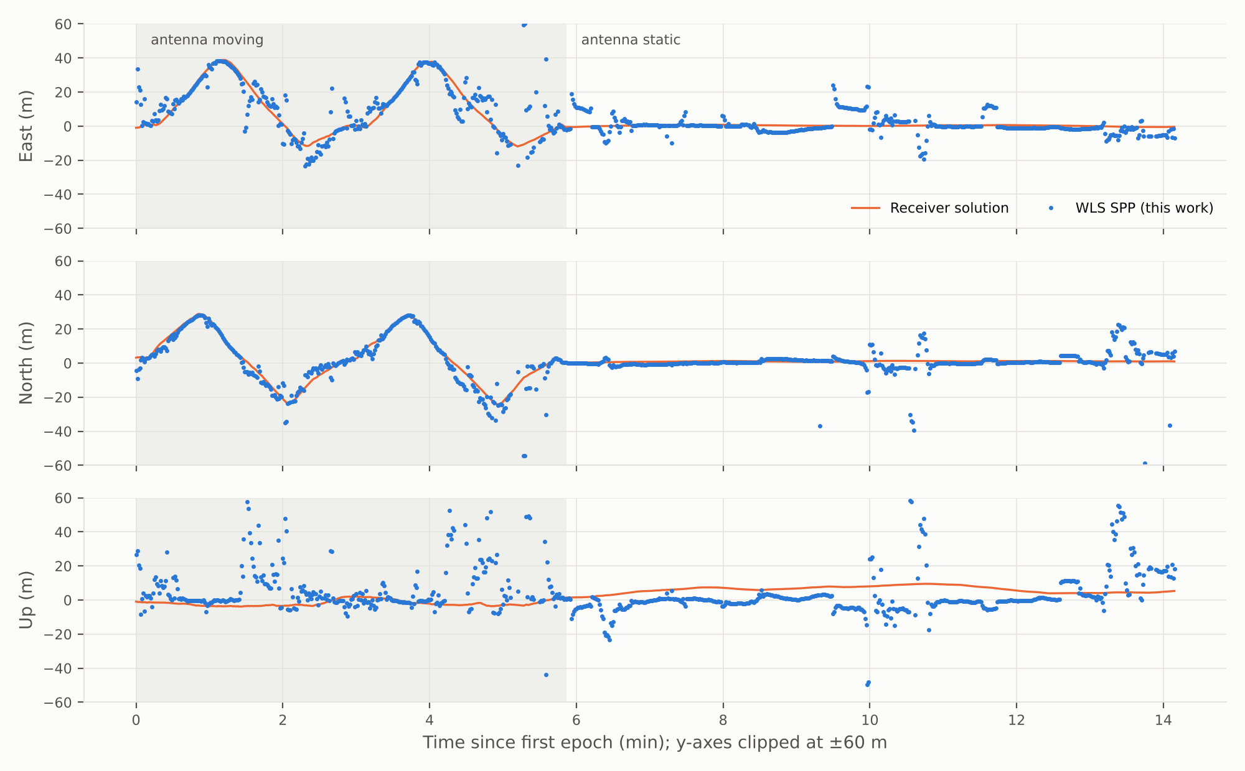
Figure 3: East, North and Up of our WLS solution and of the receiver solution against time, relative to the static position (axes clipped at ±60 m; shaded: antenna moving).
Table 2: Differences between solutions for our own data (WLS SPP minus reference), in metres.
Statistic | SPP − RTKPOST | SPP − receiver (all) | SPP − receiver (static)
Mean E / N / U (m) | [–] | -4.91 / -0.92 / 5.17 | -9.54 / -0.21 / 2.14
Std E / N / U (m) | [–] | 49.50 / 19.12 / 54.80 | 63.00 / 24.06 / 68.45
2D RMS difference (m) | [–] | 53.27 | 68.05
Median E / N / U (m) | [–] | -0.57 / -0.69 / -2.38 | -0.71 / -0.75 / -5.96
2D P50 / P95 (m) | [–] | 2.66 / 20.23 | 2.53 / 20.32
Epochs compared | [–] | 838 | 498
Static-solution consistency
498 of the 501 static epochs were solved (99.4 %; 838/853 = 98.2 % overall). Fig. 4 shows the static East–North scatter about its median. The median horizontal radius is 2.2 m and the 95th percentile 21.0 m, but 14 static epochs lie more than 50 m away. Because of them, the standard deviations are 63.06 / 24.07 / 68.52 m (E/N/U) and the mean is offset from the median by -9.27 / 0.77 / 8.19 m. The scatter has a clear structure: points line up along a few directions and form clusters that persist for tens of seconds. These are geometry and satellite-set changes, not random noise. For comparison, the receiver’s own static solution has standard deviations of 0.36 / 0.25 / 2.04 m and its median lies 0.5 m E, 1.0 m N and 6.2 m U from ours.
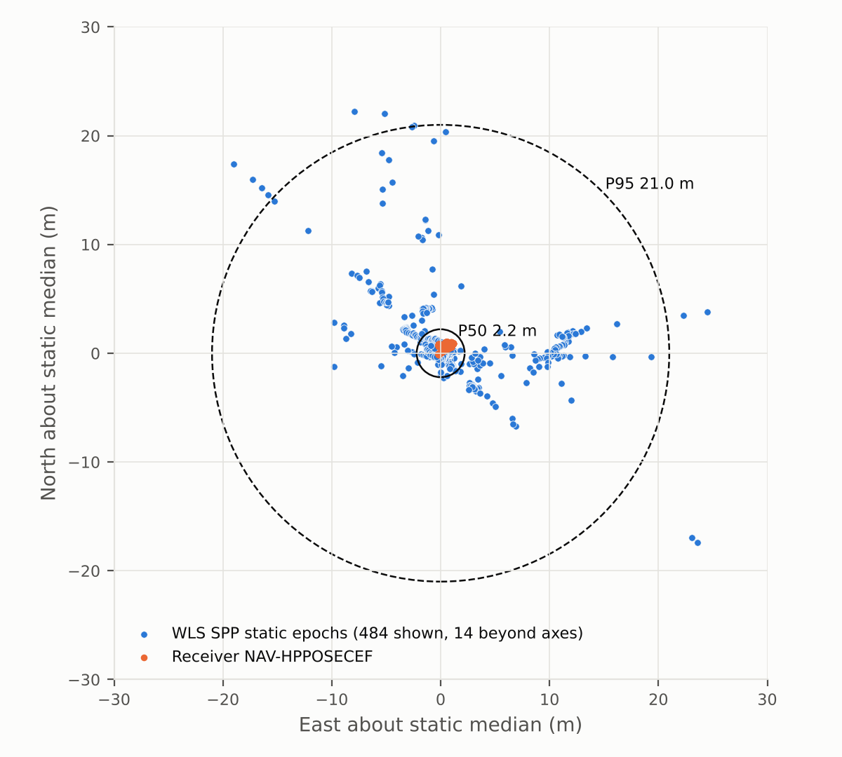
Figure 4: East–North scatter of the static WLS solution about its median, with the receiver solution; circles: 50th and 95th percentile horizontal radius.
Input checks
Post-fit residuals locate the outliers. In the worst epochs (residuals up to 620 m) G04 or G31 has just been re-acquired: C/N₀ 19–25 dB-Hz, lock time 0 ms and RXM-RAWX pseudorange standard deviation 10–41 m, against 0.08–0.32 m for the other satellites. The baseline’s 15 dB-Hz mask accepts these measurements, and with only 5–6 satellites one bad pseudorange moves the solution by tens to hundreds of metres. A C/N₀ mask of 25–30 dB-Hz, a lock-time or pseudorange-std check, or residual-based exclusion should remove most of them. These are the first improvements to test.

Benchmark Results
The GPS-only baseline (course cache benchmark/gps_csv, WLSE_spp.py --mode gps) solved 1437 of 1534 epochs (93.68 %), above the 90 % ranking threshold. The omitted epochs have fewer than four usable GPS satellites after the 15° elevation mask. GXX_benchmark.csv passes check_submission.py. The scoring reference is withheld, so RMSE values come only from the leaderboard (Table 3). [Add each improvement you test, one at a time, and check it on the example dataset first.]
Table 3: Ablation on the benchmark dataset.
Version | Change tested | 2D RMSE (m) | 3D RMSE (m) | Availability (%)
v1 | GPS-only baseline | [leaderboard] | [leaderboard] | 93.68
v2 | C/N₀ mask 25–30 dB-Hz | [–] | [–] | [–]
v3 | + residual-based exclusion | [–] | [–] | [–]
v4 | + BeiDou and Galileo | [–] | [–] | [–]
[Final 2D RMSE … m, 3D RMSE … m, 2D P95 … m, availability … %, leaderboard rank …]. UrbanNav-HK-Deep-Urban-1 [3] is recorded in a dense street canyon in Hong Kong. Tall buildings block most of the sky, so few satellites remain and the geometry is poor (high DOP). Many of the signals received are reflected (multipath) or arrive only by reflection (NLOS), which adds positive range biases of tens of metres. Our own data shows the same mechanisms on a smaller scale: weak, newly acquired signals and satellite-set changes cause most of the error, and adding constellations improves the geometry (multi-GNSS HDOP 0.57 vs GPS-only 1.46).

AI-Use Statement
We used Claude Code (Anthropic) through claude.ai/code for: porting rinex2csv.m to Python; writing the UBX-to-CSV conversion, the Klobuchar decoding and the plotting scripts; running the course solver and computing the statistics; and drafting the text of this report. We verified its output in four ways. (i) The Python converter was compared value by value with the course’s MATLAB benchmark CSVs (Section 3). (ii) The subframe decoding was checked by reproducing the ephemeris parameters RTKCONV wrote to the NAV file. (iii) The course checker was run on both CSVs, and the benchmark baseline reproduces the documented 1437/1534 epochs. (iv) The own-data solution was compared with the receiver’s independent solution. [State what each member checked and confirm that you understand the code.] Key prompts are listed in Appendix B.

Repository and Submission
- GitHub repository: https://github.com/saul-gitman/AAE-4004-lab. It contains the raw UBX log, the RINEX files, all CSVs, the scripts, the figures and a copy of the course Lab1 folder.
- “GROUP=GXX ./run_all.sh” rebuilds GXX_owndata.csv, GXX_benchmark.csv, the figures and the statistics from the raw files; a rerun gives byte-identical CSVs.
- Both CSVs pass tools/check_submission.py (own data 838 rows, 98.24 %; benchmark 1437 rows, 93.68 %). [Rename GXX to your group number and upload to the TA’s Google Drive folder.]

References
  - P. Misra and P. Enge, Global Positioning System: Signals, Measurements, and Performance, 2nd ed., Ganga-Jamuna Press, 2011.
  - P. J. G. Teunissen and O. Montenbruck (Eds.), Springer Handbook of Global Navigation Satellite Systems, Springer, 2017.
  - L.-T. Hsu et al., “UrbanNav: An open-sourced multisensory dataset for benchmarking positioning algorithms designed for urban areas,” in Proc. ION GNSS+ 2021, pp. 226–256.
  - J. A. Klobuchar, “Ionospheric time-delay algorithm for single-frequency GPS users,” IEEE Trans. Aerosp. Electron. Syst., vol. AES-23, no. 3, pp. 325–331, 1987.
  - J. Saastamoinen, “Atmospheric correction for the troposphere and stratosphere in radio ranging of satellites,” in The Use of Artificial Satellites for Geodesy, Geophys. Monogr. 15, AGU, 1972.
  - T. Takasu, RTKLIB: An Open Source Program Package for GNSS Positioning, v2.4.3, 2013; rtklibexplorer RTKLIB-EX 2.5.1.
  - u-blox, ZED-F9P Interface Description (UBX-RXM-RAWX, RXM-SFRBX, NAV-HPPOSECEF).
  - W. Wen, AAE4203 Lab 1 course repository, https://github.com/weisongwen/AAE4203-S12627 (commit ab9f0cd).

A Supplementary Figure
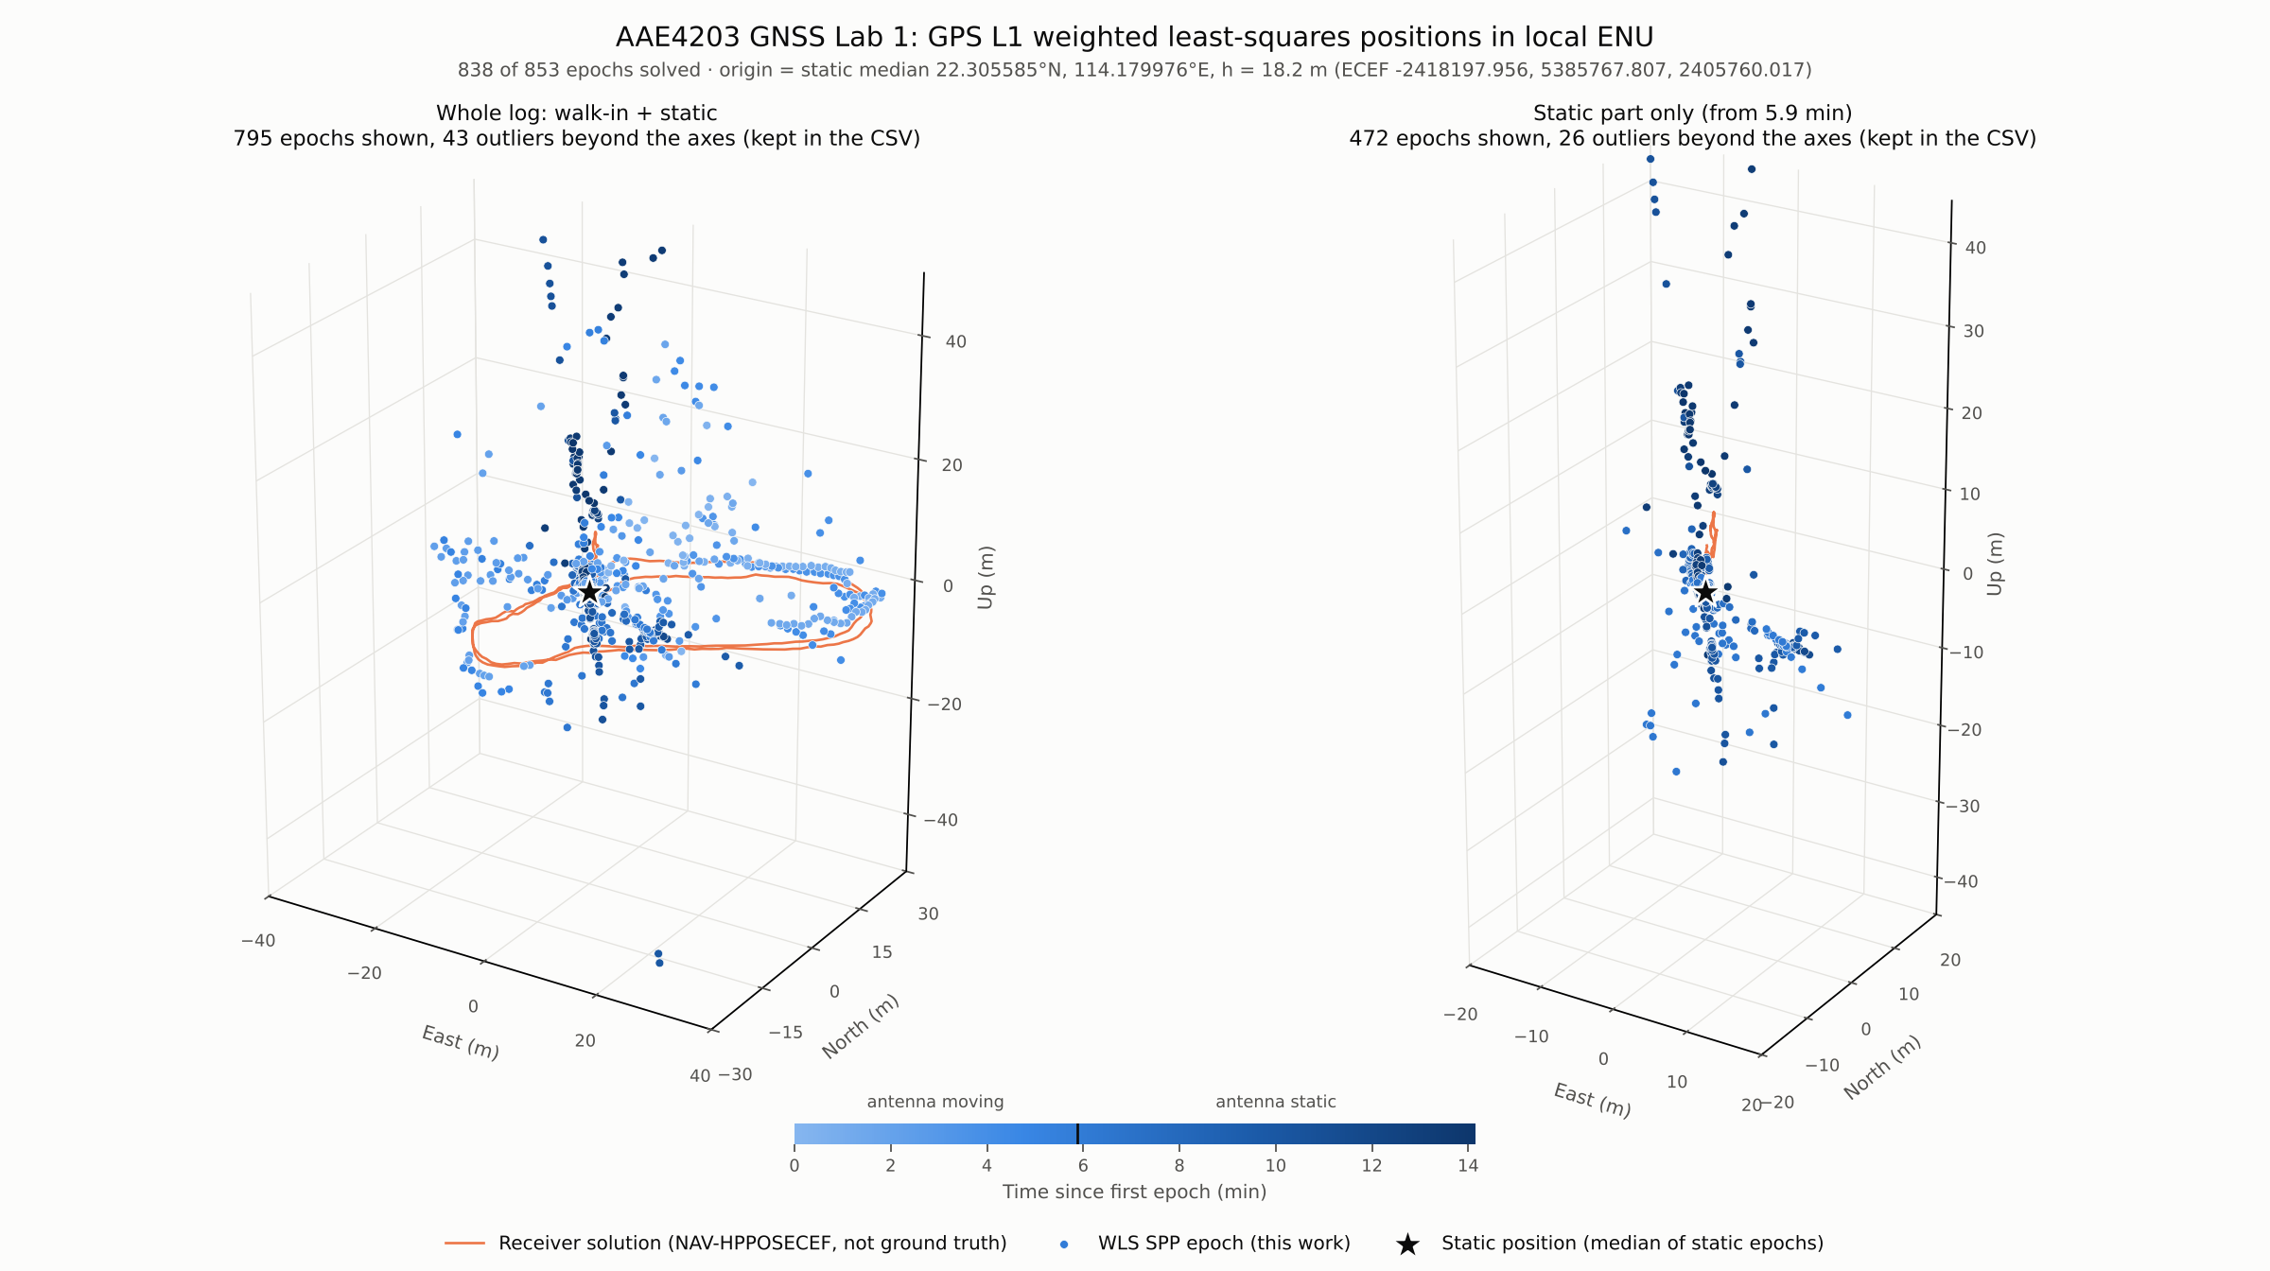
Figure A1: WLS positions in 3D local ENU: the whole log (left) and the static part (right); colour = time, orange = receiver solution, star = static position. An animation of the whole log is in figures/position_track.gif in the repository.

B Key AI Prompts
- “The ubx is the raw data; obs and nav were converted with RTKCONV … use the GitHub repo as file storage; put the raw data, processed data and the course repo; I want the CSV of the raw data, the CSV of the position result and a 3D plot of the result.” Verified: converter vs MATLAB benchmark CSVs, checker, receiver comparison.
- “Make it a GIF for the whole movement.” Verified: frames inspected against the static plot.
- “This is the report template; fill as much as you can.” Verified: every number in this report was regenerated from results/report_stats.json and summary.json by report/build_report.py; [members re-read every section].

