Nama: Ahmad S Habibi – BE3

Link Repo Tugas : <https://gitlab.com/asaddam/latmvc2>

1. Create Account

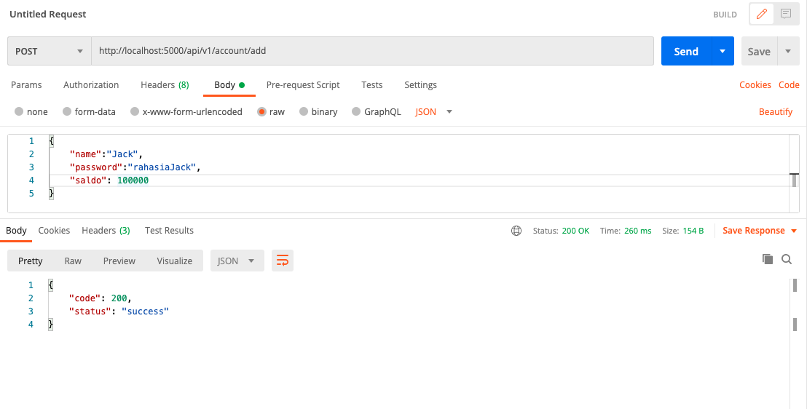

Login

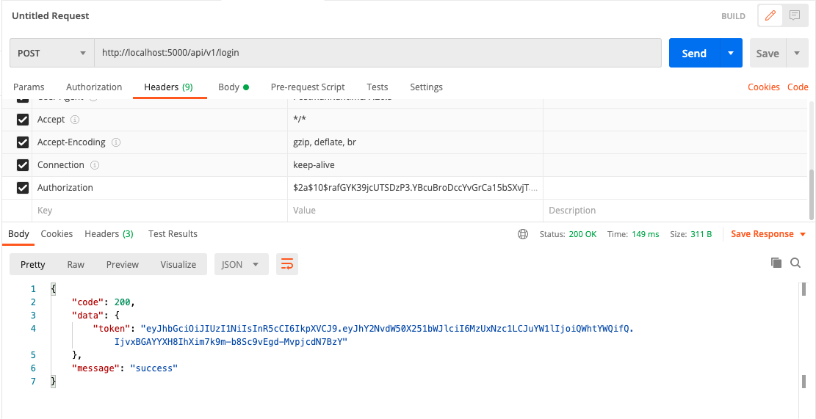

GetAccount

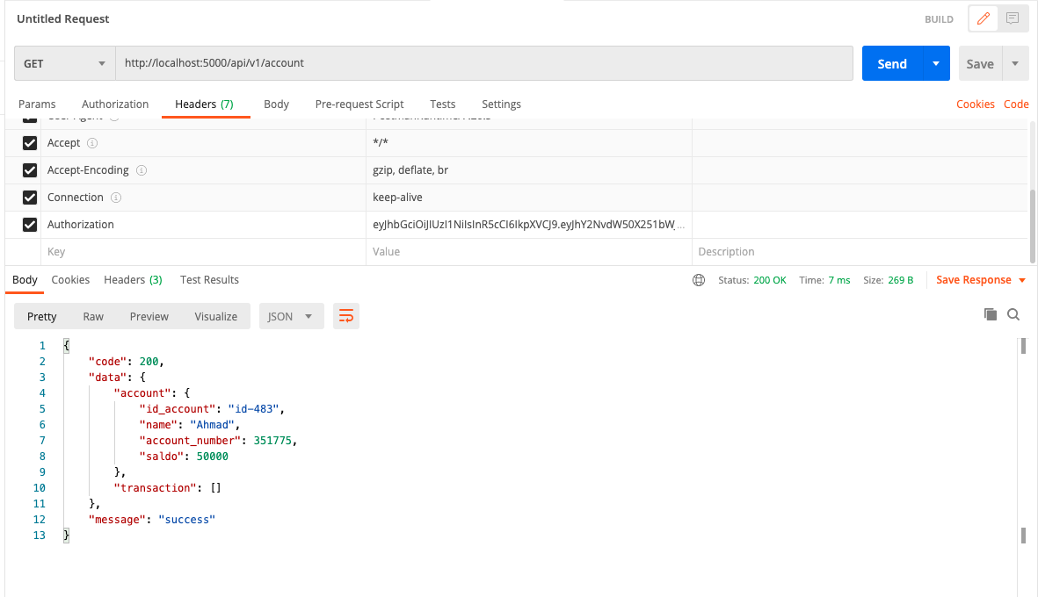

Transfer

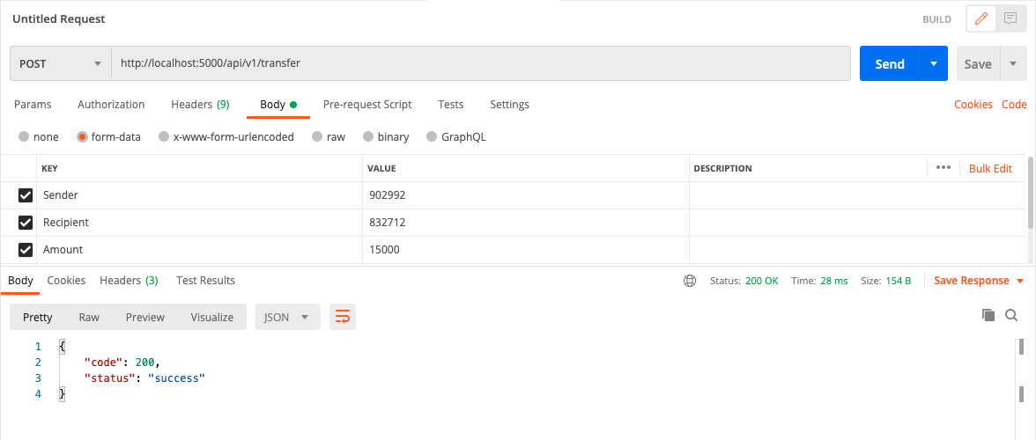

Withdraw

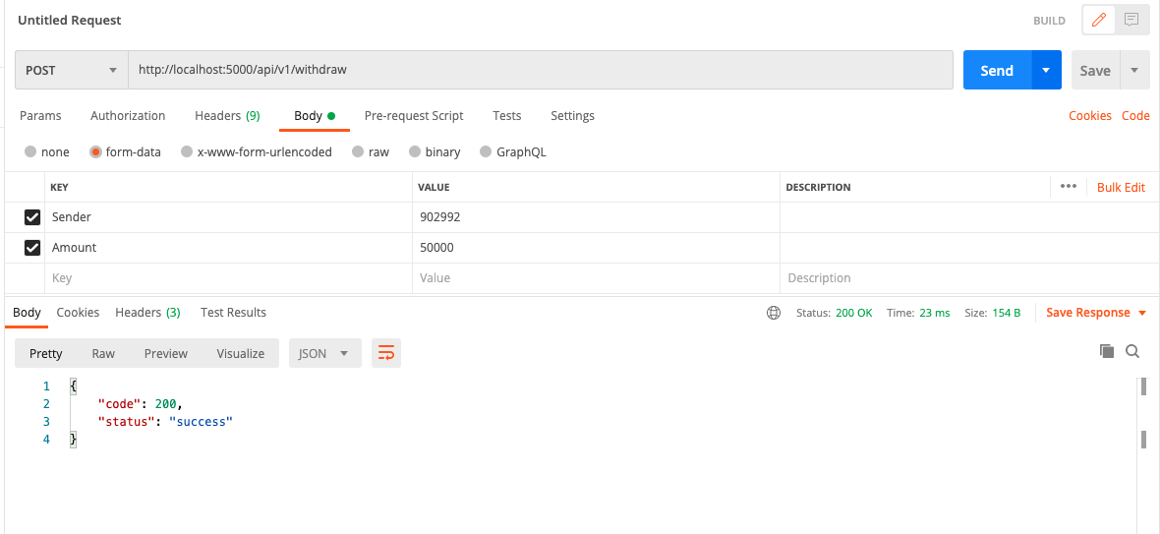

Deposit

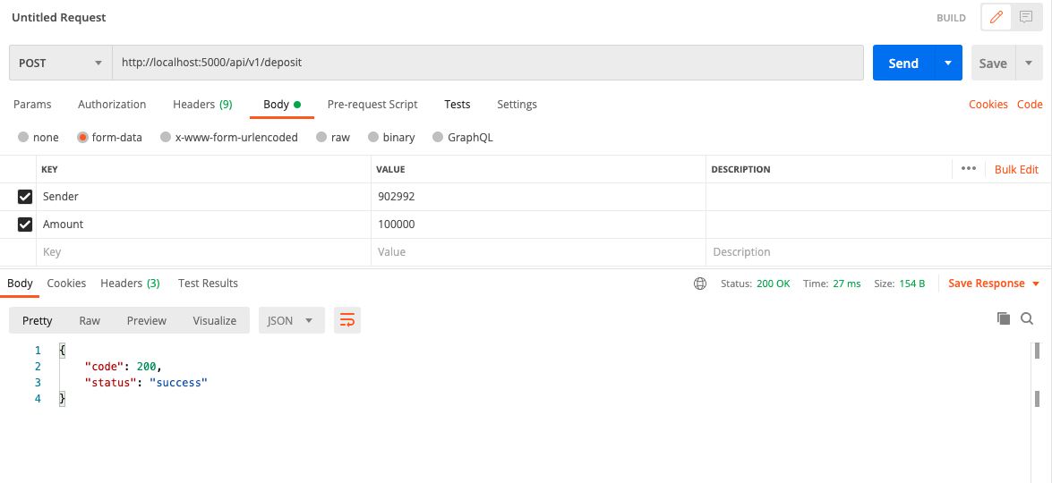

Hasil Table accounts

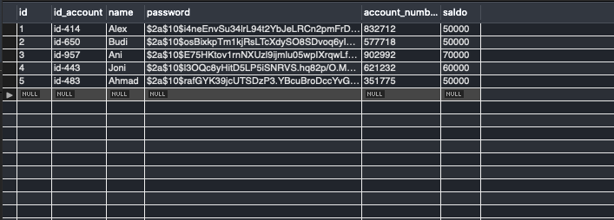

Table transactions

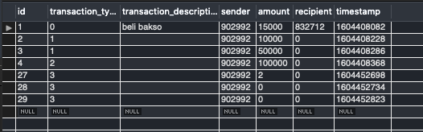

1. Method Interest : bunga yang ditambahkan sebesar 2% ke semua account

Function Interest di Models/bank.go :

func Interest (transaction Transaction) (bool,error){

err := DB.Transaction(func(tx \*gorm.DB) error {

// var account Account

var result []map[string]interface{}

tx.Model(&Account{}).Find(&result)

// fmt.Println(result[1]["saldo"])

for i, hasil := range result {

if err := tx.Model(&Account{}).Where(&Account{ID: i+1}).

Update("saldo", hasil["saldo"].(int)+(hasil["saldo"].(int)\*2/100)).Error; err != nil {

// return any error will rollback

return err

}

// fmt.Println(reflect.TypeOf(hasil["saldo"]), i)

}

transaction.TransactionType = constant.INTEREST

transaction.Timestamp = time.Now().Unix()

if err := tx.Create(&transaction).Error;err != nil {

// return any error will rollback

return err

}

return nil

});if err != nil {

return false, err

}

return true,nil

}

Function Interest di controllers/controller.go

func Interest (c \*gin.Context){

var transaction models.Transaction

if err := c.Bind(&transaction); err!= nil {

utils.WrapAPIError(c,err.Error(),http.StatusBadRequest)

return

}

flag,err := models.Interest(transaction); if flag{

utils.WrapAPISuccess(c,"success",http.StatusOK)

return

}else {

utils.WrapAPIError(c,err.Error(),http.StatusBadRequest)

return

}

}

Postman:

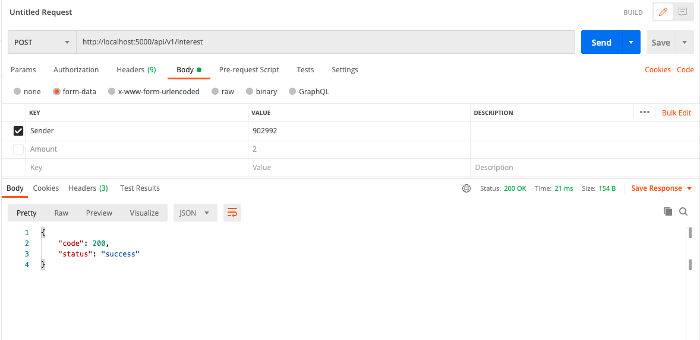

Table accounts : sebelum

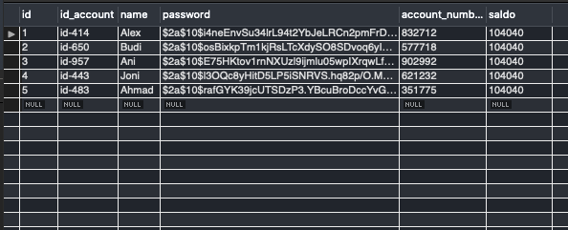

Sesudah

