INSTALL ANACONDA

<https://www.digitalocean.com/community/tutorials/how-to-install-anaconda-on-ubuntu-18-04-quickstart>

CHANGE FOLDER RIGHTS

sudo chmod -R 777 /var/DirectoryName

Dependencies

pip install -U scikit-learn

python -mpip install matplotlib

**pip install pandas**

CREATE ENVIRONMENT

Conda create –name saul

ACTIVATE THE ENVIRONMENT

Conda activate saul

PROBLEM WITH TENSORFLOW 2.0, it does not have contrib

# K-FOLD is the same

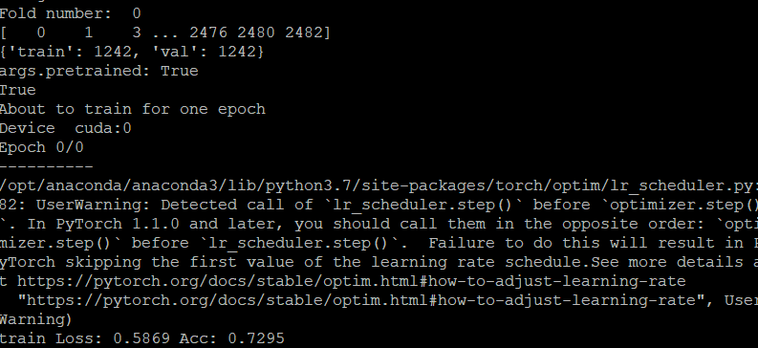

# USE NOTEPAD++ in WinSCP

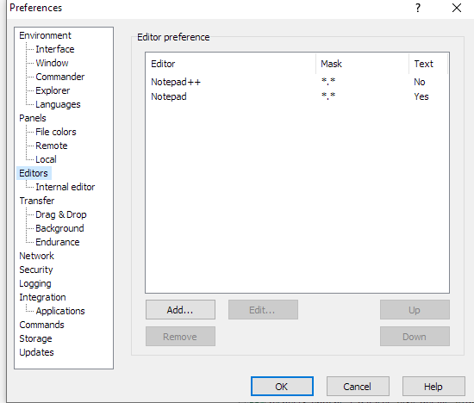

# WATCH GPU USAGE

watch -n 0.5 nvidia-smi

top (for cpu usage)

# HYPER PARAMETER FINETUNING

<https://towardsdatascience.com/a-bunch-of-tips-and-tricks-for-training-deep-neural-networks-3ca24c31ddc8>