STEPS
Upgrade pip python -m pip install --upgrade pip
Use screen for background execution
See running processes
ps -u sacalderon

convert windows file to unix
Problem with \r, use nano to edit file.
TO WATCH GPU USAGE
Watch -n 1 nvidia-smi
Execute job in background python mainTests.py &

Allow detachment, with tmux.
- ssh into the remote machine
- start tmux by typing tmux into the shell
- start the process you want inside the started tmux session
- leave/detach the tmux session by typing Ctrl+b and then d
You can now safely log off from the remote machine, your process will keep running inside tmux. When you come back again and want to check the status of your process you can use tmux attach to attach to your tmux session.

INSTALL ANACONDA
https://www.digitalocean.com/community/tutorials/how-to-install-anaconda-on-ubuntu-18-04-quickstart

CHANGE FOLDER RIGHTS
sudo chmod -R 777 /var/DirectoryName

CREATE ENVIRONMENT
Conda create –name saul
ACTIVATE THE ENVIRONMENT
Conda activate saul

PROBLEM WITH TENSORFLOW 2.0, it does not have contrib

K-FOLD is the same

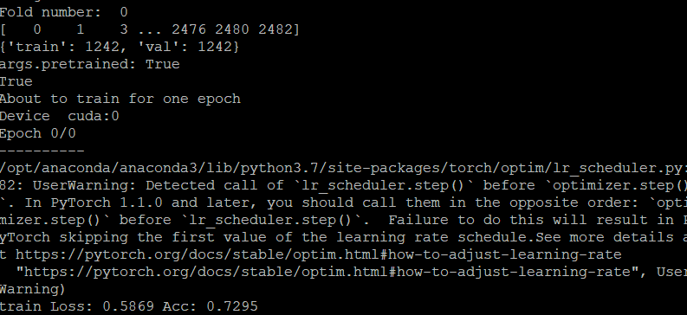

USE NOTEPAD++ in WinSCP
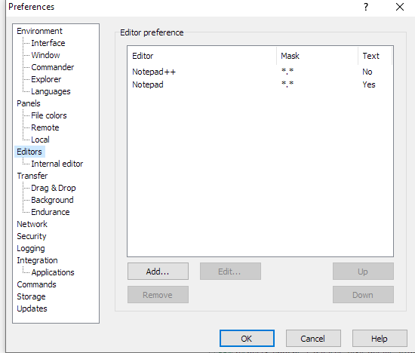

TEST DEFINITION
Run 20 times a 5 fold for model RESNET18
Run 20 times a 5 fold for model RESNET50
Run 20 times a 5 fold for model VGG16
Run 20 times a 5 fold for model Inception

