Version 2.2.2.4 changes – update highly recommended
If you see anything odd, please let me know ASAP and I will fix it.
  - New Features
  - Episodes – Timelapse identifies a sequence of images separated by a short time interval (e.g., an animal moving through a scene) and numbers them (e.g., 1/10). Useful for analyzing a sequence of related images as a whole. Try Options | Show Episodes. See User Manual – Episodes for details.
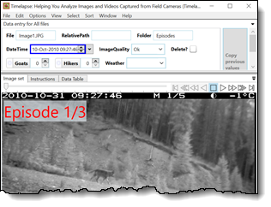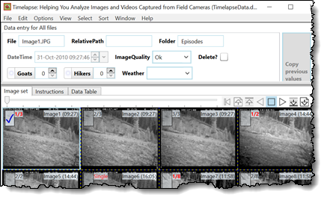
  - Tabbing – skips system-supplied fields by default as these are rarely edited (DateTime, ImageQuality, DeleteFlag), but you can change that using Options | Preferences
  - Navigating images – left/right arrow key works everywhere except on a note, date or counter field that has the focus (as they navigate the text in it). You can use Shift-left/right arrow keys, which always navigates images.
  - Other changes in recent versions
  - QuickPaste – lets you paste multiple data field values in a single click or with a shortcut key.
  - Sort Menu allows you to sort images by your data fields
  - Copy Previous Values button and QuickPaste display previews of the values that would be pasted
  - Tabbing and keyboard data entry vastly improved.
  - Bug fixes and fine tuning
  - Various, some critical.
For more details or to see changes in earlier versions:
Visit the version history at: http://saul.cpsc.ucalgary.ca/timelapse/pmwiki.php?n=Main.TimelapseVersions

