A. Develop a hash table, without using any additional libraries or classes, that has an insertion function that takes the package ID as input and inserts each of the following data components into the hash table:
• delivery address
• delivery deadline
• delivery city
• delivery zip code
• package weight
• delivery status (i.e., at the hub, en route, or delivered), including the delivery time

The HashTable class is initialized like so, with the following methods:

class HashTable:
def __init__(self, sizeOf):
self.sizeOf = sizeOf
self.table = [None] * sizeOf
def _hash(self, key):
return hash(key) % self.sizeOf
def set(self, key, obj):
index = self._hash(key)
if self.table[index] is None:
self.table[index] = []
for pair in self.table[index]:
if pair[0] == key:
pair[1] = obj
return
self.table[index].append([key, obj])

I didn’t understand the power of the hash table until I understood that hash() is the cryptographic function, and returns a large integer. Once that clicked, the rest all of a sudden made sense.

The hash table is set up with linear probing – one hash function is called, then a linear search within that bucket is implemented.

Items are loaded into the hash table using the reader from the csv package:
def load_from_csv(self, filepath):
if not os.path.isfile(filepath):
print(f"Error: file '[filepath]' does not exist.")
return
with open(filepath, mode='r', newline='', encoding='utf-8') as file:
reader = csv.reader(file)

for row in reader:
package = Package(*row)
package_id = package.package_id
self.set(package_id, package)
self.add_id(package_id)

numberOfPackages = self.len()
print(f"{numberOfPackages} packages have been loaded.")

Note that I am keeping a separate record of all package IDs entered into the hash table in the package_id_list Array.

B. Develop a look-up function that takes the package ID as input and returns each of the following corresponding data components:
• delivery address
• delivery deadline
• delivery city
• delivery zip code
• package weight
• delivery status (i.e., at the hub, en route, or delivered), including the delivery time

def show_pkg_info(self, id):
this_package = self.table.get(id)
print("Summary of Package",this_package.package_id,":")
print("\tDelivery address:",this_package.street_address)
print("\tDelivery deadline:",this_package.delivery_deadline)
print("\tDelivery city:",this_package.city)
print("\tDelivery Zip code:",this_package.zip_code)
print("\tPackage weight:",this_package.weight_kg,"kg")
print("\tDelivery Status:", this_package.get_status())
if this_package.get_status() == Status.HAS_DELIVERED:
print("\tDelivery status: package delivered at",this_package.time_delivered)

This should be relatively self-explanatory. The Status is an Enum defined in the package.py file.

C. Write an original program that will deliver all packages and meet all requirements using the attached supporting documents “Salt Lake City Downtown Map,” “WGUPS Distance Table,” and “WGUPS Package File.”
1. Create an identifying comment within the first line of a file named “main.py” that includes your student ID.
2. Include comments in your code to explain both the process and the flow of the program.

Code is included in submission.

D. Provide an intuitive interface for the user to view the delivery status (including the delivery time) of any package at any time and the total mileage traveled by all trucks. (The delivery status should report the package as at the hub, en route, or delivered. Delivery status must include the time.)
1. Provide screenshots to show the status of all packages loaded onto each truck at a time between 8:35 a.m. and 9:25 a.m.

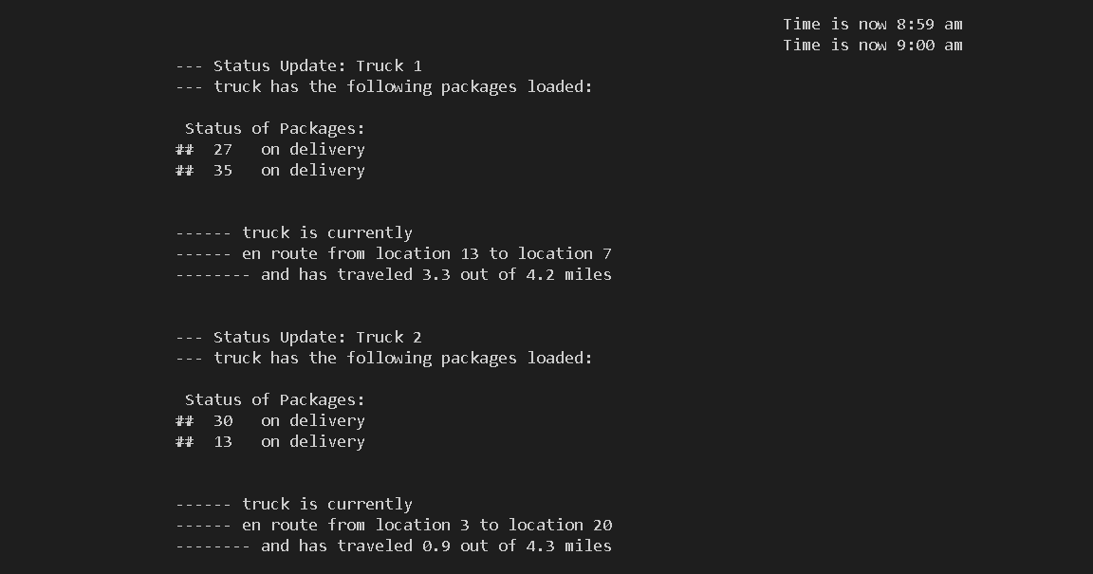
2. Provide screenshots to show the status of all packages loaded onto each truck at a time between 9:35 a.m. and 10:25 a.m.
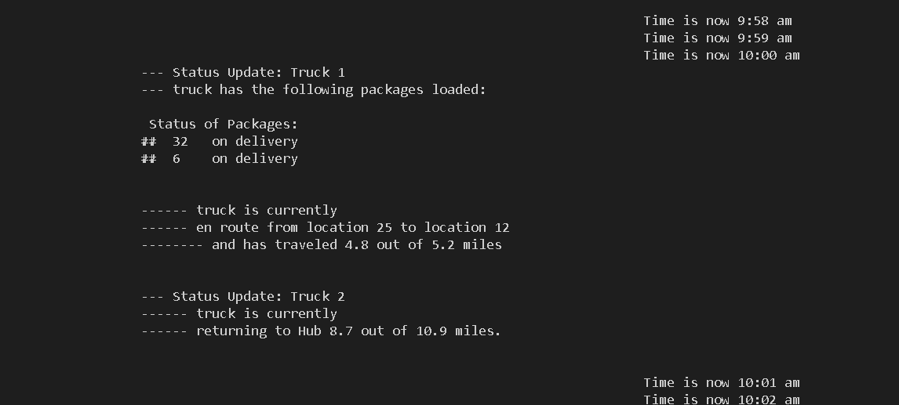

3. Provide screenshots to show the status of all packages loaded onto each truck at a time between 12:03 p.m. and 1:12 p.m.

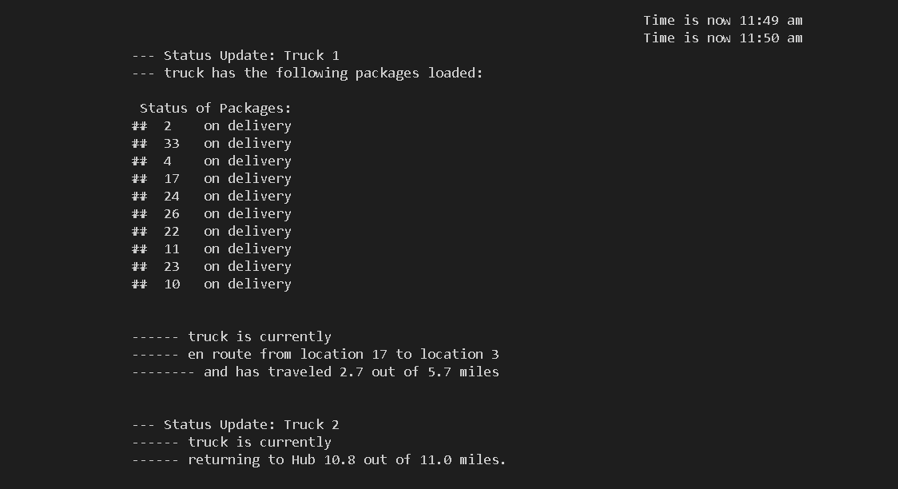

E. Provide screenshots showing successful completion of the code that includes the total mileage traveled by all trucks.
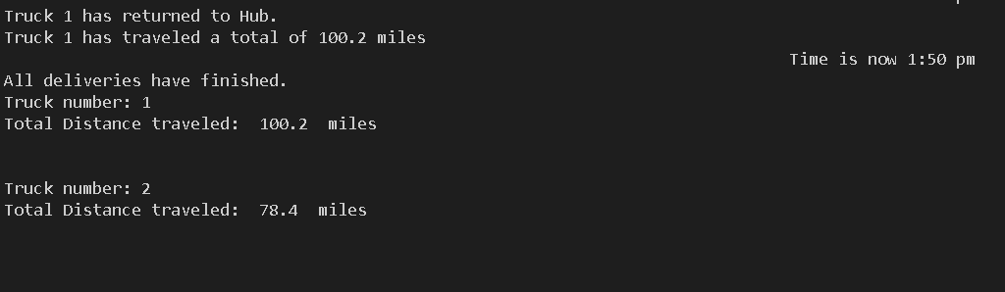

F. Justify the package delivery algorithm used in the solution as written in the original program by doing the following:
1. Describe two or more strengths of the algorithm used in the solution.

The main strengths of the algorithm implemented here is simplicity and front-loaded heuristics. The nearest neighbor algorithm is relatively simple to implement and has modest computational and memory requirements. By implementing simple heuristics (“is this package being delivered to a zip code on the north end of town?”) at the same time that the package is being sorted for business purposes (“does this package require early delivery?”), efficiency is boosted over a naive implementation of what would otherwise be a better quality algorithm, such as Djikstra’s.

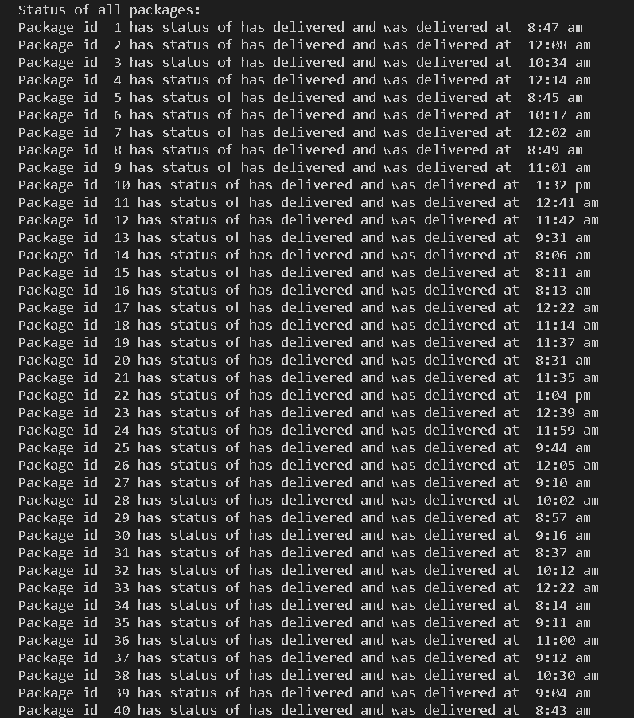
2. Verify that the algorithm used in the solution meets all requirements in the scenario.

3. Identify two other named algorithms that are different from the algorithm implemented in the solution and would meet all requirements in the scenario.

The two other named algorithms that I examined were Djikstra’s algorithm and the A* algorithm.

a. Describe how both algorithms identified in part F3 are different from the algorithm used in the solution.

Djikstra’s algorithm wouldn’t be that much more difficult to implement, but it does have higher computational and memory requirements. A* algorithm depends heavily upon the heuristics in terms of finding an optimal path, and it is so much more difficult to implement rigorously that the complexity exceeded my ability to implement.

G. Describe what you would do differently, other than the two algorithms identified in part F3, if you did this project again, including details of the modifications that would be made.

If I was to do this over I would implement the object directly instead of passing around tuple objects that just referenced the package ID and location ID. It added a little complexity and I don’t think it really benefited me in the scope of this project. A larger project, sure, but not this one.

I would have implemented my queues a little differently. The basic idea is good, I think, but I would rather have sorted them by business needs then chopped them into 16-package chunks. I would have liked to implement the ability to chunk together multiple smaller queues into larger queues, as well.

Similar to

if len(thisQueue) + len(thatQueue) > 16:
consolidatedQueue.push(thisQueue)
consolidatedQueue.push(thatQueue)

That type of thing.

H. Verify that the data structure used in the solution meets all requirements in the scenario.
1. Identify two other data structures that could meet the same requirements in the scenario.

The data structure used in this implementation is a hash table with linear probing, meaning that each bin could hold multiple objects. The benefit of this is that complexity is as simple as O(1).

A binary search tree would be suitable for this purpose but complexity would be O(log n) and it would be more difficult to instantiate.

An Array could even be used, depending on the size of the package ID, and was what I was first going to use to implement this program, since the hash function would be reduced to a simple identity.

a. Describe how each data structure identified in H1 is different from the data structure used in the solution.

A hash table was kind of overkill – the Dict structure already exists in Python, is relatively optimized, and would have allowed us to store the Package objects as either key-value pairs or directly in the case of package ID being the index of the Array. The strength of the hash table over the Array is that the key can be anything and by using a cryptographic hash function it utilizes the bins of the internal table as efficiently as can be possible.

The binary search tree could be implemented but it wouldn’t scale well to large numbers or especially if the key was anything other than a well-behaved integer, like a string. The power of the hash table is that anything can be a key, as long as it can be converted into a string of digits and fed into the hash algorithm.

I. Acknowledge sources, using in-text citations and references, for content that is quoted, paraphrased, or summarized.

No sources were quoted, paraphrased, or summarized for this paper apart from coursework.

