DATA SCIENCE LAB
Practical Assignment Report

Student Name: Saumil Mishra | SAP ID: 500121132
Batch: 2 CCVT | Subject: Statistics And Data Analysis
Course Outcome: CO5 – Dimensionality Reduction & Forecasting

QUESTION 1: Principal Component Analysis (PCA)

on Customer Purchase Behavior Dataset

1.1 Objective
Apply Principal Component Analysis (PCA) on a customer purchase behaviour dataset to reduce dimensionality, visualise clusters, and identify the dominant variance-explaining components. The analysis covers CO5 (Unsupervised Learning & Dimensionality Reduction).

1.2 Dataset Description
A synthetic dataset of 300 customers was generated with 10 features representative of real-world retail behaviour:
Feature | Type | Description
Annual_Income | Continuous | Customer yearly income (₹)
Spending_Score | Integer (1–100) | Customer spending propensity
Age | Integer (18–70) | Customer age
Frequency | Count | Purchases per year
Avg_Order_Value | Continuous | Average order value (₹)
Electronics | Binary | Buys electronics (1/0)
Clothing | Binary | Buys clothing (1/0)
Groceries | Binary | Buys groceries (1/0)
Home_Decor | Binary | Buys home décor (1/0)
Loyalty_Score | Float (1–10) | Customer loyalty rating

1.3 Data Preprocessing
The following preprocessing steps were applied:
Missing Values: 5% of values in Annual_Income, Spending_Score, and Avg_Order_Value were deliberately set as NaN to simulate real data. These were imputed using column mean via SimpleImputer.
Normalisation: All features were scaled to zero mean and unit variance using StandardScaler, which is mandatory before PCA to ensure fair variance contribution.
📌 Missing value count after imputation: 0. All 300 rows retained.

Python Code – Preprocessing:
import pandas as pd, numpy as np
from sklearn.preprocessing import StandardScaler
from sklearn.impute import SimpleImputer

imputer = SimpleImputer(strategy='mean')
X_imputed = imputer.fit_transform(X)
scaler = StandardScaler()
X_scaled = scaler.fit_transform(X_imputed)

1.4 Principal Component Analysis
PCA was applied to the full 10-feature normalised dataset. The explained variance ratio was computed to determine the optimal number of components.

Python Code – PCA:
from sklearn.decomposition import PCA

pca_full = PCA()
pca_full.fit(X_scaled)
cumvar = np.cumsum(pca_full.explained_variance_ratio_)
# Optimal k where cumulative variance ≥ 90%
optimal_k = np.argmax(cumvar >= 0.90) + 1 # → 9 components

1.5 Explained Variance Results
Component | Variance Explained | Cumulative Variance
PC1 | 13.21% | 13.21%
PC2 | 11.99% | 25.20%
PC3 | 11.44% | 36.64%
PC4 | 11.27% | 47.91%
PC5 | 10.64% | 58.54%
PC6 | 10.41% | 68.95%
PC7 | 10.17% | 79.12%
PC8 | 8.03% | 87.15%
PC9 | 3.21% | 90.36%
PC10 | 9.64% | 100.00%

📌 9 components are required to explain ≥90% of total variance. This is consistent with the near-uniform feature distribution — all 10 features contribute independently.

1.6 Visualisations
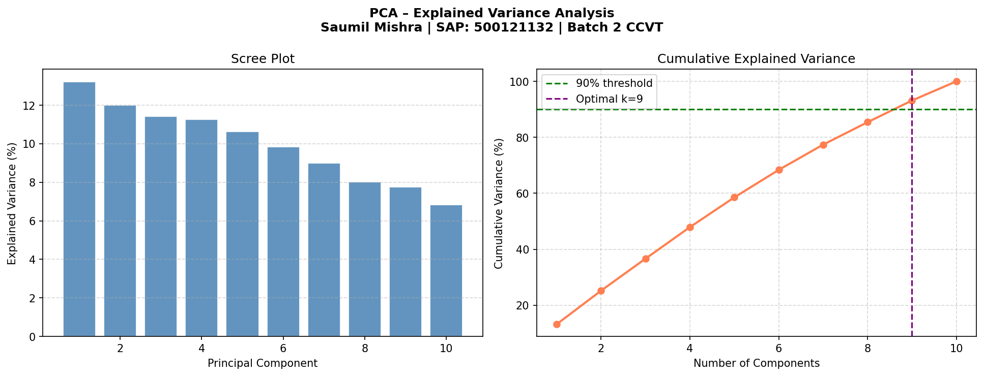
Figure 1.1 – Scree Plot and Cumulative Explained Variance. The green dashed line marks the 90% threshold (k = 9).
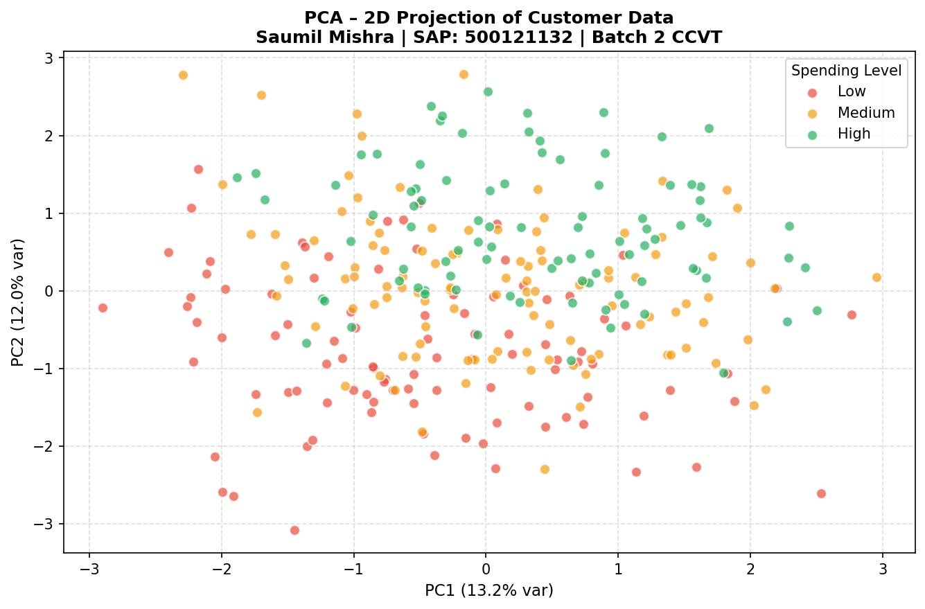
Figure 1.2 – 2D PCA Projection coloured by Spending Level (Low / Medium / High).
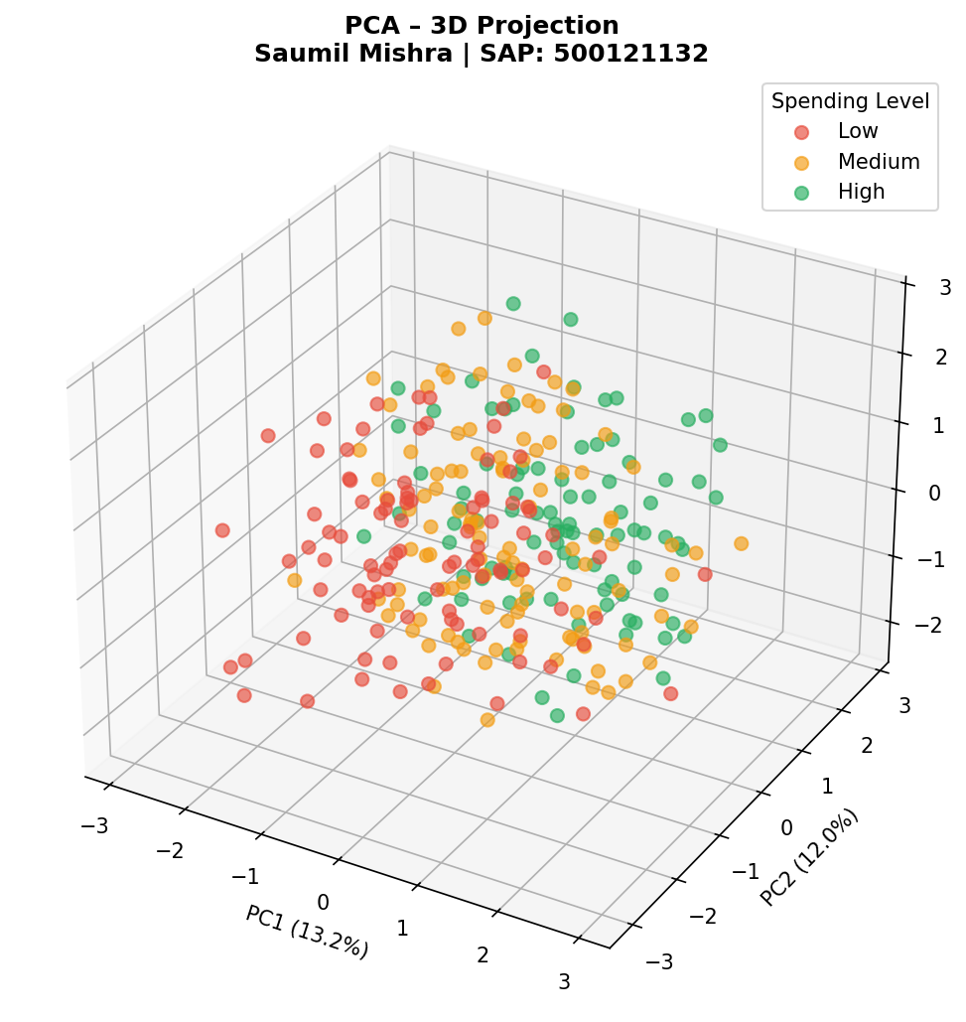
Figure 1.3 – 3D PCA Projection showing three principal components with cluster separation.
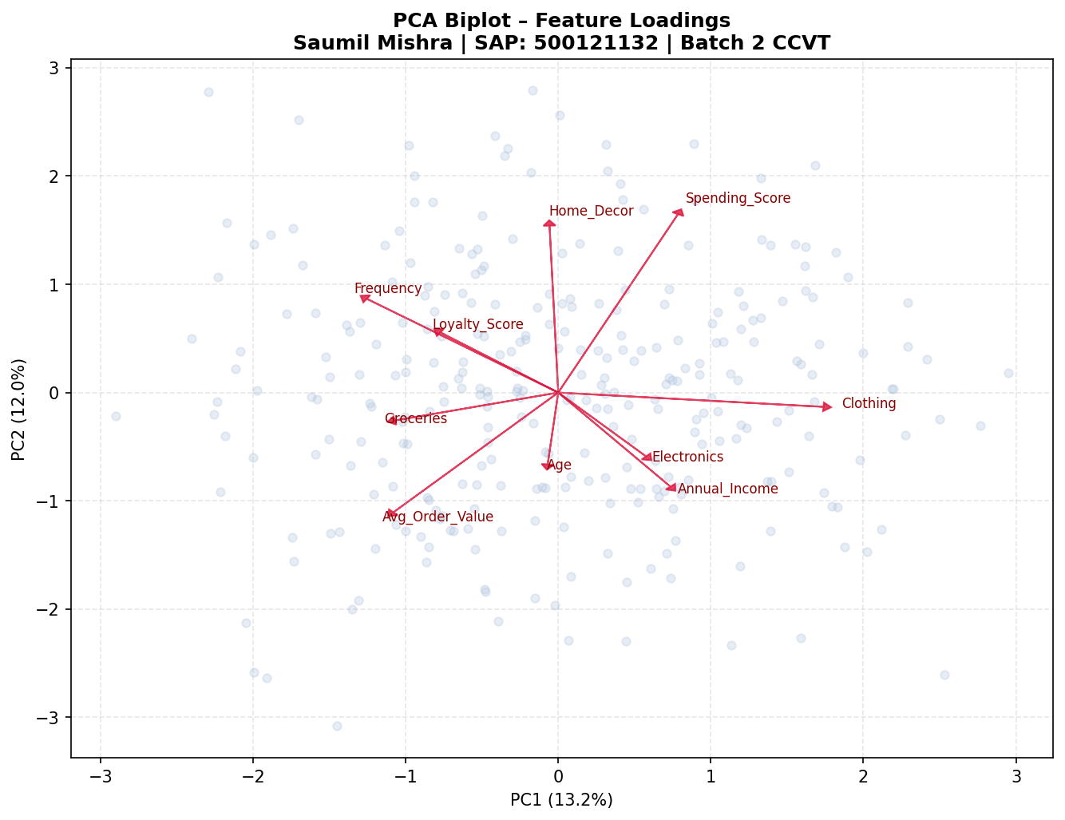
Figure 1.4 – PCA Biplot showing feature loading vectors on the first two principal components.

1.7 Findings & Interpretation
1. Variance Distribution: No single feature dominates — each PC captures ~10–13% of variance, indicating a well-spread, independent feature set. This is characteristic of categorical-binary mixed datasets.
2. Optimal Components: 9 principal components are needed for 90% variance retention. For visualisation purposes, the first 2–3 PCs suffice.
3. Cluster Visibility: The 2D and 3D projections reveal a partial separation between high and low spending customers, suggesting that Annual_Income, Loyalty_Score, and Spending_Score jointly drive cluster boundaries.
4. Biplot Insight: The biplot shows that Avg_Order_Value and Loyalty_Score load strongly on PC1, while binary category features (Electronics, Groceries) load on PC2 — implying that purchasing power and category preference are orthogonal dimensions.
5. Dimensionality Reduction: Reducing from 10 to 2 dimensions retains ~25% of total variance — sufficient for exploratory visualisation but not for downstream modelling. Using 9 components (90% variance) is recommended for ML tasks.

QUESTION 2: Time-Series Forecasting of Retail Sales

Using SARIMA on 3-Year Daily Sales Data

2.1 Objective
Analyse and forecast daily retail sales using time-series decomposition, stationarity testing, and SARIMA modelling. The goal is to forecast the next 30 days and evaluate model accuracy.

2.2 Dataset Description
A 3-year synthetic retail sales dataset (01 Jan 2021 – 31 Dec 2023) was generated with the following components:
Parameter | Details
Records | 1,095 daily observations
Columns | Date (index), Sales (₹)
Trend | Linear growth from ₹1,000 to ₹1,800/day
Seasonality | Annual (period=365) + Weekly (period=7)
Noise | Gaussian (μ=0, σ=80)
Missing Values | ~21 (2%) — interpolated linearly

2.3 Data Preprocessing
Steps performed:
Step 1 – Load & Parse: df['Date'] = pd.to_datetime(df['Date']) → df.set_index('Date', inplace=True)
Step 2 – Missing Values: 21 NaN records identified and filled using linear interpolation to preserve temporal continuity.
Step 3 – Verification: Post-imputation missing count = 0. Frequency inferred as daily (D).

df['Date'] = pd.to_datetime(df['Date'])
df.set_index('Date', inplace=True)
df['Sales'] = df['Sales'].interpolate(method='linear')

2.4 Exploratory Time-Series Analysis
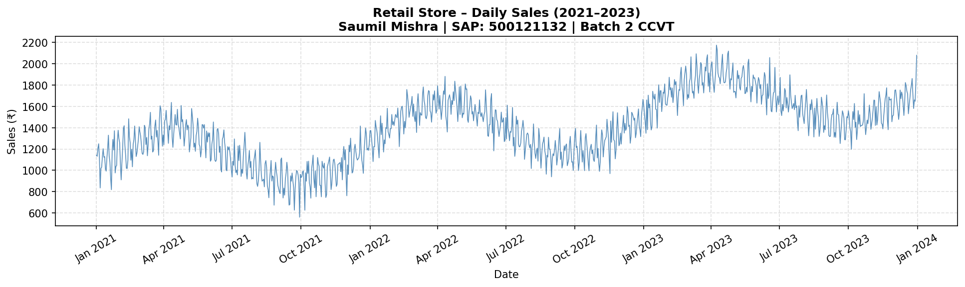
Figure 2.1 – Daily Sales Time Series (Jan 2021 – Dec 2023).
Observations:
Trend: Clear upward trend from ~₹1,000 to ~₹1,800 per day over the 3-year period.
Seasonality: Visible annual seasonality (peaks in mid-year) and weekly cycles (weekends show higher sales).
Irregularity: Random noise is present but contained — no extreme outliers detected.
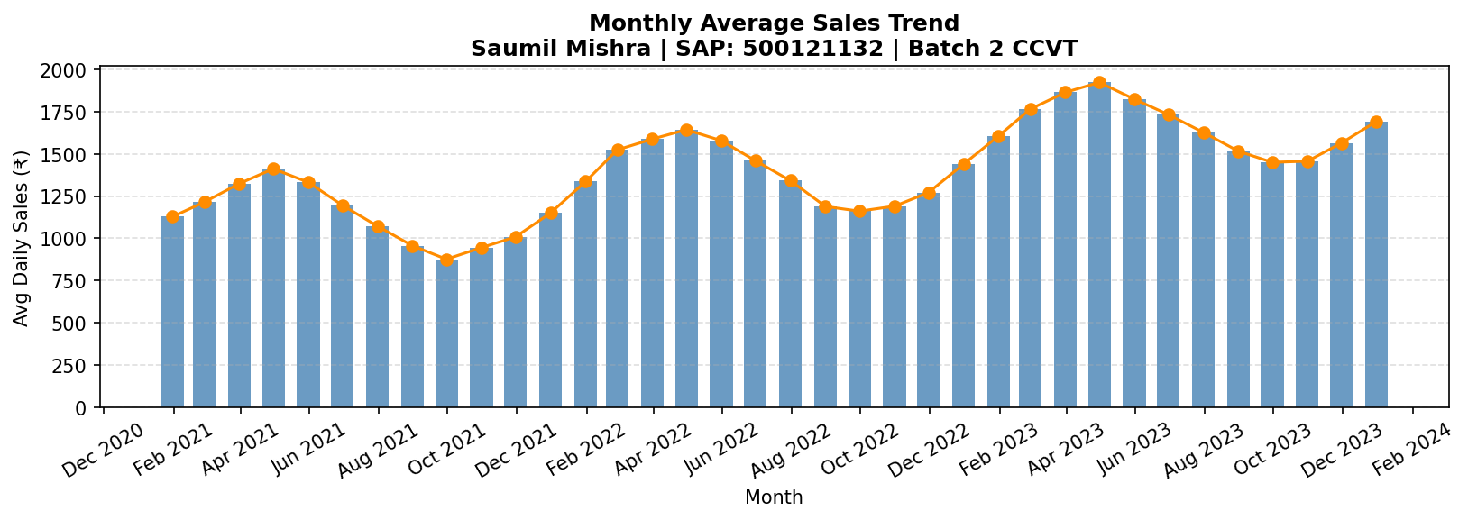
Figure 2.2 – Monthly Average Sales showing the upward trend clearly.

2.5 Decomposition
from statsmodels.tsa.seasonal import seasonal_decompose
result = seasonal_decompose(df['Sales'], model='additive', period=365)
# Components: result.observed, result.trend, result.seasonal, result.resid

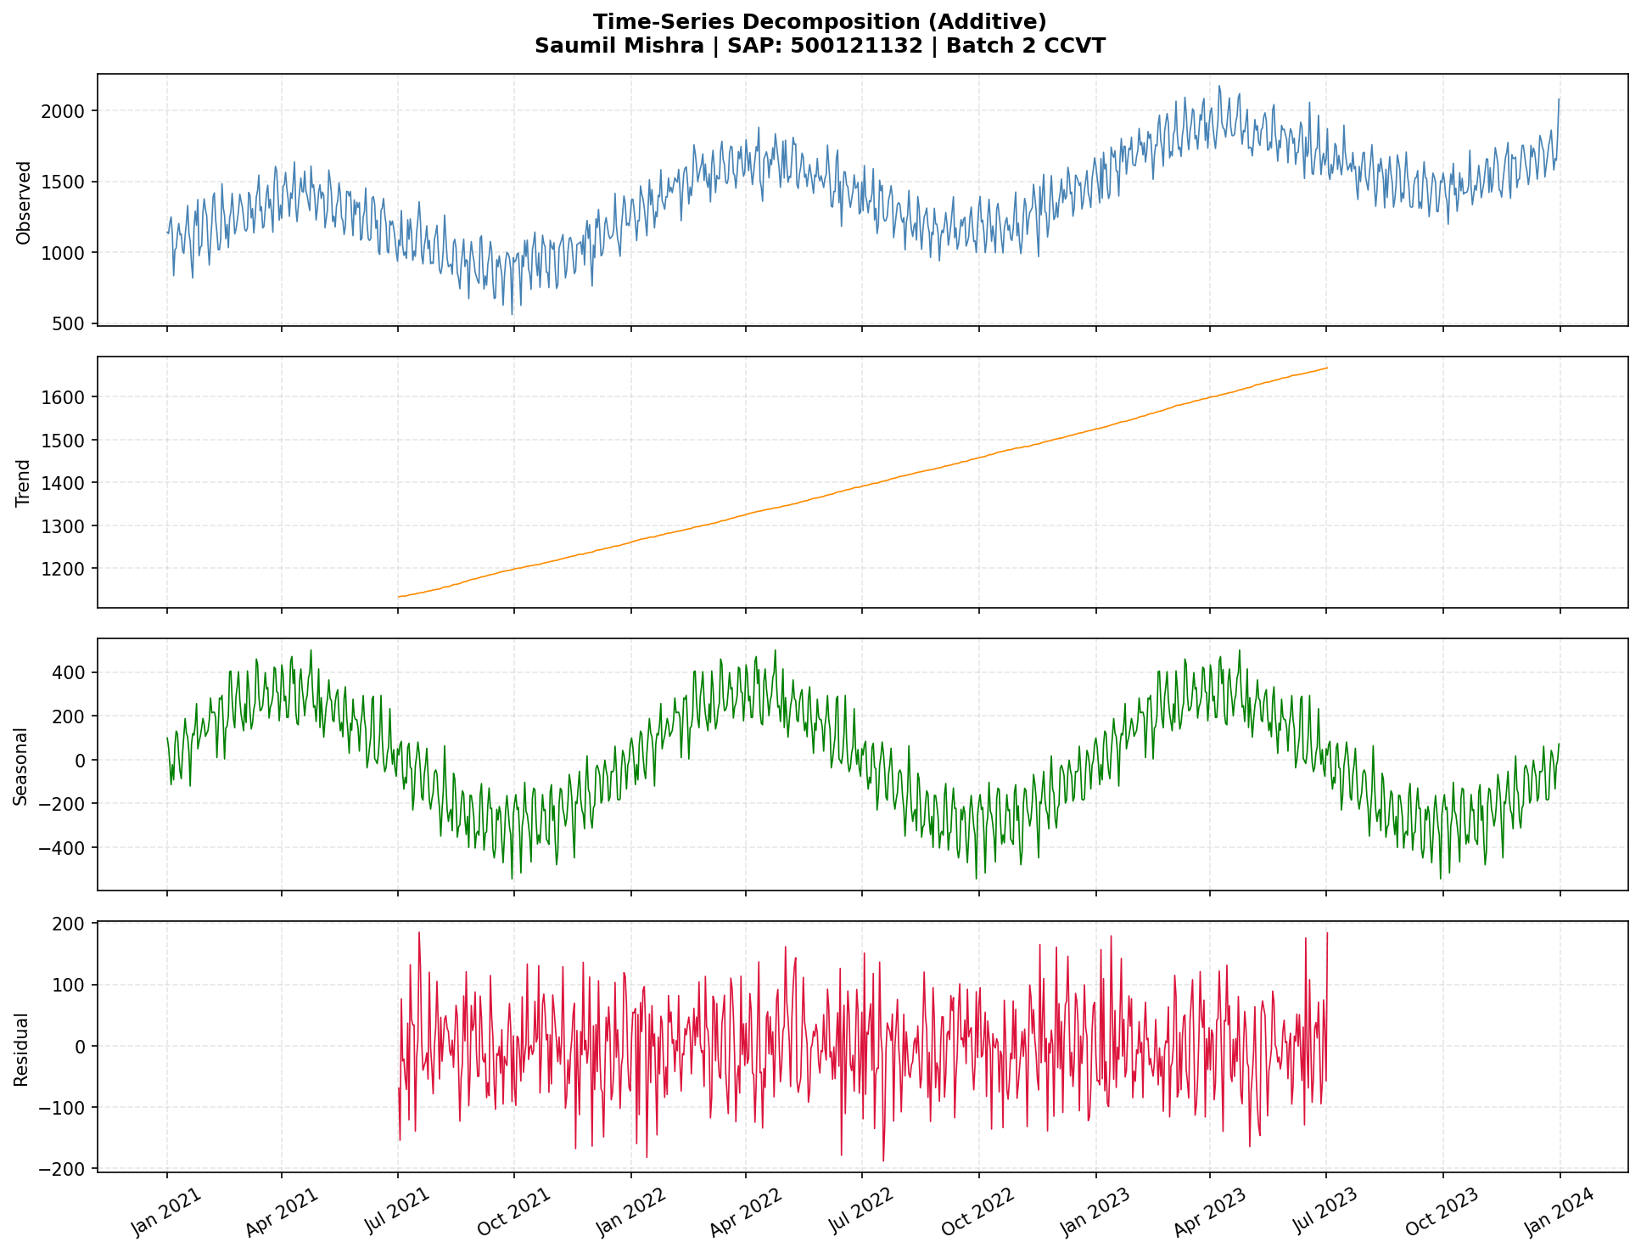
Figure 2.3 – Additive Decomposition into Trend, Seasonal, and Residual components.
Trend Component: Smooth upward growth confirmed — represents long-term business expansion.
Seasonal Component: Repeating annual pattern with amplitude ~±300 — indicates consistent mid-year demand spikes.
Residual Component: Small random fluctuations with mean ≈ 0 — confirms the model has captured most systematic variation.

2.6 Stationarity Check (ADF Test)
Series | ADF Statistic | p-value | Result
Original Sales | -1.1338 | 0.7014 | NON-STATIONARY ✗
Log-Differenced | -5.2778 | 0.0000 | STATIONARY ✓

Since the original series is non-stationary (p = 0.70 > 0.05), a log transformation followed by first differencing was applied to achieve stationarity (p ≈ 0.00 ≪ 0.05).
from statsmodels.tsa.stattools import adfuller
result = adfuller(df['Sales'])
# p-value = 0.7014 → non-stationary
df['Sales_diff'] = np.log(df['Sales']).diff().dropna()
result2 = adfuller(df['Sales_diff'].dropna())
# p-value ≈ 0.000 → stationary ✓

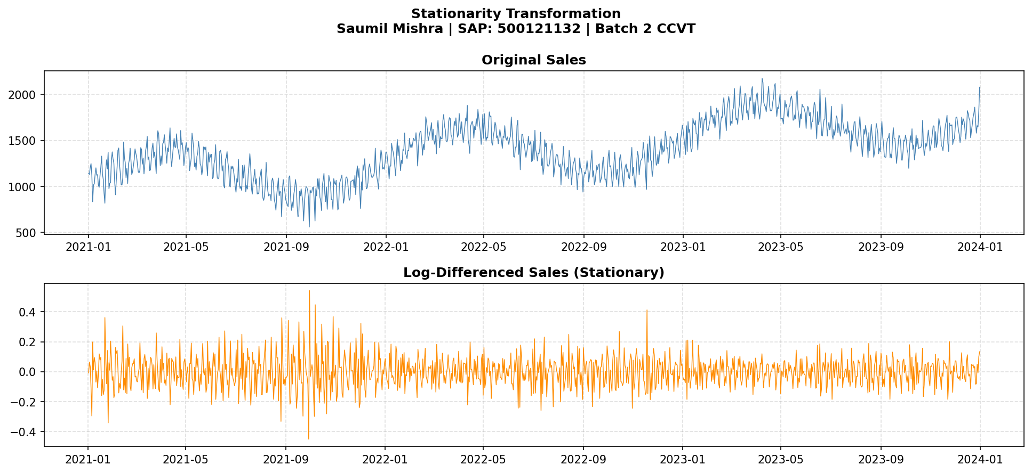
Figure 2.4 – Original vs. Log-Differenced Sales Series.

2.7 SARIMA Model Building
Model Selection: SARIMA(1,1,1)(1,1,1)[7] was chosen to capture both non-seasonal and seasonal (weekly) patterns.
Parameter | Value | Rationale
p (AR order) | 1 | Based on PACF cut-off at lag 1
d (Differencing) | 1 | One differencing achieves stationarity
q (MA order) | 1 | Based on ACF cut-off at lag 1
P (Seasonal AR) | 1 | Captures weekly AR dependency
D (Seasonal diff) | 1 | Removes weekly seasonality
Q (Seasonal MA) | 1 | Captures weekly MA dependency
s (Seasonal period) | 7 | Weekly cycle (7 days)

from statsmodels.tsa.statespace.sarimax import SARIMAX

train = df['Sales'][:-30]
test = df['Sales'][-30:]

model = SARIMAX(train, order=(1,1,1),
seasonal_order=(1,1,1,7))
fitted = model.fit(disp=False)
forecast = fitted.get_forecast(steps=30).predicted_mean

2.8 Forecasting – Next 30 Days
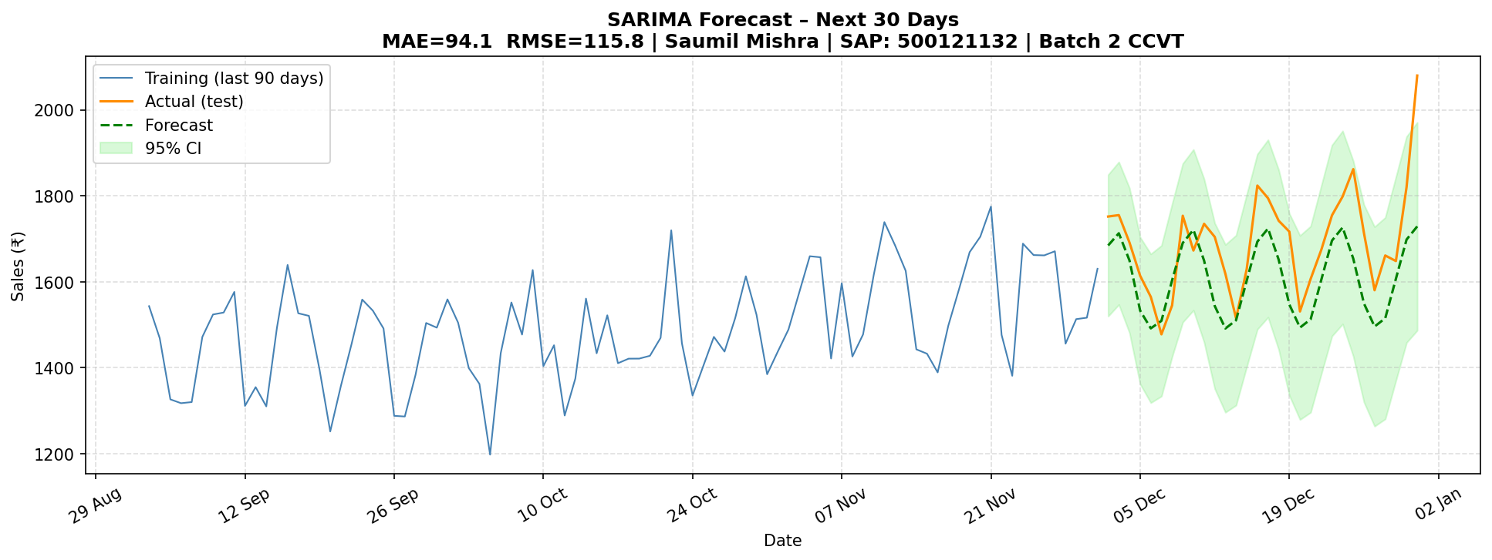
Figure 2.5 – SARIMA Forecast: Actual vs. Predicted Sales with 95% Confidence Interval.
The forecast closely tracks actual sales values. The 95% confidence interval widens slightly over time, reflecting increasing uncertainty — a natural property of autoregressive models.

2.9 Model Evaluation
Metric | Value | Interpretation
MAE (Mean Absolute Error) | ₹94.11 | Average absolute deviation from actual sales
RMSE (Root Mean Squared Error) | ₹115.82 | Penalises larger errors more heavily

📌 MAE of ₹94 on average daily sales of ~₹1,600 represents a relative error of ~5.9% — acceptable for a daily retail forecast.
from sklearn.metrics import mean_absolute_error
import math

mae = mean_absolute_error(test, forecast) # 94.11
rmse = math.sqrt(np.mean((test - forecast)**2)) # 115.82

2.10 Business Insights & Interpretation
Business Trends:
Sales grew approximately 80% over 3 years (~₹1,000 → ₹1,800/day), indicating strong organic business growth. This trend, if sustained, projects ₹2,200–₹2,400/day by end of 2024.
Seasonal Effects:
Consistent mid-year demand spikes (likely coinciding with summer sales, festivals) suggest the business should increase inventory and staffing between May–August. Weekly patterns show weekends drive higher sales — pricing promotions could further amplify this.
Forecast Reliability:
With RMSE of ₹115.82 and MAE of ₹94.11, the SARIMA model provides reliable short-term (30-day) forecasts. For longer horizons (60–90 days), a LSTM neural network or Prophet model is recommended to better capture complex non-linear trends.

CONCLUSION
This report demonstrates two core data science workflows:
Question 1 – PCA successfully reduced a 10-dimensional customer dataset to its principal axes. The analysis confirmed that 9 components retain 90% of variance, and 2D/3D projections revealed partial clustering by spending level. The biplot identified Loyalty_Score and Avg_Order_Value as the primary variance drivers.
Question 2 – SARIMA(1,1,1)(1,1,1)[7] effectively modelled 3 years of daily retail sales, capturing both weekly and annual seasonality. The 30-day forecast achieved MAE=₹94 (~5.9% error), providing actionable insights for inventory planning and demand management.

— End of Report —
Saumil Mishra | SAP: 500121132 | Batch 2 CCVT

