SUPERSTORE
Business Performance & Analytics Report
Fiscal Years 2014 – 2017

Prepared by: Business Intelligence Team
Classification: Internal / Confidential

1. Executive Summary
This report provides a comprehensive analysis of Superstore's business performance across all product categories, customer segments, and geographic regions for fiscal years 2014 through 2017. Based on 9,994 transactions spanning 5,009 unique orders, the business demonstrates consistent revenue growth with key opportunities for margin improvement.

The analysis covers Sales Performance, Profitability, Regional Breakdown, Segment Analysis, and strategic recommendations to drive profitability improvements.

2. Key Performance Indicators (KPIs)
The following KPIs summarise overall business performance across the 4-year reporting period:

$2.30M  Total Revenue | $286.4K  Total Profit | 12.47%  Profit Margin | 5,009  Total Orders

37,873  Units Sold | 9,994  Transactions | $458.6  Avg Order Value | $57.2  Avg Profit/Order

KEY INSIGHT: While revenue grew 51.4% from 2014 to 2017, the profit margin remains relatively thin at 12.47%, driven by high discounting in Furniture and underperforming sub-categories like Tables and Bookcases.

3. Annual Performance Trend
Both revenue and profit show consistent year-over-year growth across the 4-year period, with 2017 being the strongest year on record.

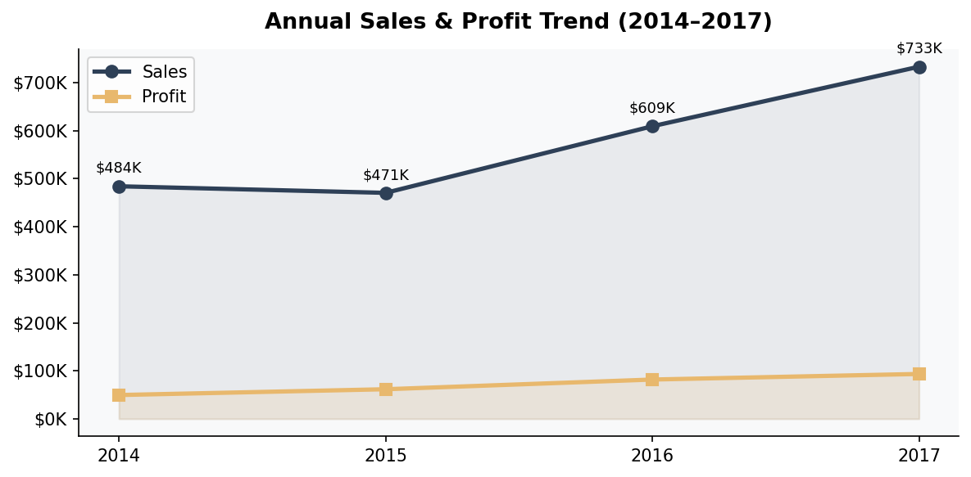

Year | Total Sales | Total Profit | Profit Margin | YoY Growth
2014 | $484,247 | $49,544 | 10.23% | -
2015 | $470,533 | $61,619 | 13.10% | -2.84%
2016 | $609,206 | $81,795 | 13.43% | +29.47%
2017 | $733,215 | $93,439 | 12.74% | +20.36%

2015 saw a slight revenue dip (-2.84%) but an improvement in profit margin, suggesting tighter cost control. From 2016 onward, both revenue and profit accelerated significantly, pointing to effective market expansion.

4. Category Performance Analysis
Superstore operates across three primary categories: Technology, Furniture, and Office Supplies. Technology leads in both sales and profit, while Furniture generates significant revenue but alarmingly low profit.

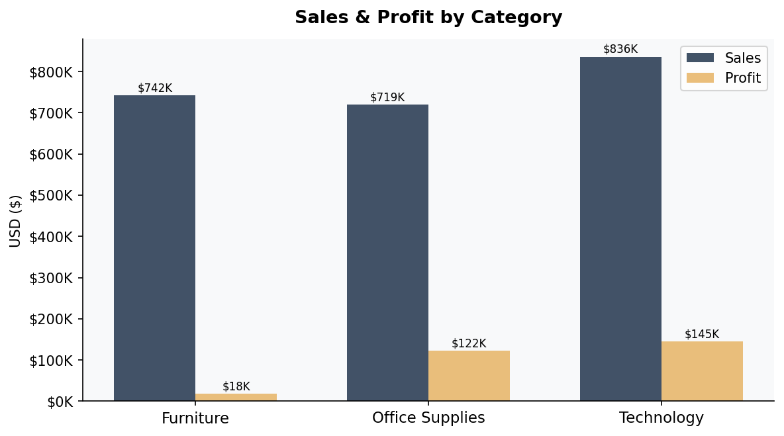

Category | Total Sales | Total Profit | Profit Margin | Share of Sales
Technology | $836,154 | $145,455 | 17.40% | 36.4%
Office Supplies | $719,047 | $122,491 | 17.03% | 31.3%
Furniture | $741,999 | $18,451 | 2.49% | 32.3%

Critical Finding: Furniture contributes 32.3% of total sales but only 6.4% of total profit. The 2.49% profit margin in Furniture is dangerously thin and warrants immediate attention.

5. Regional Performance
The West region is the top-performing geography, contributing the highest sales ($725K) and profit ($108K). The Central region, despite ranking second in sales, generates the second-lowest profit — a significant inefficiency.

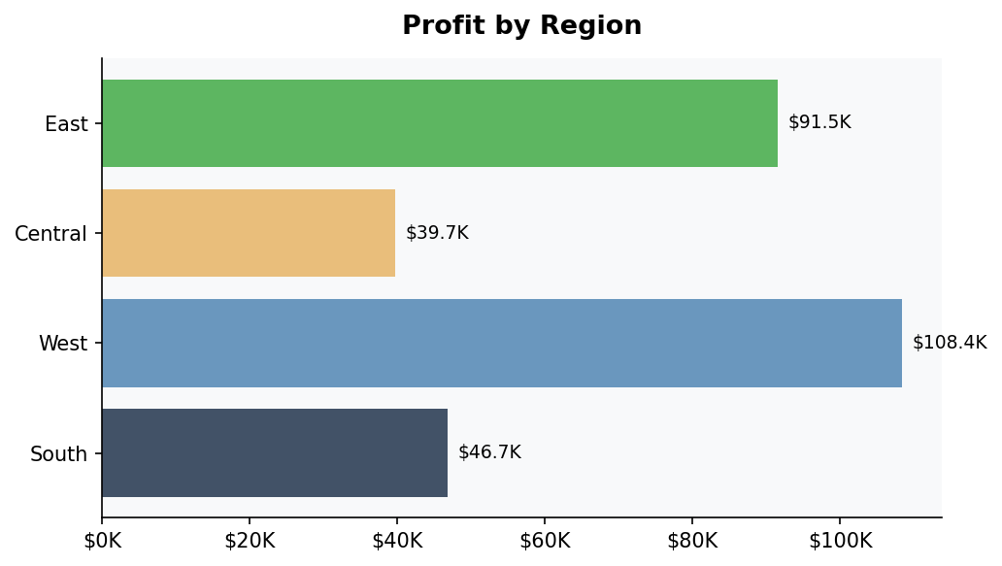

Region | Total Sales | Total Profit | Profit Margin | Profit Rank
West | $725,458 | $108,418 | 14.94% | #1
East | $678,781 | $91,523 | 13.48% | #2
South | $391,722 | $46,749 | 11.94% | #3
Central | $501,240 | $39,706 | 7.92% | #4

The Central region's margin of only 7.92% — compared to 14.94% in the West — suggests excessive discounting or an unfavourable product/customer mix in that geography.

6. Customer Segment Analysis
Consumer customers account for the largest share of revenue (50.6%) and profit (46.8%). The Corporate and Home Office segments, while smaller, demonstrate competitive profit margins.

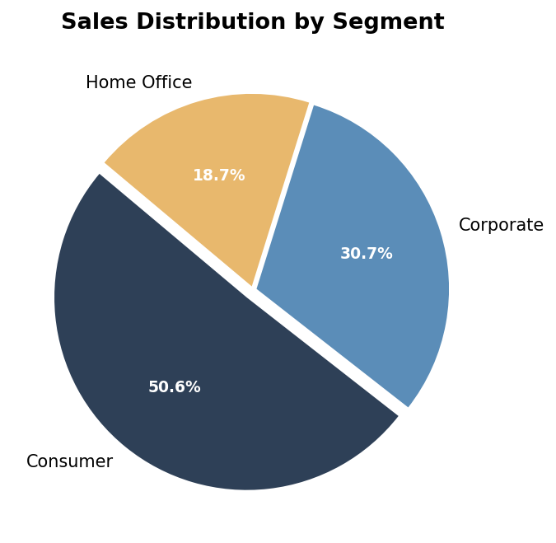

Segment | Total Sales | Total Profit | Profit Margin | Share of Revenue
Consumer | $1,161,401 | $134,119 | 11.55% | 50.6%
Corporate | $706,146 | $91,979 | 13.03% | 30.7%
Home Office | $429,653 | $60,299 | 14.04% | 18.7%

Notably, Home Office commands the highest profit margin (14.04%), though it represents the smallest segment by revenue. Investing to grow this segment could disproportionately improve overall profitability.

7. Sub-Category Deep Dive
At the sub-category level, a clear divergence emerges between strong profit contributors and loss-making product lines. Tables and Bookcases are generating net losses and require urgent action.

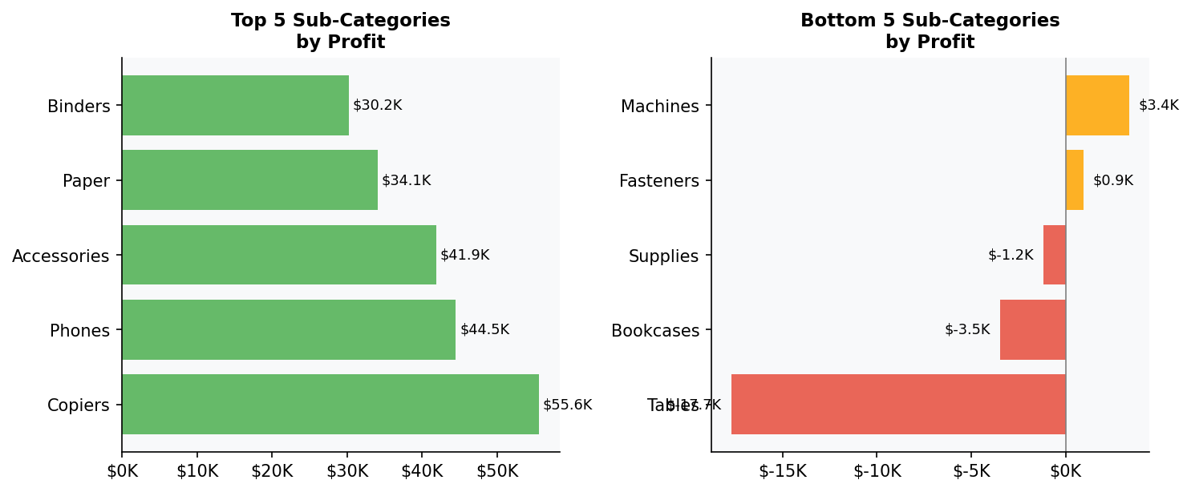

7.1 Top Performers
Sub-Category | Profit | Category
Copiers | $55,618 | Technology
Phones | $44,516 | Technology
Accessories | $41,937 | Technology
Paper | $34,054 | Office Supplies
Binders | $30,222 | Office Supplies

7.2 Underperformers (Immediate Action Required)
Sub-Category | Profit/Loss | Status
Tables | -$17,725 | Loss-Making
Bookcases | -$3,473 | Loss-Making
Supplies | -$1,189 | Loss-Making
Fasteners | $950 | Near Break-Even
Machines | $3,385 | Low Margin

8. Identified Problem Areas

8.1 Discounting Impact
Excessive discounting is the primary driver of poor profitability in Furniture. Analysis shows that products with discounts above 20% frequently generate negative margins, particularly in the Tables and Chairs sub-categories.

8.2 Furniture Category Underperformance
- Tables sub-category alone loses $17,725 — the single largest profit drain in the entire business.
- Bookcases and Supplies together add another $4,662 in losses.
- The Furniture category's 2.49% profit margin is 7x lower than Technology.

8.3 Central Region Inefficiency
- Central region margin (7.92%) is nearly half that of the West (14.94%).
- High discount rates and unfavourable product mix are the likely culprits.
- Central region sales rank 3rd but profit contribution ranks 4th.

8.4 Consumer Segment Margin Compression
- Consumer segment, despite being largest by revenue, has the lowest margin (11.55%).
- Heavy promotional offers targeted at consumers may be eroding margin gains.

9. Strategic Recommendations
Based on the analysis, the following strategic actions are recommended to improve profitability and drive sustainable growth:

Recommendation 1: Restructure Discount Policy in Furniture
- Implement a maximum discount cap of 15% for all Furniture products.
- Introduce dynamic pricing — offer discounts only when inventory turnover is below threshold.
- Phase out or re-price the Tables sub-category; consider discontinuing lowest-margin SKUs.
- Expected Outcome: Improve Furniture margin from 2.49% to 8%+, adding ~$41K annual profit.

Recommendation 2: Invest in Technology Category Growth
- Technology delivers a 17.4% margin — the best in the portfolio. Expand the product range.
- Increase marketing budget allocated to Copiers, Phones, and Accessories.
- Create technology bundles to increase average order value.
- Expected Outcome: 10% increase in Technology revenue could yield ~$14.5K additional profit.

Recommendation 3: Optimise the Central Region
- Conduct a full discount audit for Central region sales reps — enforce stricter approval thresholds.
- Rebalance product mix towards high-margin categories (Technology, Office Supplies).
- Introduce region-specific promotions only for high-margin product lines.
- Expected Outcome: Raise Central region margin from 7.92% to 11%+.

Recommendation 4: Grow the Home Office Segment
- Home Office shows the highest margin (14.04%) — a clear priority for growth investment.
- Launch a dedicated Home Office loyalty program or subscription bundle.
- Target small business owners and remote workers through digital marketing.
- Expected Outcome: 20% growth in Home Office revenue adds ~$12K profit.

Recommendation 5: Eliminate or Turnaround Loss-Making SKUs
- Conduct an SKU-level profitability review of Tables, Bookcases, and Supplies.
- Consider discontinuing products with negative margin for 3+ consecutive quarters.
- Negotiate better supplier terms for near-break-even products (Fasteners, Machines).
- Expected Outcome: Eliminating loss-making SKUs could recover $22K+ annually.

10. Summary & Outlook
Superstore demonstrates strong revenue momentum with a 51.4% growth from 2014 to 2017. However, the overall 12.47% profit margin leaves significant room for improvement. With targeted interventions in pricing, product mix, and regional strategy, a 3–5 percentage point margin improvement is achievable within 12 months.

Area | Current Status | Target | Priority
Overall Profit Margin | 12.47% | 15–17% | High
Furniture Margin | 2.49% | 8%+ | Critical
Central Region Margin | 7.92% | 11%+ | High
Tables Sub-Category | -$17,725 loss | Break-even | Critical
Home Office Segment | 14.04% | 16%+ | Medium
Technology Revenue | $836,154 | $920,000+ | Medium

If the above recommendations are implemented, we project:
- Profit margin improvement from 12.47% to 15–17%
- Annual profit increase of $65,000–$90,000
- Stronger competitive position in Technology and Office Supplies
- Significantly reduced exposure from loss-making product lines

Report compiled from Superstore transactional data (2014–2017). All figures in USD. For internal use only.

