**BEEE EXPERIMENTS LAB FILE**

Experiment 0: Breadboard, connections and Multimeter .

Images:

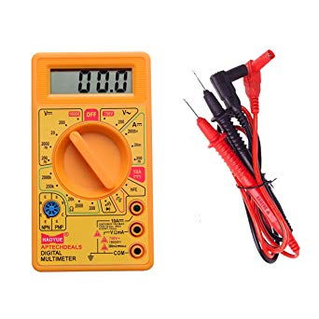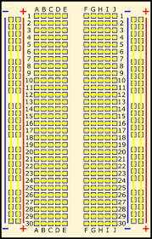

**THEORY**

**CONCEPTS USED:**

1. Connection of multiple wires to breadboard.
2. Using a rectangular board with holes in it to make connections and circuits. It is also known as breadboard.
3. The use of multimeter.
4. Parallel and series connections of resistances.
5. The proper usage of ohm's law.
6. Different purposes of Multimeter.

**LEARNING AND OBSERVATIONS:**

1. Not using resistances can damage the circuits by excessive flow of current.
2. Breadboard connections are very useful in making circuits as they provide a platform for wire connections and other component connections.
3. Breadboard connections can get shorted if the circuit is not proper.
4. A multimeter can be used to check circuit breaks.
5. A multimeter can be used to find the resistance across two terminals.
6. A multimeter can be used to find the voltage across two terminals.
7. A multimeter can be used to find the current across two terminals.

**PROBLEMS AND TROUBLESHOOTING:**

1. Breadboard connections were shorted and were discovered using the multimeter and then correcting the circuit.
2. Loose connections on the breadboard can lead to an open circuit. Problem recognized using multimeter.
3. Using inappropriate multimeter range to measure a resistance. Problem was solved by choosing a different range on the multimeter.

**PRECAUTIONS:**

1. The workplace are should be dry and not in close proximity to water.
2. Make sure the multimeter is not broken/ non functional.
3. Breadboard connections should not be short circuited.
4. Make sure the connections are appropriate and there is no loose connection.
5. Be careful while working with electrical equipment.

**LEARNING OUTCOMES:**

1. The use of breadboard for making connections.
2. The use of multimeter to find the voltage across two terminals.
3. Finding the value of resistance using multimeter.
4. Series and parallel connection of resistors.
5. Using multimeter to see if the circuit is closed or not.
6. I now have appropriate knowledge about breadboard and multimeter.
7. I now have appropriate knowledge about wiring and connections.