EduPredict
Student Academic Risk Analyzer
PROJECT TYPE | AI/ML
STUDENT | Saumya Sopan Bari
REGISTRATION NO. | 25MIM10064
UNIVERSITY | VIT Bhopal University
PROGRAM | Integrated M.Tech - Artificial Intelligence / AI & ML
REPORT DATE | 18 September 2026
PROJECT VERSION | Final Submission Report
Project objective: identify academic risk levels using measurable academic and lifestyle indicators, support early intervention, and demonstrate a complete, testable machine-learning workflow.

Contents
- Introduction
- Problem Statement
- Functional Requirements
- Non-functional Requirements
- System Architecture
- Design Diagrams
- Design Decisions & Rationale
- Implementation Details
- Screenshots / Results
- Testing Approach
- Challenges & Limitations
- Learnings & Key Takeaways
- Future Enhancements
- References

2. Introduction
EduPredict is an AI/ML-based Student Academic Risk Analyzer developed as a command-line-first project. Its purpose is to transform a small set of measurable student indicators into an academic risk category: Low, Medium, or High. The system combines data generation, validation, preprocessing, Random Forest classification, prediction, analytics, recommendation rules, metrics reporting, and automated tests in a modular Python project.
The project is designed as an academic demonstration of a complete machine-learning lifecycle rather than as a clinical or institutional decision system. It emphasizes reproducibility, clean separation of responsibilities, command-line execution, input validation, saved model artifacts, and documented testing.
The final local execution used 600 generated records and a stratified 80/20 train-test split, resulting in 120 test rows.
The reported final-run metrics were 94.17% accuracy, 93.54% weighted precision, 94.17% weighted recall, and 93.84% weighted F1-score. These values apply to the synthetic dataset used by this project and should not be interpreted as general real-world performance.

3. Problem Statement
Students can experience academic difficulty because of interacting factors such as attendance, study habits, assignment completion, internal assessment performance, previous GPA, sleep patterns, and academic backlogs. When these factors are reviewed only informally, early warning signs can be difficult to consolidate into a repeatable analysis.
The problem addressed by EduPredict is therefore: How can a simple machine-learning pipeline use structured academic and lifestyle indicators to classify a student into an academic risk level and produce actionable recommendations?
The project focuses on demonstrating the technical solution to this classification problem using reproducible synthetic data, not on replacing faculty judgment or making high-stakes decisions about individual students.

4. Functional Requirements
ID | Requirement | Expected Output
FR-01 | Generate a reproducible dataset of student records. | CSV dataset with 600 rows and 8 columns.
FR-02 | Load and validate required dataset columns. | Validated dataframe or clear error message.
FR-03 | Split data for model training and testing. | 80/20 stratified train-test split.
FR-04 | Train the Random Forest classifier. | Saved model artifact in models/.
FR-05 | Predict student academic risk. | Low / Medium / High plus confidence.
FR-06 | Generate rule-based recommendations. | Action suggestions based on input conditions.
FR-07 | Analyze dataset and feature importance. | Summary statistics and model feature importance.
FR-08 | Report evaluation metrics. | Accuracy, weighted precision/recall/F1, test-row count.
FR-09 | Run automated tests. | Pytest pass/fail status.

5. Non-functional Requirements
Quality Attribute | Implementation in EduPredict
Performance | Lightweight tabular model and CLI execution suitable for a small academic dataset.
Security / Privacy | Uses synthetic data; no personally identifying student records are required.
Quality Attribute | Implementation in EduPredict
Usability | CLI commands are simple, documented, and executable from a standard terminal.
Reliability | Fixed random seeds, explicit file checks, validation, and saved artifacts improve repeatability.
Maintainability | Responsibilities are separated into multiple Python modules instead of one monolithic file.
Portability | Uses Python, CSV, joblib, pandas, NumPy, scikit-learn, and pytest without a web server dependency.
Scalability | The modular pipeline can be extended to larger tabular datasets and additional model components.
Error Handling | Missing files, missing columns, and invalid numeric ranges raise clear errors.
Testability | Core validation, dataset generation, and recommendation logic are covered by automated tests
Observability | Console output and metrics.json provide visible execution status and evaluation evidence.
.

6. System Architecture
EduPredict follows a modular layered design. The command-line interface dispatches user commands to application services. Dataset generation and loading form the data layer; preprocessing and Random Forest training form the ML layer; prediction and recommendation modules provide decision outputs; analytics and reporting expose summaries and evaluation results. Saved artifacts are stored under data/ and models/.
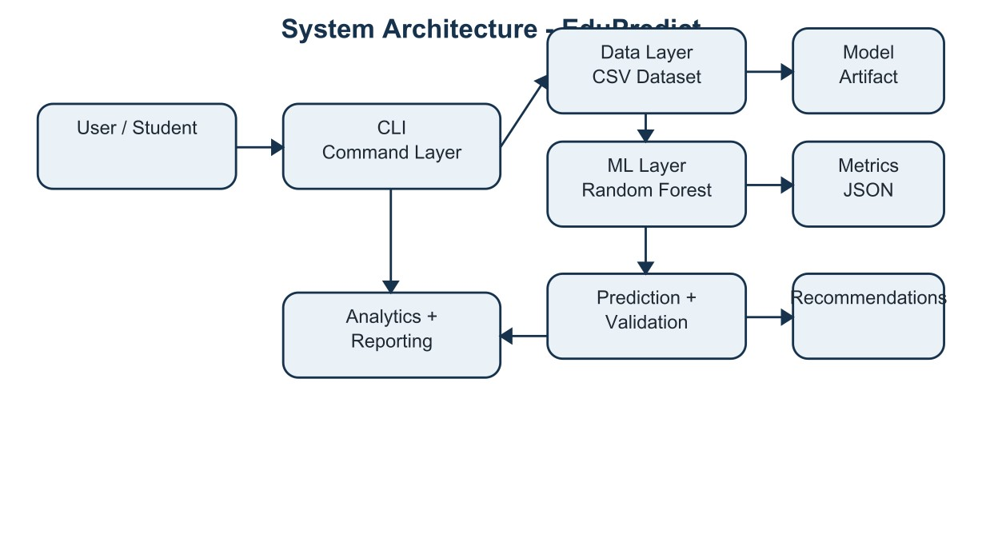
Figure 1. High-level architecture showing CLI, data, ML, prediction, analytics, and reporting components.

7. Design Diagrams
The following diagrams document system behavior and structure. The ER-style diagram is included because the project persists structured records in a CSV file, although it does not use a relational database.

6.1 Use Case Diagram
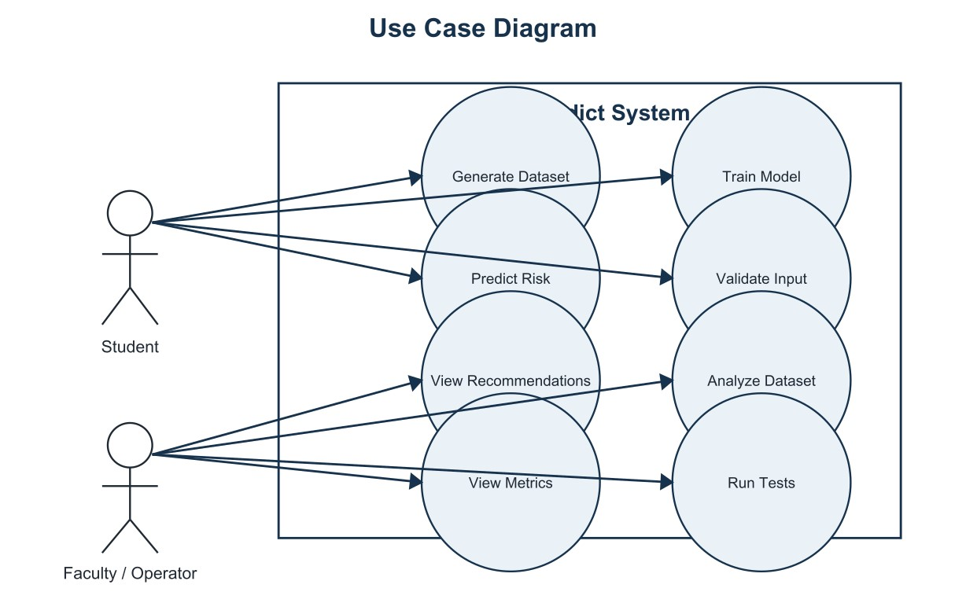
Figure 2. Use cases for the Student / Operator and EduPredict system.

6.2 Workflow Diagram
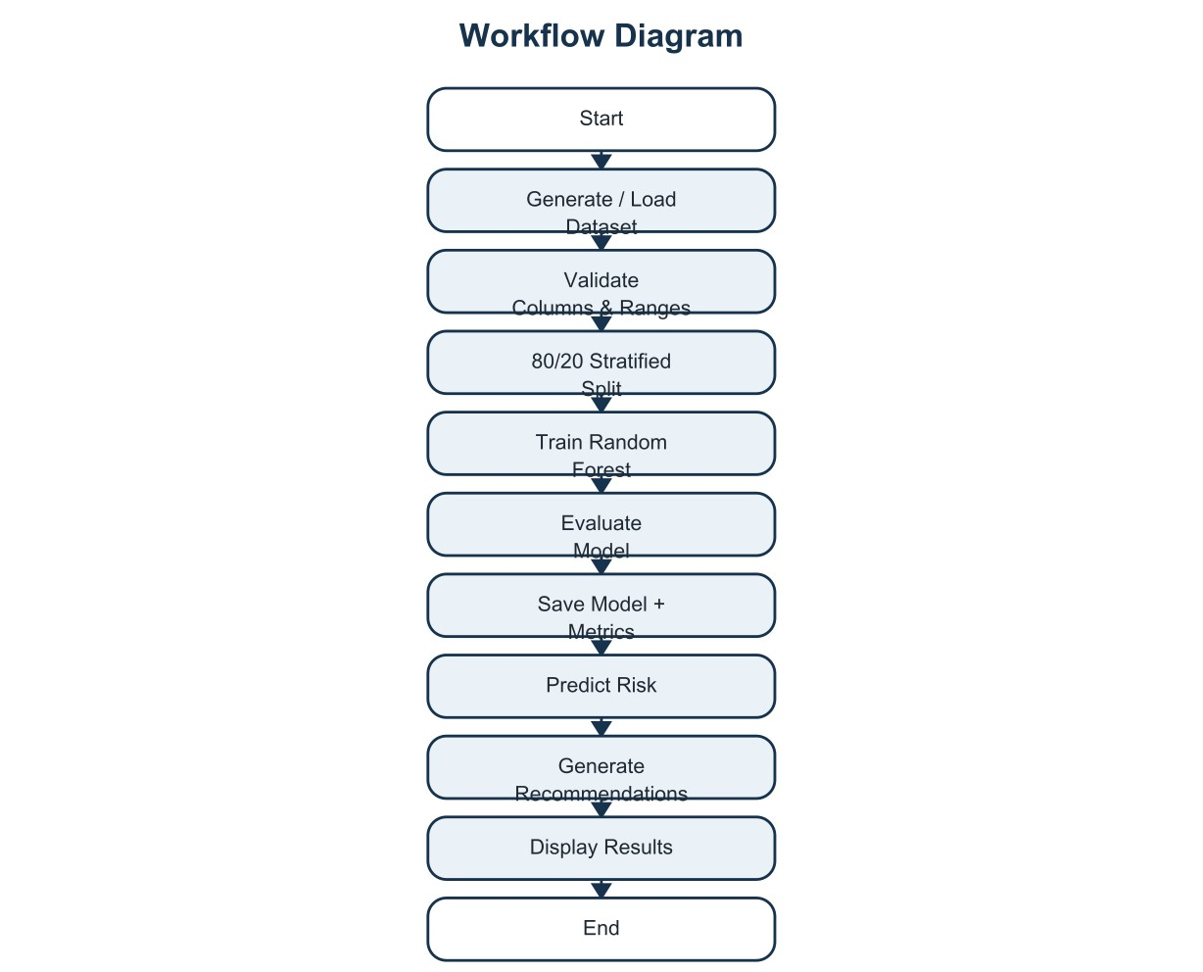
Figure 3. End-to-end workflow from data generation to evaluation and recommendations.

6.3 Sequence Diagram
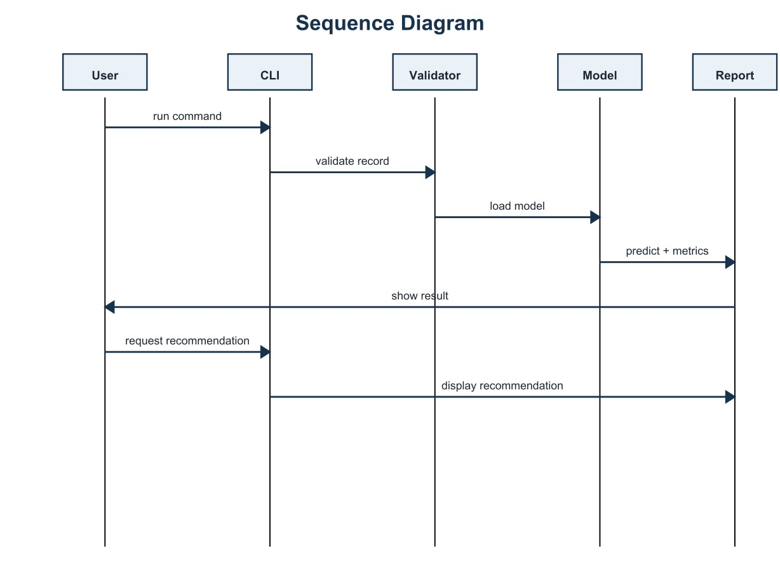
Figure 4. Command execution sequence between user, CLI, validator, model, and reporting components.

6.4 Class / Component Diagram
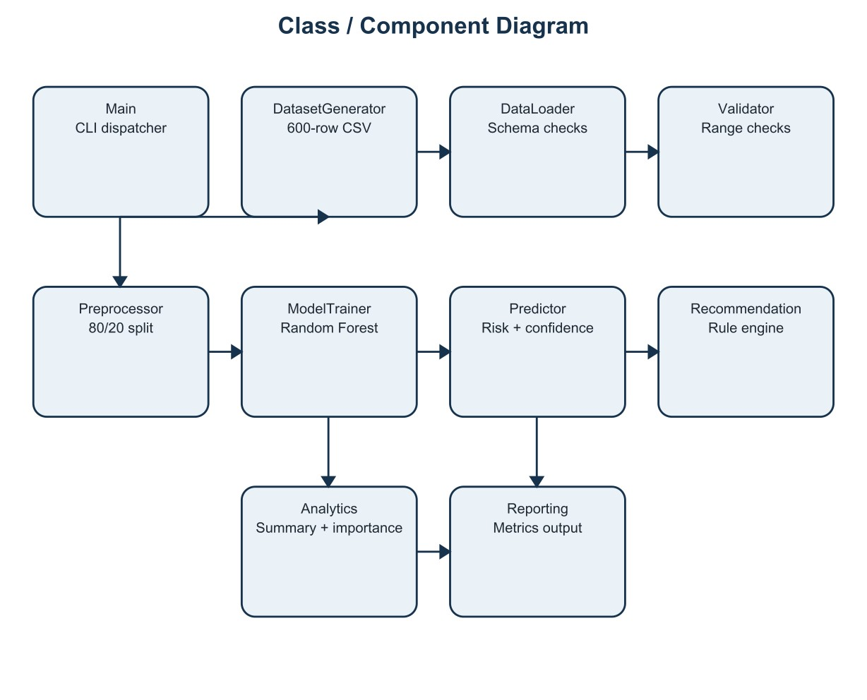
Figure 5. Main Python components and their responsibilities.

6.5 ER Diagram / Logical Storage Schema
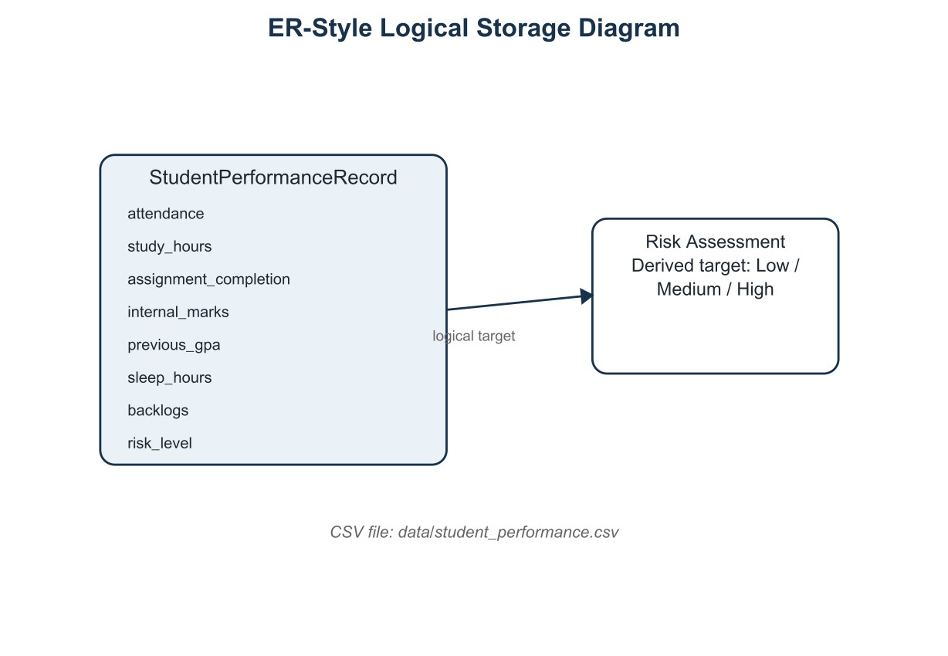
Figure 6. Logical ER-style view of the CSV record and risk target. This represents storage structure rather than a relational database with foreign keys.

8. Design Decisions & Rationale
Decision | Rationale
CLI-first application | Meets command-line execution requirements and provides an easy reproducible demonstration.
Synthetic reproducible dataset | Avoids privacy concerns and makes the project runnable without external data access.
Random Forest classifier | Suitable for nonlinear tabular relationships and provides feature importance for interpretation.
80/20 stratified split | Preserves class proportions between training and testing subsets.
class_weight="balanced" | Helps the classifier account for the strong class imbalance in the generated target.
Fixed random_state=42 | Improves reproducibility of dataset generation, splitting, and model training.
Modular source files | Separates concerns and makes maintenance, testing, and extension easier.
CSV storage | Portable and sufficient for a prototype with simple structured records.
Saved model + metrics | Allows the trained artifact and evaluation evidence to be reused after training.

9. Implementation Details
Technology stack. Python is used for the full implementation. pandas handles tabular data, NumPy is available for numerical operations, scikit-learn provides the machine-learning pipeline, joblib stores the trained model, and pytest provides automated testing.
Dataset schema. The model uses seven input features: attendance, study_hours, assignment_completion, internal_marks, previous_gpa, sleep_hours, and backlogs. The target is risk_level with values Low, Medium, and High. The final dataset contains 600 records and 8 columns.
RandomForestClassifier( n_estimators=250, max_depth=8, min_samples_leaf=3, class_weight="balanced", random_state=42 )
Preprocessing and evaluation. The source code selects the seven model features, separates the risk target, and uses an 80/20 stratified train-test split with random_state=42. Evaluation reports accuracy, weighted precision, weighted recall, weighted F1-score, and the number of test rows. The trained model is stored as models/risk_model.joblib and metrics as models/metrics.json.
Module / File | Responsibility
src/config.py | Central paths, feature names, and target definition.
src/generate_dataset.py | Creates the reproducible 600-row synthetic dataset.
src/data_loader.py | Loads CSV and checks required columns.
src/validator.py | Checks input presence, numeric types, and valid ranges.
src/preprocessor.py | Builds the stratified train-test split.
src/model.py | Trains, evaluates, saves, and loads the Random Forest model.
src/predictor.py | Validates input and returns risk plus confidence.
src/recommendation.py | Generates rule-based recommendations.
src/analytics.py | Produces dataset summary and feature importance.
src/reporting.py | Reads and prints stored evaluation metrics.
src/main.py | CLI entry point and end-to-end demo orchestration.
tests/* | Automated tests for dataset, validation, and recommendations.
Main execution commands.
python -m src.generate_dataset python -m src.main train python -m src.main predict python -m src.main analyze python -m src.main metrics python -m src.main demo python -m pytest -q

10. Screenshots / Results
The project was executed successfully from a Python virtual environment. The evidence panels below reproduce the final verified terminal output supplied during local testing. They are paired with result charts so the report contains both execution evidence and quantitative results.
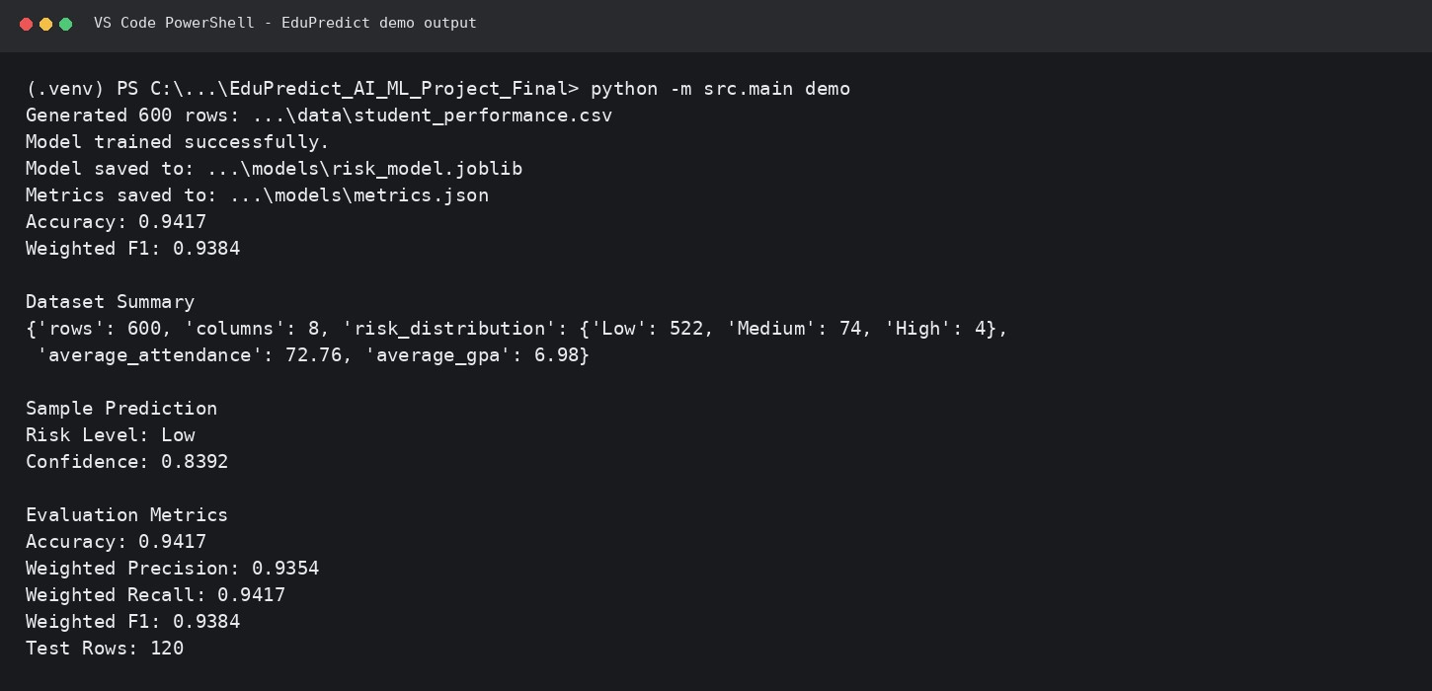
Figure 7. Recreated final demo output from the verified local execution.
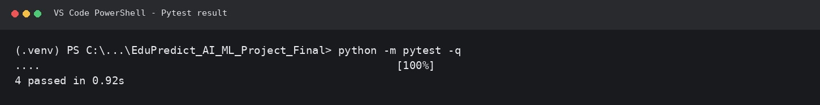
Figure 8. Recreated pytest output showing four passing automated tests.

Dataset Results
The generated dataset contains 600 records. The observed risk distribution is highly imbalanced: 522 Low-risk, 74 Medium-risk, and 4 High-risk records. Average attendance is 72.76% and average previous GPA is 6.98.
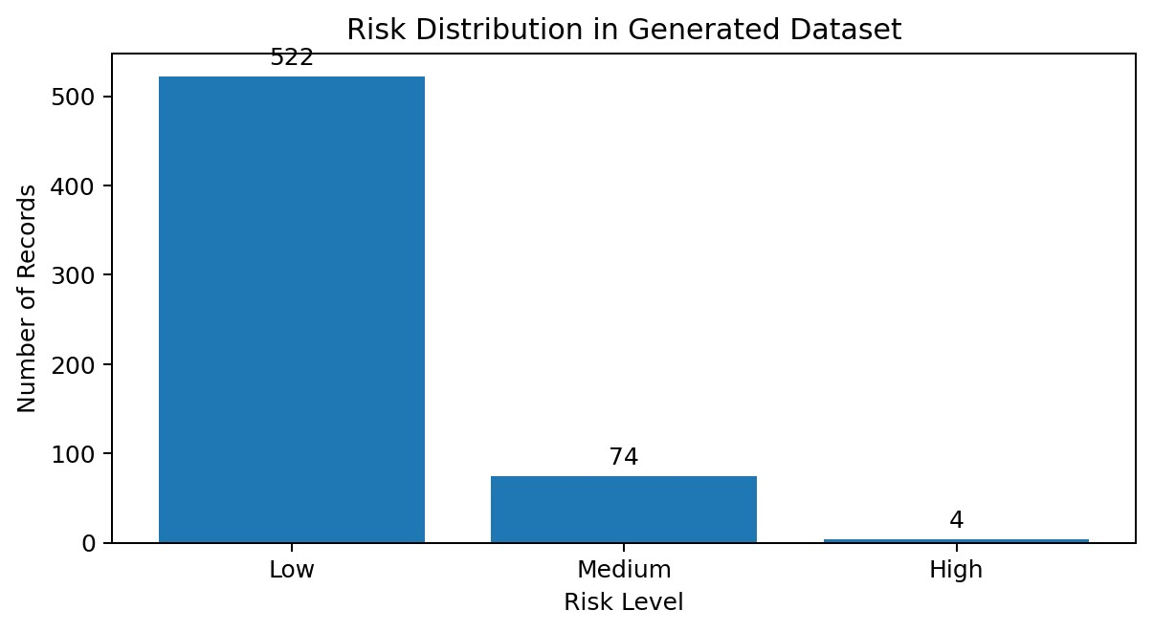
Figure 9. Distribution of the generated target classes.

Model Evaluation Results
Metric | Final Run
Accuracy | 0.9417 (94.17%)
Weighted Precision | 0.9354 (93.54%)
Weighted Recall | 0.9417 (94.17%)
Metric | Final Run
Weighted F1 | 0.9384 (93.84%)
Test Rows | 120
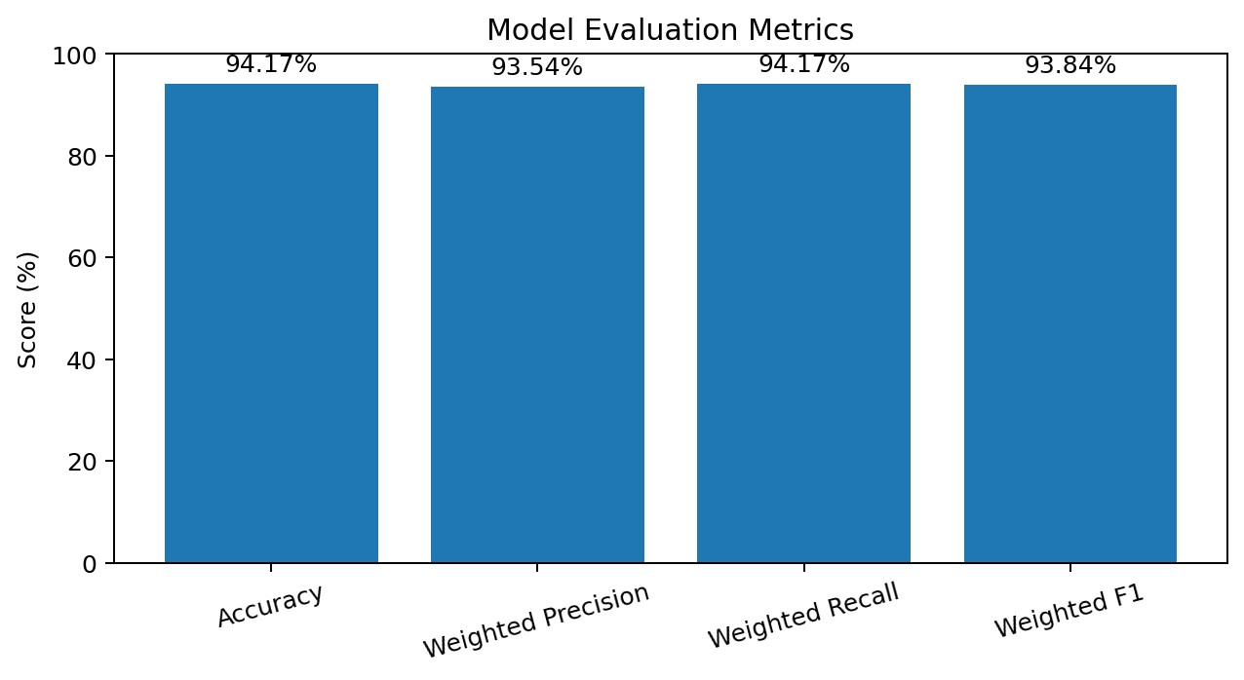
Figure 10. Final-run evaluation scores reported by the project terminal output.

Feature Importance and Sample Prediction
The final terminal output reported previous_gpa, internal_marks, backlogs, attendance, sleep_hours, and assignment_completion among the highest printed feature-importance values. The project source defines seven model inputs, including study_hours; no unreported importance value is invented in this report.
Reported Feature | Importance
previous_gpa | 0.2733
internal_marks | 0.1697
backlogs | 0.1432
attendance | 0.0840
sleep_hours | 0.0424
assignment_completion | 0.0319
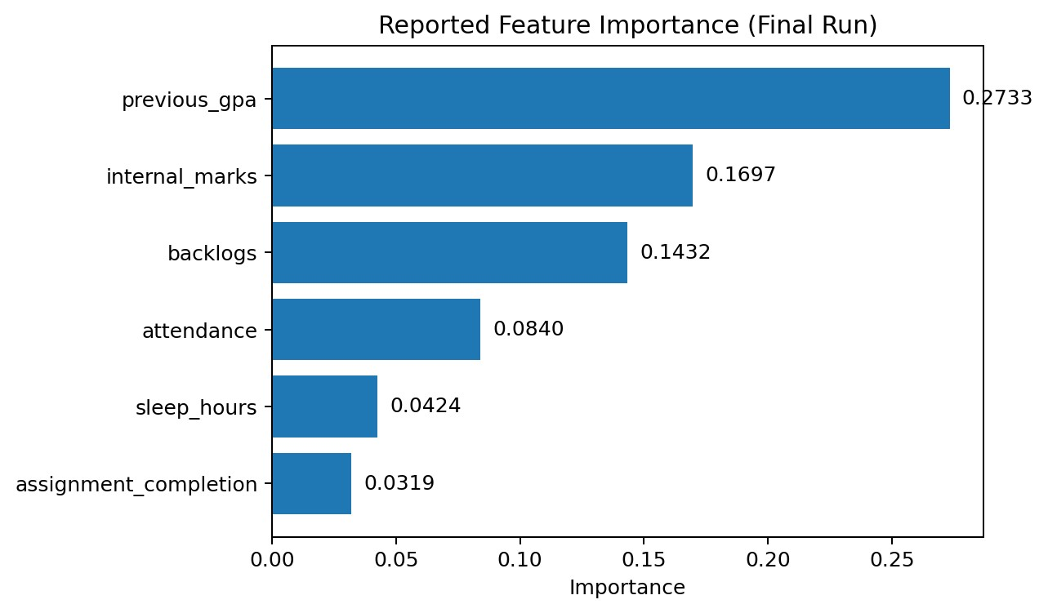
Figure 11. Reported feature importance values from the final terminal output.
The sample prediction in the verified demo was Low risk with 0.8392 confidence. The rule-based recommendation engine returned six maintenance/action suggestions based on the sample record.

11. Testing Approach
Testing combines module-level automated tests with an end-to-end command-line demonstration. Pytest is configured to discover tests from the tests/ directory while allowing the src package to be imported from the project root.
Test Area | Purpose | Final Result
Dataset generation | Confirm reproducible generation and expected required columns. | Passed
Validation | Check required numeric ranges and invalid input handling. | Passed
Recommendation logic | Confirm recommendations are returned for relevant conditions. | Passed
End-to-end demo | Generate data, train model, analyze, predict, and report metrics. | Passed
Final automated test result: 4 passed in 0.92 seconds in the verified local execution. Execution time is environment-dependent and is reported only as an observation from that run.

12. Challenges & Limitations
- The dataset is synthetic and generated by a rule-based score, so the target labels are not equivalent to labelscollected from real academic outcomes.
- The final generated target is highly imbalanced, especially for the High-risk class (4 of 600 records). This limits howconfidently the model can be interpreted for rare high-risk cases.
- The current prototype uses CSV storage rather than a database and has no web dashboard or authentication layer.
- The final report uses verified terminal output supplied during local testing. A native IDE screenshot is still preferablewhen an evaluator explicitly requires photographic screenshot evidence.

13. Learnings & Key Takeaways
- A machine-learning project needs more than a trained model; reproducible data preparation, validation, evaluation,artifact storage, and testing are equally important.
- Modular design makes it easier to identify responsibilities and isolate faults. The project separates data loading,validation, preprocessing, model training, prediction, analytics, recommendations, and reporting.
- Class imbalance can make raw accuracy look stronger than the practical picture. Weighted precision, recall, and F1provide additional context, while the synthetic target distribution remains an important limitation.
- Command-line execution improves reproducibility because setup and execution steps can be documented asdeterministic commands rather than relying on a graphical interface.
- Automated tests reduce regressions and provide objective evidence that core functionality continues to work afterchanges.

14. Future Enhancements
- Replace synthetic data with a properly anonymized, consented, institution-approved academic dataset.
- Add cross-validation and compare Random Forest with Logistic Regression, Gradient Boosting, and other suitabletabular classifiers.
- Introduce class-level reporting, confusion matrices, and calibration analysis for rare risk categories.
- Add explainability with SHAP or similar techniques to show why a record received a particular risk level.
- Add a web dashboard or REST API while retaining the current CLI as the reproducible core.
- Move from CSV to a database for larger deployments and add role-based access controls, audit logging, andmodel/version monitoring.
- Add CI workflows so tests run automatically on GitHub whenever code changes are pushed.

15. References
- Python Documentation - https://docs.python.org/3/
- pandas Documentation - https://pandas.pydata.org/docs/
- NumPy Documentation - https://numpy.org/doc/
- scikit-learn Documentation - https://scikit-learn.org/stable/
- scikit-learn RandomForestClassifier https://scikit-learn.org/stable/modules/generated/sklearn.ensemble.RandomForestClassifier.html
- pytest Documentation - https://docs.pytest.org/
- Project source documentation and design notes included in the EduPredict repository (README.md, docs/, src/,tests/).

