Data Science is an interdisciplinary field that focuses on extracting insights and knowledge from structured and unstructured data. It combines techniques from statistics, mathematics, and computer science to analyze data and draw meaningful conclusions. As organizations increasingly rely on data-driven decision-making, the demand for skilled data scientists has surged. Data Science encompasses various processes, including data collection, cleaning, exploration, analysis, and visualization, allowing businesses to make informed decisions and identify trends.  
  
  
  
  
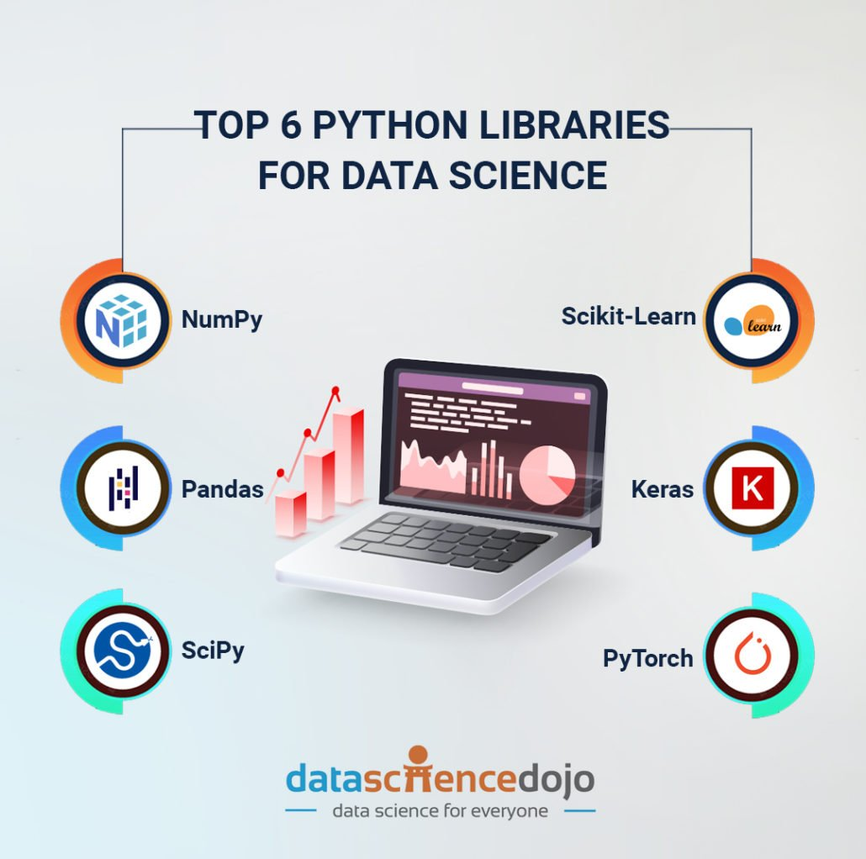

Python has emerged as one of the leading programming languages in the field of Data Science due to its simplicity, versatility, and a rich ecosystem of libraries. Libraries such as Pandas, NumPy, and Matplotlib provide powerful tools for data manipulation, numerical analysis, and visualization.   
  
  
Here are some of the essential libraries in Python that are widely used in Data Science, along with their purposes and typical usage scenarios.

|  |  |  |
| --- | --- | --- |
| **Library** | **Purpose** | **Usage** |
| **Pandas** | Data manipulation and analysis | DataFrame operations, data cleaning, and analysis |
| **NumPy** | Numerical computations | Array operations, mathematical functions, linear algebra |
| **Matplotlib** | Data visualization | Creating static, animated, and interactive plots |
| **Seaborn** | Statistical data visualization | Enhanced visualizations based on Matplotlib |
| **Scikit-learn** | Machine learning | Tools for classification, regression, clustering, and model selection |
| **TensorFlow** | Deep learning | Building and training neural networks |
| **Keras** | High-level neural networks API | Simplified interface for building neural networks |
| **Statsmodels** | Statistical modeling and hypothesis testing | Estimating models, statistical tests, and data exploration |
| **NLTK** | Natural Language Processing | Text processing and analysis for natural language |
| **OpenCV** | Computer vision | Image processing, video analysis, and computer vision applications |

Additionally, frameworks like TensorFlow and Scikit-learn facilitate machine learning and deep learning tasks, enabling data scientists to build predictive models and algorithms. Python’s strong community support and extensive documentation make it an ideal choice for both beginners and experienced data scientists, helping them to efficiently tackle complex data challenges.  
  
  
  
To explore more about it refer to below given link:-  
<https://www.w3schools.com/datascience/ds_python.asp>