PAYSLIP CALCULATION OF Andrew Muriithii*(Godrej Private Limited )*

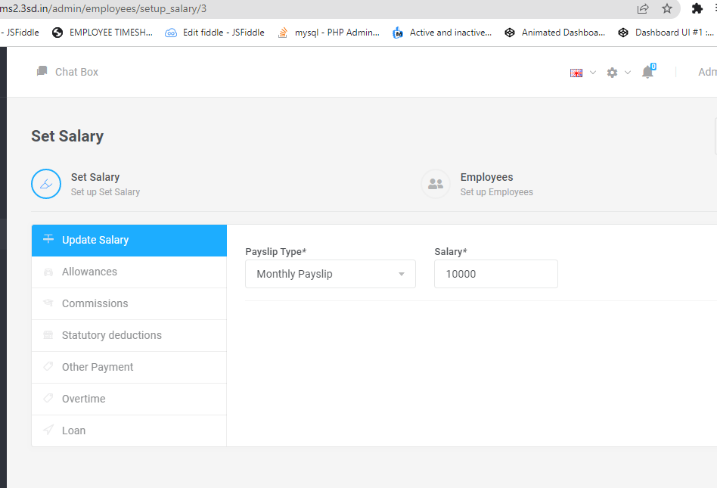

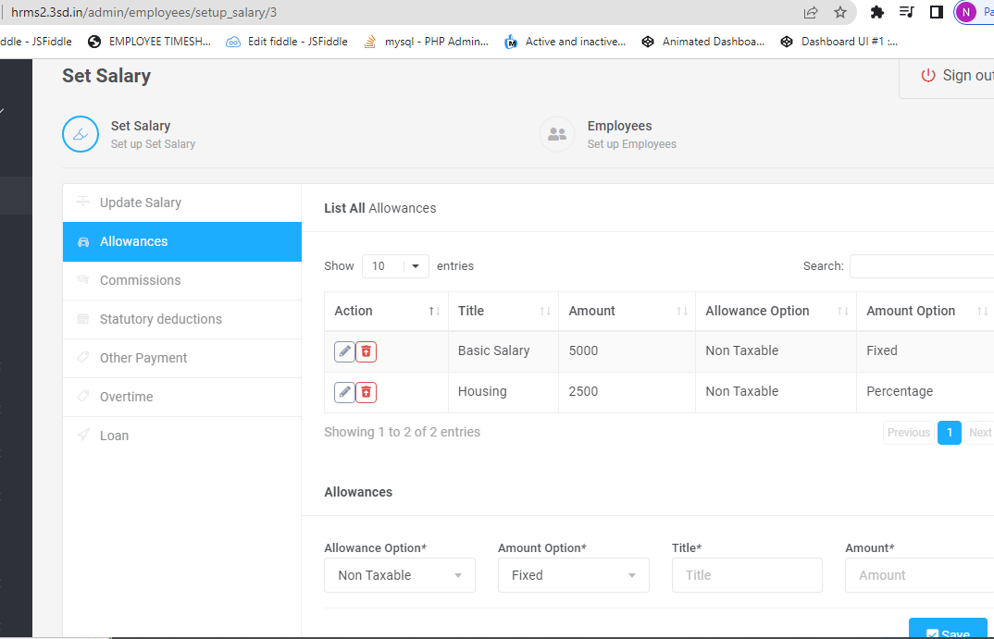

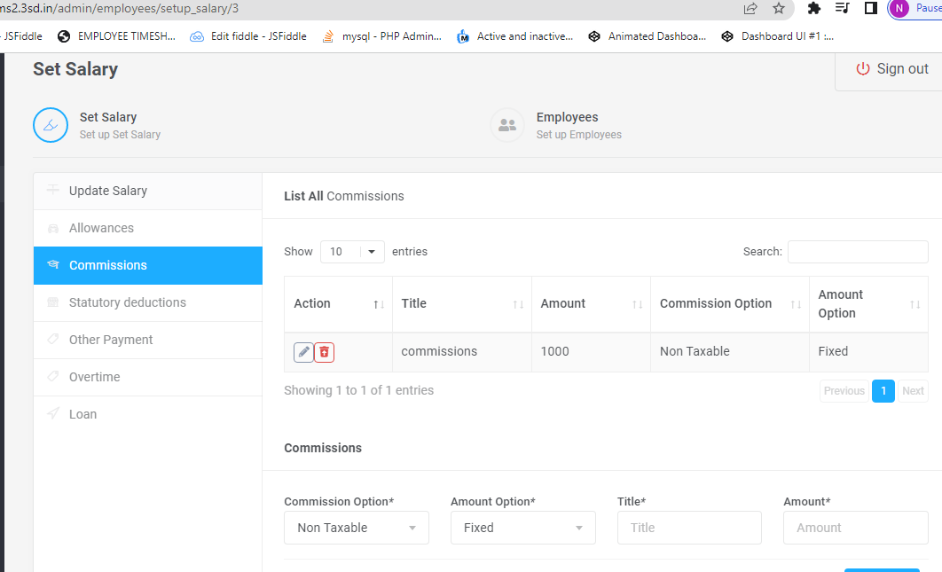

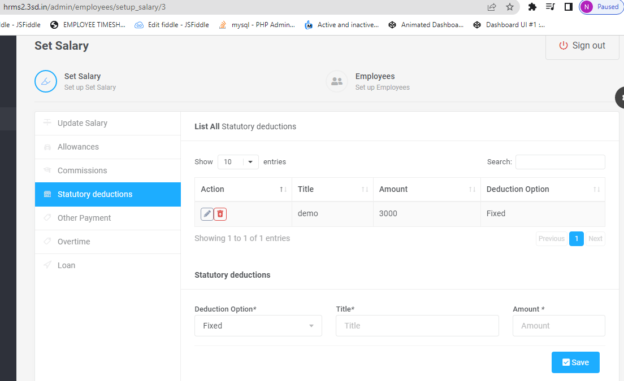

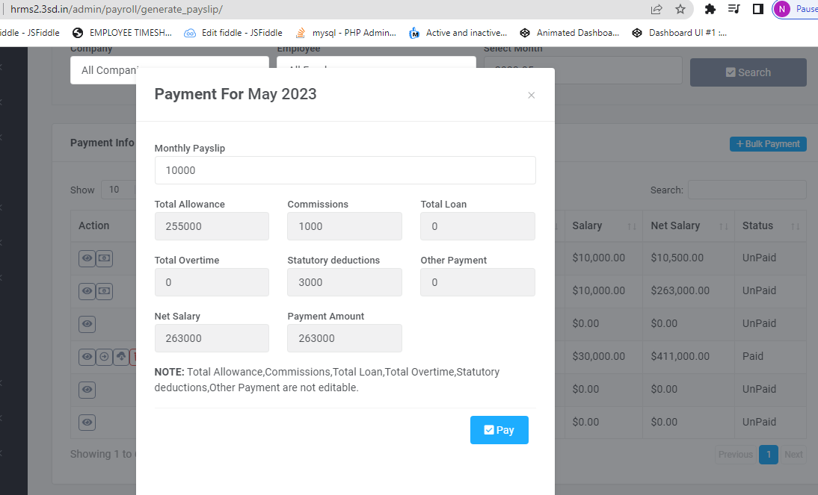

Final Calculation:

|  |  |  |  |
| --- | --- | --- | --- |
| Monthly payslip | fixed | 10000 | 10000 |
| Basic salary | fixed | 5000 | 5000 |
| housing | % | 2500 | 2500*100=250000 |
| commisions | fixed | 1000 | 1000 |
| Statutory deductions |  | 3000 | 3000 |
|  |  | Toatl | 10000+5000+250000+1000-3000=263000 |