Installed and Deployed the AWS ParallelCluster,and tested using simple program mpi_hello_world job.

AWS ParallelCluster constructs an HPC environment resembling conventional HPC clusters but with the added benefit of being scalable. Jobs are submitted to a queue. Nodes spin up as needed. Jobs are automatically launched. As nodes become idle, they are automatically shut down. Once created, the cloud-based master node provides access to standard HPC tools such as schedulers, shared storage, and a Message Passing Interface (MPI) environment. The master node maintains the scheduler and the running environment while the compute nodes spin up and down as jobs are submitted to the queue.

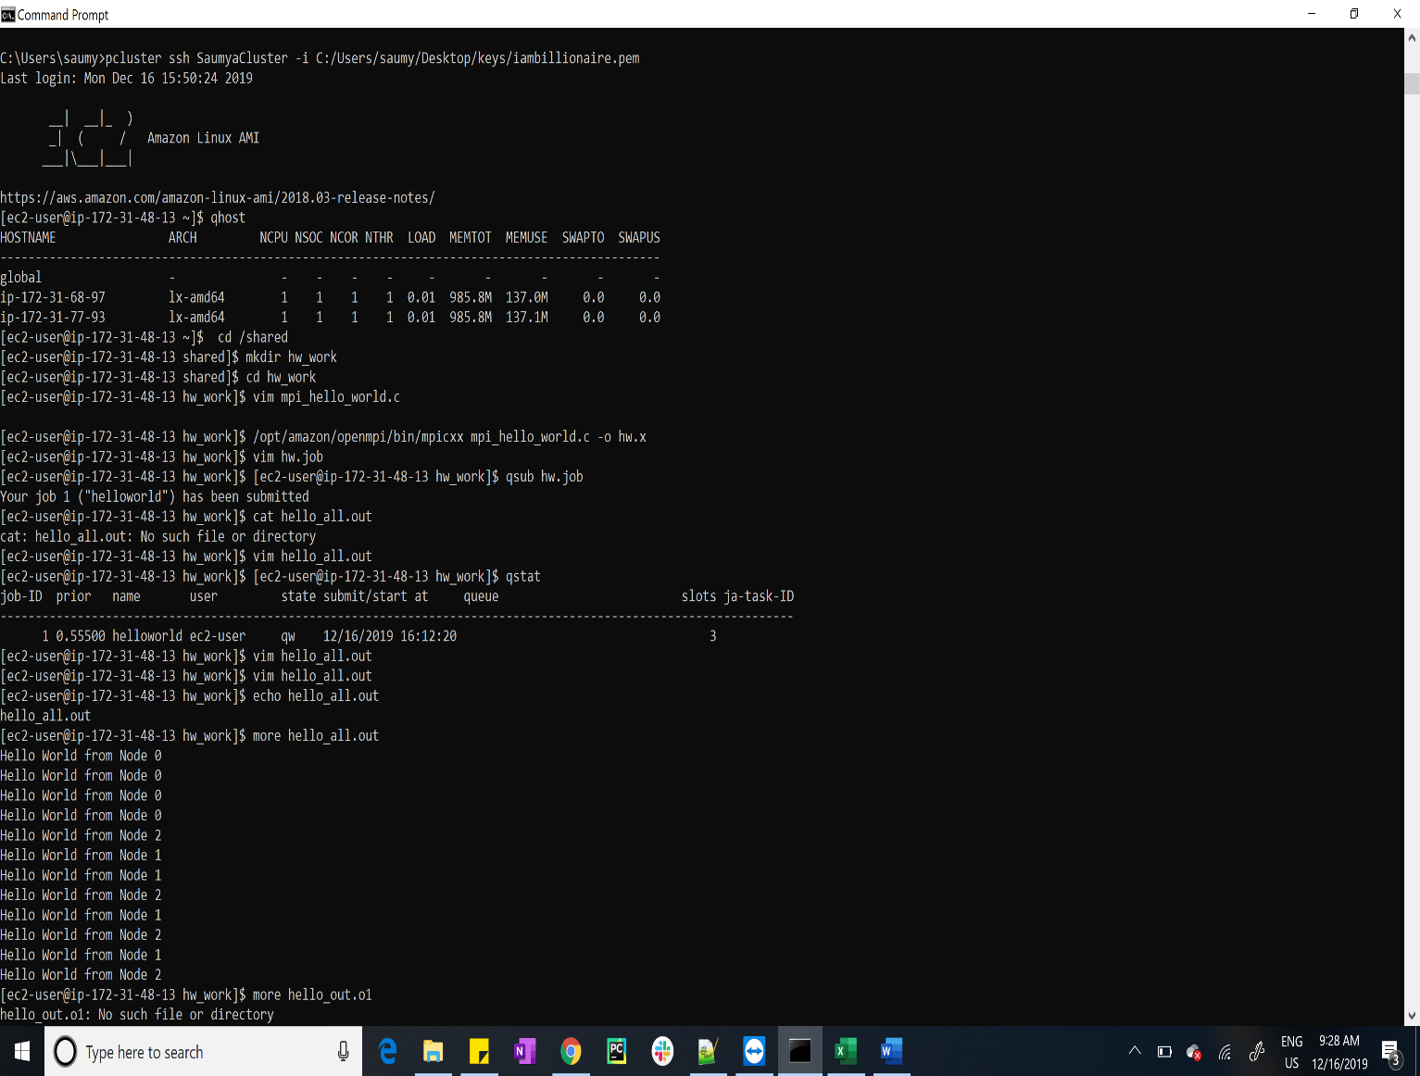

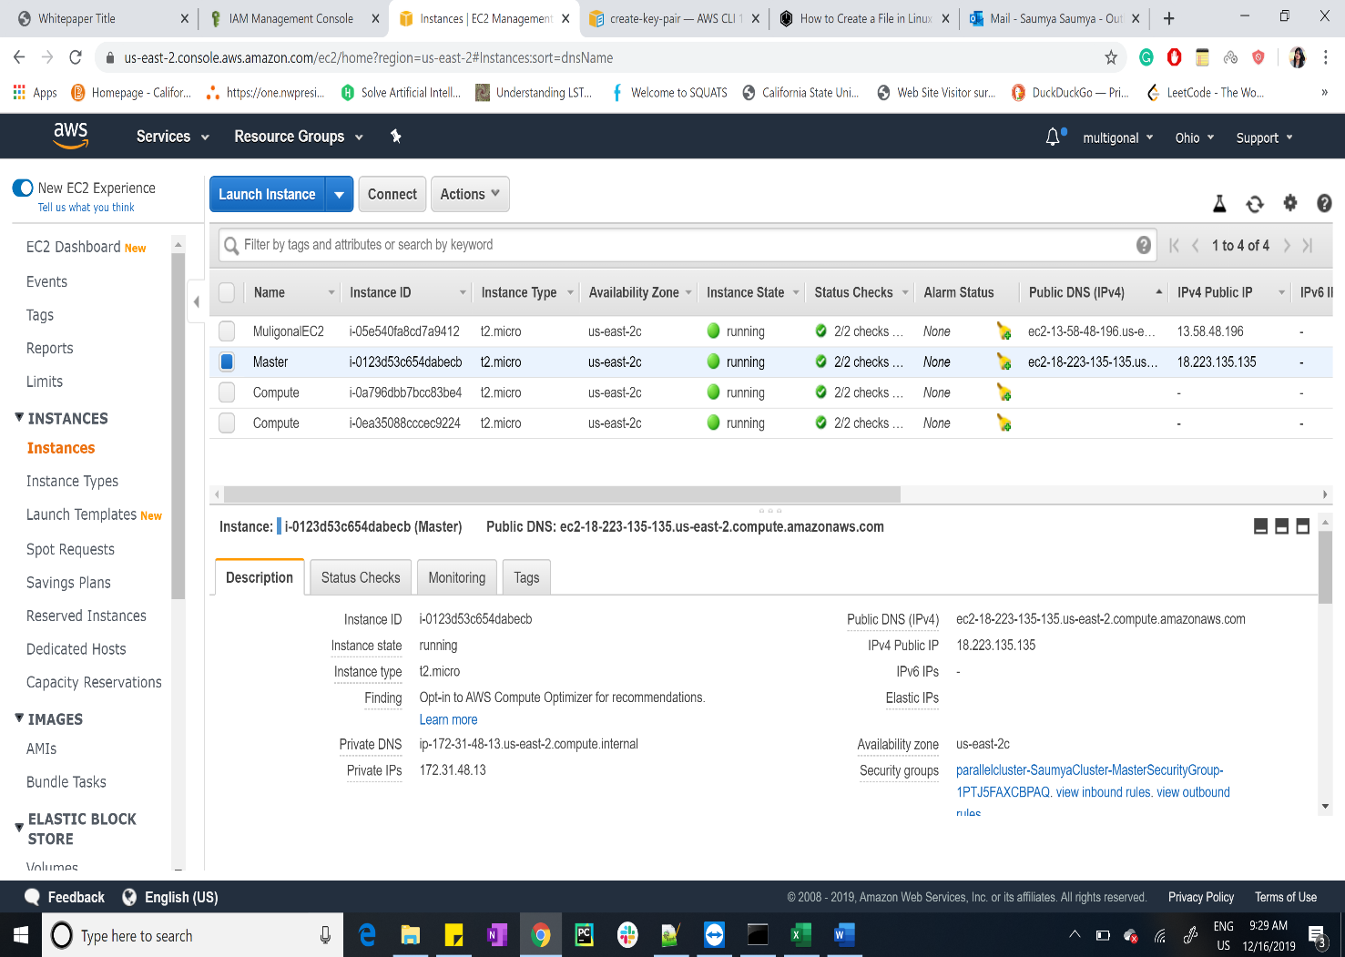

Reference

<https://d1.awsstatic.com/Projects/P4114756/deploy-elastic-hpc-cluster_project.pdf>

<https://www.open-mpi.org/doc/current/man1/mpicc.1.php>