# **The Importance of Parents Being Involved in Their Children’s Lives**

Edward Montoya, Saumya Sinha, Maharsh Soni, Aayush Srivastava, Rashmi Shree Veeraiah

Department of Applied Data Sciences, San Jose State University

DATA230: Data Visualization

Professor Seungjoon Lee

2022, December 9

**Data Visualization Final Project**

**1. Motivation:**

**“*The importance of having parents that are involved in the lives of their children.*”**

The involvement of parents in the lives of their children is of paramount importance, and the absence of parents may have a positive correlation with delinquent acts committed by juveniles. A family with two parents is better in all aspects because they can monitor and supervise their children well and respond adequately to their behavior than a family with a single parent.

Several studies have found that adolescents with strong bonds with their parents tend to perform better and have fewer behavioral problems. The first step towards wise parenting is maintaining a good relationship between parents and children. As soon as their children are born, parents should realize how vital it is for them to be reliable and accountable for their children.

The lack of proper guidance can have serious adverse effects on a child's life and can lead to character deficiencies. In this regard, while deprivation can negatively impact children's well-being when family relationships are bad, good relationships can prevent further decline in happiness. Home is the first place to learn, and Children learn from their parents. Children's behavior is influenced by watching their parents constantly, & children notice every little detail. It is through watching, listening, and imitating that they learn good and destructive behaviors. A higher level of parental involvement is associated with a lower rate of substance use among adolescents. Having parental monitoring and a healthy parent-child relationship allows for a safer environment free from peer pressure, leading to parental monitoring and a healthy parent-child relationship.

**2. Literature Review**

**2.1 The differential influence of absent and harsh fathers on juvenile delinquency**

The paper investigates the role of fathers in fostering their children's delinquent behaviors, focusing on two issues: the quality of the father-child relationship and the father's absence (Simmons et al., 2017). The findings used a broad sample of male juvenile offenders in the U.S. aged 13–17, showing that young individuals in the harsh-father group used more drugs and engaged in more criminal activity than the ones in the absent-father group. Even after accounting for the mother-child bond, this discrepancy persisted.

Adolescent delinquency is substantially correlated with the quality of the parent-child relationship. Teenagers who strongly connect to their parents are more likely to be concerned by parental expectations. Two parents are more able than single parents to keep a watchful eye on, oversee, and respond appropriately to their children's behavior. This study closely ties to our desire to comprehend how parents' impact and involvement with their children affect adolescents' engagement in delinquent behavior. We were inspired to build our visualizations on how the family-related characteristics linked to delinquent activities by the paper's discussion that strong levels of parental involvement and support are associated with reduced rates of delinquency and a lower likelihood of substance usage.

**2.2 The relationship between juvenile delinquency and family Unit structure**

The study by Mullens (2004) examined whether a child living in a very non-intact home is at risk of becoming a delinquent youth. Analysis has found that parental absence has been connected to a child’s status toward delinquent behavior for years. This paper investigates the link between parental absence and delinquent behavior to see if a relationship exists between the two. The general model was found to be statistically important. Analysis found that parental absence both physical and emotional, leads to Juvenile Delinquency. The result from this study, though lowest, adds weight to the present specific theory by finding that a statistically important relationship exists between the two.

Data was collected from juveniles who were alleged to have committed status or delinquent offenses. Each offense was categorized according to the family unit (e.g., intact, father only, mother only, etc.), offense type (e.g., underage consumption, petit larceny, breaking and entering, etc.), offense level (e.g., status misdemeanor, and felony), the victim (e.g., crimes against the person, crimes against property, etc.) and the juvenile’s age at the time the alleged offense occurred. These are the similar features and categories used in the survey questionnaire.

A child's life might suffer greatly due to inadequate guidance, which can also result in delinquency. When family ties are poor, deprivation can have a negative impact on children's well-being. A safer environment free from peer pressure is made possible by parental supervision and a positive parent-child relationship, which in turn promotes parental supervision and a positive environment for the child.

**3. Project Methodology**

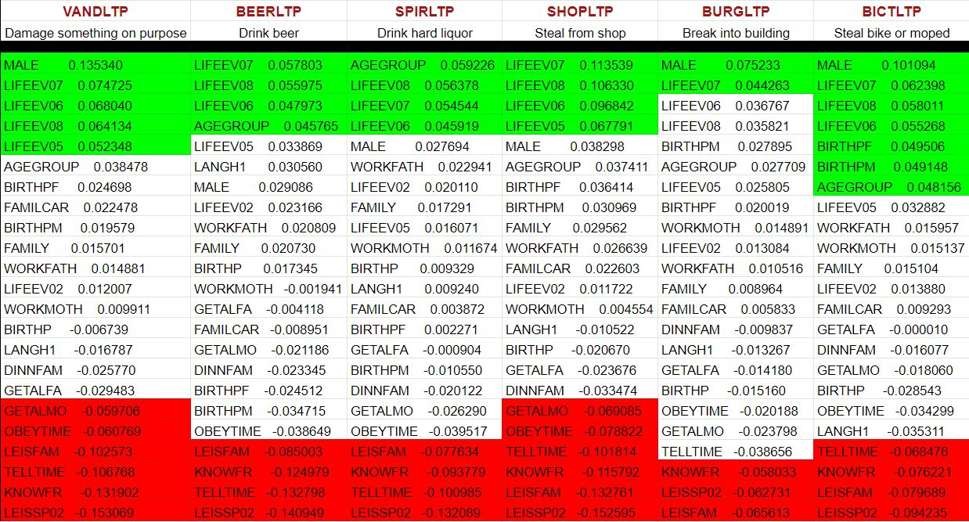

For our project methodology, we knew that our focus was on the importance of parents being involved in their children’s lives, but we had to consider how to visualize this. We decided to focus on features from the data documentation related to family, plus a few general identifying features like age and gender. This resulted in 23 features being selected. We then created a Jupyter notebook and analyzed the correlation of these 23 features with all of the 18 delinquent behavior features found in the dataset. An arbitrary threshold of 0.04 and -0.04 was used for positive and negative correlation, respectively. The figure above demonstrates our findings for correlation for the family-related features. This analysis provides insight into how we can develop a story with the family features related to our motivation. It allows us to visualize features with a strong positive and negative correlation and, perhaps, allows for insights derived from the correlation. For example, if a parent is committing acts of violence, then the child may have a higher probability also to commit violence. This is just a snapshot of the analysis conducted, but it provides a general idea of our approach.

The majority of the visualizations have been made into a normalized stacked bar- chart. We have chosen a normalized stacked bar chart as it clearly depicts the comparison of each category with respect to the whole. As they represent the percentage of each data category's relative contribution to the total, we can clearly notice our target category, which is a positive response to the questions asked related to delinquent acts. The part which represents “Yes” has been shown in vibrant colors such as red and green in order to make that category more dominant visually.

**4. Data Visualization**

**4.1 How often do you and your parents (or the adults you live with) do something together, such as going to the movies, going for a walk or hike, visiting relatives, attending a sporting event, and things like that?**

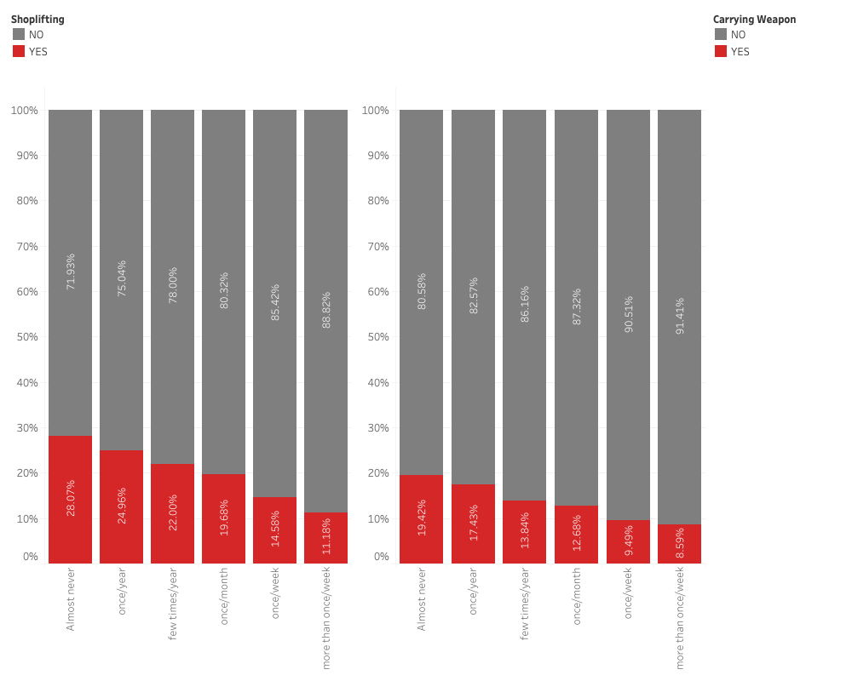

The plot consists of two normalized stacked bar charts:

The chart compares the frequency of time spent with family (1-6) in six categories, from "nearly never" to "more than once a week," to possession of a weapon and shoplifting (yes or no).

* Mark:
  + Vertical stacks of line
* Channels:
  + Size (Length) - quantitative feature
  + Position (Horizontal) - for frequency of time spent with family in 6 categories
  + Position - (Vertical) - for shoplifting and possession of weapon YES or NO categories (Color)

The reason for adopting a normalized stacked bar chart for this visualization is that it is a great choice for comparing part-to-whole relationships for each category. They represent the percentage of each data category's relative contribution to the total. The color helps to differentiate between the YES or NO categories for whether the respondents indicated that they had ever had a firearm or engaged in shoplifting for each category of time spent with family. The frequency of time spent with family is represented on the position channel (horizontal), which has six categories from 1 to 6, with 1 representing nearly never and 6 representing more than once per week.

This visualization was created using the results of the family feature correlation analysis. The goal of this visualization is to give a simple method to understand the relationship between delinquent conduct and the family feature **LEISFAM** (How frequently an individual spent time with their family engaging in some activity). The LEISFAM characteristic has a strong negative correlation (-0.132761) with both possession of **weapons** and **shoplifting** (-0.091924). In relation to the amount of time individuals spend with their families, this visualization shows the proportion of people who indicated they had engaged in shoplifting and/or had possession of a weapon and the proportion who had not. Only 11.18% of those who replied YES to shoplifting spent more than once a week with their family, while 28.07% of those who said YES spent absolutely no time with their family. As can be seen from the visualization, as people became more involved with their families, the percentage of individuals engaging in delinquent behavior declined.

**4.2 Do your parents (or the adults you live with) usually know who you are with when you go out?**

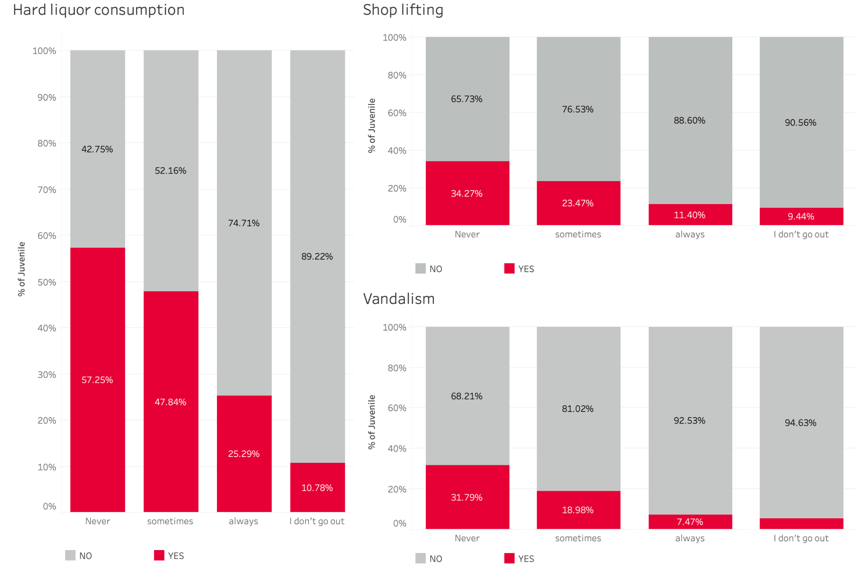

The plot consists of three normalized stacked bar charts:

The chart compares the extent of parent’s awareness about who their kid is going out with (according to the answer given by the kid), in four categories, namely: never, sometimes, always, and ‘I don’t go out’, to hard liquor consumption, shoplifting, and vandalism. All of them are categorized in Yes/No.

* Mark:
  + Vertical stacks of line
* Channels:
  + X position - for different answers given by respondent [four]. (categorical)
  + Size (Length) - % of juvenile /respondents. (quantitative)
  + Hue – Yes / No. (categorical)

A normalized stacked bar chart is chosen as normalization of the Y- axis helps in comparing part-to-whole relationships among categories, in this case, Yes/No. Each bar represents the percentage of contribution of each category as a part of the total hundred percent. The color Red (Yes) and Gray (No) differentiate between the two categories, yes or no, for the questions regarding hard liquor consumption, shoplifting, and Vandalism, which has four categories based on the initial question, “Do your parents (or the adults you live with) usually know who you are with when you go out?” namely: never, sometimes, always and ‘I don’t go out.

This visualization was created using the results of the family feature correlation analysis. The goal of this visualization is to give the user a quick approach to learning about the impact of awareness of parents about their kids’ friend circle (**KNOWFR**) on delinquent acts such as Hard Liquor Consumption **(SPIRLTP**), shoplifting (**SHOPLTP**) and vandalism (**VANDLTP**).

The KNOWFR characteristic has strong relationships with SPIRLTP (-0.093779), VANDLTP (-0.131902), and SHOPLTP (-0.115792). The graph represents the proportion of respondents who answered Yes or No to compare the effects.

**4.3. Do Parent’s separation can lead to Delinquent Act among Juveniles?**

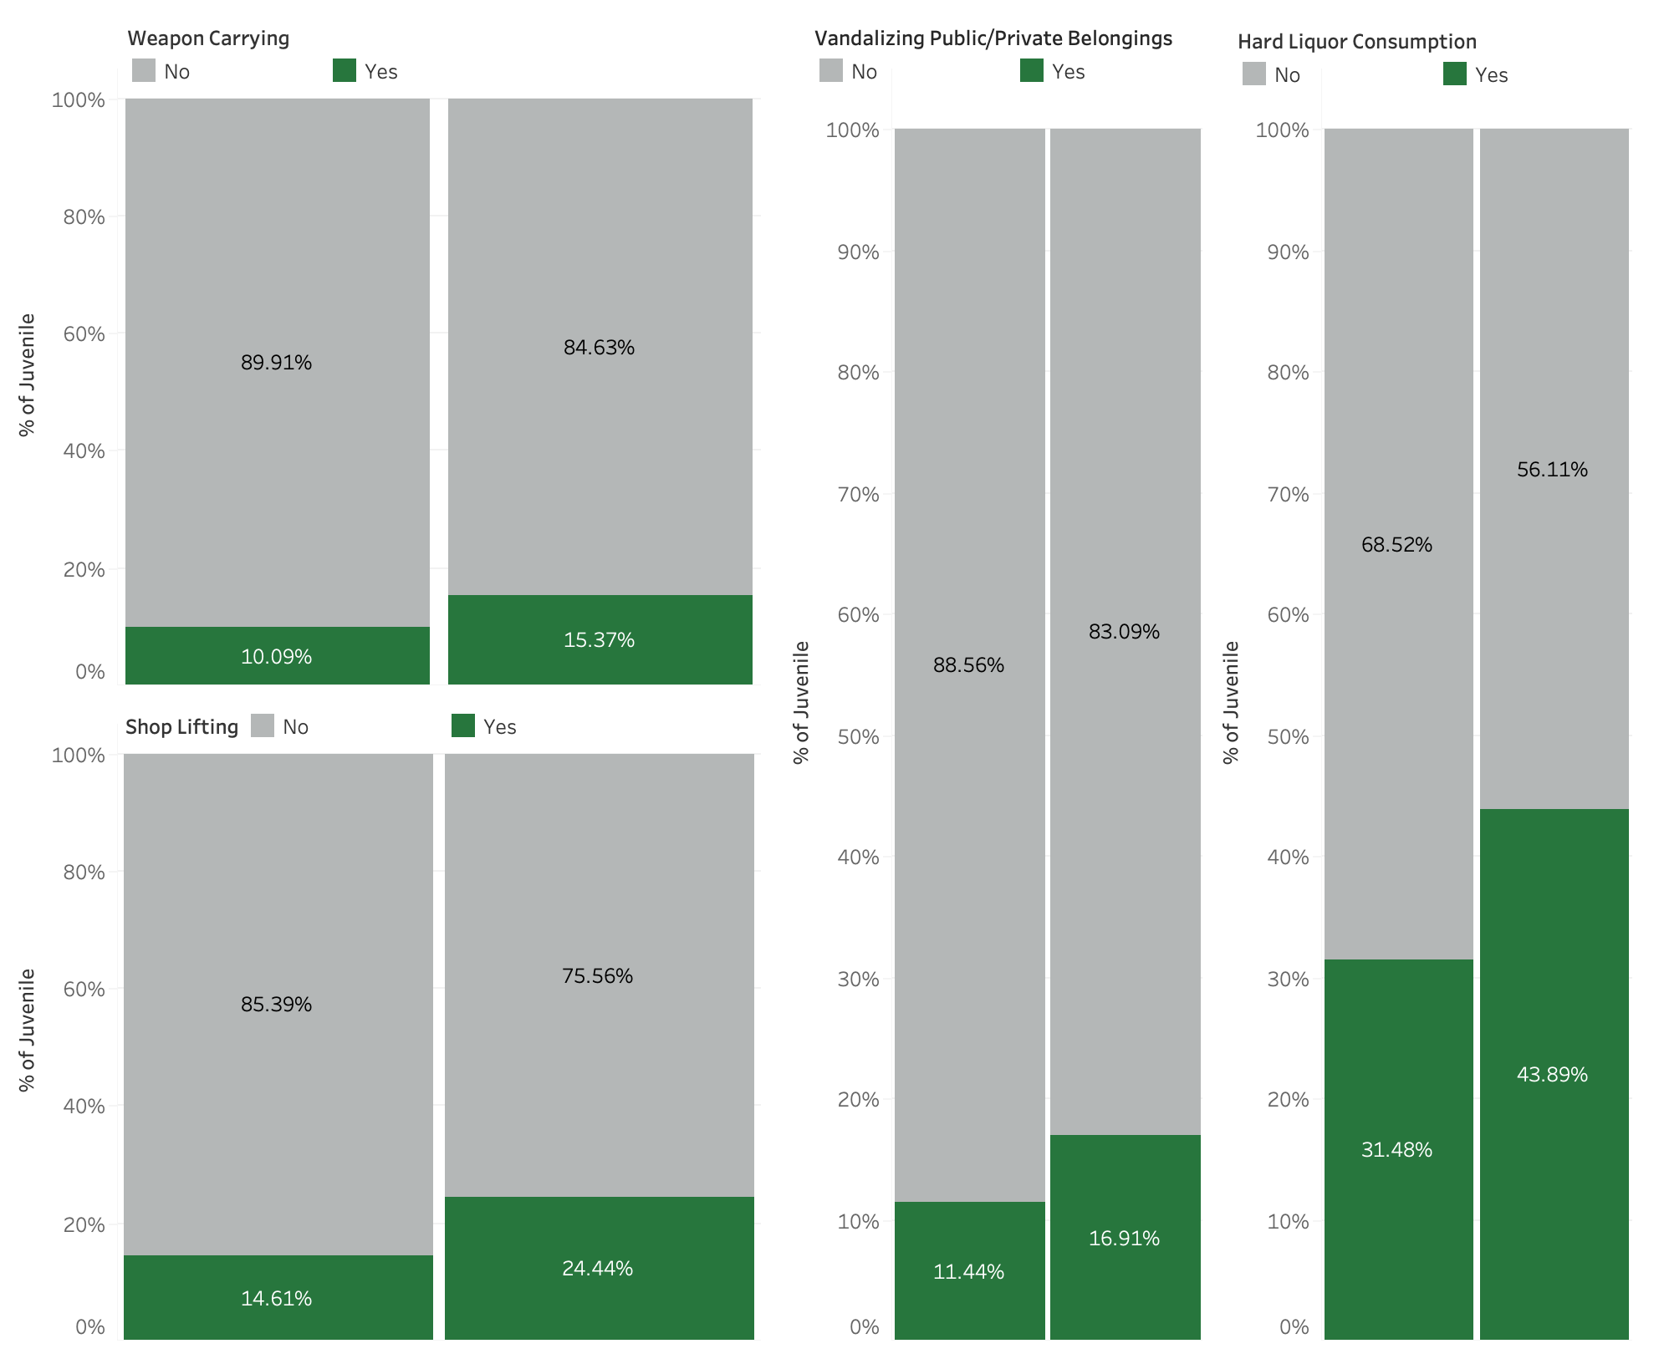

The plot consists of four normalized stacked bar charts:

* Mark:
  + Vertical stacks of line
* Channels:
  + Length (size) - Quantitative feature
  + Hue - 2 categories: No and Yes
  + Horizontal Position (or X-Position) - Total frequency of Juveniles involved in various criminal acts.
  + Vertical Position (or Y-Position) - Delinquent activities

In this visualization, a normalized stacked bar chart has been chosen due to its ability to compare quantitative values based on categories. The **size** (length) represents the quantitative value of the frequency count, the **hue** distinguishes whether the delinquent acts by juveniles are done or not (No or Yes). The **horizontal** position (X) shows the total frequency of juveniles involved in various criminal acts, while the **vertical** position (Y) shows the delinquency activities of juveniles, such as Carry weapons, Shoplifting, Vandalization, and Hard liquor consumption.

The main cause of the increase in the number of Juvenile delinquencies can be attributed to the increase in the number of divorces being witnessed in the whole world. Both the Mother and Father have particular roles that they have to play to ensure that they bring up morally upright kids.

This visualization shows if parents are divorced, then there is a high chance of their children getting involved in violence, stealing, and substance abuse. This result was carried out after performing the family feature correlation analysis. The **“LIFEEV08”** feature, which shows Parents separated or (divorced) has a strong positive correlation with **WEAPLTP** (carry weapons): 0.066217, **VANDLTP** (destroy things): 0.064134, **SHOPLTP** (stealing from shops): 0.106330, and **SPIRLTP** (drink hard liquor): 0.056378.

**4.4 Have you ever experienced problems with one of your parents with alcohol or drugs?**

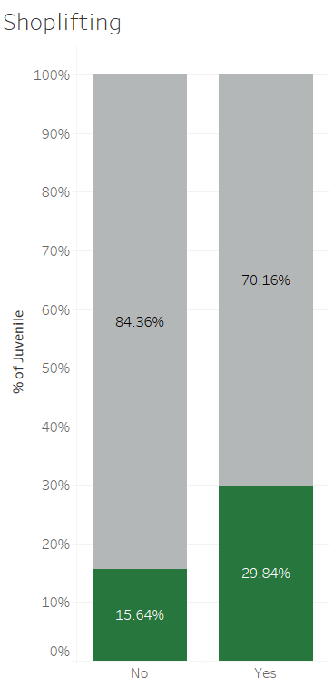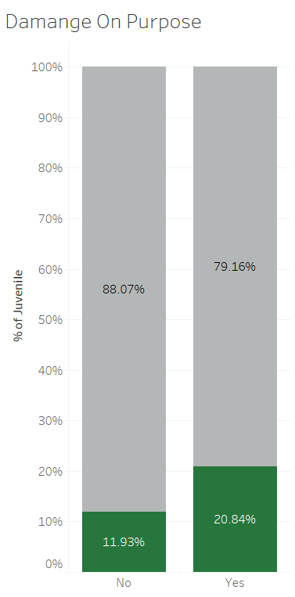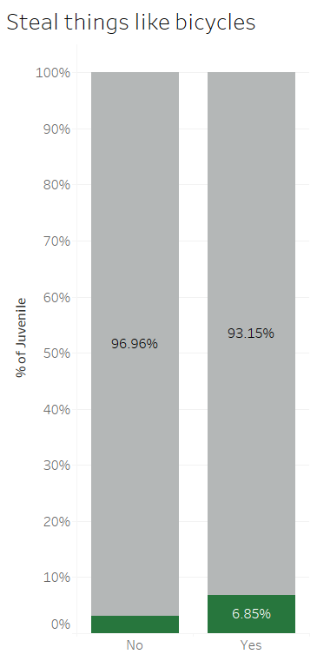

**  **

The plots consist of normalized stacked bar charts:

* Mark:
  + Vertical stacks of Line.
* Channels:
  + Size (Length) - quantitative feature.
  + Position (Horizontal) - for categories of feature**”LIFEEV06”**(parent’s substance abuse) -aligned vertically.
  + Position (Vertical) - for categorical feature(delinquent activities) - unaligned vertically (Colour).

In each of the visualizations, a normalized stacked bar chart is used to show the comparison between **each category of correlated categorical features**( such as shoplifting, damage on purpose, and stealing things) with the parent’s substance abuse feature **“LIFEEV06”**. The **size** (length) represents the quantitative value of the total juvenile, the **hue** gives the detail about how much percentage the particular correlated categorical feature comprises as a part of the whole. The **horizontal** position (X) shows the categorical feature Lifeev06, and the **vertical** position (Y) shows the delinquency activities of juveniles.

The above visualization shows the evidential change in the children's behavior due to their parents' drugs or alcohol habits. Looking into the correlations, it was found that shoplifting(**SHOPLTP**), damage on purpose(**VANDLTP**) such as bus shelter, car seats, trains, etc, and stealing of bicycles or scooters(**BICTLTP**) were mainly observed in those children whose either of their parents were involved in substance abuse issues.

**4.5 Derived Visual of Strongest Positive Correlated Family Features to Delinquent Behavior**

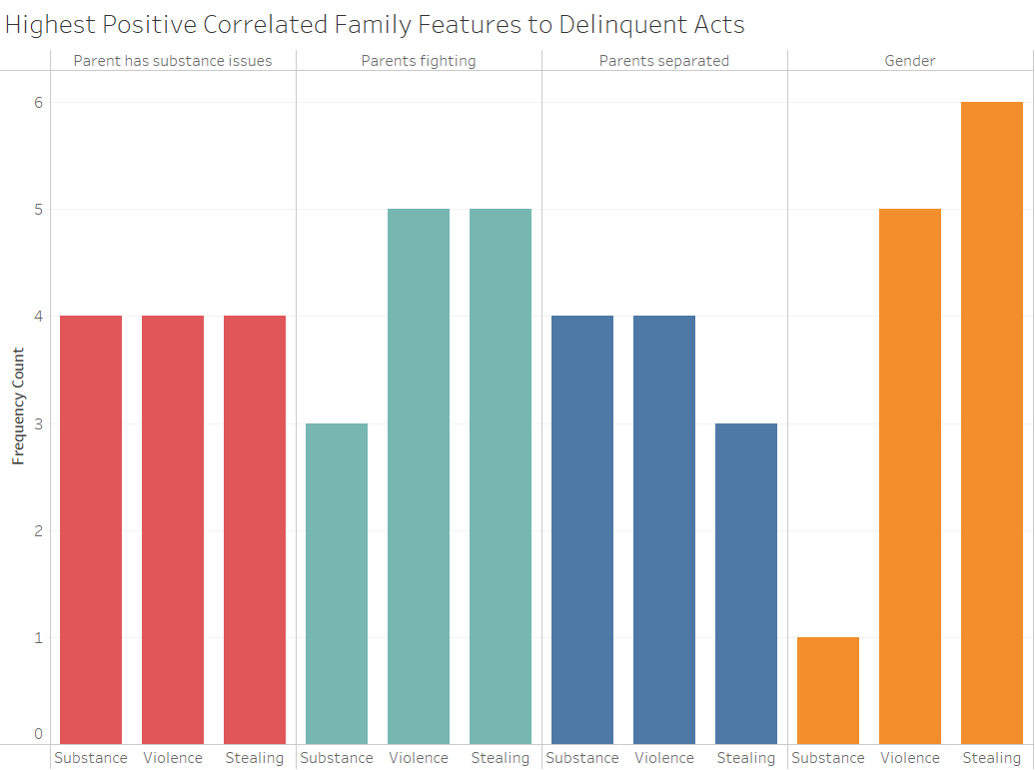

The plot consists of bar charts:

* Mark:
  + Line
* Channels:
  + Hue - Family features (categorical)
  + Size (Length) - Frequency count (quantitative)
  + X position - **Derived** delinquent behavior (categorical)

The reason that a bar chart has been chosen for this visualization is that a bar chart does an excellent job of comparing quantitative values based on categories. The channel hue allows the viewer to differentiate between each family feature. The length is used to show the quantitative values for the frequency count, and the X position is a **derived** delinquent behavior category that is grouped by the family feature.

This is a **derived** visualization. It was constructed based on the analysis conducted for the correlation of family features. This visualization depicts a frequency counter for three delinquent behaviors. The behavior categories are an aggregation of all 18 delinquent behaviors grouped into three categories, substance, violence, and stealing. This visualization intends to provide the viewer with a quick way to gain insights into the highest positively correlated family features to delinquent behavior. For example, the viewer might notice that the Gender feature strongly correlates to stealing. This could provoke interest in exploring the possible cause of this.

Additionally, the viewer might notice that violence is high for kids that live in an environment where they witness their parents fighting. This is intuitive that children might exhibit violent behavior if they live in a household that often depicts violence between the parents. This intuitive assumption is validated by the visual. Overall, this visual provides insight into delinquent behavior correlation but not causation. Understanding causation would require further research.

**5. Conclusion**

**References**

1.Angela D. Mullens. (2004).

*The Relationship Between Juvenile Delinquency and Family Unit Structure*. Marshall Digital Scholar. <https://mds.marshall.edu/cgi/viewcontent.cgi?article=1743&context=etd#:~:text=The%20study%20suggests%20that%20there,delinquent%20activity%20(Steinberg%201987)>

2.Simmons, C., Steinberg, L., Frick, P. J., & Cauffman, E. (2017).

*The differential influence of absent and harsh fathers on juvenile delinquency*. Journal of Adolescence,

*62*(1), 9–17.

The above visuals show the importance of parents being involved in their children’s lives based on correlations between several family features.

Some visuals showed negative correlations to delinquent acts such as:

* Children who are spending time with family are less likely to do delinquent acts
* If parents know where their children are and with whom, they are less likely to commit delinquent acts.

Visuals showed positive correlations to delinquent acts such as:

* If the parents are partaking in substance abuse, then their children are more likely to do delinquent acts.
* If parents are divorced/separated, it can lead to an increase in Juvenile Delinquency.

Finally, we conclude that it is vital that the parents be involved with the lives of their children for a better upbringing.

<https://doi.org/10.1016/j.adolescence.2017.10.010>