VERIFY ADVERTISEMENT

MANAGE CATEGORIES

DELETE ADVERTISEMENT

PRODUCT REQUEST

RESPONSE

MAKE PURCHASE

REGISTER/LOGIN

BUYER

ADMIN

CREATE ADV

REGISTER/LOGIN

OLX

*AIM:-TO MAKE DATA FLOW DIAGRAM ON OLX USING LUCID CHART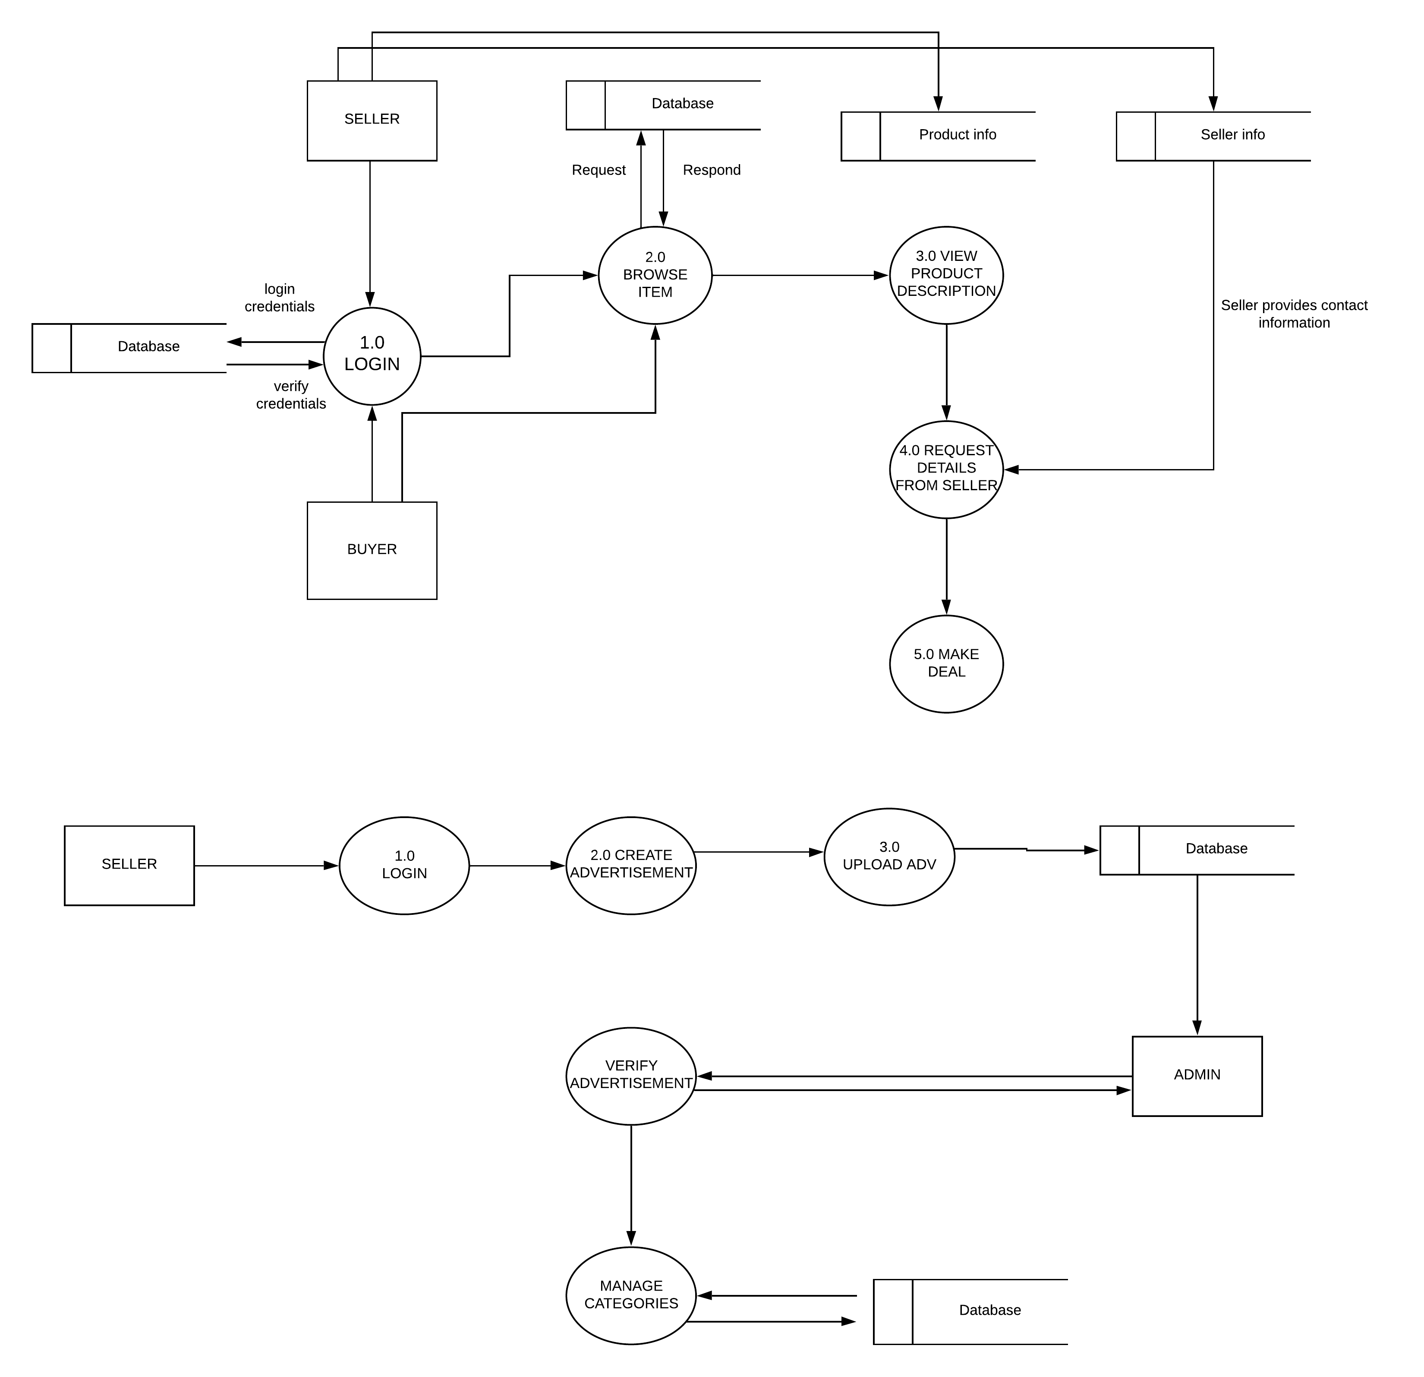*

SELLER

UPDATE ADV

***CONTEXT LEVEL DIAGRAM***

LELEVEL 1:SELLER,ADMINEL 1

LELEVEL 1:BUYER AND SELLERLEVEL 1

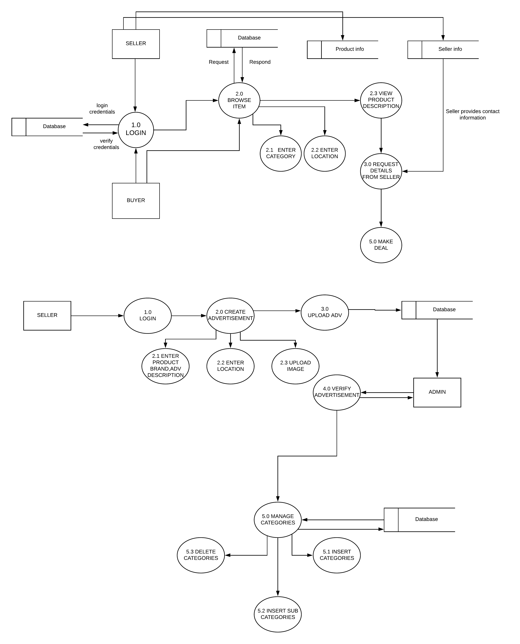

LELEVEL 2 1

LELEVEL 2L 1