*AIM:TO MAKE A SEQUENCE DIAGRAM ON GLOBAL ONLINE MARKETPLACE : OLX USING LUCID CHART*

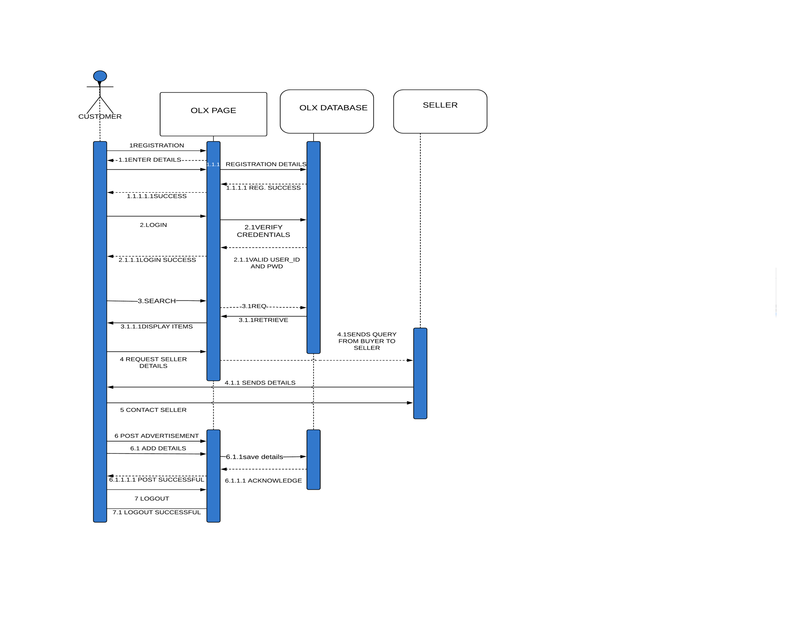

*AIM:TO MAKE A COLLABORATION DIAGRAM ON ONLINE GLOBAL MAKETPLACE - OLX USING LUCID CHART.*

*