

**INNOVATE. CREATE. SOLVE**

Bengaluru, Karnataka, India

AN INTERNSHIP REPORT

ON

“Tribute To Doctors”

#### Bachelor of Engineering

#### In

#### Electrical and Electronics Engineering

#### 

#### Submitted by : C . VENKATA SAUMYA (18R11A0212)

#### 

#### 

#### 

**COLLEGE NAME : - GEETHANJALI COLLEGE OF ENGINEERING AND**

**TECHNOLOGY 2021**

#### 

## ABOUT THE COMPANY

IC Solution (ICS) is a digital service provider that aims to provide software, designing and marketing solutions to individuals and businesses. At ICS, we believe that service and quality is the key to success

We provide all kinds of technological and designing solutions from Billing Software to Web Designs or any custom demand that you may have. Experience the service like none other!

Some of our services include:

Development - We develop responsive, functional and super-fast websites.

We keep User Experience in mind while creating websites. A website should load quickly and should be accessible even on a small view-port and slow internet connection.

Mobile Application - We offer a wide range of professional Android, iOS & Hybrid app development services for our global clients, from a start up to a large enterprise.

Design - We offer professional Graphic design, Brochure design & Logo design. We are experts in crafting visual content to convey the right message to the customers.

Consultancy - We are here to provide you with expert advice on your design and development requirement.

Videos - We create a polished professional video that impresses your audience.

**TABLE OF CONTENTS**

Table of contents i

Overview of the Project 1

About COVID-19 2

Origin 3

Tools Used 4

Implementation 5

Snapshots 21

Bibliography 25

## OVERVIEW OF THE PROJECT

## Project Name: Tribute to Doctors

**Team Members**: **NAME 1 :-**  C . VENKATA SAUMYA

**NAME 2 :-** SHOBHIT MISHRA

**NAME 3 :**- SUVARNA

**NAME 4 :**- MOHAMMED AKIF

## This project is based on Web Development And its Applications. The main objective of this project is to learn the implementation of HTML, CSS(External CSS) and JAVASCRIPT. The basic webpage of this project is created using HTML and styling of the webpage is done using CSS.

## This webpage is about the brave doctors who lost their lives during the COVID-19 second wave .

## ABOUT COVID-19

Coronavirus disease (COVID-19) is an infectious disease caused by the SARS-CoV-2 virus. Most people infected with the virus will experience mild to moderate respiratory illness and recover without requiring special treatment. However, some will become seriously ill and require medical attention. Older people and those with underlying medical conditions like cardiovascular disease, diabetes, chronic respiratory disease, or cancer are more likely to develop serious illness. Anyone can get sick with COVID-19 and become seriously ill or die at any age.

The best way to prevent and slow down transmission is to be well informed about the disease and how the virus spreads. Protect yourself and others from infection by staying at least 1 meter apart from others, wearing a properly fitted mask, and washing your hands or using an alcohol-based rub frequently. Get vaccinated when it’s your turn and follow local guidance . The virus can spread from an infected person’s mouth or nose in small liquid particles when they cough, sneeze, speak, sing or breathe. These particles range from larger respiratory droplets to smaller aerosols. It is important to practice respiratory etiquette, for example by coughing into a flexed elbow, and to stay home and self-isolate until you recover if you feel unwell.

**ORIGIN OF CORONAVIRUS**

Many health experts believe that the new strain of coronavirus likely originated in

bats or pangolins. The first transmission to humans was in Wuhan, China. Since then, the

virus has mostly spread through person-to-person contact . The new strain of coronavirus is called severe acute respiratory syndrome coronavirus 2 (SARS-CoV-2). The virus causes coronavirus disease 19 (COVID-19).

The new coronavirus has spread rapidly in many parts of the world. On March 11, 2020,

the World Health Organization (WHO)Trusted Source declared COVID-19 a pandemic.

A pandemic occurs when a disease that people are not immune to spreads across large

regions.

The recent outbreak began in Wuhan, a city in the Hubei province of China. Reports of

the first COVID-19 cases started in December 2019.

Coronaviruses are common in certain species of animals, such as cattle and camels.

Although the transmission of coronaviruses from animals to humans is rare Trusted

Source, this new strain likely came from bats, though one study suggests pangolins may

be the origin.

However, it remains unclear exactly how the virus first spread to humans.

Some reports trace the earliest cases back to a seafood and animal market in Wuhan. It

may have been from here that SARS-CoV-2 started to spread to humans.

# TOOLS USED

### Software Requirement

* Google Chrome or Microsoft Edge of latest version.
* Front End: HTML, CSS, JS (optional)
* Linux 7.1 or Windows XP/7/8/10 OS or Mac OS

### Hardware Requirements

* Pentium 200-MHz computer with a minimum of 64 MB of RAM (128 MB of RAM recommended).
* Monitor with a refresh rate of at least 40Hz for a smooth GUI experience (optional).

# IMPLEMENTATION

# Source Code (P1.HTML):

# <!DOCTYPE html>

# <html>

# <head>

# 

# <meta charset="utf-8">

# <meta http-equiv="X-UA-Compatible" content="IE=edge">

# 

# <title>Tribute To Doctors</title>

# <meta name="description" content="">

# <meta name="viewport" content="width=device-width, initial-scale=1">

# <link rel="stylesheet" href="style.css">

# 

# </head>

# 

# <body class="body1">

# <div class="navbar">

# <p><h1 class="head">Tribute to Doctors</h1></p>

# </div>

# <div class="body2">

# <h2 class="heading1">A Tribute To The Real Unsung Heroes Of The Pandemic</h2>

# <img class="img1" src="image1.jpg">

# 

# <p1 class="para1">

# In the midst of the prevalent COVID pandemic, the IMA said that 798 doctors died during the second wave across the country of which a maximum of 128 doctors lost their lives in Delhi , followed by Bihar at 115, as per ANI. As per the IMA, Uttar Pradesh lost 79 doctors.<br>

# States like Maharashtra and Kerala where the prevalence of the Delta Plus variant of Covid-19 is on a rise , also reported deaths of doctors in double digits.

# </p1>

# <div class="pa2">

# <p2 class="para2">

# Pondicherry reported the lowest deaths of doctors by logging one death only. Hour after Prime Minister Narendra Modi on Sunday praised doctors for going out of their way to extend help to people ring the coronavirus pandemic, IMA President Dr JA Jayalal said that the PM has assured that doctors will be respected, protected and safeguarded.<br>

# A large number of factors must have contributed to the large number of deaths of doctors across states, spread of Covid-19 infection in different states played a major role. States and UTs like Delhi, Uttar Pradesh, West Bengal, had reported a large number of daily Coronavirus cases during the second wave which explains high Covid-19 related casualty figures among doctors in these states. However, there were some notable exceptions including Maharashtra which contributed the highest number of cases to the nationwide tally in the initial days of the second wave but the number of deaths in Maharashtra was only 23. Karnataka which faced an upsurge of Coronavirus during the fag end of second wave also reported only 9 Covid-19 related casualties among doctors.

# </p2>

# </div>

# 

# <img class="img2" src="image2.png">

# 

# <div class="pa3">

# <p3 class="para3">

# Many doctors share their experience of working tirelessly during the pandemic . During , these covid times they worked day and night , for serving the covid patients , like a soldier who guards our country from enemies , saving millions of our lives. They worked very hard , though they were not self-quarantined , but had a lot of fear about taking deadly virus with them home . They had to even sacrifice spending time with their loved one's and were brave enough to work hard for our country . But still , in some parts of our country , the doctors and the doctor's professionals were beaten abusively by the covid patients due to some shortage of supplies , collecting samples from the suspected covid patients and even higher medication fees during the covid times and this made many doctors emotional and hopeless during those times .

# </p3>

# </div>

# 

# <div class="pa4>

# <p4 class="para4">

# Prime Minister Shri Narendra Modi has emphasized the need for vaccination to all citizens of our country , mainly for the age group of 18 and above . He had supported and encouraged a lot of people to compulsorily take vaccines , so that to fight against this corona virus . The vaccines called Covaxin and Covishield were the two most important vaccines which were supplied to our country , India . For this , the scientists and doctors worked relentlessly hard to examine about the deadly virus and to develop any cure for it . At presently , these vaccines are being developed to produce immunities in our bodies , so that it can fight against any further virus . Hence , in remembrance of our brave doctors , who had been a backbone of our country , during the covid times , we're celebrating this year's National Doctors' Day (July 1) in remembrance of the veteran Dr BC Roy. We're so much pleased that PM Modi greeted the medical fraternity for the Doctors' Day," the IMA President had said.

# </p4>

# </div>

# </div>

# 

# <div class=”iframe”>

# <center><iframe width="642" height="361" src="https://www.youtube.com/embed/VB9iELUVZEg?autoplay=1&mute=1"

# title="YouTube video player" frameborder="0" allow="accelerometer; autoplay; clipboard-write;encrypted-media; gyroscope; picture-in-picture" allowfullscreen></iframe></center> </div>

# </body>

# </html>

# IMPLEMENTATION

# Source Code (P1.CSS+P1.JS(if used)):

.body1 {

background-color: #d5ecc2;

align-items: center;

}

.navbar {

overflow: hidden;

background-color: grey;

width: 99%;

position: fixed;

}

.head{

display: block;

text-align: center;

font-size: 40px;

}

.img1{

float: right;

height: 5%;

width: 17%;

}

.img2{

padding-top: 8%

height: 30%;

width: 50%;

margin-left: 30%;

}

.body2{

padding-bottom: 15%;

padding-top: 10%;

margin-left: 2%;

margin-right: 2%;

font-size: 18px;

}

.heading1{

text-align: center;

}

.pa3{

padding-top: 4%;

}

.pa4{

padding-top:4%;

}

.iframe{

Padding-top:100px;

}

# IMPLEMENTATION

# Snapshots :

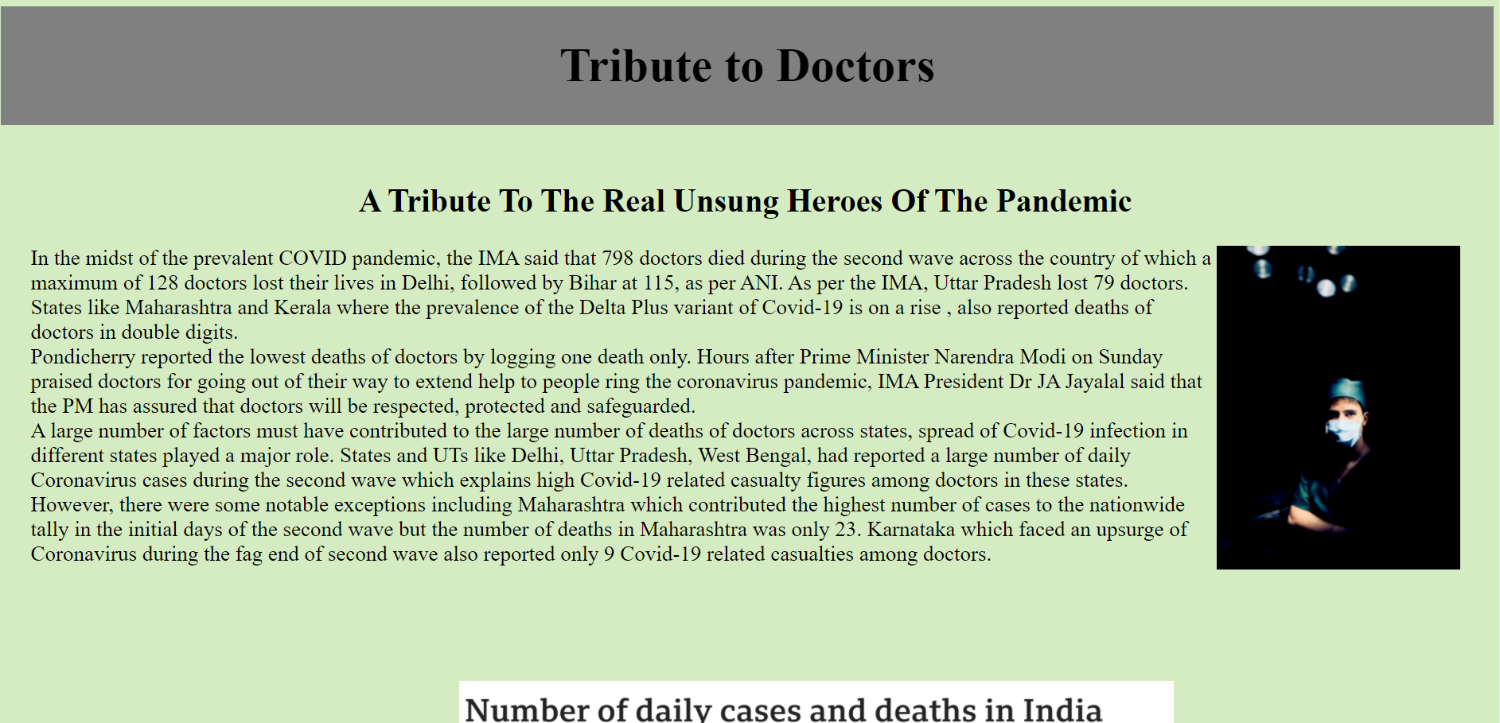

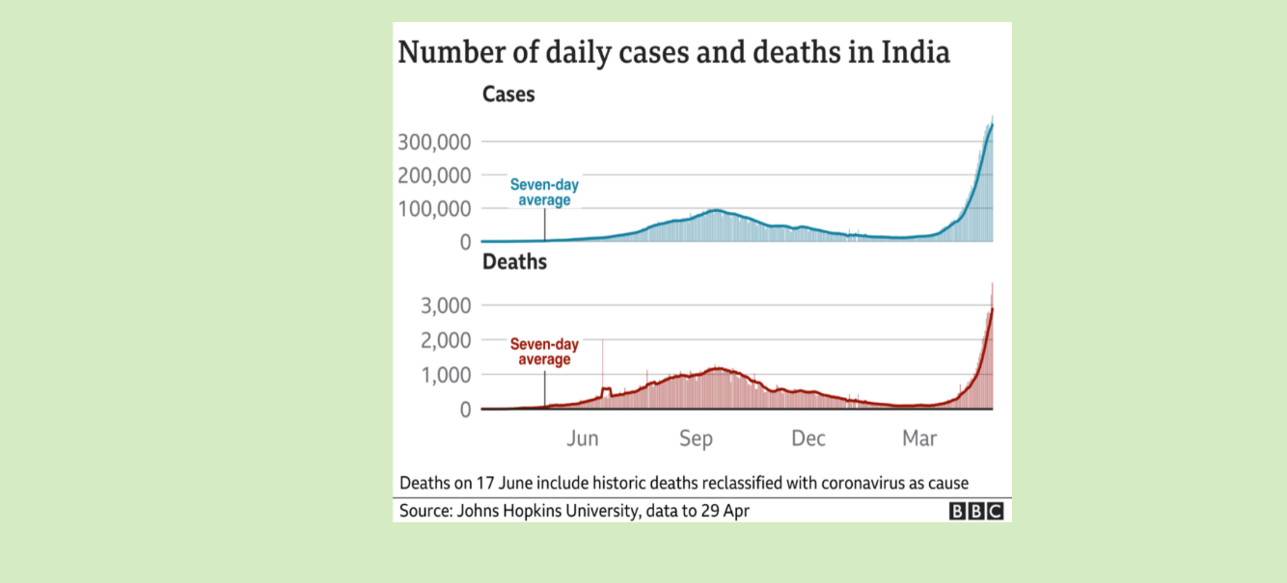

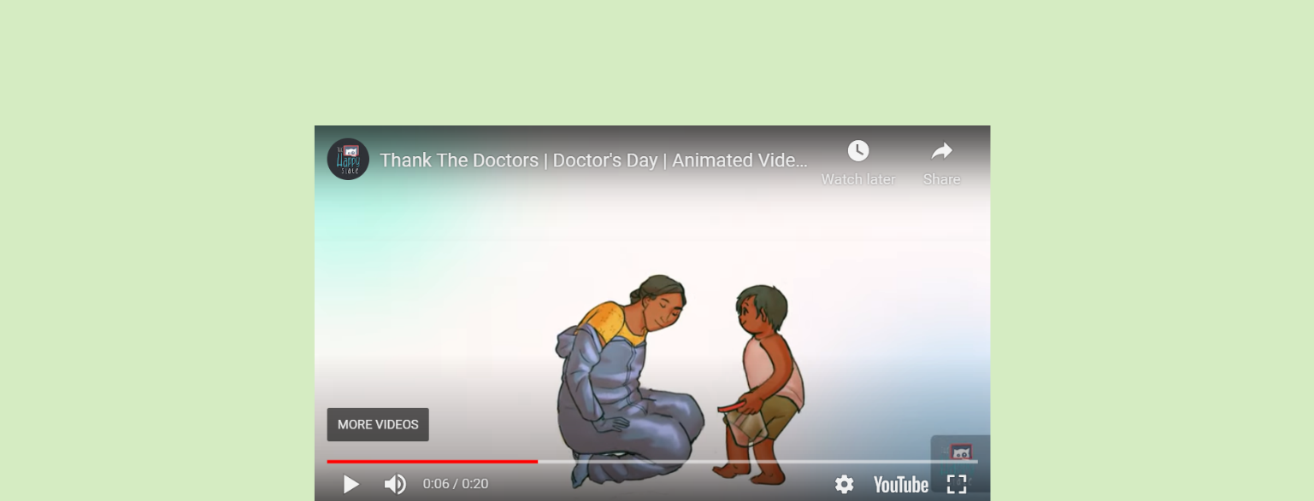

**BIBLIOGRAPHY**

* https://www.youtube.com/embed/VB9iELUVZEg

## ABOUT MY TEAM

**TEAM MEMBERS :-**

**NAME:-** SUVARNA

**NAME:-** SHOBHIT MISHRA

**NAME:-** MOHAMMED AKIF