Symmetry: Lines of Symmetry & Rotational Symmetry
Notes for Deep — 11+ Maths (Shape & Symmetry)

1. What is a Line of Symmetry?
A line of symmetry (also called a mirror line or axis of reflection) is a line that divides a shape into two halves that are exact mirror images of each other.
If you folded the shape along this line, one half would land exactly on top of the other half — every point matches up perfectly.
Test to find it:
Imagine folding the shape (or trace it onto paper and physically fold). If the two halves match exactly along a fold line, that line is a line of symmetry. Keep testing different lines — vertical, horizontal, and diagonal — until you have found them all.

2. What is Rotational Symmetry?
A shape has rotational symmetry if it looks exactly the same after being turned (rotated) about a fixed centre point, before it completes one full 360° turn.
The order of rotational symmetry is the number of times the shape matches its original outline during one complete 360° turn.
Important rule:
Every shape technically matches itself once it turns all the way round (360°). So the smallest possible order is 1 — and order 1 really means "no rotational symmetry." Only say a shape HAS rotational symmetry if the order is 2 or more.

3. Key Formulas
Shape type | Lines of symmetry | Order of rotational symmetry | Angle turned each match
Regular polygon with n sides  (equal sides & angles) | = n | = n | = 360° ÷ n
Irregular shape | Check by folding  (no formula) | Check by rotating  (no formula) | —

Worked example of the formula: a regular hexagon has n = 6 sides, so it has 6 lines of symmetry and rotational symmetry of order 6, matching every 360° ÷ 6 = 60° turn.

4. Quick Reference — Common Shapes
Shape | Lines of symmetry | Order of rotational symmetry
Equilateral triangle | 3 | 3
Isosceles triangle (not equilateral) | 1 | 1 (none)
Square | 4 | 4
Rectangle (not a square) | 2 | 2
Rhombus (not a square) | 2 | 2
Parallelogram (not a rectangle/rhombus) | 0 | 2
Regular pentagon | 5 | 5
Regular hexagon | 6 | 6
Circle | infinite | infinite
Letter W | 1 | 1 (none)
Letter S / Letter Z | 0 | 2
Letter H / Letter X | 2 | 2
Most irregular shapes | 0 | 1 (none)

5. Exam Tips
- Lines of symmetry and rotational symmetry are separate checks — a shape can have one without the other (e.g. the letter W: 1 line, no rotational symmetry).
- Always check vertical, horizontal AND diagonal lines when hunting for lines of symmetry — don't stop after checking just up-down and left-right.
- For rotational symmetry, physically (or mentally) spin the shape a quarter-turn at a time and check if the outline still matches.
- "Order 1" and "no rotational symmetry" mean the same thing — don't write "0" for order, the lowest possible order is 1.
- An irregular shape (sides/angles all different, no obvious pattern) almost always has 0 lines of symmetry and order 1 rotational symmetry.

6. Solved Questions from Deep's Worksheet

Question 2 — Lines of symmetry & order of rotational symmetry
"How many lines of symmetry does the below shape have? What is its order of rotational symmetry?"
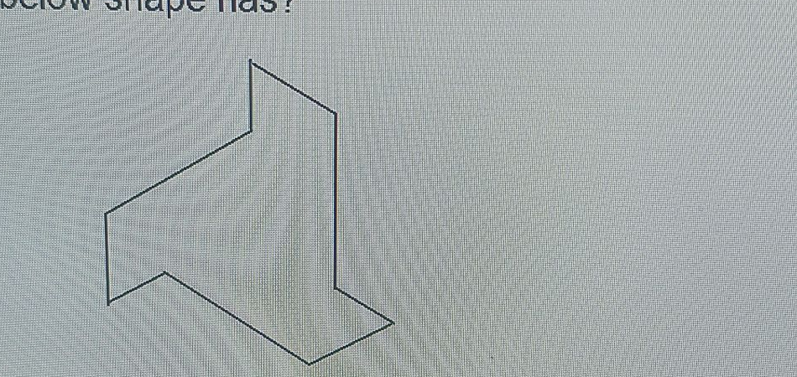
How to solve it:
1. Look at the shape — every side is a different length and every angle is different. There is no straight line you can draw that splits it into two mirror-image halves, so it has 0 lines of symmetry.
2. Now imagine spinning it. Because no two parts of the outline are the same shape/size and arranged evenly around a centre, it only ever matches its start position after a full 360° turn.
Answer:
a) Lines of symmetry = 0
b) Order of rotational symmetry = 1 (i.e. no rotational symmetry)

Question 27 — Comparing five shapes (A–E)
"Which shapes have one line of symmetry and no rotational symmetry? What is the order of rotational symmetry for shape E?"
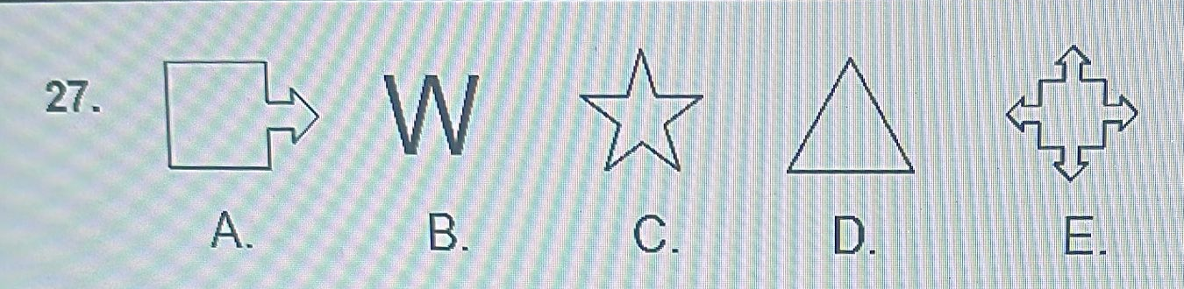
Go through every shape one at a time, checking lines of symmetry first, then order of rotational symmetry:
Shape | Lines of symmetry | Order of rotational symmetry | Fits the rule (1 line, no rotation)?
A — square + arrow | 0 (arrow breaks the balance) | 1 (none) | No — 0 lines
B — letter W | 1 (straight down the middle) | 1 (none) | Yes
C — 5-point star | 5 | 5 | No — has rotational symmetry
D — isosceles triangle | 1 (straight down the middle) | 1 (none) | Yes
E — 4-way arrow (compass shape) | 4 (up-down, left-right, and both diagonals) | 4 | No — has rotational symmetry

Answer a):
Shapes B (W) and D (triangle) each have exactly one line of symmetry and no rotational symmetry.

Answer b):
Shape E has rotational symmetry of order 4 — turning it by 90° (a quarter turn) four times brings it back to a matching position each time before completing the full 360°.

Practice Reminder
Before Deep's next test: pick any 5 everyday objects or letters (e.g. road signs, capital letters A–Z) and for each one work out both the lines of symmetry AND the order of rotational symmetry using the folding/spinning tests above. This builds the habit of checking both properties every time, not just one.

