**Training Report**

Of Industrial Training Undertaken At

**Bharat Electronics Limited, Ghaziabad**

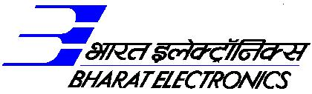

**Submitted By: Under the Guidance of:**

**Name:** Saumya Mishra **Name:** Vinod Kumar

**UPT No:** 022 **Designation:** Snr.DGM

**College:** Kalinga Institute of Industrial **Department:** D&E, RADAR

Technology, Bhubaneswar

**Bharat Electronics Limited**

(A Govt. Of India Enterprise, Ministry of Defence)

Ghaziabad

**Acknowledgement**

I am highly grateful to Bharat Electronics Limited Ghaziabad, one of the leading defence organizations of the nation, for providing me an opportunity to undertake training at Ghaziabad, Uttar Pradesh. It was a great learning experience as I was introduced to various aspects of the working of the organization, the latest state of the art technologies & machines used in the manufacturing processes. It was wonderful to see the company striving hard to keep up the national security at par with the rest of the world. I would like to express my sincere gratitude towards Mr. Mukul Nautiyal (Manager, D&E-Radar/IFF) and Mr. Vinod Kumar (Snr. DGM, D&E-Radar) for their regular support and guidance that helped me in successful completion of my training. At the end I would like to thank all the staff members of BEL, Ghaziabad who made this training a rich learning experience.

**Monopulse Equation and GUI Generator**

Submitted by: Saumya Mishra (21052357@kiit.ac.in)

School of Computer Engineering, KIIT Deemed to be University, Bhubneswar-751024, Odisha, India

1. **Introduction**

Radar, an acronym for Radio Detection and Ranging, is a system that uses radio waves to detect, locate, and track objects. By emitting electromagnetic waves and analyzing the reflected signals, radar can determine the distance, speed, and direction of objects, ranging from aircraft and ships to weather formations and terrain.

This project is based on a monopulse radar. Monopulse radar is a sophisticated type of radar system that enhances target detection and tracking accuracy by simultaneously comparing the received signals from multiple antennas or antenna beams. Unlike traditional radar systems that rely on sequential measurements to determine a target's direction, monopulse radar uses a single pulse to extract angular information, reducing errors caused by target movement or environmental conditions. This is achieved by analyzing the phase and amplitude differences between the signals received in different channels.

In radar systems, an FPGA (Field-Programmable Gate Array) is a re-configurable integrated circuit used for high-speed signal processing, beam-forming, and data handling. FPGAs enable real-time processing of radar signals, dynamic control of antenna arrays, and execution of complex detection and tracking algorithms. Their flexibility allows for updates and adaptations to evolving technologies, enhancing radar performance and efficiency.

In this project, the radar receiver (denoted by Ro) transmits the collected data to the FPGA. The FPGA then uses a UDP port to forward the data to the software running on a PowerPC. The software processes the data by performing the necessary filtering and extraction, and the final output is displayed on the GUI[Fig.1].

UDP

Port

FPGA

FPGA

FPGA

To

Filtered

Daa

GUI

Power PC

Software

FGPA

Ro

Fig. 1 RADAR

The data obtained from radar systems often includes substantial irrelevant information, complicating the process of drawing accurate conclusions. In monopulse radar systems, errors in target direction determination arise due to the assumption that the target is aligned with the main beam's axis. To address this issue, we developed a program that filters the received radar data, performs necessary analyses, and formulates a monopulse equation with minimized error. Additionally, the program visualizes the equation through graphical representation, enhancing the interpretation and accuracy of the target's location.

* 1. **Keywords Involved**

This project contains various keywords, which we should be aware of in order to have a better understanding of the project.

1. **Code number**

This project focuses on the Identification of Friend or Foe (IFF) Laboratory. It explores various communication modes with aircraft, which differ based on purpose and urgency.

1. Mode 1 and Mode 2: These are exclusively for military aircraft communication. Mode 1 uses Radio Frequency (RF) to return the mission code, while Mode 2 returns the aircraft's tail number.
2. Mode 3/A and Mode 3/C: These modes are used for interrogating commercial aircraft.
3. Mode 4 (ISI): For more secure communication, Mode 4 is employed. It involves 32-bit encryption and decryption of the RF signal.

(iv) Emergency Codes: Aircraft can change their code to specific default numbers under certain conditions, such as emergencies like hijackings or mayday situations.

In this project, the term "code number" specifically refers to the identification number received during communication with aircraft using Mode 3/A RF.

1. **Sigma**

To transmit radio waves using a radiating rod, two types of feed mechanisms can be employed: current feed and voltage feed. In the current feed method, an electric current is supplied to a rod made of an appropriate material, causing it to emit radio waves. This process generates dipoles with both negative and positive charges. However, a single dipole is insufficient for radar applications due to its limited strength. Therefore, we utilize an array of dipoles to enhance the signal. Within this array, "sigma" represents the total voltage, which is the sum of the voltages from each dipole in the field.

1. **Delta**

Contrasting to sigma, delta refers to the negation, or difference in voltages in the dipole field. In a monopulse radar system, it refers to the difference in the received signal's amplitude or phase between two or more receiver channels. This difference is used to determine the direction of a target relative to the radar's boresight (central axis).

1. **Azimuth Change Pulse (ACP)**

The location and range of an aircraft are determined by transmitting a wave that reaches the aircraft. The aircraft then sends back a signal, which is received by the receiver. This entire process is referred to as a "hit."

Upon sending the signal, a 12-bit shaft encoder is activated. When the reply signal is received, the encoder is stopped to capture the current value, a process known as ACP latching.

To facilitate mathematical operations and analysis, the captured data is processed by multiplying it by 360 (representing the full range of radar in degrees) and then dividing by 4096 (the range of the 12-bit encoder, which operates from 0 to 4096). This calculation yields the azimuth in degrees.

1. **Scan number**

This refers to how often the radar completes a full scan cycle (e.g., 360 degrees horizontally). It is usually measured in scans per second (Hz) or scans per minute.

1. **Solution Algorithm**
   1. **Extraction and Filtering of Data**

The initial step involves data extraction, where information is obtained from UDP packets, resulting in a pcap file format[Fig. 2]. Next, we integrate the file path of this pcap file into our program **"data_from_pcap.py"**, responsible for converting the data into a CSV format, stored as "data_from_pcap.csv". This process encompasses extracting crucial parameters like code number, sigma, delta, and ACP.

Next, depending upon whether the code number is detected above or below the boresight of the beam, the two sides are declared as positive or negative side (0 or 1) to narrow down the search area.

Subsequently, the program proceeds to compute the number of scans associated with each code number. This calculated data is then saved in the file "code_and_scan.csv". By analyzing these scan numbers, we gain insights into the frequency of radar sweeps corresponding to specific operational codes. Ultimately, the output comprises two files: "data_from_pcap.csv" and "code_and_scan.csv", encapsulating the extracted data and the computed scan numbers for further analysis.

This process can be time taking, depending upon the size of the pcap file.

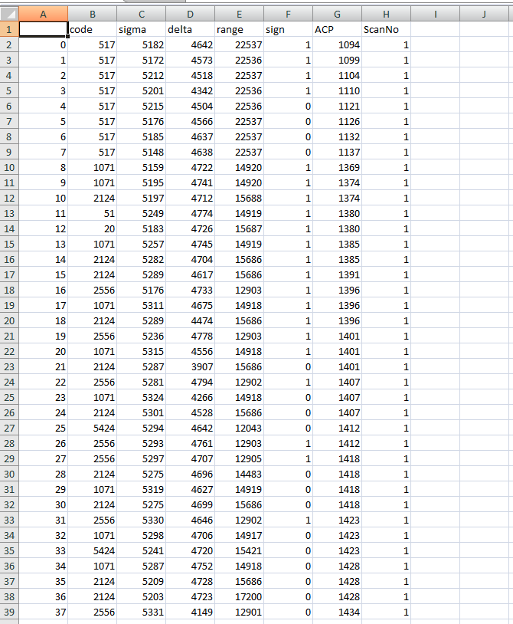

Fig. 2 Pcap File

* 1. **Data Analytics**

1. **Building Dictionary to Manage Scan Data**

The script **“GetCodeScanAndACPInDictionary.py”** constructs a dictionary to efficiently manage scan data. This dictionary uses "code" as the primary key, with "ScanNo" and "ACP" as secondary keys associated with each code. The script leverages a group-by clause to achieve this. The resulting dictionary is then saved as a JSON file named "scan.json".

1. **Applying ACP Filter and Validating Targets**

Next, the program **“applyAcpFilterAndGetValidTarget.py”** refines the scan data for more accurate target identification. Here's why this filtering is crucial:

1. Radar Noise: the radar can capture ACP information beyond the intended beam width. This introduces noise into the data.
2. Outlier Detection: ACP values are expected to exhibit a consistent upward trend. The script identifies and removes outliers that deviate from this pattern.
3. Search Region Constraints: The filtering ensures that ACP values fall within the valid search region, which is either 0 or 1.

The filtered and validated data is then saved as a CSV file named "after_apply_beamWidthCriteria_Scan_and_code.csv".

1. **Selecting Top 10 Data**

The python file **"Top10_inbound_or_outbound.py"** is then run to select the 10 most consistent scan number data for higher accuracy while plotting the monopulse equation. The script also gives the description of the data. The output files are "no_of_scan_and_code.csv" and "no_of_scan_per_code.csv"

1. **Apply 100 km Filter**

Radio waves provide much inaccurate data after ranges such as 100 km due to optic phenomenon such as interference of wave. Due to this reason, we filter out the code numbers having range more than 100 km using **"Range_filter_on_top10.py".** The output file is "Range_filter_on_top_10_target.csv"

1. **Obi Calculation**

The script **"top10Range100km_allscan_Sigma-delta_increasing_sign1.py"** generates a file containing the different ACP values along with their corresponding obi values (sigma - delta) of all the 10 targets, which are under 100 km range.

The output file which is obtained in this step is “DifferentACP_vs_sigma-delta_Top10_range100km_allScan_sigma-delta_increasing.csv"

* 1. **Visualization**

The general form of the monopulse equation is y = ax3+bx2+cx+d where the coefficients refer to different values. For visualization, we use the script **“graphformation.py”** which first drops the NA values, gives the monopulse equation, and finally prints the graph with obi value on x-axis and ACP on y-axis[Fig. 3].

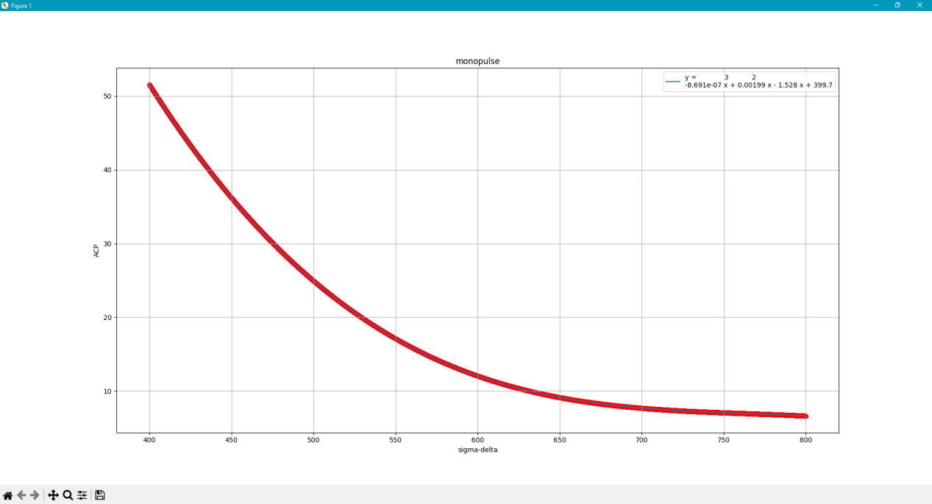

Fig. 3 Monopulse Equation

Further, **"csvGeneration_for_callibration_load.py"** generates the file which is responsible for loading in the GUI, with the output file named "calibration_load.csv".

1. **Conclusion**

Effective data extraction and filtering were crucial components of this project. We developed a program that efficiently extracts relevant data from UDP packets and filters out noise, ensuring accurate target identification. This process was essential for maintaining the integrity of the radar data and enhancing the overall reliability of the system. By addressing the challenges of radar noise and outlier detection, we ensured that the processed data was both accurate and useful for further analysis.

Accurate calculation and visualization of the monopulse equation were significant achievements of this project. By computing the monopulse equation and visualizing it through a graphical user interface, we improved the interpretability of radar data and enhanced the accuracy of target location determination. This visualization facilitated better understanding and enabled more precise tracking of targets.

The optimization for real-time processing was another critical aspect. The use of FPGA for high-speed signal processing and dynamic control of antenna arrays enabled real-time data handling and processing, which is crucial for radar operations. This capability ensured that the radar system could respond promptly to dynamic scenarios.

Comprehensive data analysis was achieved through the development of various scripts, allowing for effective processing and analysis of radar data. These scripts generated meaningful insights and ensured reliable performance of the radar system. The methodologies developed during this project can be leveraged for further enhancements in radar systems.

In conclusion, the successful completion of this project contributed to the advancement of radar technology at BEL. The insights gained and the methodologies developed stand as a testament to the potential of integrating cutting-edge technology and innovative algorithms in achieving superior radar performance.