**ADDING INTELLIGENCE TO ROBOTIC PROCESS INFORMATION**

**-SAUMYA ARORA**

**ABSTRACT: -**

**Robotic process automation (or RPA) is a form of business process automation technology based on metaphorical software robots (bots) or artificial intelligence (AI)/digital workers. It is sometimes referred to as *software robotics* (not to be confused with**[**robot software**](https://en.wikipedia.org/wiki/Robot_software)**).**

**In traditional**[**workflow**](https://en.wikipedia.org/wiki/Workflow)[**automation**](https://en.wikipedia.org/wiki/Automation)**tools, a**[**software developer**](https://en.wikipedia.org/wiki/Software_developer)**produces a list of actions to automate a task and interface to the back-end system using internal**[**application programming interfaces**](https://en.wikipedia.org/wiki/Application_programming_interfaces)**(APIs) or dedicated**[**scripting language**](https://en.wikipedia.org/wiki/Scripting_language)**. In contrast, RPA systems develop the action list by watching the user perform that task in the application's**[**graphical user interface**](https://en.wikipedia.org/wiki/Graphical_user_interface) **(GUI) and then perform the automation by repeating those tasks directly in the GUI. This can lower the barrier to the use of automation in products that might not otherwise feature APIs for this purpose.**

**RPA tools have strong technical similarities to**[**graphical user interface testing**](https://en.wikipedia.org/wiki/Graphical_user_interface_testing) **tools. These tools also automate interactions with the GUI and often do so by** [**repeating a set of demonstration actions**](https://en.wikipedia.org/wiki/Programming_by_demonstration)**performed by a user. RPA tools differ from such systems in that they allow data to be handled in and between multiple applications, for instance, receiving an** [**email**](https://en.wikipedia.org/wiki/Email)**containing an invoice, extracting the data, and then typing that into a**[**bookkeeping**](https://en.wikipedia.org/wiki/Bookkeeping)**system.**

**TABLE OF CONTENTS: -**

* AUTOMATION
* WHY AUTOMATION PROCESS IS SO IMPORTANT?
* ROBOTIC PROCESS AUTOMATION
* TYPES OF ROBOTIC PROCESS AUTOMATION
* BUSINESS BENEFITS OF RPA
* WHY IS RPA TRANSFORMATIVE?
* GENERAL USES OF RPA
* IMPORTANT FEATURES AND CAPABILITIES IN RPA TECHNOLOGY
* RPA AS THE FASTEST GROWING ENTERPRISE IN THE SOFTWARE WORLD
* IS RPA AS SAME AS ARTIFICIAL INTELLIGENCE (AI)?
* HOW IT IS DIFFERENT FROM DESKTOP APPLICATIONS?
* RPA TOOLS
* ADVANTAGES OF RPA
* DISADVANTAGES OF RPA
* CONCLUSION

**AUTOMATION: -**



**Automation describes a wide range of technologies that reduces human intervention in processes.** Human intervention is reduced by predetermining the decision criteria, subprocess, relationships, and related actions and embodying that predetermination in machines.

It includes the use of various control systems for operating equipment **such as machinery, processes in factories, boilers, and heat treating ovens, switching on telephone networks, steering, and stabilization of ships, aircraft, and other applications and vehicles reduced with human intervention**

It crosses all functions within the industry from installation, integration, and maintenance to design, procurement, and management, automation even reaches into the marketing and sales functions of these industries. It involves a very broad range of technologies including robotics and expert systems, telemetry and communications, electro-optics, cybersecurity, process measurement and control, sensors, wireless applications, system integration, test measurement, and many more.

**WHY AUTOMATION PROCESS IS SO IMPORTANT?**

**Let us understand this with the help of an example: -**

Think about the cell phone and computer you use every day to do your job or think of any modern convenience or necessity. Just about anything you can think of is the result of the complex process. Without talented individuals to design, build, improve, and maintain this process, these technological advances would never have occurred and future innovation would be impossible. Without automation professionals, our world and our future would be very different. The work of automation professionals is critically important to the preservation of health, safety, and welfare of the public and the sustainability and enhancement of our quality of life.

**ROBOTIC PROCESS AUTOMATION: -**

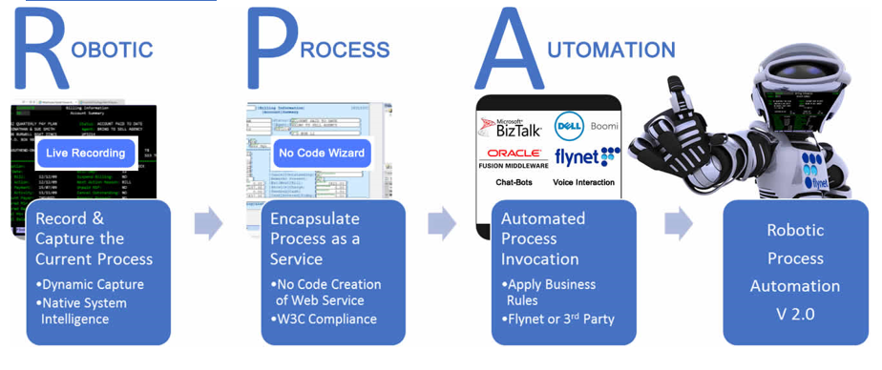

**If “Machine Learning” sounds like the beginning of a bleak dystopian future- think Terminator mixed with the matrix-then “Robotic Process Automation” must be the phase when the machines rise to rule humankind with ruthless efficiency.**

Fortunately, Robotic Process Automation (RPA) involves nothing of the sort, except perhaps for the efficiency part. There isn't even any robotics involved in this automation software. Rather they are software robots running on a physical or virtual machine.

**Robotics Process Automation (RPA) is a software technology that makes it easy to build, deploy, and manage software robots that emulate humans’ actions interacting with the digital systems and software**. Just like people, software robots can do things like understanding what’s on a screen, complete the right keystrokes, navigate systems, identify and extract data, and perform a wide range of defined actions. But software robots can do it faster and more consistently than people, without the need to get up and stretch or take a coffee break.

**TYPES OF RPA: -**

1. **Attended automation:** These tools will require human intervention while performing automation processes.
2. **Unattended automation:** These tools are intelligent and have decision-making capabilities.
3. **Hybrid RPA:** These tools will have combined capabilities of both attended and unattended automation tools.

**BUSINESS BENEFITS OF RPA: -**

1. **Cost Savings: -** One of the biggest advantages of robotic process automation is the immediate and significant reduction in expenditure it can deliver. When work is automated, not only is it completed faster, but it also can be performed round the clock at a much lower rate. So, you get greater output for less, which results in a better bottom line.
2. **Consistency: -** Robotics is a safe, non-invasive technology that doesn't interfere with the inherent systems and provides perfect consistency in performing the activities across the board every time.
3. **Quality, Accurate Work: -** Let’s face it. Even the most careful human can and will make a mistake. Multiply those errors by the number of people you have performing routine tasks for your company, and you could be looking at a pretty costly problem. With RPA, the work is performed error-free. Better quality means higher satisfaction rates, which – again – is good for your company’s profitability.
4. **Improved Analytics: -** Having access to error-free, accurate data from various sources would improve the quality of analytics in the process. This leads to better decision-making and betterment of the process execution.
5. **Increased Employee Productivity: -** RPA ultimately facilitates humans and robots to do just what they excel at. As RPA frees the employees from their mundane tasks, they can focus on more and more client and customer interaction, relationship management, and other such activities where humans naturally excel at. Having satisfied clients and customers only mean better business.
6. **Increased Customer Satisfaction: -** Delivering better quality of work with high accuracy and improved customer/client interaction leads to increased customer and client satisfaction, this only adds to the goodwill of the business.
7. **Faster*: -*** As bots are handling the execution here, a larger amount of work can be done in a relatively much shorter period. A faster delivery, coupled with accuracy becomes the norm with automation.
8. **Reconciliation From Multiple Systems: -** It makes the tallying of data and information from the multiple systems possible which generates information that helps with the integration of the process.
9. **Versatility: -** It is applicable across industries and can perform a wide range of tasks. Any rule-based process that can be defined and is repeatable makes an ideal automation candidate.
10. **Better IT Support and Management: -** RPA improves the operational quality of the service desk and monitors the network. This enables companies to handle short-term spikes without having to recruit extra staff or train them.

**WHY IS RPA TRANSFORMATIVE?**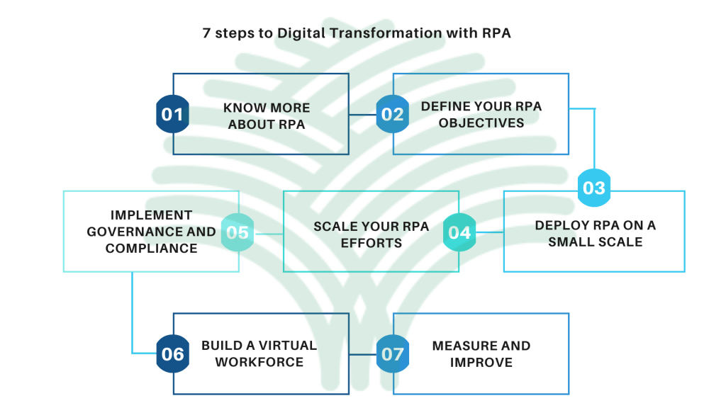

RPA technology is changing how the world gets the work done. Software robots instead of people do repetitive and lower-value work **like logging into applications and systems, moving files and folders, extracting, copying, and inserting data, filling in forms, and completing routine analysis and reports.** Advanced robots can even perform cognitive processes like interpreting a text, engaging in chats and conversations, understanding unstructured data, and applying advanced machine learning models to make complex decisions.

When robots do these types of repetitive, high-volume tasks, humans are freed to focus on the things they do best and enjoy more like innovating, collaborating, creating, and interacting with customers. **Enterprises get a boost, too like higher productivity, efficiency, and resilience.** It’s no wonder that RPA is rewriting the story of work and workflow

As per facts, 90% of employees are currently burdened with boring and repetitive tasks that could easily be automated, according to **THINK AUTOMATION**. RPA can help to free up employee time by carrying out the manual, administrative tasks so that other staff can focus on the value-based tasks instead. **This also helps to eliminate human error because bots are programmed to follow routine tasks with extreme accuracy, so there is no risk of typos or incorrect information entries.**

**GENERAL USES OF RPA: -**

1. **Customer Service: -** RPA automation changes how businesses can deal with their customers. Namely, it makes ticket resolution significantly easier and faster. **EXAMPLE: -** A company is receiving a stream of complaints, but until now has been dealing with them manually, one at a time, with a human agent. They install an RPA bot, which is programmed to sort and process the information gathered from the complaints into determined categories.

**If complaints fall into categories that have pre-determined courses of action, those actions can then be undertaken by the bot.** These are all actions that would otherwise be performed by a human, but RPA allows for quicker resolution.

1. **Invoice Processing: -** Financial processes are crucially important to the everyday functions of any company. Invoices can be difficult be a process. When dealt with manually, people can expect to deal with disparate file formats, awkward email attachments to deal with—these routine tasks take up a lot of time and energy.

An automated RPA bot can help by recognizing files and dissecting data from them without any human input. **Invoicing would be considered a prime candidate for automation.** This is because invoicing by its nature is a rules-based process; it’s simply reporting a state of affairs to the customer’s which makes it a perfect job for an unattended RPA bot.

**EXAMPLE: -** A bot is programmed to check on a particular folder. When an invoice file is put into the folder, the bot is alerted and proceeds to read and document all the relevant necessary information and disseminate it to where it needs to go.

**This vastly reduces the time it takes for a customer to receive the information they need, improving their satisfaction. It also removes the necessity for an employee to spend their day performing invoicing demonstrably automatable tasks.**

1. **Boost Productivity: -** When you’re employing a specialist who excels in their field, and they’re spending hours on inputting or gathering data, that is a waste of your money and their time.



**The principal advantage of automation with RPA is that you’re effectively hiring another employee to do that job at a small fraction of the price. These bots never have to take a break, never make a mistake, and work 24/7.**

The effect this has on human workers is substantial. There is also the additional advantage of making your employees happier and improving their job satisfaction. No one wants to spend their time doing manual data entry, especially not when automation alternatives are readily available.

1. 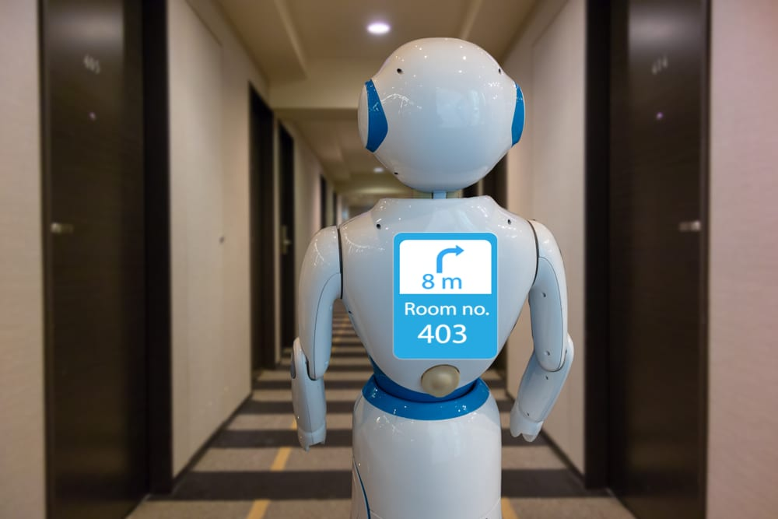**Employee Onboarding: -** Onboarding is often littered with administrative tasks that need completing—often mundane and repetitive. It can be used to automatically generate and send offers and trigger an automated workflow when the employee’s account is created. As most business owners will know, paper is expensive and wasteful.

**RPA can also be used to reduce the amount of paperwork you process, by having an electronic capture system that removes the need to create paper copies of documents by receiving and dealing with them digitally.**

1. **Payroll: -** Most HR employees understand how tedious and time-consuming payroll processing can be. **Bots can be used extensively to help your payroll team by standardizing your processes. Instead of studiously looking over spreadsheets and writing out checks by hand, get a system that does it for you.**

An automated payroll can be designed to do a large swathe of payments, like salaries, overtime, commissions, bonuses, raises, wage deductions, and expenses. Your HR staff will be better served with an automation system to help them so they can deal with tasks that need them.

1. **Storing Information: -** Big data is a huge aspect of modern business. MNCs preside over more data now than ever before, and the volume of data is growing exponentially. Because of this, being able to effectively sort through your mountains of data is vital.

**RPA is invaluable to organizations because it can sift through large amounts of data wirelessly, with no errors, and around the clock.** **This is where RPA automation is at its best**—it can streamline the process that would take a human a lot longer and allow them to do something that needs a human touch.

Automation like this is most successful in situations where the task is predictable and manual, as bots can be specifically assigned to do that one simple task.

As the amount of data within MNCs increases over time which it will, businesses will need to utilize methods such as RPA which will help organize this influx of information and store it in a central repository quickly and without the chance for error that is common with humans.

1. **Analytics: -** Removing the human element from data gathering is also important when it comes to providing you with data analytics and insights. The amount of data in business provides great opportunities for valuable insights into what can be improved within your processes.

**For decision-makers, quality data is an important tool.** Unfortunately, because of human error, these business leaders can have to deal with data that is of poor quality. **With RPA, not only can they tirelessly go through great amounts of data, but they can be programmed to spot information that is useful to humans.**

Bots excel at this, and it ensures that the data you have is high quality and defined by the rules that you set—**meaning you only get exactly what you need. So, as far as trawling large data sets goes, RPA is completely unparalleled in performing these tasks.**

And this is no small thing either—companies rely on data more now than they ever have done, whether it’s for market research or assessing the performance of their employees.

**IMPORTANT FEATURES AND CAPABILITIES IN RPA TECHNOLOGY: -**

1. **Simple Bot Creation Interface: -** RPA tools allow creating bots quickly and effortlessly by capturing mouse click and keystrokes with built-in screen recorder components. Many RPA products include the option to create and edit bots manually using the Task Editor.
2. **Rule-based Exception Handling: -** RPA system supports deployments with rules-based exception handling. This feature proactively handles the exception. Just consider a robot reports an exception, and then the following actions are triggered: -
   1. 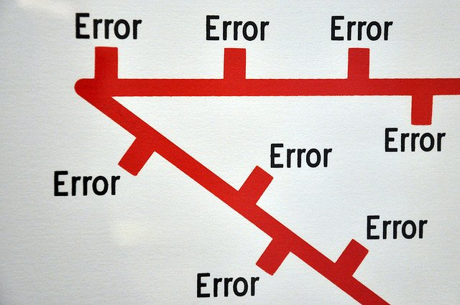The server re-assigns the same process to another bot for a retry as well as removes the 1stbot from production.
   2. In case the retry is successful, the server maintains the reassignment and raises a level 2 alert to report exception & resolution.
   3. If the retry is unsuccessful, it stops the 2ndbot and raises a level 1 alert to report exceptions as well as failed resolutions.
3. **Debugging: -** The biggest benefit of RPA from a development perspective is its capability to go through a process and adjust dynamically**. Some RPA tools require stopping running to make the change and replicate the process. Other RPA tools allow dynamic interaction while debugging.** It also allows changing variable values to test different scenarios

without start and stop the running. This dynamic approach of debugging allows to develop on the fly and to resolve issues in a production environment without requiring changes to the process.

1. **Actionable Intelligence: -** The actionable intelligence feature of the RPA refers to **the ability to gain and apply knowledge as skills**. Robots that obtain both structured and unstructured data convert it into information and transforms the information into actionable intelligence for the end-user or customer. **AI and cognitive intelligence are the common features of RPA solutions.** They can involve machine learning, computer visions, and cognitive automation to help bots improve decision-making over the period. Hence, most of its functionalities can be automated without the need for extra extensions.
2. 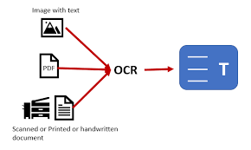**Optical Character Recognition (OCR):** - Outlining the optical character recognition in the RPA platform becomes a new trend today. Some RPA vendors begin expanding the capability of the RPA portfolio by taping advanced OCR to include simpler data extraction from documents and images**.**

**The most standard feature of the RPA tool is screen scraping that deals with capturing bitmap data from the system screen and cross-check it against stored details to decipher it.** This is attained by integrating with OCR engines like Google and Microsoft. In addition to text recognition, it possesses the capability to structure data while reading structured documents. Invoices, tax forms, claim to process, and rating generators are some document sets that make customer requires OCR with RPA initiatives.

1. **Seamless Integration:** - The core enterprise RPA integration is merging with the various 3rdparty applications in the digital infrastructure of businesses. With seamless integration, RPA tools provide unparalleled flexibility in evaluating the digital workforce performance. The following table depicts the most common integration in robotic process automation software.
2. **Less Script or Script Less Automation:** - The modern RPA tools are code-free and can automate any application in any department where the admin or clerical work is performed across an enterprise. Hence, the employees with less programming skills can create bots, just through GUI and different intuitive wizards. **This low-code or less code development platform reduces the amount of hand-coding writing and enables accelerated delivery of business apps. In addition, this platform lowers the initial cost of installation, training as well as deployment.**

**RPA AS THE FASTEST GROWING ENTERPRISE IN THE SOFTWARE WORLD: -**

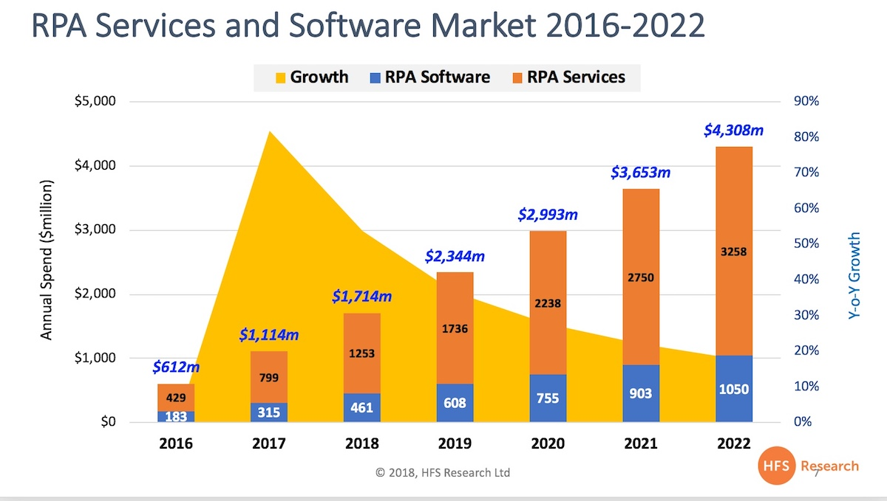

**RPA will reach$4.3 bn by 2022.**

**So why is RPA growing above initial analyst estimates?**

1. RPA vendors, particularly **UiPath and Automation Anywhere (AA),** have been able to recognize more revenues than expected. Bots’ licenses are being sold and deployed faster than we envisaged, due to effective training programs and aggressive support from third-party services firms.
2. The slowdown in new business process outsourcing engagements is driving more focus from enterprises in discrete strategies to drive efficiencies and digitize processes (and encourage more [bots plus human engagements](https://www.horsesforsources.com/rpa-new-outsourcing_051018)).
3. The shift in the focus of RPA from job elimination to augmenting talent, digitizing processes, and extending the life of legacy IT systems has increased the appetite of operations executives to fast-track RPA training programs and invest in broader intelligent automation strategies – even though most enterprises are still in the **“**[**tinkering phase**](https://www.horsesforsources.com/hyper-connected-intelligent-automation_082618)**”.**
4. The initial adoption of "attended RPA", which makes up the majority of RPA and RDA engagements currently in play will eventually drive more "unattended RPA" where the increased value will be created and genuine alignment between RPA models proving to be a [gateway to broader AI engagements](https://www.horsesforsources.com/RPA-gateway-drug_181010).
5. The ramp-up from service providers and consultants to support enterprise adoption has continued unabated, especially with the flattening of outsourcing investments and the waning interest in Global Business Services models. This reliance on third parties has proven to be a key dynamic behind the growth in RPA as solution providers prefer to sell through the services channel for larger enterprise deals and accelerate client training and development. **The**[**strong focus**](https://www.linkedin.com/feed/update/urn:li:activity:6465318934529785856/) **from the likes of Accenture, Capgemini, Deloitte, EY, and KPMG has given the RPA market immense credibility.**

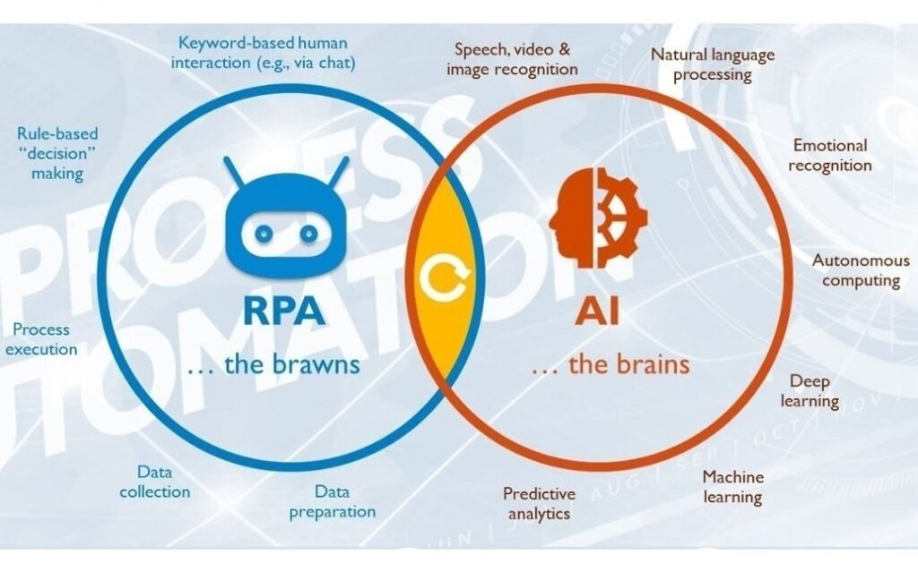**IS RPA AS SAME AS ARTIFICIAL INTELLIGENCE (AI)?**

**RPA is not AI; AI is not RPA.** But the combination of RPA and AI unlocks massive new possibilities for enterprises everywhere. For one thing, **RPA technology now makes it possible to insert advanced AI skills in the form of machine learning models, natural language processing (NLP), character and image recognition, and more into RPA robots.** Giving robots these AI skills dramatically expands their ability to handle cognitive processes that require things like:

1. **Understanding documents including semi-structured or unstructured data**
2. **Visualizing screens (including virtual desktops)**
3. **Comprehending speech and carrying on conversations and chats**

AI is also making it possible to scientifically discover a complete range of automation opportunities and build a robust automation pipeline through RPA applications like process mining. After some time when companies need to accelerate their integration of AI into front-line activities and decisions, many are finding that RPA can serve as **AI’s ‘last-**mile delivery system.

Robots can be configured to apply machine learning models to automated decision-making processes and analyses, bringing machine intelligence deep into day-to-day operations.

**While RPA is used to work in conjunction with people by automating repetitive processes (attended automation), AI is viewed as a form of technology to replace human labor and automated end-to-end (unattended automation). RPA uses structured inputs and logic, while ai uses inputs and develops its logic. Combining both RPA and AI can create a fully autonomous process**

### How Is It Different from A Desktop Application?

### Both Desktop applications, as well as RPA, perform multiple tasks.

**But how are these two different?**

**The difference will be identified when it comes to decision-making capability**. RPA helps with front-end operations and back-end operations.

While dealing with the front-end operations RPA will require an understanding of the natural language. Backend operations require dealing only with structured and unstructured data. Dealing with structured data means working with a database and dealing with unstructured data includes working with documents and images.

**RPA TOOLS: -**

1. **BLUE PRISM: -**

Blue Prism RPA provides all core capabilities. It can work on any platform with any application. For using this tool, you should have programming skills but it is user-friendly for developers. This tool is perfect for medium and large organizations.

**Features:**

* It supports a multi-environment deployment model.
* Security provided for network and software credentials.
* It can be used on any platform.
* Can work for any application.

**Pros:**

* High-speed execution.
* Platform independence.

**Cons:**

* You should have programming skills.
* High price.

1. **INFLECTRAA RAPISE: -**

Rapise provides support for hybrid business scenarios. It can automate Web, Desktop, and Mobile applications. It is friendly both for programmers and non-developers. Rapise is an on-premise solution.

This tool is perfect for small and medium organizations.

**Features:**

* Supports automation projects of any size
* Record and play functionality
* Web & desktop automation; Web and screen scraping
* REST and SOAP calls and email processing (Gmail, Office 365, private mail servers)
* Provides an open platform for enhancements and integration
* Provides special support for Microsoft Dynamics applications.

**Pros:**

* Non-developer friendly
* Backed up with training and certifications.
* Fast execution.

**Cons:**

* Windows-only platform



1. **UIPATH: -**

UiPath provides all core capabilities. It provides support for Citrix. It is user-friendly for non-developers too. It can handle complex processes. And this tool is perfect for any size of business.

**Features:**

* It provides security by managing credentials, providing encryption and access controls based on the role.
* It can automate faster. Eight to ten times faster automation through Citrix too.
* It provides an open platform.
* It can handle any process, in any number, irrespective of its complexity.

**Pros:**

* No programming skills are required.
* Ease of use through drag and drop facility.
* It provides good features, free of cost.

**Cons:**

* Limited coding functionality.

1. **AUTOMATION ANYWHERE: -**

Automation Anywhere provides all core capabilities. It provides on-premise and cloud services. This user-friendly tool is perfect for medium and large organizations.

**Features:**

* Provides Bank-grade security.
* Provides security through authentication, encryption, and credentials.
* Real-time reports and analytics.
* Provides platform independence.

**Pros:**

* User-friendliness.

**Cons**

* IQBot needs improvement.

1. **PEGA: -**

Pega is a Business Process Management tool. It can be used on desktop servers. It provides only cloud-based solutions or services. It can work on Windows, Linux, and Mac. This tool is perfect for medium and large businesses.

**Features:**

* It will help you in the deployment of your solutions to the customers.
* It provides a cloud-based solution.
* It doesn’t store any execution data in a database, rather everything gets stored in the memory.
* With this tool, you can distribute the work to desktops, servers, and employees as well.

**Pros:**

* Because of the event-driven approach, it works faster.
* It is a robust and reliable tool.

**Cons:**

* There is no on-premise solution.

1. **CONTEXTOR: -**

This tool is perfect for any size front office. It provides on-premise and cloud services. It provides support for Citrix. It works for all workstation applications.

**Features:**

* Contextor can communicate with the active applications as well as with the applications that are minimized.
* It can communicate with all workstation applications in parallel.
* It supports Citrix and RDP hybrid virtualization environments.
* It provides reports and analytics.

**Pros:**

* It works fast.
* It can be easily integrated with AI.

**Cons:**

* It only supports the Windows operating system.

1. **KOFAX: -**

Kofax can work with any application virtually. Coding skills are not mandatory for this tool. It can process data from any website, desktop application, and portal.

**Features:**

* It does repetitive tasks efficiently.
* 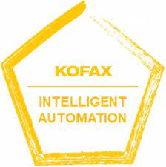Intelligent tool for monitoring and optimizing the processes.
* It can be managed centrally from a server.
* Easy to integrate with Kapow Katalyst Platform.

**Pros:**

* Efficient tool.
* It can work fast.

**Cons:**

* Needs to improve training videos.
* It may be a little difficult to learn.

1. **SOFTMOTIVE: -**

Softomotive has two solutions for robotic process automation. It includes Enterprise Automation and Desktop automation. Enterprise automation will help in increasing the productivity, performance, and efficiency of enterprises. And Desktop automation is for individuals and small teams.

It can automate desktop and web-based tasks.

**Features:**

* This tool will help you from the design process to the production process.
* It provides accuracy, security, and error handling.
* It can be easily integrated with SAP, Salesforce, Oracle Financials, and PeopleSoft Automation, etc.
* It is supported by .NET and SQL server.

**Pros:**

* Easy to use.
* It works five times faster than humans.

**Cons:**

* It is supported only by the SQL server.

1. **VISUAL CORN: -**

Visual Cron is an automation tool for task scheduling and integration. It is for Windows only. Programming skills are not mandatory for this tool.

**Features:**

* You can customize tasks according to technology.
* You can do programming using the API.
* Visual Cron can develop the features, as per your requirements.
* User-friendly interface.
* You can use the tool even if you don’t have programming knowledge.

**Pros:**

* Easy to learn.

**Cons:**

* It supports only the Windows operating system.

## **Advantages of RPA: -**

### Code-Free

### Non-Disruptive

### User-Friendly

### Rich-Analytical Suite

### Security

### Rule-based Exception Handling

### Hosting and Deployment Options

### Actionable Intelligence

## **Disadvantages of RPA: -**

### Potential Job Losses

### Initial Investment Costs

### Hiring Skilled Staff

### Employee Resistance

### Process Selection

### CONCLUSION: -

### In conclusion, RPA and AI are both valuable technologies that can be used for the organization’s digital transformation. However, the choice of implementing either RPA or AI (or both) depends on the requirements of the organization. So, they both are right at their ends and no one is superior.

### Reference and Links: -

### https://www.isa.org/about-isa/what-is-automation automation

### <https://www.10xds.com/blog/insights/advantages-of-robotic-process-automation/> business benefits

### <https://www.bizagi.com/en/blog/robotic-process-automation/rpa-and-dpa-why-you-need-both-for-digital-transformation> RPA

### <https://www.impactmybiz.com/blog/blog-7-uses-robotic-process-automation-rpa/> USE

### <https://ivlglobal.com/11-features-of-rpa-that-you-should-know/> features and benefits

### <https://www.horsesforsources.com/RPA-forecast-2016-2022_120118> RPA growth

### <https://www.javatpoint.com/rpa-vs-ai#:~:text=RPA%20is%20a%20software%20robot,thinking'%20and%20'learning> '. rpa vs ai

### <https://www.javatpoint.com/advantages-and-disadvantages-of-rpa> ADVANTAGE DISADVANTAGE

### <https://github.com/saumyaarora80/Saumya-Adding-intellingece-to-RPA> GITHUB