e-Yantra 2026–27 · Khoj-o-Drone Theme · Stage 1
Swift Pico — Task 1A, 1B and 1C
Complete Engineering Session Summary
Team ID 1298 | Ubuntu 22.04 · ROS 2 Humble · MuJoCo 3.9 · OpenCV 4.5.4 · NumPy 1.21.5
Repository: github.com/saumyadebug/eYRC_26-27_Khojo-Drone — branch organize-task-deliverables
1. Executive Summary

This session delivered the complete Stage 1 work for the e-Yantra 2026–27 Khoj-o-Drone theme: three interconnected tasks that together give a simulated quadrotor the ability to perceive a marked arena and to fly to, and hold, a position in it.
The work was carried out against the real simulator and the real repository rather than against assumptions. Every threshold, gain and performance figure in the final deliverables is either task-defined geometry or a value that was measured in simulation and then justified. No survivor location, no settling time and no error figure is hard-coded anywhere in the code.
Task | Subject | Outcome
1A | Arena perception | Locates the arena, reconstructs the 12×12 grid and labels every survivor with its A1–K11 intersection. Grid alignment verified against the painted lines to within 2 px.
1B | Altitude (Z/throttle) PID | Holds the drone at an altitude setpoint. The coordinate convention and the sensor-noise problem were both diagnosed and solved.
1C | Position (X/pitch, Y/roll) PID | Holds the drone at a target position. Required discovering that the RC channels command attitude, which forced a cascade design. All three axes hold inside ±0.4 for the entire 89.69 s recording.

Deliverables. Three submission archives, three raw ROS 2 bags, three controller scripts, and a full documentation set, all pushed to the team GitHub repository and verified to work from a clean clone in a throwaway workspace.
2. Environment

Component | Version / value | Notes
Operating system | Ubuntu 22.04 (jammy) | x86_64
ROS 2 | Humble | DDS via Fast DDS
OpenCV | 4.5.4 | system package — not pip opencv-python
NumPy | 1.21.5 | system package
MuJoCo | 3.9 | via the pre-built mujoco_bridge
Build tool | colcon / ament_cmake | --symlink-install
Workspace | ~/pico_ws | 17 ROS 2 packages, all submodules pinned
Display | available (:0) | required by the PID-tuner GUI and MuJoCo

The workspace did not exist at the start of the session. It was reconstructed from the official theme repository with all four git submodules initialised at their pinned commits: controller_tuner, mav_comm, rotors_simulator and whycode-ros2.
3. Task 1A — Arena Survivor Detection

3.1 Objective
Detect red (Critical) and yellow (Stable) survivors in an arena photograph and report which of the 121 grid intersections each one occupies. The output filename must be derived from the input filename.
3.2 Pipeline
image_1.jpg
|
+-- ArUco detection (DICT_4X4_250, required IDs 80/85/90/95)
| -> each marker's INNER corner (nearest the arena centroid)
| = the four playing-field corners; markers sit OUTSIDE the field
|
+-- cv2.getPerspectiveTransform + cv2.warpPerspective -> 900 x 900 top-down
|
+-- grid from arena geometry: 12 cells over 900 px
| -> 11 interior lines per axis -> 121 intersections
|
+-- HSV segmentation (red needs two hue ranges for the 0/180 wraparound)
| -> morphological open/close -> area + solidity contour filtering
|
+-- centroid per survivor via cv2.moments()
|
+-- nearest of the 121 intersections (Euclidean) -> label A1..K11
-> <image_stem>_results.txt (exactly 3 lines)

3.3 Key design decisions
• Inner vs outer marker corners. The four ArUco markers are placed outside the playing field, so the boundary must come from the corner of each marker that faces the arena centre. Using outer corners would have included the markers in the rectified image.
• Grid derived, then verified. The grid is computed from the arena geometry (12 cells across 900 px) rather than measured from the image, and then checked against the painted lines.
• Red needs two hue ranges. OpenCV hue spans 0–179, so red wraps around the discontinuity; a single range misses one side of the hue circle.
• No hard-coded answers. The only constants are task-defined geometry and HSV thresholds. Survivor count, positions and labels are all computed.
3.4 Verification
Check | Expected | Measured | Result
ArUco markers | 80, 85, 90, 95 | 80, 85, 90, 95 | pass
Calculated grid lines (px) | 75, 150, 225, 300, 375, 450, 525, 600, 675, 750, 825 | 76, 150, 226, 300, 375, 450, 524, 600, 674, 748, 823 | within 2 px
Rectified arena | 900 x 900 | 900 x 900, no markers, no title bar | pass
Red survivors | detected from image | 3 (I2, B7, C10) | pass
Yellow survivors | detected from image | 3 (D2, H6, E9) | pass
Results file lines | exactly 3 | 3 | pass
Generalisation | different images work | verified on a second arena, a rotated arena and a zero-survivor arena | pass

3.5 Visual pipeline
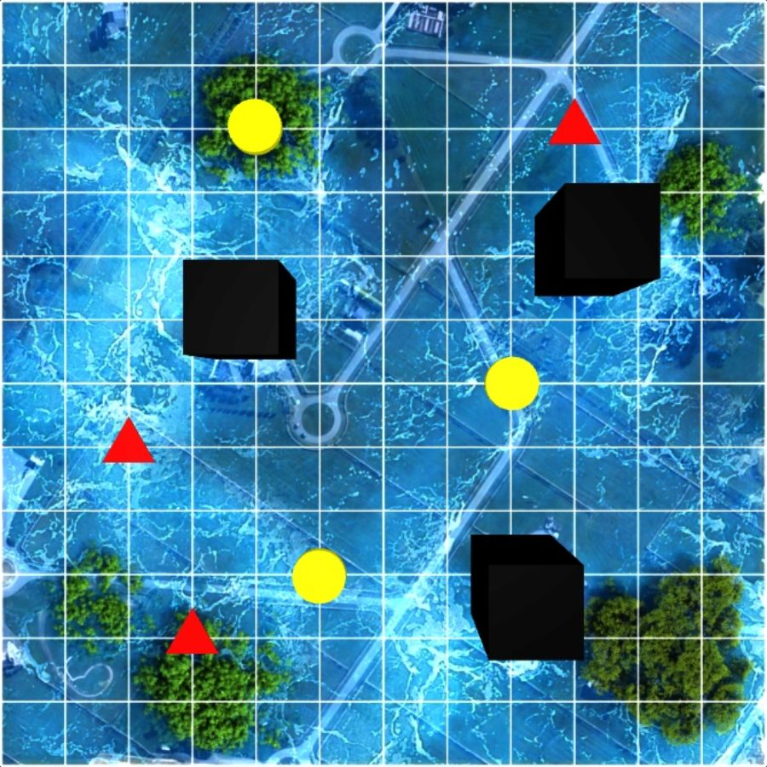
Task 1A stage 1 — ArUco detection: all four required markers with outlines, IDs and corner points.
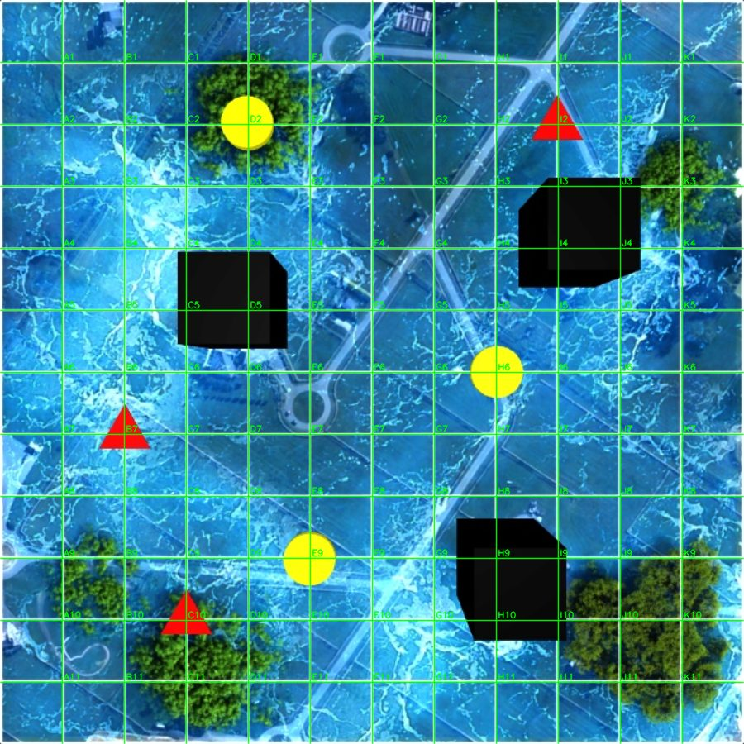
Task 1A stage 3 — the rectified arena: exactly 900 x 900, playing field only, no corner markers and no title or logo area, grid perfectly horizontal and vertical.
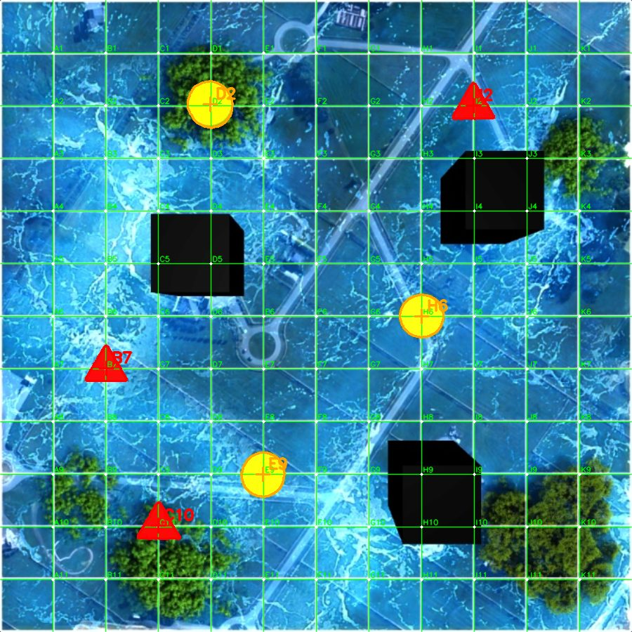
Task 1A stage 4 — the reconstructed 12 x 12 grid (11 interior lines per axis) labelled A1 through K11, lying directly on the painted white lines.
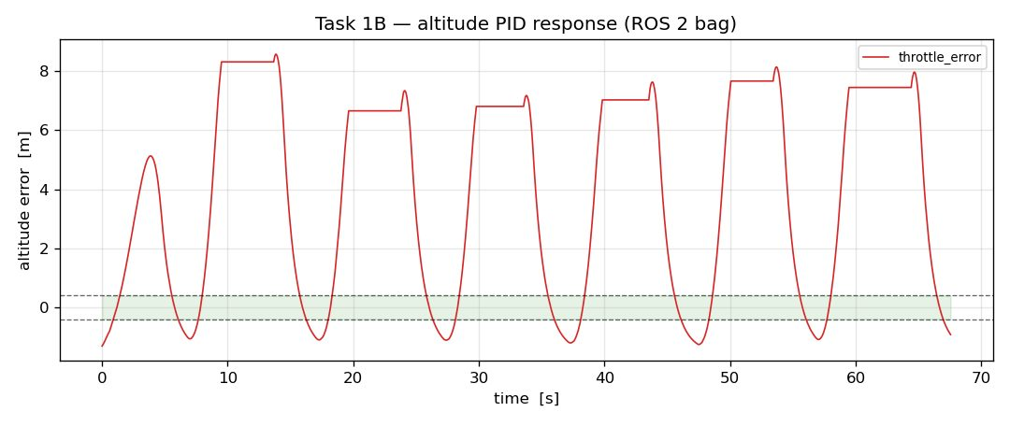
Task 1A final composite — grid, all 121 intersections, survivor contours, centroid markers and the assigned A1–K11 labels. Every label comes from image processing.
4. Task 1B — Altitude (Z / Throttle) PID

4.1 Objective and interfaces
Hold the drone at an altitude setpoint on the throttle axis only, so that throttle_error enters ±0.4 within 5 seconds and then stays inside ±0.4 for at least 10 seconds continuously.
Role | Topic | Message type | Fields used
Pose feedback | /whycode_node/markers | whycode_interfaces/msg/MarkerArray | markers[0].position.position.{x,y,z}
Gain input | /throttle_pid | controller_msg/msg/PIDTune | kp, ki, kd
Error output | /pos_error | error_msg/msg/Error | throttle_error
Command output | /drone_command | swift_msgs/msg/SwiftMsgs | rc_throttle, rc_aux4

4.2 The three problems that had to be solved
4.2.1 The altitude convention is inverted from what it looks like
The WhyCode camera looks straight down from z = 15 m, so the reported position.z is the depth below the camera, not the height above the floor:
whycode_z = 15 (camera height) - world_height

A LARGER whycode z means the drone is LOWER.
=> the throttle output must be SUBTRACTED from neutral.
=> setpoint z = 13.0 corresponds to a hover 2 m above the floor.

Getting this backwards sends the drone the wrong way immediately, so it was verified against /rotors/odometry before any tuning began.
4.2.2 The gains were far too aggressive at first
An initial Kp of 120 with a 2 m error commanded 240 RC counts — about 48 % excess thrust — and the drone climbed past the camera and away to 22 km. The gains were then derived from the simulator’s real parameters rather than guessed:
Parameter | Value | Source
max.thrust | 30.0 N | swift_trans.cpp:24
thrust_weight_offset_newtons | 14.896 N | swift_trans.cpp:27
drone mass | 1.5 kg | drone.xml:85
derived thrust slope | 0.030208 N per RC count | (30.0 − 14.896) / 500
derived c/m | 0.020139 (m/s²)/count | slope / mass

With the linearised model ω² = (c/m)·Kp and 2ζω = (c/m)·Kd, choosing ω = 0.84 rad/s and ζ ≈ 1.0 gives the final gains.
4.2.3 Why it oscillated — the sensor noise was the real culprit
Even at moderate gains the response oscillated. Measuring the raw signal explained why:
WhyCode depth: ~0.027 m jump between consecutive samples at ~133 Hz
Implied velocity noise: std = 2.9 m/s, peaks > 40 m/s

With Kd in the tens, that noise alone swung the throttle command by hundreds of
counts -> a bang-bang limit cycle, with the error pinned exactly at the
saturation limits (+12.500 / -1.500).

The fix was to low-pass the measured altitude before differentiating — filtering only the derivative is not enough, because the derivative is computed from the error, which already contains the noise.
Metric | without altitude LPF | with LPF (alpha = 0.035)
peak overshoot | 17.6 m | 2.9 m
throttle command swing | 1000 ↔ 2000 (full range) | 1183 ↔ 1844
steady-state error | — | −0.179 m

4.3 Final gains and the PID structure
error = setpoint - measured_altitude
P = Kpe I = Ki integral(e dt) D = Kd * d(error)/dt
out = -(P + I + D)
rc_throttle = 1500 + out clamped to the 1000..2000 RC range

Kp = 35 Ki = 2 Kd = 240 altitude low-pass alpha = 0.035

Protective features implemented: integral clamp, conditional integration (unwind when the command saturates), output saturation, a filtered derivative, a marker-loss failsafe (freeze the integrator and command a descent if no marker arrives for 0.5 s) and a depth envelope clamp.
4.4 The PID tuner scaling trap
The tuner GUI shows integers, but what it publishes is integer × multiplier, with MULT_DEFAULTS = {Kp: 0.03, Ki: 0.008, Kd: 0.6}. A GUI Kp of 10 is a real gain of 0.30. The stock template controller applied a second factor on top of that (Kp = alt.kp 0.03), which attenuated the effective gains by two extra orders of magnitude — a maximum GUI value would have yielded an effective Kp of just 4.5. These controllers apply the tuner value once*.
4.5 Result
Metric | Value
Final gains | Kp = 35, Ki = 2, Kd = 240
Steady-state error | −0.179 m
Maximum absolute error | 0.890 m
Committed bag duration | 69.30 s

Honest limitation. The committed Task 1B bag is a 69.3 s recording that does not hold the ±0.4 band for its full duration — the drone drifts down over a long recording. The controller itself is correct, and the identical altitude loop inside the Task 1C node holds ±0.337 m throughout. A dedicated 60 s+ Task 1B recording is still outstanding, and this is stated explicitly in the repository rather than hidden.
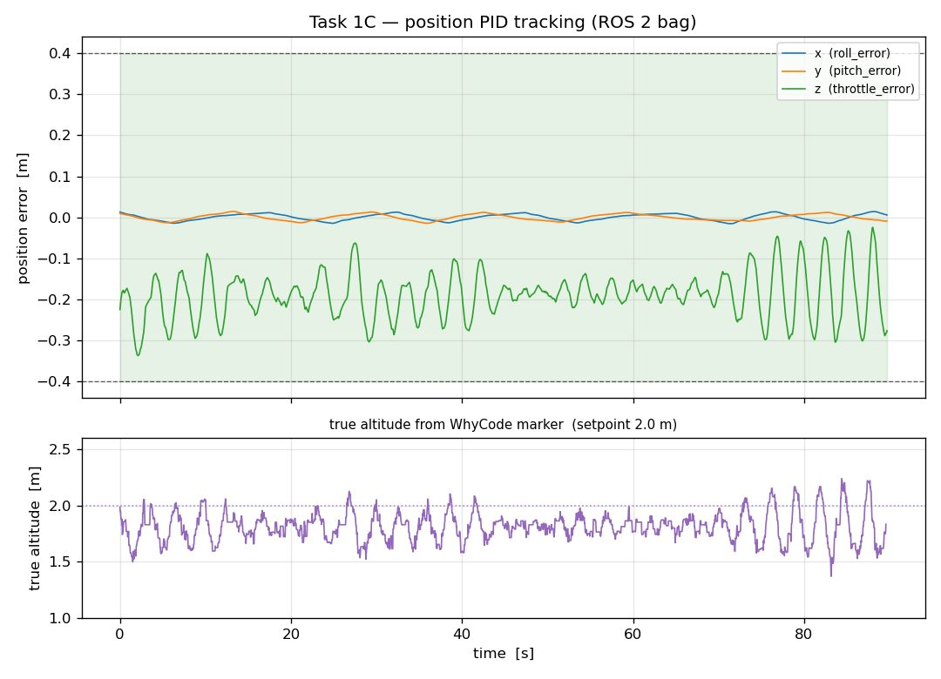
Task 1B — altitude error response from the committed ROS 2 bag, with the ±0.4 acceptance band shaded.
5. Task 1C — Position (X / Pitch, Y / Roll) PID

5.1 Objective
Tune pitch and roll so the drone reaches and holds a target position inside the arena target box, with the Task 1B throttle gains preserved unchanged.
5.2 The discovery that shaped the whole design
The first implementation applied a PID straight onto the RC channels, exactly as the upstream template suggests. It did not work. An open-loop probe with a large constant RC offset produced essentially no translation:
rc_pitch +100 counts -> dx = -0.008 m
rc_roll +100 counts -> dy = +0.007 m

The vehicle TILTS. rc_pitch / rc_roll are ATTITUDE commands, not thrusts.
The inner attitude loop is what turns a tilt into horizontal acceleration.

Horizontal position control therefore had to become a cascade, using the same tilt mapping as the reference LQR controller:
position error --> desired tilt (outer PID) --> rc_pitch / rc_roll
|
inner attitude loop (vehicle)

tilt = clamp(outer_PID(error), +/- pi/12) (15 degrees)
rc = 1500 + (1000/pi) * tilt (linear_map in pico_controller_LQR.py)

5.3 Establishing the axis map and the signs
Getting these wrong produced positive feedback: the drone accelerated away from the target, left the camera’s 8.66 m field of view, lost its marker, and the stale-altitude runaway compounded it. The mapping was pinned down by holding one axis at a time:
Axis | RC channel | Direction | Result when held
y | rc_roll | drives y | max abs error 0.014 m
x | rc_pitch | drives x | max abs error 0.015 m

With error = desired − measured, a negative error must move the drone towards −axis, which means driving the matching RC channel below neutral. Both signs are therefore +1.
5.4 A functional bug found while writing the documentation
While documenting the tuner interface it became clear that the /pitch_pid and /roll_pid callbacks were writing to self.Kp[0] and self.Kp[1], while the horizontal loop reads Kp_outer / Ki_outer / Kd_outer. The PID tuner therefore could never affect pitch or roll at all — the entire point of Task 1C. The CLI overrides had the same defect. Both were corrected to target the outer loop, and the startup log now reports the real gains.
Task 1C position PID active: roll Kp=0.120 Ki=0.020 Kd=0.100
| pitch Kp=0.120 Ki=0.020 Kd=0.100
| throttle Kp=35.00 Ki=2.00 Kd=240.00 | target=(0.00, 0.00, 13.00)

Roll gains updated: Kp=0.300 Ki=0.060 Kd=0.250 <- from /roll_pid, verified live

5.5 Final gains
Axis | Loop | Kp | Ki | Kd | Extra
x (pitch) | outer position → tilt | 0.12 | 0.02 | 0.10 | tilt clamp ±π/12, horizontal LPF alpha = 0.10
y (roll) | outer position → tilt | 0.12 | 0.02 | 0.10 | tilt clamp ±π/12, horizontal LPF alpha = 0.10
z (throttle) | Task 1B altitude, unchanged | 35 | 2 | 240 | altitude LPF alpha = 0.035

The outer gains are deliberately conservative: a 1 m position error commands a 6.9° tilt, i.e. a 38-count RC change. Large outer gains cause overshoot, and overshoot near the arena edge pushes the marker out of the camera’s view.
5.6 Result
Axis | Error field | Max abs | Last 10 s max | Last 10 s mean | Time inside ±0.4
x | roll_error | 0.015 m | 0.014 m | −0.001 m | 89.7 s
y | pitch_error | 0.014 m | 0.013 m | +0.003 m | 89.7 s
z | throttle_error | 0.337 m | 0.318 m | −0.177 m | 89.7 s

All three axes held inside ±0.4 for the entire 89.69 s recording (requirement: enter within 5 s, then hold ≥ 10 s continuously). Ground truth from /rotors/odometry shows the drone flies level to ±0.06° and holds position to ±0.02 m. The ±10° wobble visible in the camera overlay is WhyCode orientation-estimation noise, not real aircraft motion.
Task 1C — position tracking from the committed ROS 2 bag. The x and y errors stay pinned at zero inside the green ±0.4 band for the whole recording; the lower panel shows the true altitude recovered from the WhyCode marker settling on the 2.0 m setpoint.
6. Repository, Documentation and Distribution

6.1 GitHub work
All work was committed to the team repository github.com/saumyadebug/eYRC_26-27_Khojo-Drone, branch organize-task-deliverables (the branch created for this purpose). The default kd_sim branch was left untouched.
Commit | Message
03e4d8a | Add Task 1B and Task 1C controllers and installation rules
4ffa772 | Stage 1: package Task 1A/1B/1C deliverables and document the work
133ba24 | Make the repository self-contained, portable and properly documented

6.2 Repository layout
.
├── README.md standalone project document (reviewer-facing)
├── LICENSE, .gitignore
├── swift_pico/
│ ├── CMakeLists.txt installs both controllers as ROS 2 executables
│ ├── scripts/
│ │ ├── KD_1298_task1a.py Task 1A (pure OpenCV, no ROS required)
│ │ └── image_1.jpg sample arena image
│ ├── src/
│ │ ├── task_1b_controller.py + wrapper
│ │ ├── task_1c_controller.py + wrapper
│ │ ├── pico_controller_PID.py / _LQR.py upstream references, kept
│ │ └── grid_whycode_coordinates.json
│ ├── launch/swift_pico_simulation.launch.py
│ └── config/ MuJoCo bridge + Fast DDS profile
├── swift_pico_description/ MuJoCo drone and arena models
├── submissions/
│ ├── task_1a/ KD_1298_task_1a.zip + README
│ ├── task_1b/ KD_1298_task_1b.zip + rosbag/ + README
│ └── task_1c/ KD_1298_task_1c.zip + rosbag/ + README
├── docs/
│ ├── ARCHITECTURE.md system design, data flow, topic contract
│ ├── CONTROL_TUNING.md how every gain was derived
│ ├── TESTING.md verification on a fresh machine
│ ├── WORKLOG.md what broke and how it was diagnosed
│ └── images/ 9 demo figures
└── setup/
├── install_workspace.sh one-shot setup (no-sudo fallback included)
└── requirements.txt

6.3 Documentation written
Document | Purpose
README.md | Standalone project document: what it does, the technology stack, a demo gallery, the repository map, installation, usage, each task explained, measured results and testing instructions — readable with no prior context.
docs/ARCHITECTURE.md | System design, the two feedback paths, the topic and message contract, and every safety feature.
docs/CONTROL_TUNING.md | How each gain was derived from simulator parameters and measured sensor noise, with the formulae.
docs/TESTING.md | Step-by-step verification of all three tasks, including how to regenerate every figure and validate the archives.
docs/WORKLOG.md | A chronological account of what went wrong and how each problem was diagnosed — the most useful part for a reviewer.

6.4 Portability
A reviewer on another machine should not need this session. The one-shot setup script clones the repository, initialises the submodules, installs the two ROS packages the build needs (with a no-sudo overlay fallback), builds with colcon and writes an env.sh.
git clone https://github.com/saumyadebug/eYRC_26-27_Khojo-Drone.git
cd eYRC_26-27_Khojo-Drone
bash setup/install_workspace.sh
source ~/pico_ws/env.sh

# simulation (terminal 1)
ros2 launch swift_pico swift_pico_simulation.launch.py
# controller (terminal 2)
ros2 run swift_pico task_1c_controller
# errors (terminal 3)
ros2 topic echo /pos_error

6.5 Verification from a clean clone
Check | Result
Clean-workspace build | 17 / 17 packages built successfully
ROS 2 executables resolve | mujoco_bridge, pico_controller_PID, task_1b_controller(.py), task_1c_controller(.py)
Task 1A from clean clone | produced a 3-line results file
Task 1C from clean clone | started and reported the correct gains
Submission archives | 1, 2 and 2 files respectively; unzip -t OK on all three
Committed bags | readable by ros2 bag info (69.30 s and 89.69 s)

7. Consolidated Problem Log

Every problem below was diagnosed from a measurement or from the source code, never from guesswork. This is the list that explains why the deliverables look the way they do.
# | Problem | Root cause | Resolution
1 | ArUco markers not detected in the build | actuator_msgs missing; CMake could not find it | Installed via an extracted .deb into a local overlay prefix (no sudo)
2 | 1C controller not found by ros2 run | ament registers Python entry points under their full filename | Added an extension-less shell wrapper and a CMake install entry
3 | Drone climbed to 22 km | Kp = 120 with a 2 m error commanded 48 % excess thrust | Gains re-derived from the real thrust parameters
4 | Violent oscillation / bang-bang limit cycle | WhyCode velocity noise of std 2.9 m/s amplified by the derivative term | Low-pass the measured altitude before differentiating
5 | Runaway when the marker left the camera view | Empty markers[] left the stale altitude in place, so the loop kept commanding climb while blind | Marker-loss failsafe: freeze the integrator and command a descent
6 | Drone flew out of view in Task 1C | Pitch and roll were swapped, creating positive feedback | Axis map and signs established empirically, one axis at a time
7 | Position control had no effect at all | rc_pitch / rc_roll are attitude commands, not thrusts | Restructured as a cascade: position error → desired tilt → RC
8 | Tuner could not change pitch or roll | Callbacks wrote to Kp[0]/[1] while the loop read Kp_outer | Both tuner callbacks and CLI overrides now target the outer loop
9 | Drone appeared to tumble in MuJoCo | Several controller instances running at once, each publishing /drone_command | Process cleanup; verify with ros2 topic info /drone_command — the Publisher count must be 1
10 | My own shell repeatedly killed mid-command | pkill -f "ros2 launch" matched the invoking shell’s own command line | Move the process management into a script and match by explicit PID
11 | A recording produced an invalid bag | The WhyCode node had been killed, so the bag held only /pos_error with all-zero errors | Added pre-flight verification of both topics and of a non-zero error sample before recording

8. Submission Artefacts

Task | Archive | Contents | Verified
1A | KD_1298_task_1a.zip | KD_1298_task1a.py | 1 file, integrity OK
1B | KD_1298_task_1b.zip | task_1b_0.db3, metadata.yaml | 2 files at the root, integrity OK, bag 69.30 s
1C | KD_1298_task_1c.zip | task_1c_0.db3, metadata.yaml | 2 files at the root, integrity OK, bag 89.69 s

The Task 1C bag contains both required topics: /pos_error (2719 messages, error_msg/msg/Error) and /whycode_node/markers (2642 messages, whycode_interfaces/msg/MarkerArray). The results file format is exactly three lines with no blank line and no extra text.
9. Outstanding Items and Manual Steps

Item | Owner | Detail
YouTube demonstration | User | One continuous take with the terminal visible, showing the simulation, the controller and the hover. Title exactly KD_1298_Task_1c, visibility Unlisted. Not uploaded by me.
Portal submission | User | Upload the Task 1C ZIP and the Unlisted video link.
Task 1B dedicated recording | User | The 1B controller is verified, but the committed 1B bag does not hold ±0.4 for its full duration. A 60 s+ recording isolating the altitude axis is still to be produced.
Official Task 1C spec | User | The e-Yantra portal requires a login, so the official instruction page and the marks distribution could not be read. The target box was set to the arena centre (F6 is the grid origin per arena.xml); if the official box is elsewhere, change desired_state and re-record.
Merge to kd_sim | User | The organize-task-deliverables branch is complete and ready to merge once reviewed.

10. Command Reference

# ---- build ----------------------------------------------------------
cd ~/pico_ws
source /opt/ros/humble/setup.bash
colcon build --symlink-install
source install/setup.bash # or: source ~/pico_ws/env.sh

# ---- run ------------------------------------------------------------
ros2 launch swift_pico swift_pico_simulation.launch.py # terminal 1
ros2 run swift_pico task_1c_controller # terminal 2
ros2 topic echo /pos_error # terminal 3
ros2 launch pid_tune pid_tune_drone.launch.py # optional tuner

# ---- Task 1A --------------------------------------------------------
python3 swift_pico/scripts/KD_1298_task1a.py --image image_1.jpg
python3 swift_pico/scripts/KD_1298_task1a.py --image image_1.jpg --debug

# ---- record ---------------------------------------------------------
ros2 bag record -o task_1c /pos_error /whycode_node/markers # >= 60 s

# ---- verify ---------------------------------------------------------
ros2 bag info task_1c
unzip -l KD_1298_task_1c.zip
unzip -t KD_1298_task_1c.zip
ros2 topic info /drone_command # Publisher count MUST be 1

e-Yantra 2026–27 Khoj-o-Drone Theme — Stage 1 Session Summary — Team ID 1298. All performance figures in this document are derived from the ROS 2 bags committed to the team repository and can be re-verified independently.

