TUT 1: Python program for Image import, display and manipulation(Resize, color update etc)

Saumya Dhorje 18
AIDS-B 12414484

- OUTPUT:
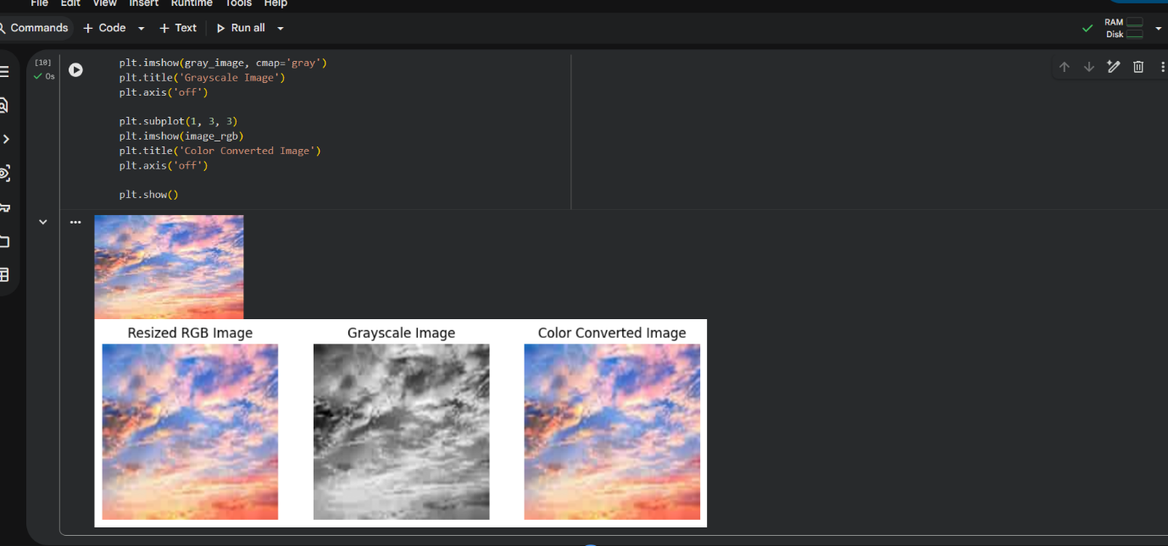

- CODE:
# Step 1: Import required libraries
import cv2
from matplotlib import pyplot as plt

# Step 2: Read the image
image = cv2.imread('sample_image.jpg')

# Step 3: Display original image using OpenCV
cv2.imshow('Original Image', image)
cv2.waitKey(0)
cv2.destroyAllWindows()

# Step 4: Resize the image
resized_image = cv2.resize(image, (300, 300))

# Step 5: Convert BGR to RGB
image_rgb = cv2.cvtColor(resized_image, cv2.COLOR_BGR2RGB)

# Step 6: Convert image to Grayscale
gray_image = cv2.cvtColor(resized_image, cv2.COLOR_BGR2GRAY)

# Step 7: Display images using Matplotlib
plt.figure(figsize=(10, 4))

plt.subplot(1, 3, 1)
plt.imshow(image_rgb)
plt.title('Resized RGB Image')
plt.axis('off')

plt.subplot(1, 3, 2)
plt.imshow(gray_image, cmap='gray')
plt.title('Grayscale Image')
plt.axis('off')

plt.subplot(1, 3, 3)
plt.imshow(image_rgb)
plt.title('Color Converted Image')
plt.axis('off')

plt.show()

Theory
Image processing in Python can be performed using the OpenCV library.
OpenCV reads images in BGR format, whereas Matplotlib displays images in RGB format.
Basic image manipulation includes:
- Resizing: Changing image dimensions
- Color Conversion: Converting BGR to RGB or Grayscale

Algorithm
- Import required libraries (cv2, matplotlib).
- Read the image using cv2.imread().
- Display the original image.
- Resize the image using cv2.resize().
- Convert the image color from BGR to RGB.
- Convert the image to Grayscale.
- Display all processed images.

Output
- Original image is displayed.
- Image is resized to 300 × 300 pixels.
- Color format is converted from BGR to RGB.
- Grayscale version of the image is displayed.

Result
Thus, a Python program to import, display, resize, and perform color conversion on an image was successfully executed.

Conclusion
This experiment demonstrates basic image processing techniques using Python and OpenCV, which form the foundation for advanced applications such as computer vision and machine learning.

