ASSIGNMENT NO. 10
Shourya Desai
Roll No. 4
AIDS-B
PRN : 12412056
Batch 2

Title

Representation of Uncertain Knowledge using Probabilistic Facts and Rules in Prolog

Problem Statement

To represent uncertain knowledge related to weather conditions using probabilistic facts and rules in Prolog and to perform queries that calculate the probability of events like rain prediction.

Objectives
- To understand uncertainty in real-world weather prediction.
- To represent probabilistic weather conditions in Prolog.
- To define rules for predicting rain based on conditions.
- To compute probability of rain using queries.
- To apply probabilistic reasoning in AI systems.

Theory
In real-world applications, information is often uncertain or incomplete. Classical logic represents facts as either true or false, but many AI problems require reasoning with degrees of belief. In real-world applications like weather forecasting, information is uncertain and depends on multiple factors such as humidity, cloud cover, and wind conditions.

Uncertain Knowledge
Uncertain knowledge refers to information that cannot be predicted with complete certainty but is associated with probabilities.
Probabilistic Reasoning
Probabilistic reasoning uses probability theory to make decisions under uncertainty.
In Prolog:
• Facts are assigned probabilities
• Rules combine probabilities
• Queries compute likelihood of outcomes

Algorithm
- Step 1: Identify uncertain weather factors (humidity, clouds, wind).
- Step 2: Assign probabilities to these factors.
- Step 3: Represent probabilistic facts in Prolog.
- Step 4: Define rules for rain prediction.
- Step 5: Execute queries.
- Step 6: Display probability results.

Program
fact(humidity, 0.7).
fact(cloudy, 0.6).
fact(windy, 0.5).
fact(low_pressure, 0.6).
fact(high_temperature, 0.4).
fact(cold_weather, 0.5).
fact(moist_air, 0.6).
fact(dark_clouds, 0.7).

probability_of_rain(P) :-
fact(humidity, H),
fact(cloudy, C),
P is H * C.

probability_of_heavy_rain(P) :-
fact(humidity, H),
fact(cloudy, C),
fact(low_pressure, L),
P is H * C * L.

probability_of_storm(P) :-
probability_of_rain(R),
fact(windy, W),
P is R * W.

probability_of_thunderstorm(P) :-
probability_of_storm(S),
fact(high_temperature, T),
P is S * T.

probability_of_drizzle(P) :-
fact(cloudy, C),
fact(moist_air, M),
P is C * M * 0.5.

probability_of_fog(P) :-
fact(cold_weather, C),
fact(moist_air, M),
P is C * M.

probability_of_bad_weather(P) :-
probability_of_rain(R),
probability_of_storm(S),
probability_of_fog(F),
P is (R + S + F) / 3.

Queries and Output
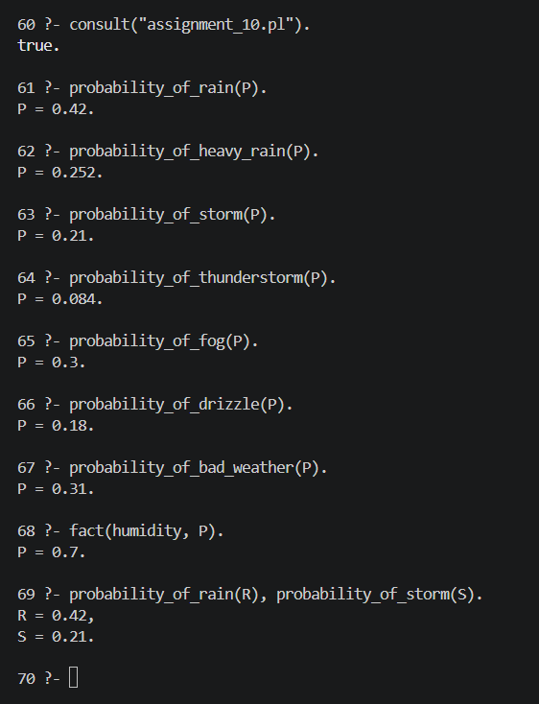
Result
Thus, uncertain knowledge related to weather conditions was successfully represented using probabilistic facts and rules in Prolog, and probabilities of events like rain and storm were computed.

Conclusion
Prolog can effectively represent uncertain knowledge in real-world domains such as weather forecasting. By assigning probabilities to facts and combining them using rules, probabilistic reasoning can be performed for decision-making under uncertainty.

Viva Voce Questions
- What in uncertain knowledge?\
- Why is probability needed in AI?
- How are probabilistic facts represented in Prolog?
- How are probabilities combined in rules?
- What is probabilistic reasoning?
- Give one real-world application of uncertain knowledge.

