ASSIGNMENT NO. 11
Saumya Dhorje
AIDS-B
Roll No. 18
Batch 2
12414484

Title

Implementation of a Simple Bayesian Network in Prolog and Performing Inference

Problem Statement

To implement a Bayesian Network in Prolog for spam email detection using probabilistic relationships and perform inference to calculate the probability that an email is spam.

Objectives
- To understand Bayesian Networks in real-world applications.
- To model uncertainty in email classification.
- To represent conditional probabilities in Prolog.
- To perform inference for spam detection.
- To apply probabilistic reasoning in AI.

Theory
A Bayesian Network represents probabilistic relationships between variables.
In spam detection:
- Spam depends on features like keywords, links, and sender
- Each feature contributes probabilistically

Real-World Application: Spam Detection
Variables:
- Spam (S)
- Contains “Free” word (F)
- Contains link (L)
Bayesian Networks use Bayes’ theorem to compute probabilities:
$$P(A∣B)=\frac{P(B∣A)⋅P(A)}{P(B)}$$
In Prolog, Bayesian Networks can be implemented by:
- Representing prior probabilities as facts
- Representing conditional probabilities using rules
- Computing joint probabilities using multiplication

Bayesian Network Structure
- Spam → FreeWord
- Spam → Link
- Algorithm
Algorithm
- Step 1: Identify variables (Spam, Free, Link).
- Step 2: Define dependencies.
- Step 3: Assign prior probabilities.
- Step 4: Define conditional probabilities.
- Step 5: Represent in Prolog.
- Step 6: Perform inference.

Program
prob(spam, 0.4).
prob(not_spam, 0.6).

prob(free_word, spam, 0.7).
prob(free_word, not_spam, 0.1).

prob(link, spam, 0.6).
prob(link, not_spam, 0.2).

joint_spam(P) :-
prob(spam, Ps),
prob(free_word, spam, Pf),
prob(link, spam, Pl),
P is Ps * Pf * Pl.

joint_not_spam(P) :-
prob(not_spam, Pns),
prob(free_word, not_spam, Pf),
prob(link, not_spam, Pl),
P is Pns * Pf * Pl.

prob_spam_given_features(P) :-
joint_spam(Ps),
joint_not_spam(Pns),
Total is Ps + Pns,
P is Ps / Total.

Queries and Output
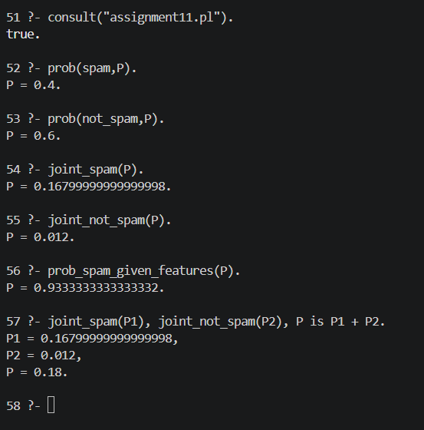
Result

The Bayesian Network successfully computed prior, joint, and posterior probabilities for spam detection using probabilistic inference.

Conclusion
This model demonstrates how Bayesian Networks can classify emails using probability distributions and conditional dependencies. The system effectively calculates the likelihood of spam using observed features.

Viva Voce Questions
  - What is a Bayesian Network?
  - What does a node represent in a Bayesian Network?
  - What is a Conditional Probability Table?
  - How is inference performed in a Bayesian Network?
  - Why Bayesian Networks are useful in AI?

