ASSIGNMENT NO. 12
Saumya Dhorje
AIDS-B
Roll No. 18
PRN 12414484
Batch 2

Title

Design and Implementation of an Expert System in Prolog using Rules and Inference

Problem Statement
To design and implement an expert system in Prolog for a chosen domain using rules and inference to suggest outcomes based on user input. (Carrer Domain/ Loan Approval System/ Movie Recommendation System/ Travel Recommendation System/ Food Recommendation System/ Laptop Recommendation System/ Smart Home Expert System/ Plant Disease Detection/Vehicle Troubleshooting System)

Objectives
- To understand expert systems in AI
- To represent knowledge using rules
- To apply inference mechanism in Prolog
- To interact with users using queries
- To simulate decision making systems

Theory
An Expert System is an AI program that uses knowledge and rules to solve problems like a human expert.
It consists of:
- Knowledge Base – facts and rules about a domain
- Inference Engine – applies rules to known facts
- User Interface – accepts input and displays conclusions
Algorithm
- Step 1: Identify domain (career selection)
- Step 2: Define facts (interest, skills)
- Step 3: Define rules.
- Step 4: Accept user input
- Step 5: Apply inference.
- Step 6: Display result

Program
% FACTS
genre(inception,sci_fi).
genre(interstellar,sci_fi).
genre(avengers,action).
genre(john_wick,action).
genre(conjuring,horror).
genre(notebook,romance).
genre('3_idiots',comedy).

% RULES
recommend(Movie):-
write('Do you like action movies? (yes/no): '),
read(X),
X = yes,
genre(Movie,action).

recommend(Movie):-
write('Do you like sci_fi movies? (yes/no): '),
read(X),
X = yes,
genre(Movie,sci_fi).

recommend(Movie):-
write('Do you like horror movies? (yes/no): '),
read(X),
X = yes,
genre(Movie,horror).

recommend(Movie):-
write('Do you like romance movies? (yes/no): '),
read(X),
X = yes,
genre(Movie,romance).

recommend(Movie):-
write('Do you like comedy movies? (yes/no): '),
read(X),
X = yes,
genre(Movie,comedy).

start :-
recommend(Movie),
write('Recommended Movie: '),
write(Movie).

Output
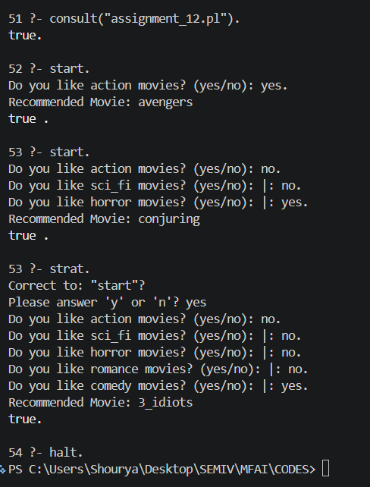
Result
The expert system successfully suggests a career based on user input using rule-based inference.

Conclusion
Expert systems simulate human decision-making using rules and logical inference. Prolog is well-suited for implementing such systems.

Viva Voce Questions
- What is an expert system?
- What is inference in Prolog?
- Difference between facts and rules
- What is knowledge base?
- Give real-life example of expert system.

