ASSIGNMENT NO. 6
Saumya Dhorje
AIDS B
Roll No. 18
Batch 2
PRN : 12414484

Title

Implementation of Forward Chaining in Prolog using First-Order Definite Clauses.

Problem Statement

To design and implement a Smart Agriculture Crop Advisory Expert System using Prolog that applies forward chaining inference on first-order definite clauses to recommend suitable crops based on soil type, rainfall, and temperature conditions.

Objectives
- To understand forward chaining inference in rule-based expert systems.
- To represent agricultural knowledge using first-order definite clauses.
- To implement a data-driven reasoning system using Prolog.
- To infer suitable crops automatically from environmental conditions.
- To demonstrate the use of AI in agriculture decision support systems.

Theory
Expert systems are AI systems that emulate the decision-making ability of a human expert. In agriculture, expert systems help farmers decide suitable crops based on environmental conditions.
Forward chaining is a data-driven reasoning technique where inference starts from known facts and repeatedly applies rules to derive new conclusions.
In this experiment, a Crop Advisory Expert System is created where environmental factors such as soil type, rainfall, and temperature are represented as facts, and rules infer the most suitable crop.
Key Characteristics of Forward Chaining:
- Starts from known facts and derives new facts.
- Uses IF–THEN rules (definite clauses).
- Suitable for expert systems and decision support systems.
In Prolog:
- Facts represent environmental conditions.
- Rules represent agricultural knowledge.
- Inference derives recommended crops automatically.
Algorithm
- Step 1: Define facts representing environmental conditions such as soil type, rainfall, and temperature.
- Step 2: Represent agricultural knowledge using definite clauses in the form:
Head :- Body.
- Step 3: Load the Prolog program into the SWI-Prolog environment.
- Step 4: Apply forward chaining inference by querying the system.
- Step 5: Use rules to infer suitable crops from environmental conditions.
- Step 6: Display recommended crops.

Program

Step 1: Define Facts
Soil type
Rainfall level
Temperature level

Step 2: Define Definite Clauses (Rules)
Rule 1: Rice grows well in clay soil with high rainfall
Rule 2: Wheat grows well in moderate temperature and medium rainfall
Rule 3: Cotton grows well in black soil and high temperature
Rule 4: Maize grows well in moderate rainfall

Code
soil(clay).
rainfall(high).
temperature(moderate).

% Rice
crop(rice) :-
soil(clay),
rainfall(high),
temperature(moderate).

% Wheat
crop(wheat) :-
rainfall(medium),
temperature(moderate).

% Cotton
crop(cotton) :-
soil(black),
temperature(high).

% Maize
crop(maize) :-
rainfall(medium).

% Sugarcane
crop(sugarcane) :-
rainfall(high),
temperature(high).

% Groundnut
crop(groundnut) :-
soil(loamy),
rainfall(medium).

% Barley
crop(barley) :-
rainfall(low),
temperature(moderate).

% Paddy (similar to rice)
crop(paddy) :-
soil(clay),
rainfall(high).

% Millets (low rainfall + high temp)
crop(millets) :-
rainfall(low),
temperature(high).

% Vegetables
crop(vegetables) :-
soil(loamy),
rainfall(medium),
temperature(moderate).

% Pulses
crop(pulses) :-
rainfall(medium),
temperature(moderate).

% Jowar
crop(jowar) :-
rainfall(low),
temperature(high).

suggest :-
crop(X),
write('Recommended Crop: '), write(X), nl,
fail.

suggest.

Sample Queries and Output
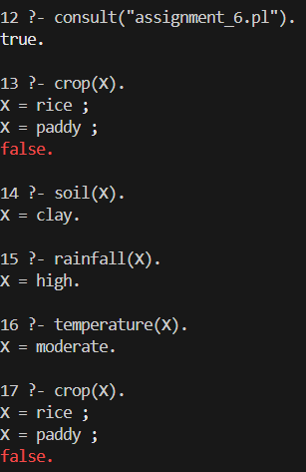
Result
The Smart Agriculture Crop Advisory Expert System successfully inferred suitable crops using forward chaining inference and first-order definite clauses.

Conclusion
Forward chaining enables Prolog to perform data-driven reasoning, where conclusions are derived progressively from known facts. This approach is widely used in expert systems, rule-based reasoning, and AI decision-making applications.

