Saumya Dhorje
AIDS-B
Roll No. 18
Batch 2
PRN: 12414484

ASSIGNMENT NO. 7

Title
Implementation of Backward Chaining in Prolog for Query-Based Reasoning.

Problem Statement

To implement a backward chaining inference mechanism in Prolog for a crop advisory expert system such that queries about suitable crops are answered by reasoning backward through a knowledge base of environmental conditions and rules.

Objectives
- To understand the concept of backward chaining inference.
- To represent agricultural knowledge using Prolog rules and facts.
- To implement goal-driven reasoning in Prolog.
- To answer crop recommendation queries from a knowledge base.
- To compare backward chaining with forward chaining inference.

Theory
Backward chaining is a goal-driven inference technique used in Artificial Intelligence. Instead of starting from facts, the system begins with a goal or query and works backward through rules to determine whether the goal can be satisfied using known facts.
Backward chaining is a goal-driven inference technique used in Artificial Intelligence. Instead of starting from facts, the system begins with a goal or query and works backward through rules to determine whether the goal can be satisfied using known facts.
In a Crop Advisory Expert System, backward chaining can be used to check whether a particular crop is suitable based on soil type, rainfall, and temperature conditions.
Key Characteristics of Backward Chaining:
- Starts from a goal or query
- Works backward through rules
- Uses recursion and backtracking
- Suitable for diagnostic systems and expert systems
Backward Chaining In Prolog:
Prolog inherently uses backward chaining:
- A query is treated as a goal
- Prolog tries to satisfy the goal using rules
- Subgoals are generated recursively
- Backtracking is used to explore alternatives
Algorithm

- Step 1: Suitable for diagnostic systems and expert systems
- Step 2: Represent crop suitability knowledge using rules in the form:
Head :- Body.
- Step 3: Load the Prolog program in SWI-Prolog.
- Step 4: Ask a query about a specific crop.
- Step 5: Prolog searches for rules whose head matches the query.
- Step 6: The system checks whether the conditions in the rule body are satisfied.
- Step 7: If all conditions are true, the goal is proven.

Program

Step 1: Define Facts
Soil type
Rainfall level
Temperature level

Step 2: Define Rules
Rule 1: Rice grows well in clay soil with high rainfall
Rule 2: Wheat grows well in moderate temperature and medium rainfall
Rule 3: Cotton grows well in black soil and high temperature
Rule 4: Maize grows well in moderate rainfall

Code
soil(clay).
rainfall(high).
temperature(moderate).

/* ----------- RULES ----------- */

% Rice
crop(rice) :-
soil(clay),
rainfall(high),
temperature(moderate).

% Wheat
crop(wheat) :-
rainfall(medium),
temperature(moderate).

% Cotton
crop(cotton) :-
soil(black),
temperature(high).

% Maize
crop(maize) :-
rainfall(medium).

/* ----------- EXTRA RULES ----------- */

% Sugarcane
crop(sugarcane) :-
rainfall(high),
temperature(high).

% Groundnut
crop(groundnut) :-
soil(loamy),
rainfall(medium).

% Barley
crop(barley) :-
rainfall(low),
temperature(moderate).

% Paddy
crop(paddy) :-
soil(clay),
rainfall(high).

% Millets
crop(millets) :-
rainfall(low),
temperature(high).

% Vegetables
crop(vegetables) :-
soil(loamy),
rainfall(medium),
temperature(moderate).

% Pulses
crop(pulses) :-
rainfall(medium),
temperature(moderate).

Sample Queries and Output
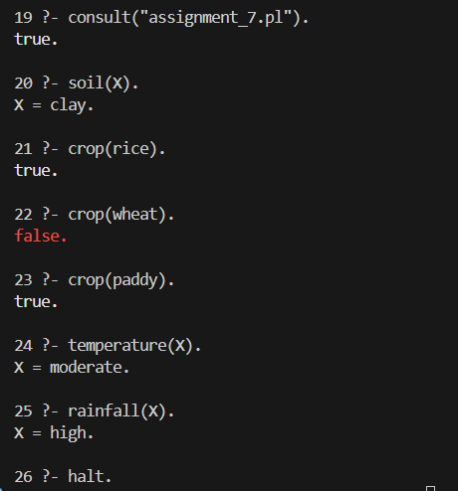

Result
The crop advisory expert system successfully answered queries using backward chaining inference based on the knowledge base.

Conclusion
Backward chaining allows Prolog to answer queries by reasoning backward from the goal to supporting facts. This approach is widely used in expert systems such as medical diagnosis, troubleshooting systems, and decision support systems.

