ASSIGNMENT-01

* create your account on AWS using ROOT or IAM user.
* Once you create an account in AWS then you can again access it by log back in .
* then go to EC2(elastic cloud compute) services.
* then you can find Instances (on left hand side) click on it and select region (Asia Pacific Mumbai).
* Name your instance and select your desired OS in which you want to launch instance.
* Then select instance type t2.micro.
* under key-pair login section create new key pair name and select private key file format (.pem) and then click on create key pair option.
* Private key file .pem will be downloaded.
* Leave all the settings as default.
* Click on launch instance option at bottom-right.

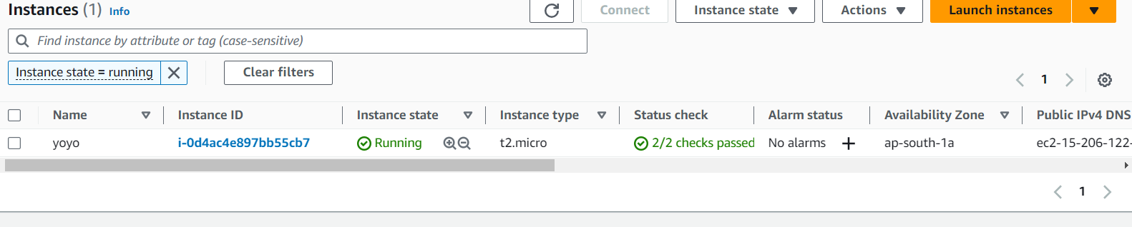

* Select your instance then click on connect option then click on RDP client and download Remote Desktop File.
* Now your Remote Desktop File starts downloading.
* Now go on get password and it will ask you to upload your private key file now upload it .
* Then go on the decrypt password option copy it in your Remote Desktop File, then click on connect .
* Then your Virtual window will opened and you are ready to use it.

