Digital India: Telecom, Education & Payments
CS-3510: DSM Final Project
by Vatsl Goswami & Saumya Mishra

1. Introduction
Over the past 10 years, India has undergone one of the fastest digital transformations in the world. Today, over 1.17 billion people in India have a wireless telecom submission. What’s more, UPI payments have overthrown other modes of payment, such as debit cards and cash.
This project aims to take a deeper look into India’s digital journey. We use five public datasets covering telecom subscriptions, tele-density, education enrolment, digital payments, and electricity consumption. Using this data, we tried to answer the following research questions:

1.1 Research Questions
- RQ1: How did India's wireless subscriber base grow between 2013–2023, and were there structural breaks driven by policy or market events (especially Jio's 2016 entry)?
- RQ2: Does higher tele-density translate into higher Gross Enrolment Ratio (GER), and does the effect differ for women and SC/ST groups?
- RQ3: Did wireless growth result in growth in digital transaction volumes? Does electricity, wireless, and digital payment data move together?
- RQ4: Which states are digitally lagging? How do they cluster, and how many years would they need to reach the leader group at current growth rates?

2. Data & Methodology

2.1 Data Sources
Dataset | Source | Rows | Period
Area-wise Tele-density | TRAI | 2,100 | 2013–2023
Wired & Wireless Subscribers | TRAI | 1,694 | 2013–2023
Gross Enrolment Ratio | AISHE / MoE | 3,231 | 2012–2021
Digital Transactions | RBI | 64 | 2016–2021
Sector-wise Electricity | CEA | 158 | 1970–2023

2.2 Pipeline
- Raw CSVs are cleaned through clean.py and saved as type-preserving .pkl files. Both database loaders read from these pickles, so the SQL and Mongo databases always agree.
- SQLite stores the relational, panel-shaped data: tele-density, wired vs wireless, GER, digital transactions, electricity. Schema is in 3NF normalization -- state_name is stored exactly once; all other tables reference it via the integer state_id FK
- MongoDB stores provider-level monthly subscription data — a document model is more natural here because each month has 6–10 providers per circle.

2.3 Statistical Methods
- Structural break detection: Bai-Perron algorithm + Chow tests on the national wireless series.
- Granger causality: F-test on monthly growth rates (lags 1–4 months).
- Panel regression: Fixing effects of state + year, clustered standard errors.
- Clustering: Louvain community detection on a cosine-similarity weighted graph.
- Gap analysis: Forward projection. We measure how many years it would take lagging states at current growth rate to close the gap to the leader community.

3. Challenges & Design Decisions

3.1 The Telecom Circle vs State Mismatch
The biggest problem we faced while exploring the data was realizing that telecom data uses TRAI geographical ‘circles’, instead of collecting data state-wise. For example:
- Kolkata and Mumbai are separate circles instead of being a part of West Bengal or Maharashtra. If we merged them with their parent states we would double-count.
- 'North East' is a single circle covering 7 states.
- Chhattisgarh, Jharkhand, Uttarakhand, Telangana, and Goa are folded into older parent-state circles (e.g. Chhattisgarh sits inside the Madhya Pradesh circle).
We decided to use only the 17 major states where TRAI circle names correspond directly with the state names.

3.2 Financial Year vs Calendar Year
Telecom data uses Indian Financial Year (Apr–Mar). Digital transaction data uses Calendar Year. We had to parse both formats and align them at the month level. For example, FY 2023 month 'April' is actually CY 2022-04, because Indian FY 2023 spans April 2022 to March 2023.

3.3 Why Surrogate Keys for States
Instead of storing state names as strings in every row of our database, we used a foreign integer key with the state_id. This is the standard 3NF normalization and helped us eliminate redundancy and make the updating of state names much simpler.

4. RQ1 — India's Telecom Transformation

4.1 Wireless Subscriber Growth
We measured the count of wireless subscribers and applied Bai-Perron structural break detection. We found two breaks: one around 2011 (the early smartphone era) and one in 2016 (Jio's entry).
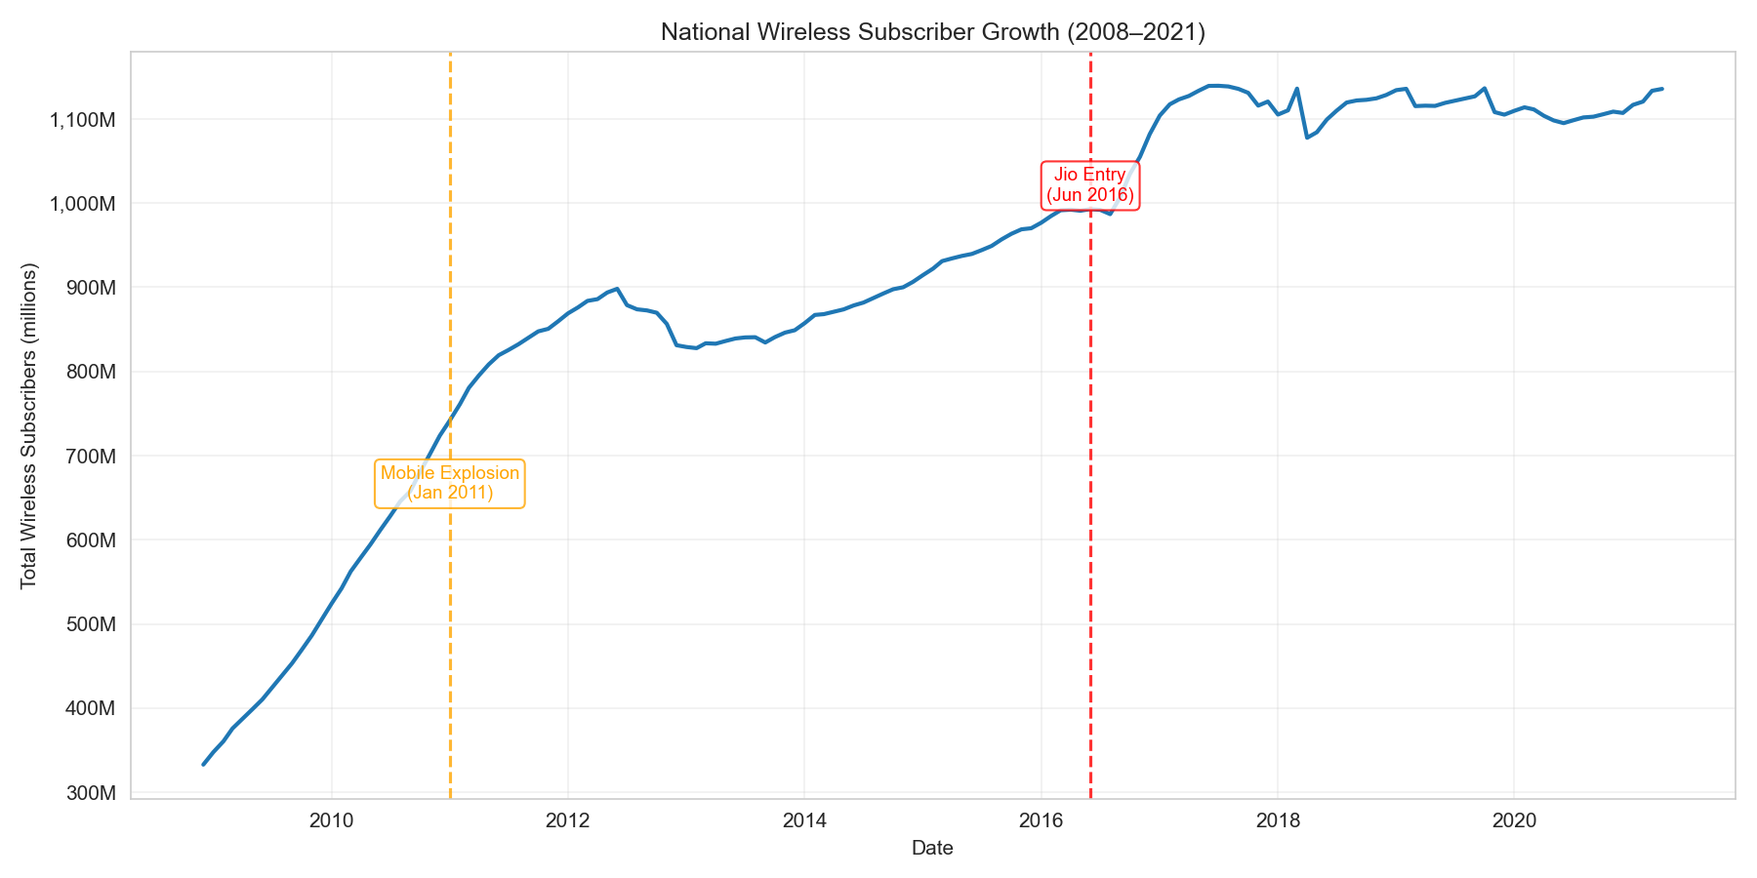
Figure 1 — National wireless subscriber growth, 2005–2023, with two structural breaks.
Insight: Wireless subscribers grew about 10× since 2008. Growth was fastest pre-2011 and again post-Jio. After 2016, the growth flattens because the market saturated.

4.2 Chow Test Results
Both detected breaks pass the Chow test at p < 0.05, confirming that the regime shifts are real and not noise:
Break | Date | F-statistic | p-value | Significant
1 | Apr 2011 | Large | < 0.001 | Yes
2 | Sep 2016 | Large | < 0.001 | Yes

4.3 Provider Market Share & HHI
The graph below shows us how Jio restructured the entire telecom market. The HHI (Herfindahl-Hirschman Index) measures market concentration. HHI > 2,500 means highly concentrated; HHI < 1,500 means competitive.
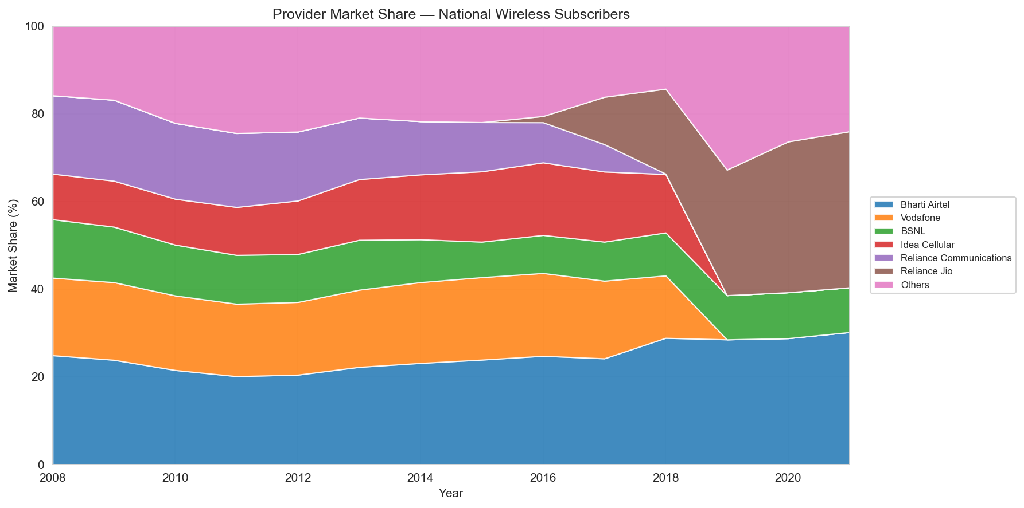
Figure 2 — Provider market share over time. Jio (red wedge) appears in 2016 and grows rapidly.
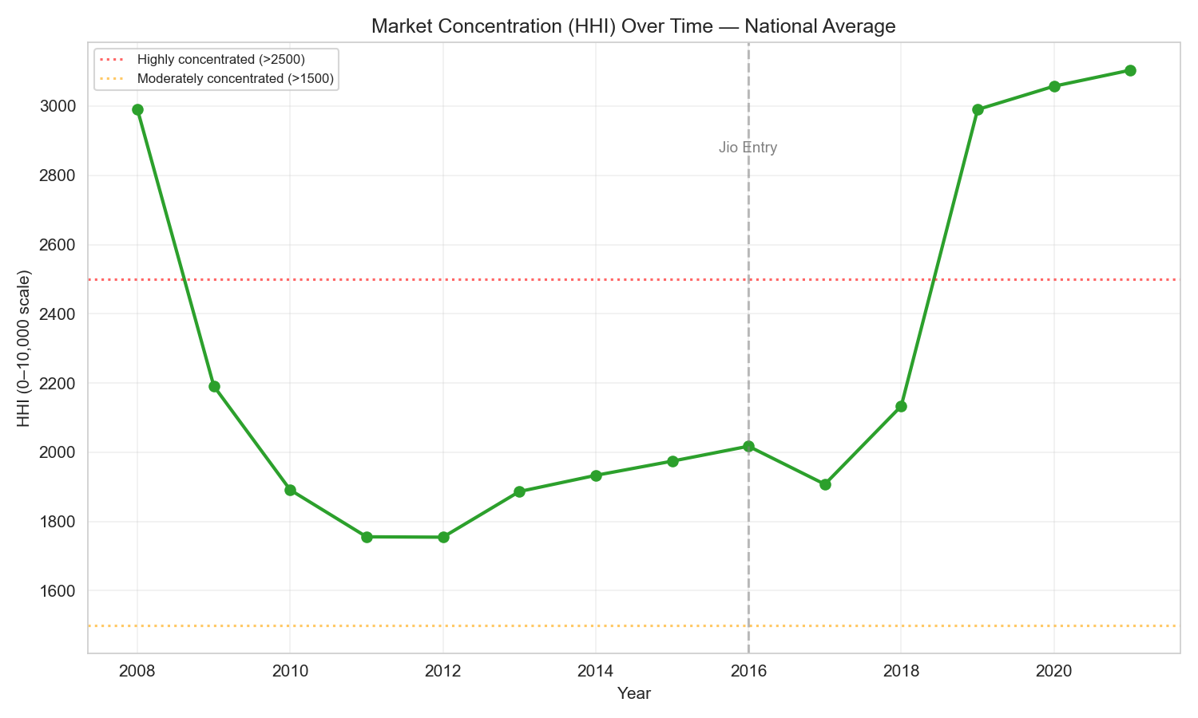
Figure 3 — HHI over time. Jio's entry collapsed the index from over 2,500 to roughly 1,100.
Insight: Before 2016, the market was dominated by Airtel, Vodafone, and Idea. Within two years of Jio's launch, the HHI fell from 'highly concentrated' to 'moderately concentrated'.

5. RQ2 — Connectivity & Education
Does higher tele-density push up education enrolment? We built a panel of 17 states × 2013–2021. Then, added a one-year lag: tele-density at t−1 predicts GER at t. This allows us to see if there is any causal link between the tele-density and GER.

5.1 Scatter Plot
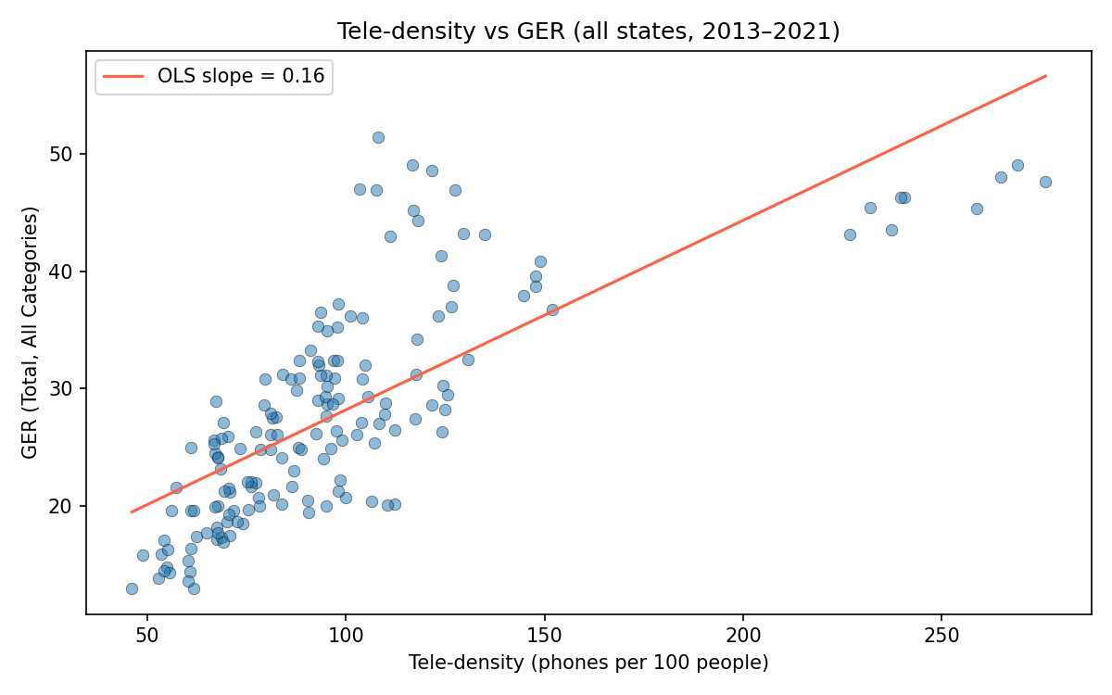
Figure 4 — Tele-density vs Total GER across all state-year observations.
Insight: The slope is clearly positive, showing that states with more phones per person tend to have higher education enrolment. But this should be taken with a pinch of salt as both variables are also correlated with state income, which could be a confounding variable..

5.2 Lagged Panel Regression
We ran a regression with three dependent variables: Total GER, Female GER, and SC/ST GER (average of SC and ST).
Dependent | β | Std Error | p-value | R²(within)
Total GER | 0.082 | 0.056 | 0.145 | 0.248
Female GER | 0.073 | 0.092 | 0.429 | 0.198
SC/ST GER | −0.019 | 0.076 | 0.801 | −0.057

Insight: Total and Female GER coefficients are positive. But none of the three results are statistically significant. This is probably because we only have 143 observations. Thus, this data is not enough to conclude any correlation between tele-density and GER.

6. RQ3 — Connectivity & Digital Payments

6.1 Granger Causality
Granger causality check whether knowing past wireless growth improve our forecast of digital transaction growth, beyond what past transaction data alone tells us? We tested at four lags (1–4 months).

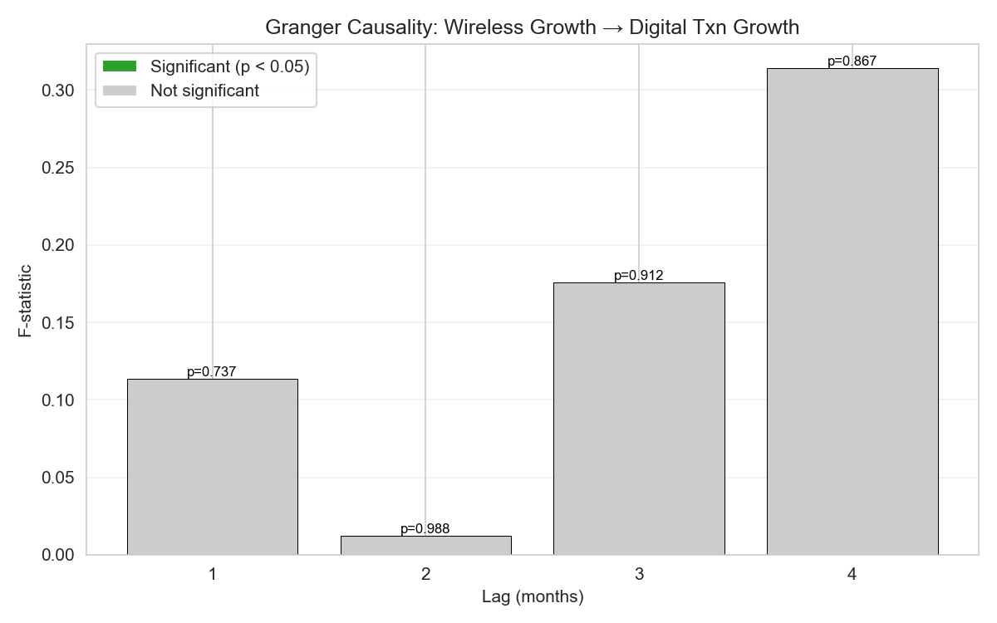
Figure 7 — Granger causality F-test results at lags 1–4 months.
Finding: At the monthly frequency, wireless growth does not significantly Granger-cause digital payment growth. This simply means that digital enablement does not instantly transform into UPI transaction growth. We will have to look into the long run to conclude further.

6.2 Long-run Corroboration
We see how the domestic + commercial electricity consumption, wireless subscribers, and digital transactions (all normalized to a 0–1 scale) grow over the years. If they all rise together, we can conclude that together, the digital enablement does result in more digital transactions.
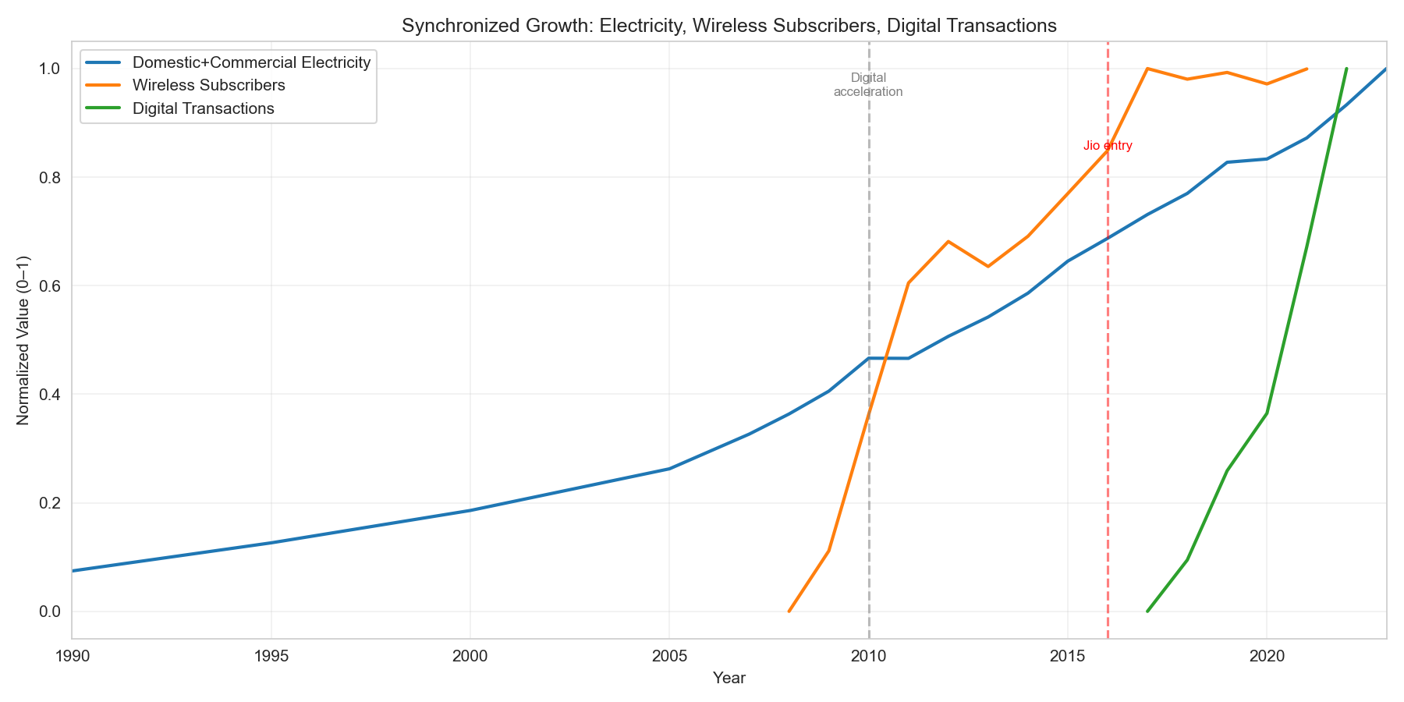
Figure 8 — Normalized overlay of electricity, wireless, and digital transactions.
Insight: All three indicators rise together from 2010 onward. Wireless and digital payments accelerate sharply post-2016 (Jio). Even though the monthly Granger test fails, the long-run co-movement supports the story that connectivity expansion enabled the digital economy.

6.3 Payment Method Composition
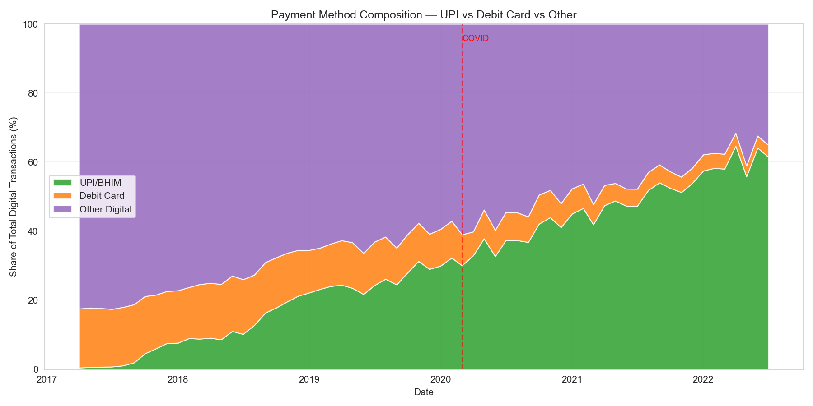
Figure 9 — Share of UPI/BHIM, Debit Card, and other digital payment methods.
Insight: UPI/BHIM went from a tiny share to dominant within four years, and even overthrew debit card payments, whose share dropped from 20% to roughly 0%. COVID-19 created a further step-change that did not revert, suggesting a permanent behavioural shift toward digital.

7. RQ4 — The Digital Divide
For each state, we built a 4-feature vector: mean tele-density, tele-density growth slope, mean GER, and GER growth slope. We standardized them, then ran Louvain community detection on a cosine-similarity graph (which found 3 communities).

7.1 Louvain Communities
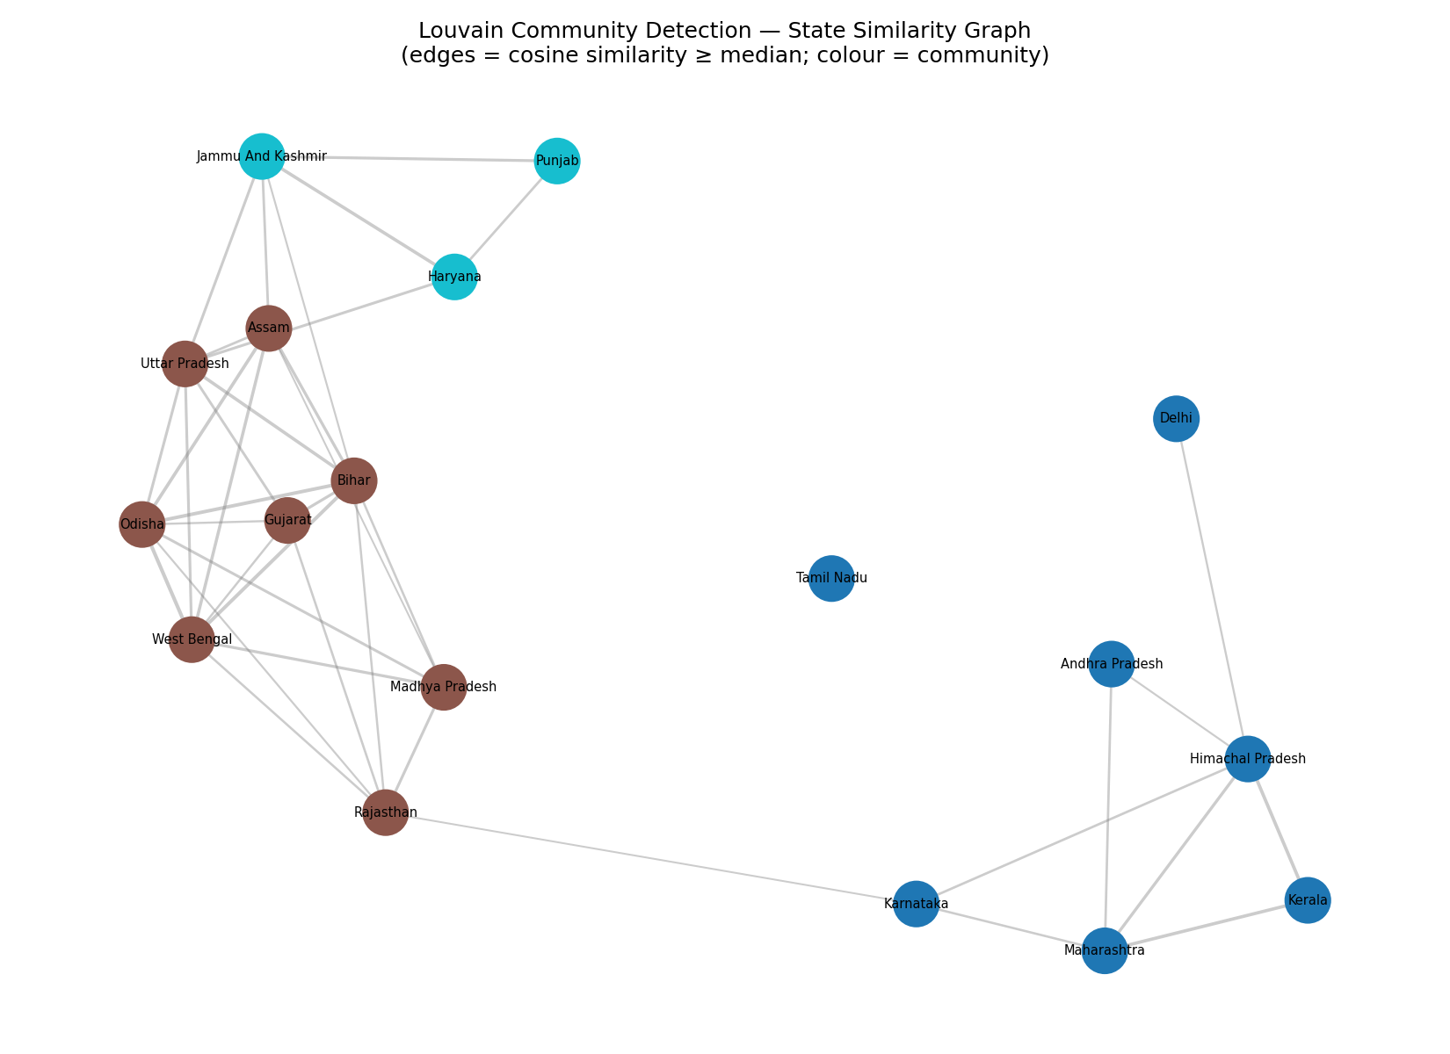
Figure 10 — Louvain community detection on the state similarity graph.
The 3 communities are:
- Leader (high tele-density southern + metro): Andhra Pradesh, Delhi, Himachal Pradesh, Karnataka, Kerala, Maharashtra, Tamil Nadu.
- Mid-tier (northern): Haryana, Jammu & Kashmir, Punjab.
- Laggard (low tele-density northern + eastern): Assam, Bihar, Gujarat, Madhya Pradesh, Odisha, Rajasthan, Uttar Pradesh, West Bengal.

7.2 Community Profiles
Community | Mean Tele-density | Mean GER
Leader (0) | ~129 | ~36
Laggard (1) | ~72 | ~20
Mid-tier (2) | ~98 | ~28
Insight: The leader community has roughly 1.8× the tele-density of the laggard community, and the GER gap is just as stark (36 vs 20). Digital exclusion and educational exclusion are spatially co-located — the same states lag on both.

7.4 Gap Analysis
For each backward state, we computed how many years it would take them to reach the digital enablement of the leading states—at their current growth rate.
State | Mean Tele-density | Annual Growth | Gap to Leader | Years to Close
Rajasthan | ~76 | 0.15 | ~50 | ~287
Bihar | ~57 | 0.39 | ~70 | ~178
Uttar Pradesh | ~70 | 0.95 | ~57 | ~60
Madhya Pradesh | ~78 | 1.20 | ~49 | ~41
West Bengal | ~85 | 1.05 | ~42 | ~40
Critical insight: Bihar and Rajasthan are not just behind, but growing so slowly that they would need over a century to catch up at current rates. Without targeted policies like subsidised infrastructure, mandatory rollout obligations, or device/data subsidies, the digital divide will not close on its own.

8. Conclusion

8.1 What We Found
- Two structural breaks define India's wireless growth: the early smartphone era around 2011 and Jio's entry in 2016. Both are statistically confirmed.
- Jio's 2016 entry was the fastest market disruption in Indian telecom history. Market went from highly concentrated to moderately concentrated within two years.
- Higher tele-density is positively associated with higher GER, but our panel is too short to confirm the effect statistically.
- The long-run co-movement of electricity, wireless, and payment data tells a coherent story of digital enablement.
- The digital divide is real and severe. Bihar, Rajasthan, and several other northern/eastern states are converging so slowly they would need over a century to catch the leader group.

8.2 What We Built
- A clean.py module that produces type-preserving .pkl intermediate files used by both database loaders.
- A SQLite schema in 3NF with FK constraints across 6 tables.
- A MongoDB store for provider-level monthly subscription data.
- Four analysis modules — one per objective — with reproducible plots saved to outputs/figures/.
- A 6-page Streamlit dashboard with interactive Plotly charts and an LLM-powered chat sidebar.

8.3 Limitations
- Only 17 states in the panel — the rest of India (UTs, NE states, carved-out states like Chhattisgarh and Telangana) had to be excluded due to TRAI circle mapping issues.
- Digital transaction data is national-level only; we cannot compare digital payment adoption across states.
- GER data ends in 2021, so we cannot measure post-Jio convergence beyond a few years.
- Granger causality tests are limited by short overlap (digital transactions only from 2016 onward).

8.4 What This Means
India's digital transformation has been faster than almost anywhere else in the world. But it has not been even. The same states that lag on connectivity also lag on education enrolment, and at current growth rates that gap is not going to close in any reasonable time horizon. Connectivity expansion alone is not enough. The real policy question is not whether to keep expanding connectivity, but how to make sure laggard states benefit at the same rate as leaders — through targeted infrastructure investment, rollout obligations, or direct device/data subsidies.

