**REPORT 1**

Theme: Made In India

horizontal line

# 

# Introduction

I haven’t started much of coding yet. I just developed the Navbar. I have designed the logo of the brand and also drew a rough layout of how the webpage will be like. The brand I created is “Hamara Utpaad’ which is an online platform for writing content about various products that are made in India.

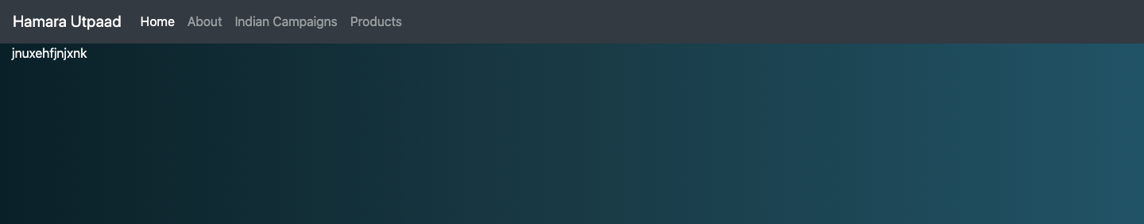

Here is the Navbar that I have created till now. This is just basic . I will modify it later.

Indian Campaigns: This includes the various campaigns India has done to promote Indian products and goods.