Generate Password
- Run GeneratePassword.py to call the Bounded-Memory Enforcer with the automaton defining the property, the input sequence and the buffer size.

- Run GeneratePasswordPerformanceEval.py to compare the performance of both the Bounded-Memory Enforcer and the Ideal Enforcer.

- state4.csv, state6.csv and state10.csv contains the performance table when number of states in the automaton are 4, 6 and 10 respectively.

Effect on increasing number of states
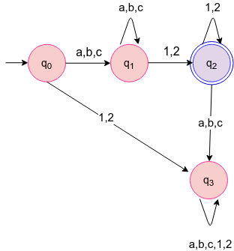
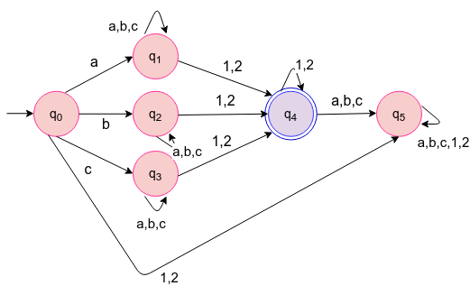
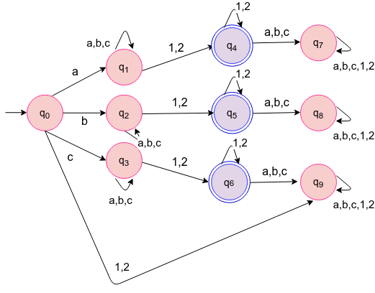

input sequence(100000)
buffer size=10
Number of states | Time taken by Ideal Enforcer | Time taken by Bounded Memory Enforcer | Number of times clean function is called
4 | 0.0924771547318 | 0.595969700813 | 99988
6 | 0.128909039497 | 0.727431249619 | 99988
10 | 0.189109373093 | 0.90841190815 | 99988

