- P1=exactly one 1

Effect on increasing number of states
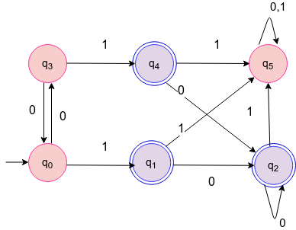
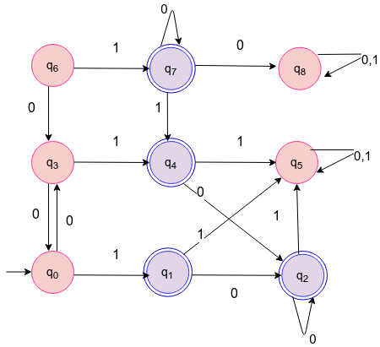

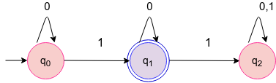

input sequence(100000)
buffer size=10
Number of states | Time taken by Ideal Enforcer | Time taken by Bounded Memory Enforcer | Number of times clean function is called
3
6
9

