Auction Database Schema

Project-3

Students:

|  |  |  |
| --- | --- | --- |
| Rishi Gupta | 2021A7PS0690P |  |
| Saumya Sharma | 2021A7PS0544P |  |

For the Live Auction Database schema, the ER Diagram is as follows:

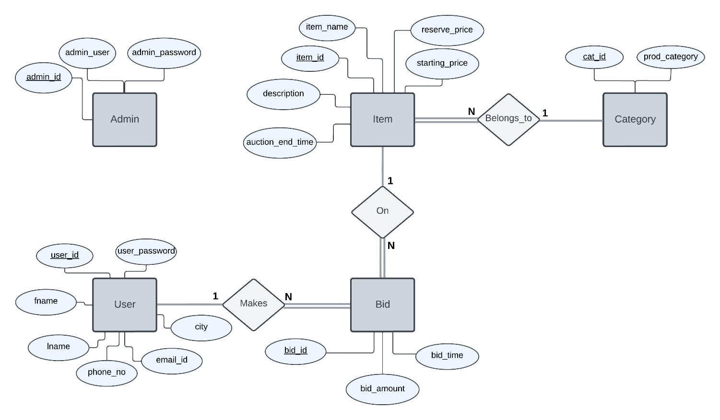

*The Entity Relationship Diagram*

The ER Diagram contains the following

Entities

* Admin
* User
* Item
* Category
* Bid

Relationships

* Makes: User Makes A Bid
* On: A Bid is On Item
* Belongs To: An Item Belongs to a Category

Relational Cardinalities:

* *Makes:* 1:N (from User to Bid)
  + *A user can make multiple bids but a bid can be made by only one user.*
* *On:* 1:N (from Item to Bid)
  + *An item can have multiple bids on it but a bid can be made on only one item.*
* *Belongs To:* 1:N (from Category to Item)
  + *An item can belong to only one category and a category can have multiple items listed.*

Resolving the ER Diagram into Relational Schema,

* The Entity Sets have been resolved into respective schemas
* The relational table for Belongs to Relation would contains two attributes: item_id and cat_id.
  + On(*item_id,cat_id)*
  + *Item_id is the primary key since relationship is many to one from item to category*
  + *Since only two attributes exist and item_id is the primary key, the cat_id has been included in the table for items.*
* The relational table for On Relation would contains two attributes: item_id and bid_id.
  + On(*bid_id,item_id)*
  + *Bid_id is the primary key since relationship is many to one from bid to item*
  + *Since only two attributes exist and bid_id is the primary key, the item_id has been included in the table for bids.*
* The relational table for Makes Relation would contains two attributes: user_id and bid_id.
  + On(*bid_id,user_id)*
  + *Bid_id is the primary key since relationship is many to one from bid to user.*
  + *Since only two attributes exist and bid_id is the primary key, the user_id has been included in the table for bids.*

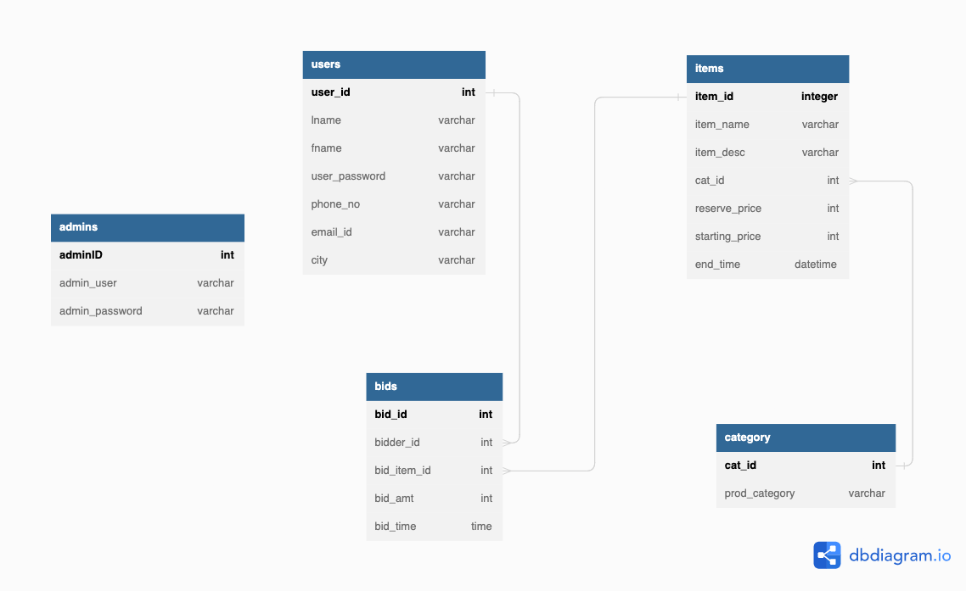

Keys:

* Admins: adminID (primary key)
* Users: user_id (primary key)
* Items: item_id (primay key)
* Category: cat_id (primary key)
* Bids: bid_id (primary key), (bid_item_id, bid_amt) is a candidate key

The following Functional Dependencies exist in the tables

* Users:
  + user_id -> (fname, lname, user_password, phone_no, email_id, city)
* Items:
  + item_id -> (item_id, item_name, item_desc, cat_id, reerve_price, starting_price, end_time)
* Bids:
  + bidder_id -> (bidder_id, bid_item_id, bid_amt, bid_time)
  + (bid_item_id, bid_amt) -> (bid_id, bid_time, bidder_id)
* Admins:
  + adminId -> (admin_user, admin_password)
* Category:
  + cat_id -> (prod_category)

The foreign key constraints are as follows:

* items.cat_id references the primary key of Categories, category.cat_id
* bids.bid_item_id references the primary key of Items, items.item_id
* bids.bidder_id references the primary key of Users, users._id

Normalisation

Condition for 1NF

For 1NF, all attributes in a relation have an atomic value (no multivalued attributes). This is done by creating a new relation with the primary key and the multivalued attributes.

Since all attributes are atomic in the schema, the schema is in 1NF

Condition for 2NF

All non-prime attributes of a relation have to be fully functionally dependent on every candidate key.

The candidate keys in this schema cannot be minimalised any further for any dependency. Thus the relations are in 2NF.

Condition for 3NF

For 3NF, either of the two conditions must hold in dependency X->Y

* X is a superkey
* Y is a prime attribute

Since all functional dependencies involve the primary key in the Left Hand Side, the relations are in 3NF.

Instances of the Tables

Bids

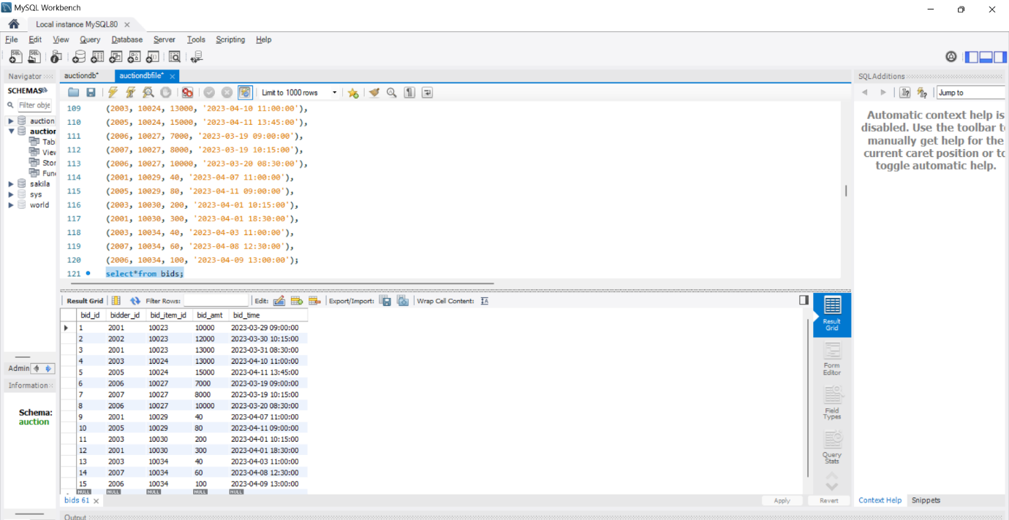

Admins

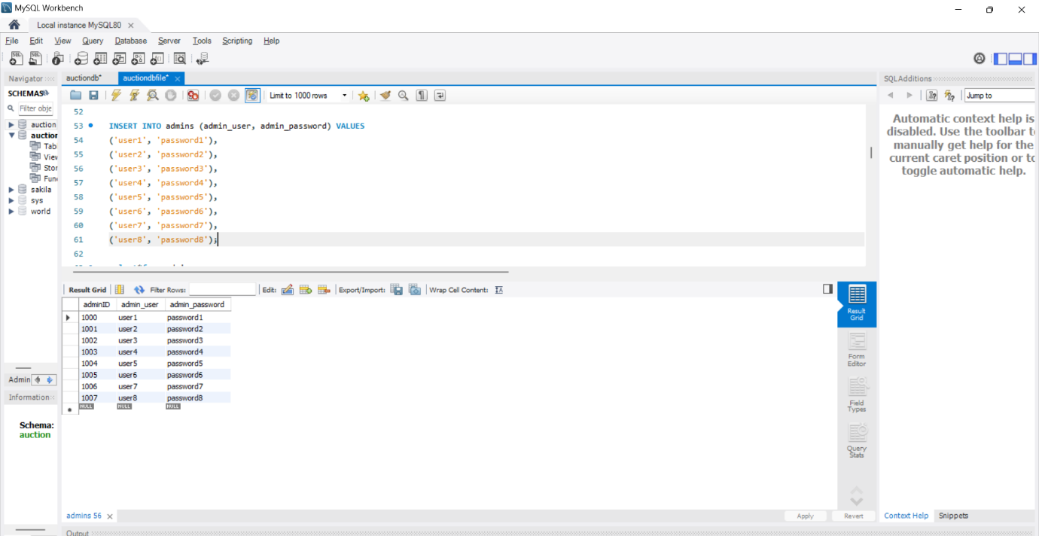

Category

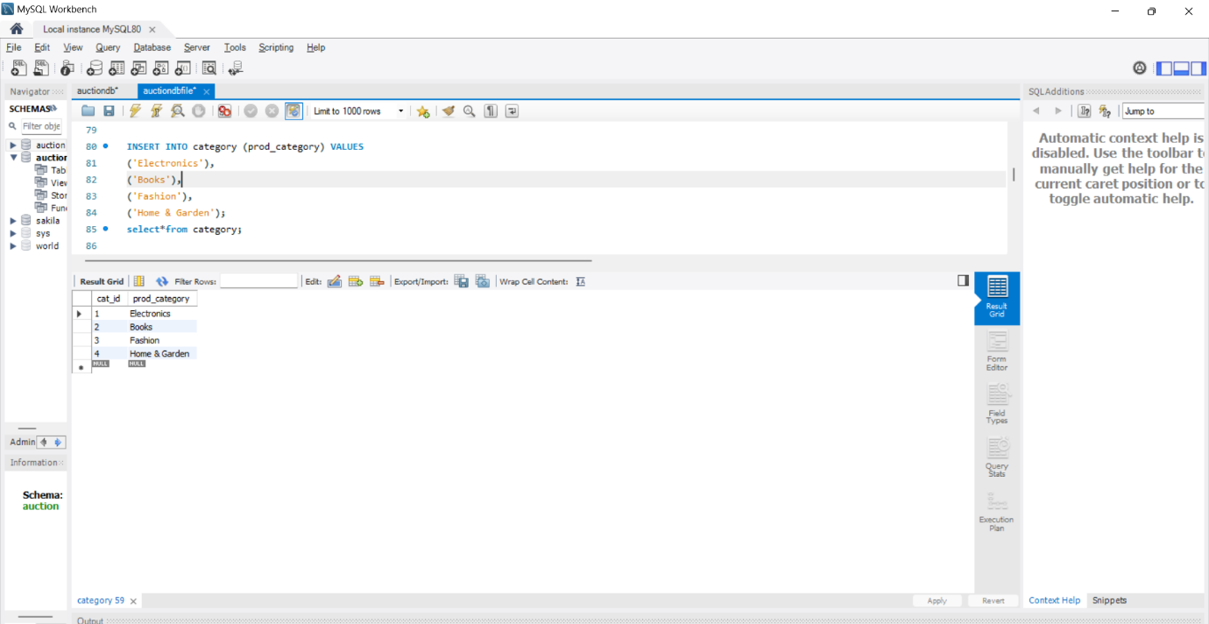

Users

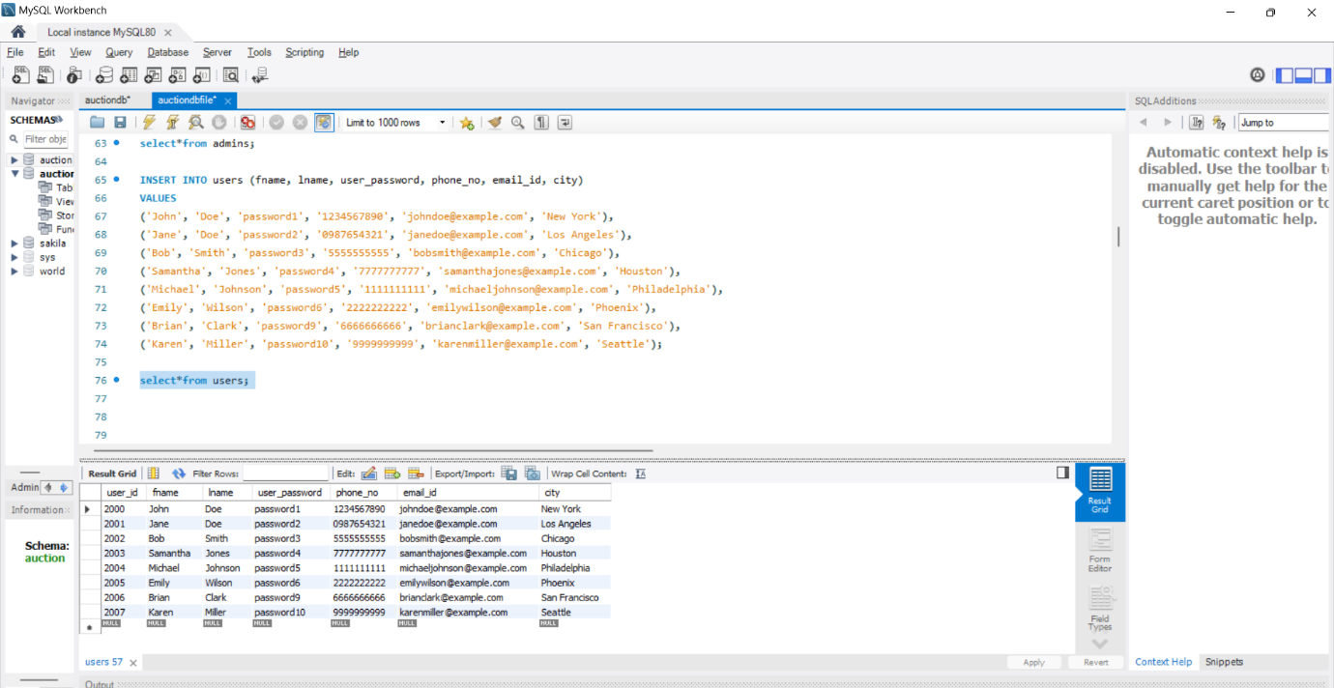

Items

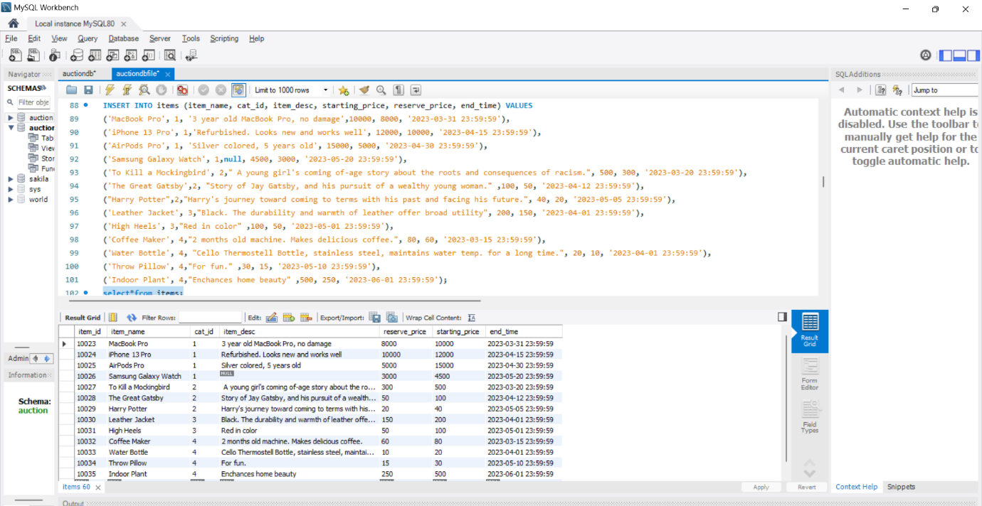

Screenshots of Queries

1. What is the highest bid amount for a specific item in the current auction?

select i.item_id as Item_ID, i.item_name as Item, max(b.bid_amt) as Max_Amount

from items i

join bids b

on i.item_id=b.bid_item_id

where bid_item_id=10034;

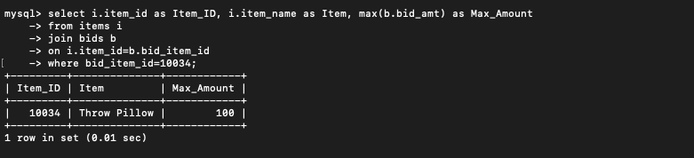

1. How many bids have been placed on a specific item so far?

select i.item_id as Item_ID, i.item_name as Item, count(*) as No_of_Bids

from items i

join bids b

on i.item_id=b.bid_item_id

where i.item_id=10034;

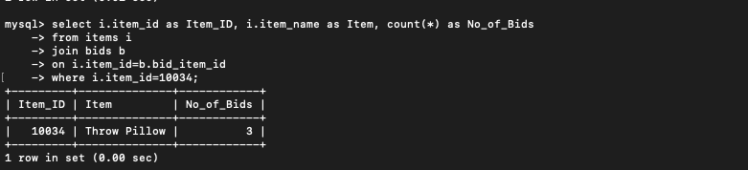

1. Who is the current highest bidder for a specific item?

select i.item_id as Item_ID, i.item_name as Item, concat(u.fname,' ',u.lname) as 'Highest Bidder'

from (items i

join bids b

on i.item_id=b.bid_item_id

join users u

on b.bidder_id=u.user_id)

where i.item_id=10027

order by b.bid_amt

limit 1;

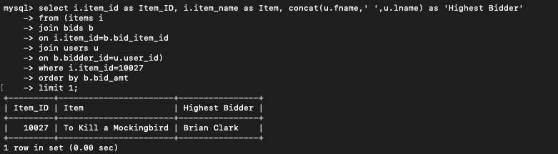

1. How many items are currently available for auction?

select count(*) as 'Items Available' from items

where now()<items.end_time;

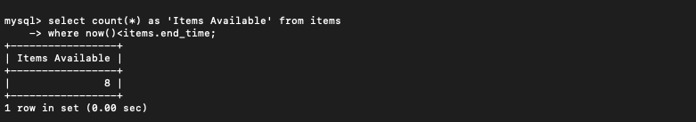

1. What is the bidding history for a specific user?

select u.user_id,concat(u.fname,' ',u.lname) as 'Bidder', i.item_name as 'Item', bid_amt as 'Bid', b.bid_time as 'Time'

from (users u

join bids b

on u.user_id=b.bidder_id

join items i

on i.item_id=b.bid_item_id)

where u.user_id=2001

order by b.bid_time desc;

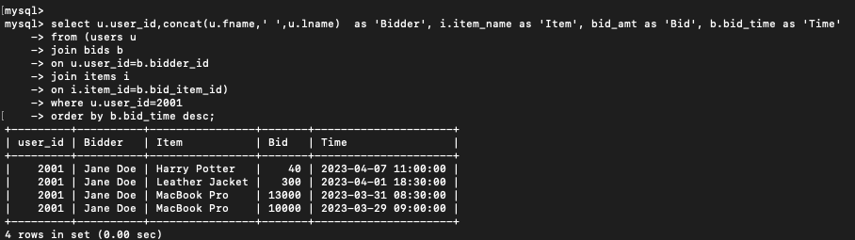

1. How many users have placed bids on a specific item?

select i.item_id as 'Item Id', i.item_name as 'Item', count(distinct b.bidder_id) as 'Number of Bidders'

from items i

join bids b

on i.item_id=b.bid_item_id

where i.item_id=10024;

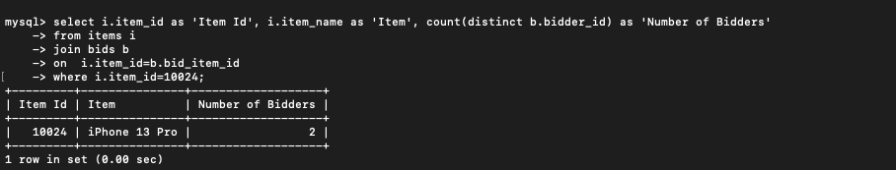

1. What is the total amount of all the bids placed on a specific item?

select i.item_name as "Item", sum(b.bid_amt) as 'Total Bid Value' from

items i join bids b

on i.item_id=b.bid_item_id

where i.item_id=10024;

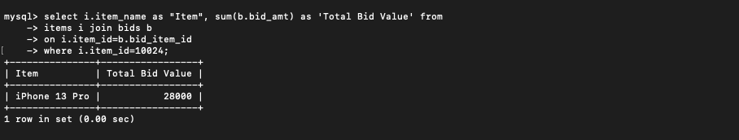

1. 8. What is the status of a specific bid (i.e., winning or losing)?

select b1.bid_id as 'Bid Id', (case

when b1.bid_amt=(select max(b2.bid_amt)

from bids b2

where b2.bid_item_id=b1.bid_item_id)

then 'Winning'

else 'Losing'

end) as 'Status'

from bids b1

where b1.bid_id=10;

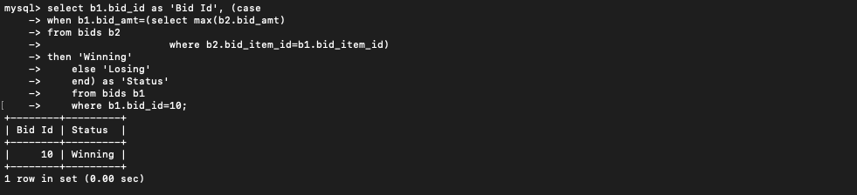

1. 9. How many items has a specific user bid on in the current auction?

select u .user_id as 'User Id', concat(u.fname,' ',u.lname) as 'Selected User', count(distinct b.bid_item_id) as 'Number of items'

from users u

join bids b

on u.user_id=b.bidder_id

where u.user_id=2001;

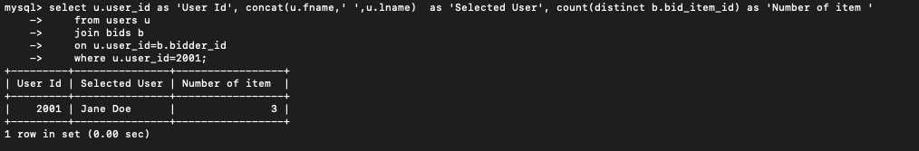

1. What is the total amount of all the bids placed by a specific user in the current auction?

select u .user_id as 'User Id', concat(u.fname,' ',u.lname) as 'Selected User',sum(b.bid_amt) as 'Total Bid Value'

from users u

join bids b

on u.user_id=b.bidder_id

where b.bidder_id=2001;

