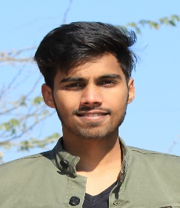

Kartikrathi408@gmail.com

8209362013

Castle Hostel, near Metro

College, Knowledge Park 3,

Greater Noida

# SKILLS

Python

AutoCAD

Java

C

Html

# LANGUAGES

English

*Full Professional Proficiency*

Hindi

*Native or Bilingual Proficiency*

**INTERESTS**

Drawing

Reading

Mythology

Cooking

Playing

Trekking

|  |
| --- |
| Kartik Rathi  To secure a position with a stable and profitable organization, where I can be a member of a team and utilize my knowledge to the fullest and also to help my organization. |

# EDUCATION

|  |  |
| --- | --- |
| **10th Class**  Noble International School, Jodhpur | *9.8 CGPA* |
| **12th Class**  Noble International School, Jodhpur  *5/2017 - 03/2018*, | *78.4%* |
| **B. Tech Computer Science Engineering**  Sharda University, Greater Noida  *07/2018 - Present*,  **PERSONAL PROJECTS** | *8.2 CGPA* |
| Train Reservation System Using Java (04/2019 - 06/2019)  Exam Sitting Arrangement for students & teachers using ML (08/2020 – 10/2020)  Face Mask Identification and social distancing using ML (08/2020 – 10/2020)  **ORGANIZATIONS & Working Experience** |  |
| Worked with NSS Cell (08/2018 - 09/2019)  Part of ERT committee Chorus (02/2019 - 03/2019)  **ACHIEVEMENTS** |  |

Secured 3rd position in Java Course Exam by HTML online.