Assignment 15.1

Problem Statement :-

1. Write a simple program to show inheritance in scala.

2. Write a simple program to show multiple inheritance in scala. Solution:-

Program to show inheritance in scala

In this program, we are performing an inheritance of a class into another class. In the class Employee we have defined Salary as float, and inherited Employee into the class Programmer where we have defined Bonus as Int.

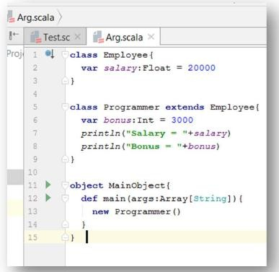

You will notice that Salary gives an output with decimals whereas Bonus gives an output as proper number.

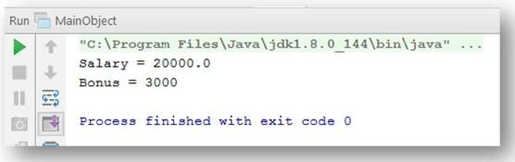

**Program to show multiple inheritance in scala**

In this program, we are performing multiple inheritance. We are going to inherit Class A ->Class B and Class B -> Class C. We haven’t specified any object type for the variables Salary1 and Salary2.

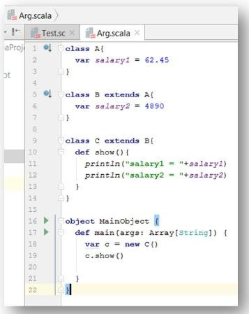

You will notice that the output has decimals as well as proper number since we

haven’t defined object type for the variables.

